A Quick Linux VM on Windows with Vagrant
Created by Quality Thought
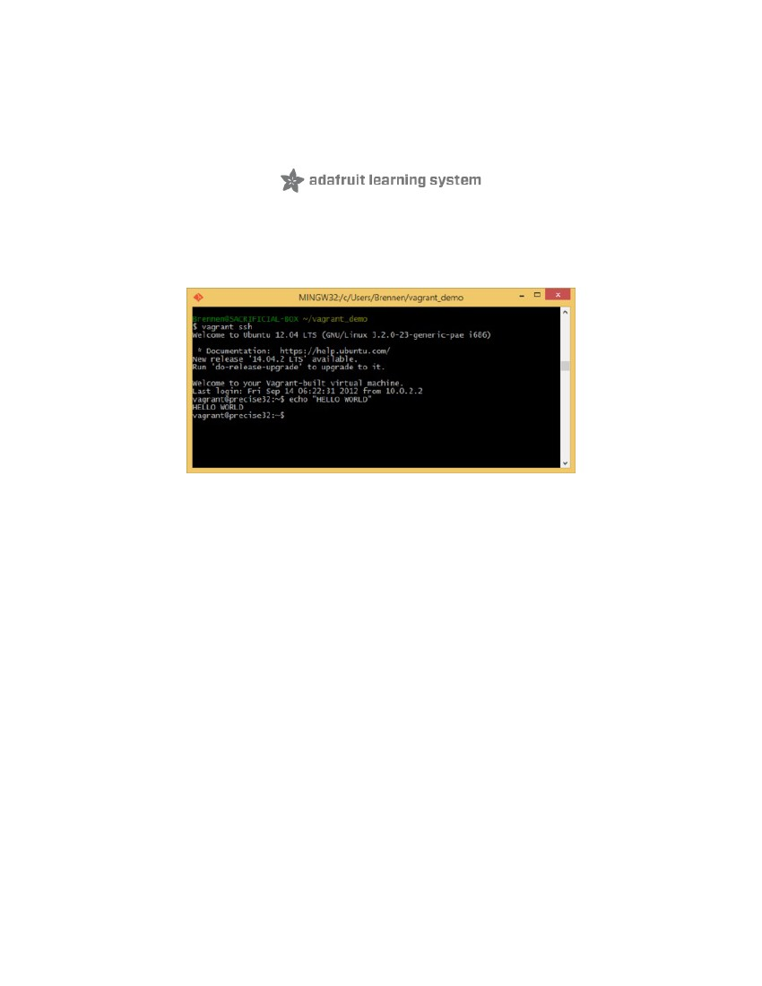

Guide Contents
Guide Contents
Overview
Install Vagrant
Install msysGit
Install VirtualBox
Run Bash and Fire up a New Vagrant Box
2
3
5
10
14
16
http://qualitythoughtchefpuppetdocker.blogspot.in/
Page 2 of 18


Overview

http://qualitythoughtchefpuppetdocker.blogspot.in/
Vagrant is a software package designed to let you easily create disposable VMs from a library of
freely-downloadable images and connect to them, all with a few simple commands in a terminal.
The idea is that you can continue to run your desktop OS like Mac OS X or Windows 7 or whatever,
but then make a tiny new Linux computer in a window that you can connect to whenever you need
to run Linux software
Unfortunately this isn't quite as seamless on Windows machines as on GNU/Linux or OS X systems,
but with a few minutes of effort you should be able to do this any time you feel like it:
Page 3 of 18
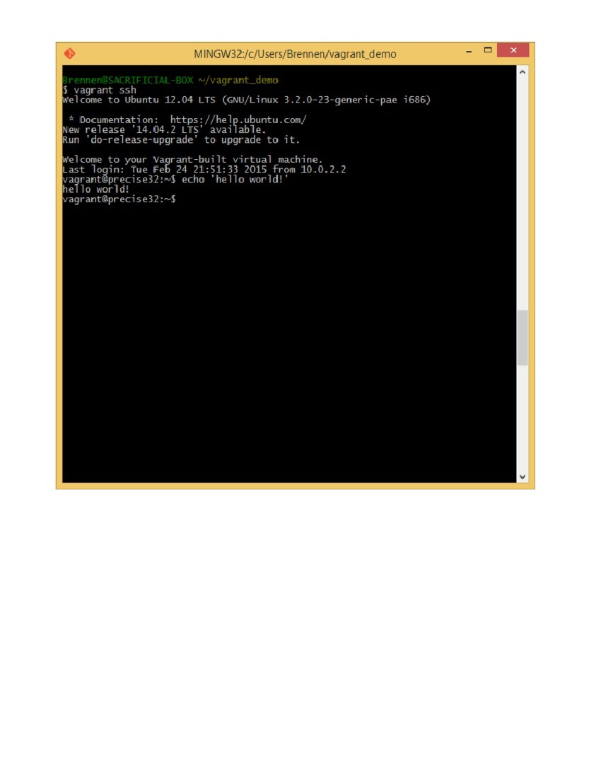
This is a brief guide to installing the three moving pieces needed to make this work well on a
Windows machine:
1. Vagrant itself
2. VirtualBox to run virtual machines
3. msysGit, a Windows distribution of Git and some other Unix tools, for cloning git repositories
containing Vagrant configurations and connecting to your new VM with SSH
http://qualitythoughtchefpuppetdocker.blogspot.in/
Page 4 of 18

Install Vagrant
First, hit the Vagrant site (https://www.vagrantup.com/downloads.html) and look for a "DOWNLOAD" button.
Click on the Windows installer link, and save the installer:
http://qualitythoughtchefpuppetdocker.blogspot.in/
Page 5 of 18
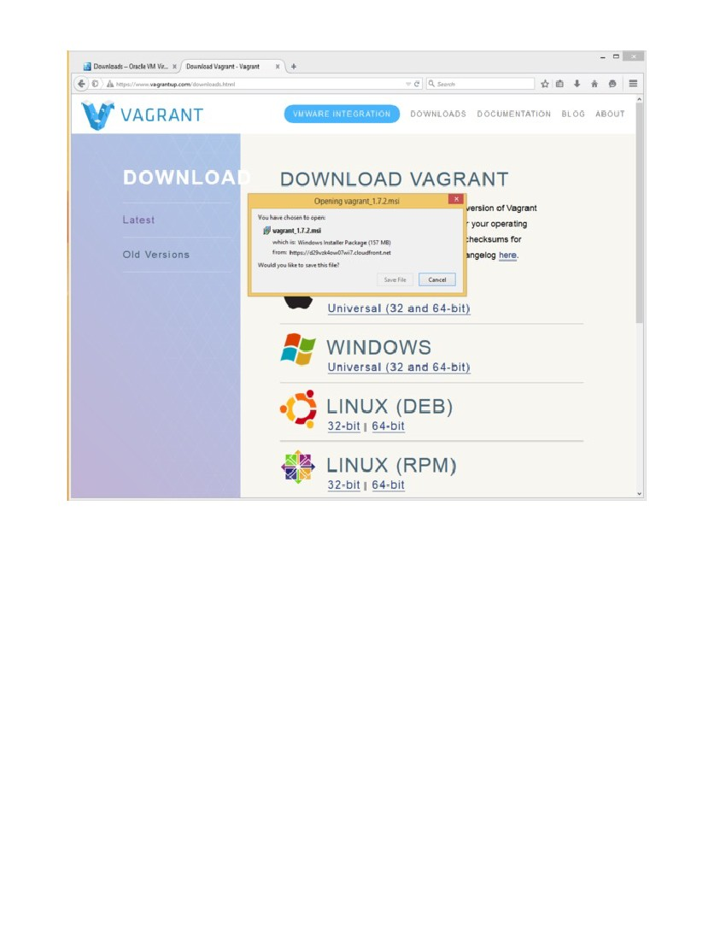
Then run the installer. Default choices should be fine.
http://qualitythoughtchefpuppetdocker.blogspot.in/
Page 6 of 18
http://qualitythoughtchefpuppetdocker.blogspot.in/
Page 7 of 18
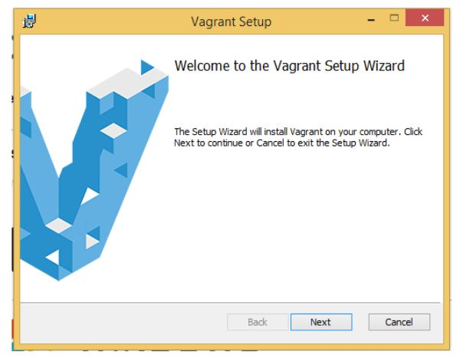
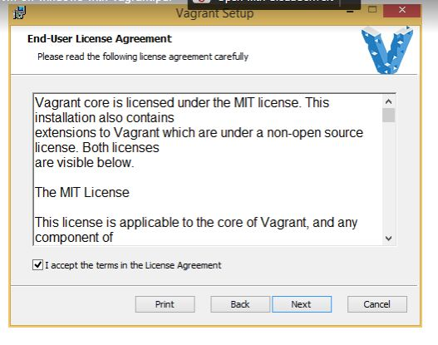
http://qualitythoughtchefpuppetdocker.blogspot.in/
Page 8 of 18
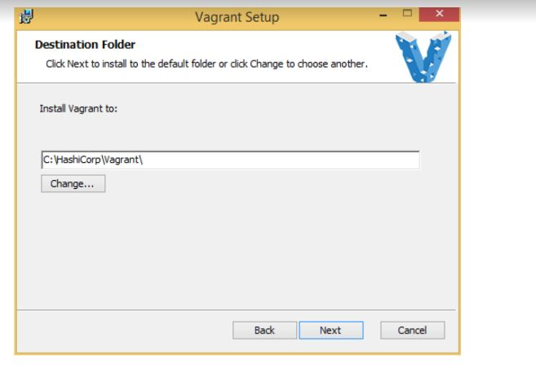
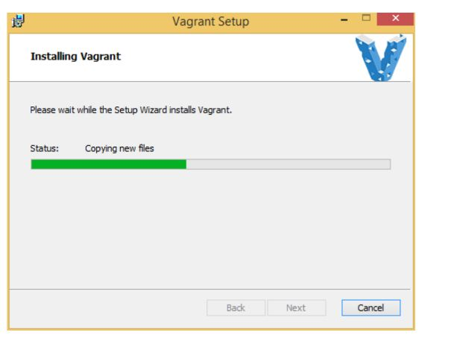
http://qualitythoughtchefpuppetdocker.blogspot.in/
Page 9 of 18
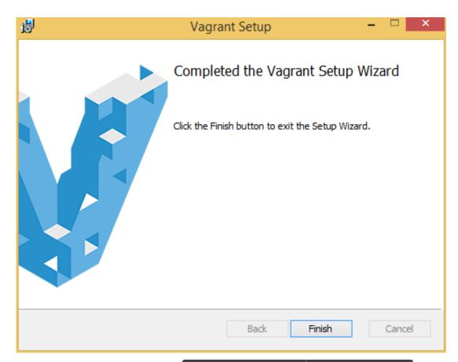
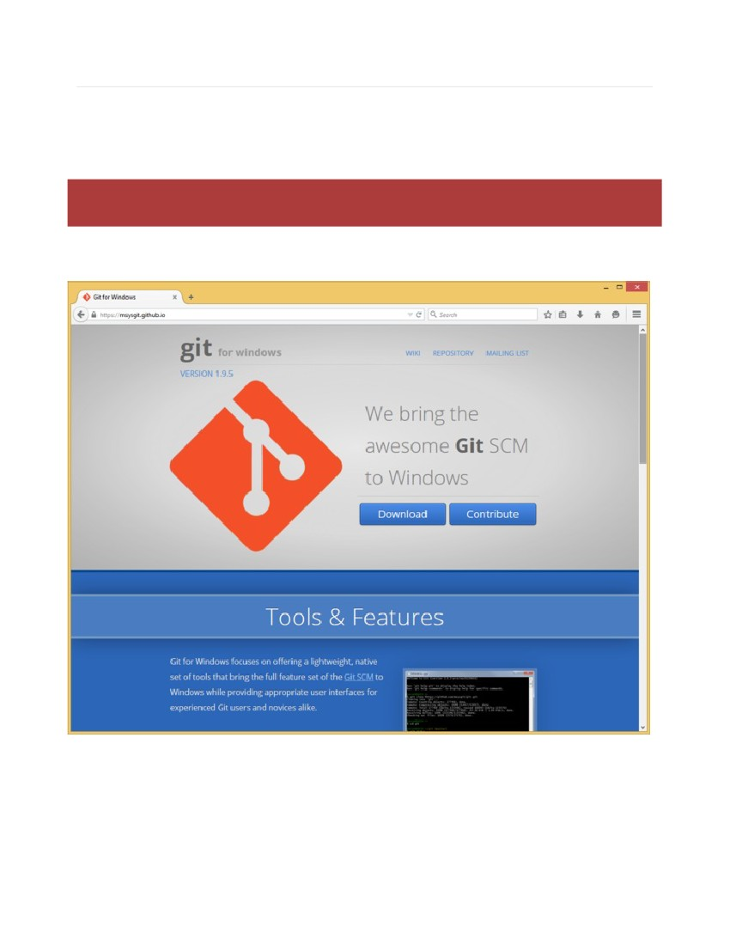
Install Git
Next, we'll install Git, which is a distribution of the git version control
system (https://git-scm.com/downloads). Git isn't strictly necessary for working with Vagrant, but it provides a
version of the Bash shell, SSH, and other tools we'll find helpful. Later on, if you have Git installed,
you can use it to keep up to date with things like the Kernel-o-Matic (https://git-scm.com/downloads).
Again, visit the site (https://git-scm.com/downloads) and look for a "Download" button.
Run the installer. Windows will likely ask you several times if you'd like to allow the installer to run
and modify your system.
http://qualitythoughtchefpuppetdocker.blogspot.in/
Page 10 of 18

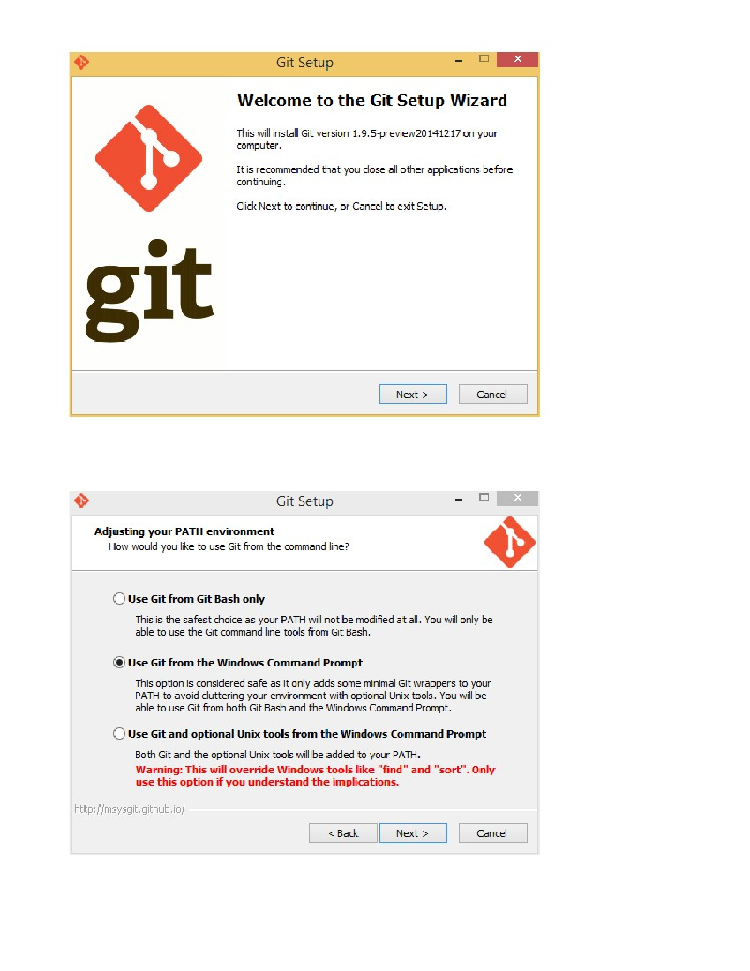
For most options, the defaults should be acceptable. You may want to select "Use Git from the
Windows Command Prompt", but it shouldn't make any real difference for our purposes.
http://qualitythoughtchefpuppetdocker.blogspot.in/
Page 11 of 18
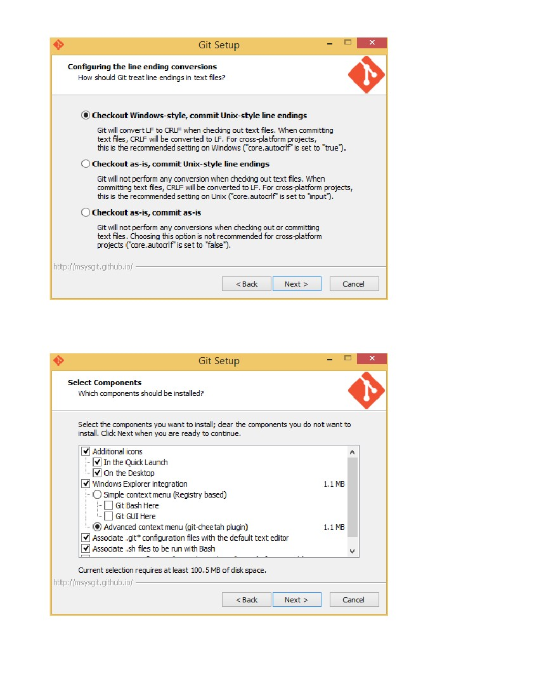
For convenience, you might want to choose "In the Quick Launch" and "On the Desktop" under
"Additional icons".
http://qualitythoughtchefpuppetdocker.blogspot.in/
Page 12 of 18
http://qualitythoughtchefpuppetdocker.blogspot.in/
Page 13 of 18
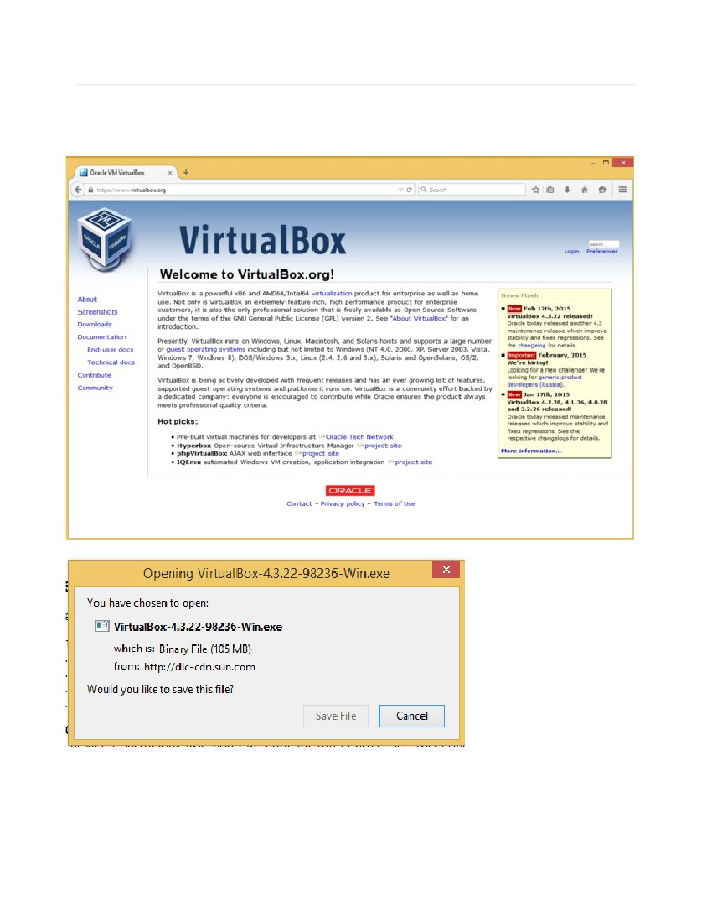
Install VirtualBox
Lastly, we need VirtualBox to actually run the virtual machine we're going to configure. Head to
virtualbox.org (https://www.virtualbox.org) and look for the Downloads (https://www.virtualbox.org/wiki/Downloads) link, then find the
Windows installer.
As with Vagrant and msysGit, run the installer, and click through options. Defaults should be fine.
http://qualitythoughtchefpuppetdocker.blogspot.in/
Page 14 of 18
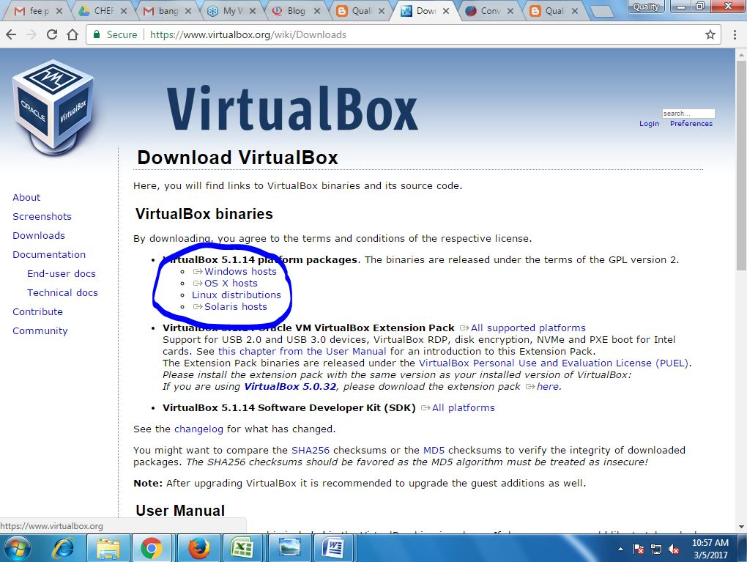
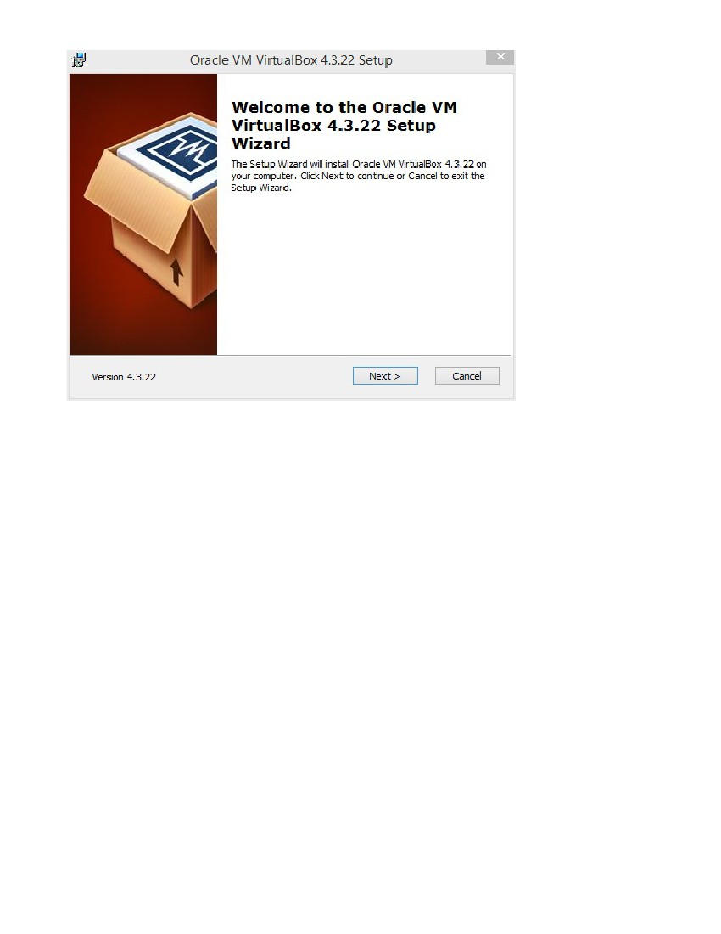
If all has gone well, you should be ready to start up a Vagrant box.
http://qualitythoughtchefpuppetdocker.blogspot.in/
Page 15 of 18
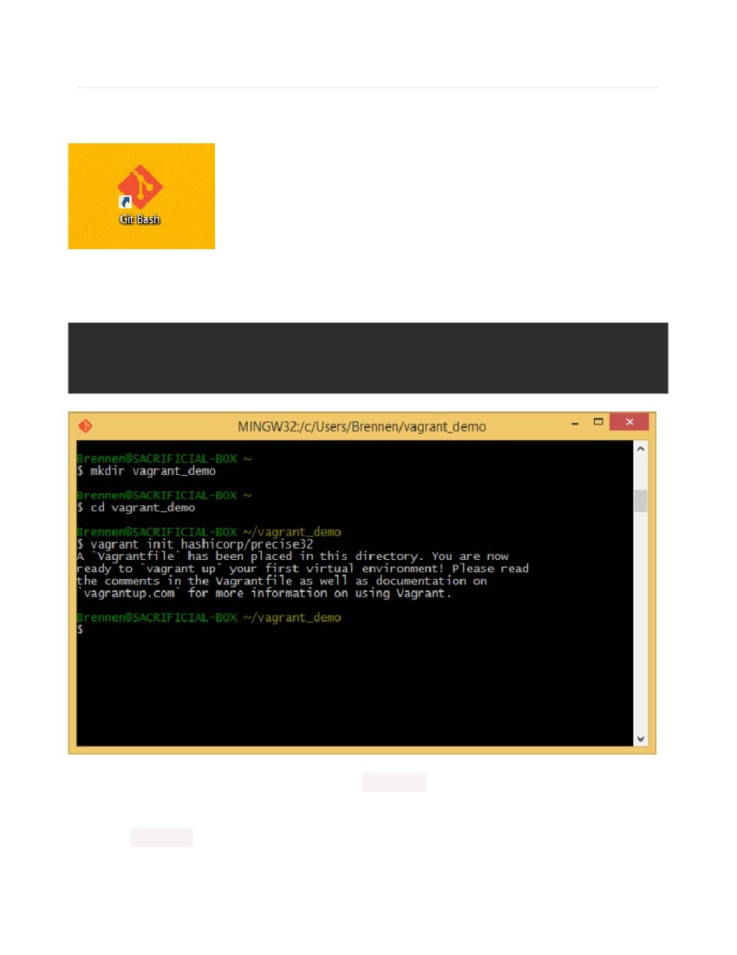
Run Bash and Fire up a New Vagrant Box
First, look for the Git Bash prompt provided by msysGit. It's probably on your desktop, but if you
can't find it there, have a look in the Start Menu.
This is a version of Bash, which is a standard shell on GNU/Linux systems (for shell basics, start
here (https://atlas.hashicorp.com/boxes/search?)). Fire it up and enter the following commands:
mkdir vagrant_demo
cd vagrant_demo
vagrant init hashicorp/precise32
You should now have a folder containing a basic Vagrantfile . (There's a lot of
documentation (https://www.vagrantup.com/downloads.html) on Vagrantfiles.)
Next, do vagrant up , which should download an image, set it up, and start a virtual machine running
in VirtualBox. This will probably take a while.
http://qualitythoughtchefpuppetdocker.blogspot.in/
Page 16 of 18
http://qualitythoughtchefpuppetdocker.blogspot.in/
Page 17 of 18
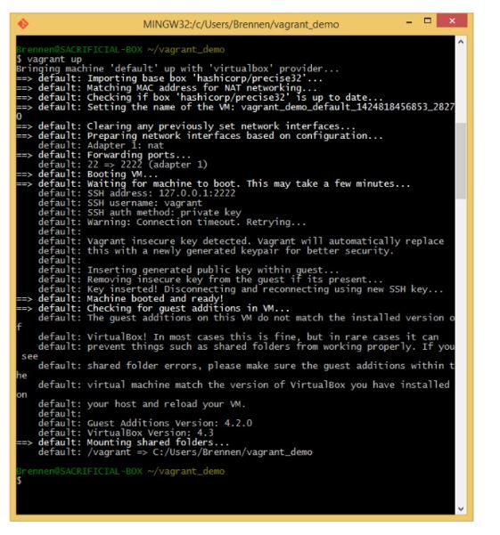
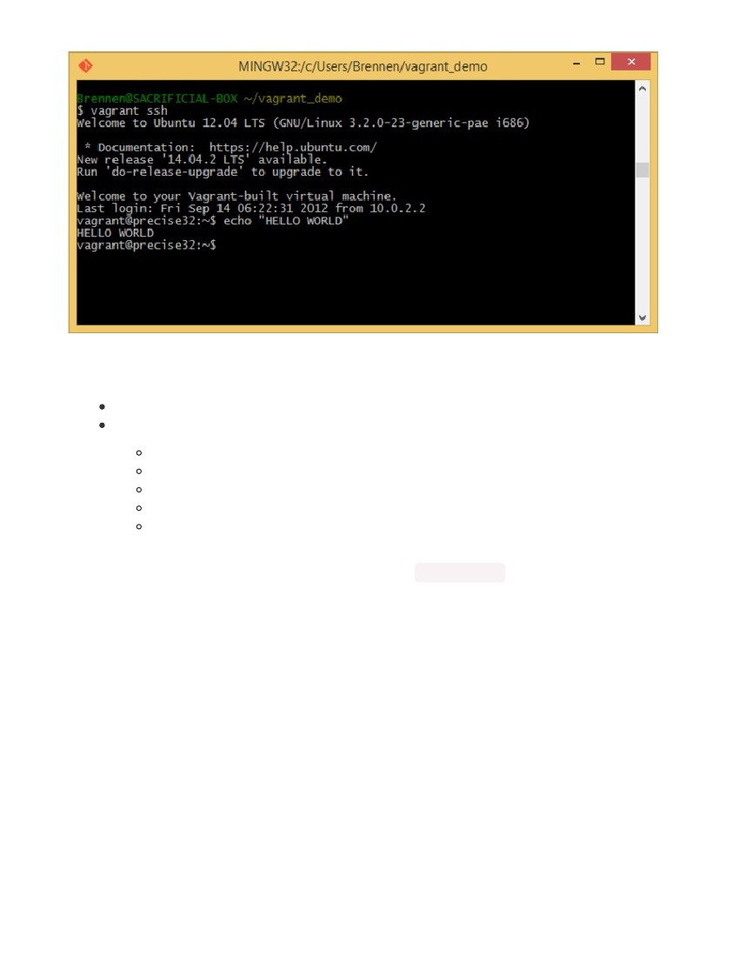
There you have it: A working Linux VM. What now? Well, you can:
Continue with the Getting Started section (https://www.vagrantup.com/downloads.html) of the official Vagrant manual.
Check out our ongoing series of introductory Linux tutorials:
What is this "Linux", anyhow? (https://www.vagrantup.com/downloads.html)
What is the Command Line? (https://www.vagrantup.com/docs/)
Once you're done with a machine, you can remove it with vagrant destroy .
http://qualitythoughtchefpuppetdocker.blogspot.in/
If you're interested in trying other operating systems and configurations, read the manual on
boxes (https://atlas.hashicorp.com/boxes/search?), then have a look at the list of available boxes from
Page 18 of 18

