INTERNAL · NO APPROVALS · DEVELOPMENT ONLY

Florida evidence-backed Eyeball review
Generated 2026-09-21T20:57:50.183Z. Ten priority records, three blocked branches, and 92 legacy holds.
Freshness: VALID UNTIL THE EXACT EXPIRY BELOW. Evidence receipt had not expired at generation time. It expires exactly at 2026-09-25T21:18:23.012Z; no freshness is claimed after that instant.
A text or screenshot match is not approval. Screenshots are direct offline renderings of saved official raw HTML with outbound requests blocked. Browser-default styling appears where the saved page referenced an external stylesheet. Yellow highlighting is an annotation.
Reviewer: ________________________________________
Date: ____________________
Packet notes: ________________________________________________________________________________

PRIORITY 1 · RECOVERED BATCH E · NO APPROVAL

Use, possession, manufacture, delivery, transportation, advertisement, or retail sale of drug paraphernalia, specified machines, and materials
Record ID: fl-fs-893-147-4-b-use-possession-manufacture-delivery-transportation-advertisement-or-retail-sale-of-drug-paraphernalia-specified-machines-and-materials
Exact scope: Fla. Stat. § 893.147(4)(b)

Proposed EN / ES / ZH explanations
EN: Using, possessing with intent to use, or manufacturing with intent to use drug paraphernalia, while knowing or under circumstances where one reasonably should know it will be used to transport a contraband article within § 932.701(2)(a)1.'s narcotics-related definition. Third-degree felony. This record is confined to § 932.701(2)(a)1.: a chapter 893 controlled substance, or a substance, device, paraphernalia, currency, or other means of exchange used, attempted to be used, or intended to be used in violation of chapter 893, when the state's facts clearly suffice to establish probable cause of a nexus between the seized article and narcotics activity. It does not include the other contraband-article categories in § 932.701(2)(a).
ES: Usar, poseer con intención de usar o fabricar con intención de usar parafernalia de drogas, sabiendo o en circunstancias en que razonablemente debería saberse que se usará para transportar un bien de contrabando comprendido en la definición relacionada con narcóticos del § 932.701(2)(a)1. Delito grave de tercer grado. Este registro se limita al § 932.701(2)(a)1.: una sustancia controlada conforme al capítulo 893, o una sustancia, dispositivo, parafernalia, moneda u otro medio de intercambio usado, que se intentó usar o destinado a usarse en infracción del capítulo 893, cuando los hechos presentados por el estado sean claramente suficientes para establecer causa probable de un nexo entre el bien incautado y la actividad de narcóticos. No incluye las demás categorías de bienes de contrabando del § 932.701(2)(a).
ZH: 使用、意图使用而持有，或意图使用而制造吸毒用具，同时明知或在理应知道的情形下，该用具将被用于运输第932.701(2)(a)1条涉毒定义范围内的违禁物品。 三级重罪。本记录仅限第932.701(2)(a)1条：第893章所定义的受管制物质，或已经、曾试图或意图用于违反第893章的物质、装置、用具、货币或其他交换手段，且州方提出的全部事实明确足以确立合理根据，相信被扣押物品与毒品活动之间存在关联。它不包括第932.701(2)(a)条中的其他违禁物品类别。
Spanish and Chinese text has no fluent-speaker or attorney approval in this packet.

Exact quoted support and anchor accounting
Matched means one normalized occurrence in the saved snapshot text. It does not mean legally sufficient or approved.
Anchor | Status | Count | Exact quote | Screenshot
identity-1 | matched | 1 | Use, possession, manufacture, delivery, transportation, advertisement, or retail sale of drug paraphernalia, specified machines, and materials | highlighted in saved raw HTML
conduct-2 | matched | 1 | Contraband as defined in s. 932.701(2)(a)1. | highlighted in saved raw HTML
grading-3 | matched | 1 | Any person who violates this subsection commits a felony of the third degree, punishable as provided in s. 775.082, s. 775.083, or s. 775.084. | highlighted in saved raw HTML

Saved-source evidence frames
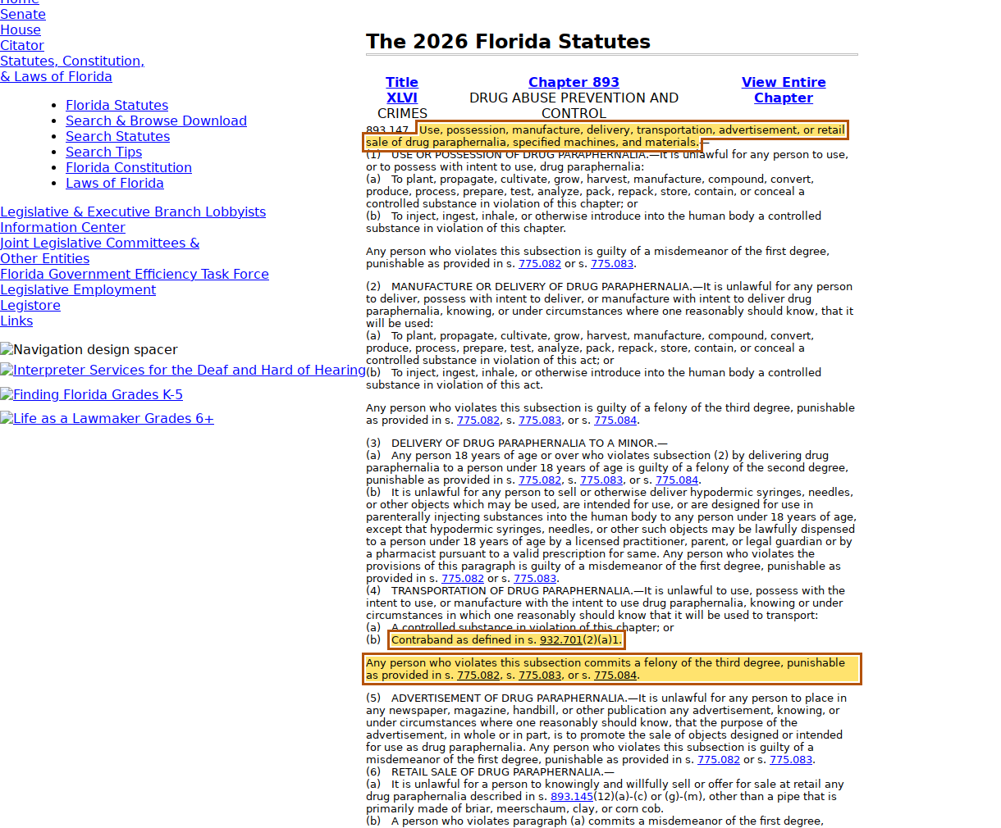
Frame 1. Direct offline rendering of saved official raw HTML; outbound resources blocked; yellow outline is the review annotation. Context around the complete qualification is retained.

Accessible source and provenance
Official source URL: https://www.leg.state.fl.us/statutes/index.cfm?App_mode=Display_Statute&URL=0800-0899/0893/Sections/0893.147.html
Edition: Florida Statutes 2026
Raw HTML retrieved: 2026-09-18T21:21:35.068Z
Parsed evidence retrieved: 2026-09-18T21:21:35.068Z
Raw HTML SHA-256: 01b23557772bf988cd581414b0e086c201139020bf1f16a80dae55f511de560c
Normalized source-text SHA-256: d087a2f6005abfe8a24146886d094031a6c97758d2cb684073db085a562ed536
identity · matched: Use, possession, manufacture, delivery, transportation, advertisement, or retail sale of drug paraphernalia, specified machines, and materials
conduct · matched: Contraband as defined in s. 932.701(2)(a)1.
grading · matched: Any person who violates this subsection commits a felony of the third degree, punishable as provided in s. 775.082, s. 775.083, or s. 775.084.

Dependencies, defenses, exceptions, and boundaries
Analyst boundary: This record is confined to paragraph (4)(b) and only § 932.701(2)(a)1.'s narcotics-related definition: a chapter 893 controlled substance, or a substance, device, paraphernalia, currency, or other means of exchange used, attempted to be used, or intended to be used in violation of chapter 893, subject to the stated probable-cause nexus standard. It does not infer or include the other contraband-article categories in § 932.701(2)(a). Section 893.145 supports the parent term “drug paraphernalia”; §§ 893.02 and 893.03 support the incorporated controlled-substance term.
Section | Role | Edition | Retrieved | Content SHA-256 | Validation
§ 893.147 | offense | Florida Statutes 2026 | 2026-09-18T21:21:35.068Z | d087a2f6005abfe8a24146886d094031a6c97758d2cb684073db085a562ed536 | validated
§ 893.147 | grading | Florida Statutes 2026 | 2026-09-18T21:21:35.068Z | d087a2f6005abfe8a24146886d094031a6c97758d2cb684073db085a562ed536 | validated
§ 893.147 | justification | Florida Statutes 2026 | 2026-09-18T21:21:35.068Z | d087a2f6005abfe8a24146886d094031a6c97758d2cb684073db085a562ed536 | validated
§ 893.145 | definition | Florida Statutes 2026 | 2026-09-18T21:21:32.884Z | d9a2d3ad35d00cd483160e5fdc42cfece961cd466e04c58230f67faed79cafc0 | validated
§ 932.701 | definition | Florida Statutes 2026 | 2026-09-18T21:21:45.142Z | bbd401d5df7cfba062191d5f8fa58fcb2d2be49587fc0a7f7678e0b4413389d1 | validated
§ 893.02 | definition | Florida Statutes 2026 | 2026-09-18T21:21:21.928Z | 5356b206019ee59d5f872b601345d6569be3a55a0728d6292949a4edc1ca4e17 | validated
§ 893.03 | definition | Florida Statutes 2026 | 2026-09-18T21:21:24.137Z | 81424abc014f4f34e775b7e0d8c2d47d5e03963c81bf17a5f6b99552eb0ba4a1 | validated

Precise review question
Does Fla. Stat. § 893.147(4)(b) support this record at exactly the proposed scope, rather than a neighboring or broader branch? Do the quoted anchors establish every stated conduct, mental-state, victim/age or harm condition, defense or exception, and grade described in the EN/ES/ZH explanations? Are these dependency roles complete: § 893.147 (offense), § 893.147 (grading), § 893.147 (justification), § 893.145 (definition), § 932.701 (definition), § 893.02 (definition), § 893.03 (definition)? Is this boundary accurate: This record is confined to paragraph (4)(b) and only § 932.701(2)(a)1.'s narcotics-related definition: a chapter 893 controlled substance, or a substance, device, paraphernalia, currency, or other means of exchange used, attempted to be used, or intended to be used in violation of chapter 893, subject to the stated probable-cause nexus standard. It does not infer or include the other contraband-article categories in § 932.701(2)(a). Section 893.145 supports the parent term “drug paraphernalia”; §§ 893.02 and 893.03 support the incorporated controlled-substance term. For any “no,” identify the exact text and choose hold, correct, split, reclassify, deduplicate, or remove. A screenshot match is not approval.

Blank decision
☐ publish ☐ hold ☐ correct ☐ split ☐ reclassify ☐ deduplicate ☐ remove
Decision / exact action: __________________________________________________________________
Required notes / exact corrections: ____________________________________________________________
________________________________________________________________________________________
________________________________________________________________________________________
Reviewer: ________________________________________
Date: ____________________
Record hash: fa38bb19625e1de3d6f950bc7e62f2d53fd97499e30fc3719b670309ff5528b7
Evidence hash: 167bae56334aa77962c6ab6a67aa54275a6023b59d3e2bc016d42959497ec1c6
Combined decision-binding hash: 314bc5d53defe7f0776174ae33e53b0bef15267543515240cd514719ae6794b8

PRIORITY 2 · BATCH F · NO APPROVAL

Abuse, aggravated abuse, and neglect of an elderly person or disabled adult; penalties
Record ID: fl-fs-825-102-1-abuse-aggravated-abuse-and-neglect-of-an-elderly-person-or-disabled-adult-penalties
Exact scope: Fla. Stat. § 825.102(1)

Proposed EN / ES / ZH explanations
EN: Knowingly or willfully abusing an elderly person or disabled adult, without causing great bodily harm, permanent disability, or permanent disfigurement. Abuse includes intentionally inflicting injury, an intentional act reasonably expected to cause injury, actively encouraging such an act, or the specified intentional and unauthorized isolation or restriction of family access. Third-degree felony. For the isolation or family-access branch, it is a defense that the defendant reasonably believed the action was necessary to protect the person's welfare. Section 825.101 supplies the controlling definitions of elderly person and disabled adult.
ES: Abusar a sabiendas o deliberadamente de una persona anciana o un adulto con discapacidad, sin causar gran daño corporal, discapacidad permanente ni desfiguración permanente. El abuso incluye infligir intencionalmente una lesión, realizar un acto intencional del que razonablemente se espere una lesión, alentar activamente tal acto, o el aislamiento o la restricción intencional y sin autoridad del acceso familiar en las circunstancias especificadas. Delito grave de tercer grado. Para la rama de aislamiento o restricción del acceso familiar, es defensa que el acusado creyera razonablemente que la medida era necesaria para proteger el bienestar de la persona. El § 825.101 contiene las definiciones aplicables de persona anciana y adulto con discapacidad.
ZH: 明知或故意虐待老年人或残障成年人，但未造成严重身体伤害、永久残疾或永久毁容。虐待包括故意造成伤害、实施可合理预期导致伤害的故意行为、积极鼓励他人实施此类行为，或在法定情形下故意且无合法授权地隔离该人或限制其与家人接触。 三级重罪。对于隔离或限制家人接触的分支，被告有合理理由相信该行为为保护该人的福祉所必要，属于一项抗辩。第825.101条规定了老年人和残障成年人的适用定义。
Spanish and Chinese text has no fluent-speaker or attorney approval in this packet.

Exact quoted support and anchor accounting
Matched means one normalized occurrence in the saved snapshot text. It does not mean legally sufficient or approved.
Anchor | Status | Count | Exact quote | Screenshot
identity-1 | matched | 1 | Abuse, aggravated abuse, and neglect of an elderly person or disabled adult; penalties | highlighted in saved raw HTML
conduct-2 | matched | 1 | Intentional infliction of physical or psychological injury upon an elderly person or disabled adult; | highlighted in saved raw HTML
conduct-3 | matched | 1 | An intentional act that could reasonably be expected to result in physical or psychological injury to an elderly person or disabled adult; | highlighted in saved raw HTML
conduct-4 | matched | 1 | Active encouragement of any person to commit an act that results or could reasonably be expected to result in physical or psychological injury to an elderly person or disabled adult; or | highlighted in saved raw HTML
conduct-5 | matched | 1 | Intentionally, and without lawful authority, isolating or restricting access of an elderly person or a disabled adult to family members for any length of time which could reasonably be expected to result in physical or psychological injury to the elderly person or disabled adult, or with the intent to promote, facilitate, conceal, or disguise some form of criminal activity involving the person or property of the elderly person or disabled adult. It is a defense to a violation of this paragraph that the defendant had reasonable cause to believe that his or her action was necessary to protect the elderly person or disabled adult from danger to his or her welfare. | highlighted in saved raw HTML
conduct-6 | matched | 1 | A person who knowingly or willfully abuses an elderly person or disabled adult without causing great bodily harm, permanent disability, or permanent disfigurement to the elderly person or disabled adult commits a felony of the third degree, punishable as provided in s. 775.082, s. 775.083, or s. 775.084. | highlighted in saved raw HTML
grading-7 | matched | 1 | A person who knowingly or willfully abuses an elderly person or disabled adult without causing great bodily harm, permanent disability, or permanent disfigurement to the elderly person or disabled adult commits a felony of the third degree, punishable as provided in s. 775.082, s. 775.083, or s. 775.084. | highlighted in saved raw HTML

Saved-source evidence frames
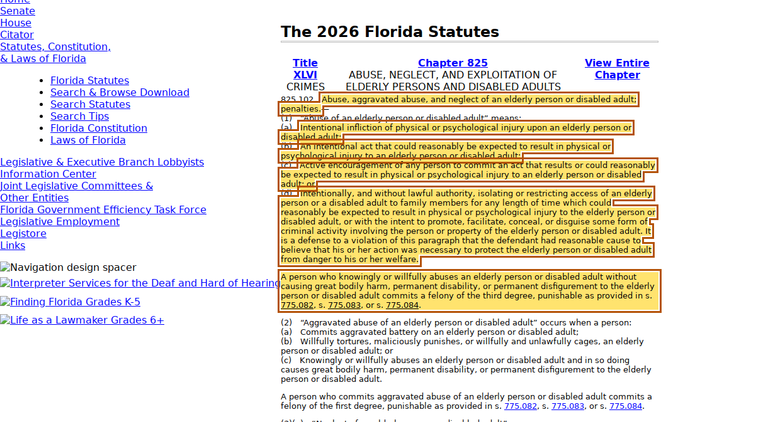
Frame 1. Direct offline rendering of saved official raw HTML; outbound resources blocked; yellow outline is the review annotation. Context around the complete qualification is retained.

Accessible source and provenance
Official source URL: https://www.leg.state.fl.us/statutes/index.cfm?App_mode=Display_Statute&URL=0800-0899/0825/Sections/0825.102.html
Edition: Florida Statutes 2026
Raw HTML retrieved: 2026-09-18T15:56:36.841Z
Parsed evidence retrieved: 2026-09-18T21:20:40.467Z
Raw HTML SHA-256: 6b56aead0da3ad3c9d2f2dea3c6e5b5a89dc0b42943d36dc3c5ae4c829f5f1d9
Normalized source-text SHA-256: 3e10ae58cfc3cb0bac6f33f759cfcabebfd47b4669469d3feab4d028dad80813
identity · matched: Abuse, aggravated abuse, and neglect of an elderly person or disabled adult; penalties
conduct · matched: Intentional infliction of physical or psychological injury upon an elderly person or disabled adult;
conduct · matched: An intentional act that could reasonably be expected to result in physical or psychological injury to an elderly person or disabled adult;
conduct · matched: Active encouragement of any person to commit an act that results or could reasonably be expected to result in physical or psychological injury to an elderly person or disabled adult; or
conduct · matched: Intentionally, and without lawful authority, isolating or restricting access of an elderly person or a disabled adult to family members for any length of time which could reasonably be expected to result in physical or psychological injury to the elderly person or disabled adult, or with the intent to promote, facilitate, conceal, or disguise some form of criminal activity involving the person or property of the elderly person or disabled adult. It is a defense to a violation of this paragraph that the defendant had reasonable cause to believe that his or her action was necessary to protect the elderly person or disabled adult from danger to his or her welfare.
conduct · matched: A person who knowingly or willfully abuses an elderly person or disabled adult without causing great bodily harm, permanent disability, or permanent disfigurement to the elderly person or disabled adult commits a felony of the third degree, punishable as provided in s. 775.082, s. 775.083, or s. 775.084.
grading · matched: A person who knowingly or willfully abuses an elderly person or disabled adult without causing great bodily harm, permanent disability, or permanent disfigurement to the elderly person or disabled adult commits a felony of the third degree, punishable as provided in s. 775.082, s. 775.083, or s. 775.084.

Dependencies, defenses, exceptions, and boundaries
Analyst boundary: Scope is exactly subsection (1), including all four statutory abuse alternatives and the paragraph (d) defense. It excludes aggravated abuse and both neglect grades. Section 825.101 is required for the victim definitions.
Section | Role | Edition | Retrieved | Content SHA-256 | Validation
§ 825.102 | offense | Florida Statutes 2026 | 2026-09-18T21:20:40.467Z | 3e10ae58cfc3cb0bac6f33f759cfcabebfd47b4669469d3feab4d028dad80813 | validated
§ 825.102 | grading | Florida Statutes 2026 | 2026-09-18T21:20:40.467Z | 3e10ae58cfc3cb0bac6f33f759cfcabebfd47b4669469d3feab4d028dad80813 | validated
§ 825.102 | exception | Florida Statutes 2026 | 2026-09-18T21:20:40.467Z | 3e10ae58cfc3cb0bac6f33f759cfcabebfd47b4669469d3feab4d028dad80813 | validated
§ 825.101 | definition | Florida Statutes 2026 | 2026-09-18T21:20:38.076Z | d17c072dc5d6a9fd01ebba7d209167df5daa51f5f6f7b252d423bc37824fc15c | validated
§ 775.082 | penalty | Florida Statutes 2026 | 2026-09-18T21:18:58.265Z | ce7d77dd9b8582b3f7e8559aa0784d7798c48dd70f51aff79dbccebe94bedd9c | validated
§ 775.083 | penalty | Florida Statutes 2026 | 2026-09-18T21:19:00.479Z | d4e9a9527ef821de6935f5763bf7ccf7fd6dc0bdc59014b0c9e063611d2768a7 | validated
§ 775.084 | penalty | Florida Statutes 2026 | 2026-09-18T21:19:02.633Z | e2f0ef78192f6448f7552357472ee5e402a791da88c7ca3e64cb1424f9c98d53 | validated

Precise review question
Does Fla. Stat. § 825.102(1) support this record at exactly the proposed scope, rather than a neighboring or broader branch? Do the quoted anchors establish every stated conduct, mental-state, victim/age or harm condition, defense or exception, and grade described in the EN/ES/ZH explanations? Are these dependency roles complete: § 825.102 (offense), § 825.102 (grading), § 825.102 (exception), § 825.101 (definition), § 775.082 (penalty), § 775.083 (penalty), § 775.084 (penalty)? Is this boundary accurate: Scope is exactly subsection (1), including all four statutory abuse alternatives and the paragraph (d) defense. It excludes aggravated abuse and both neglect grades. Section 825.101 is required for the victim definitions. For any “no,” identify the exact text and choose hold, correct, split, reclassify, deduplicate, or remove. A screenshot match is not approval.

Blank decision
☐ publish ☐ hold ☐ correct ☐ split ☐ reclassify ☐ deduplicate ☐ remove
Decision / exact action: __________________________________________________________________
Required notes / exact corrections: ____________________________________________________________
________________________________________________________________________________________
________________________________________________________________________________________
Reviewer: ________________________________________
Date: ____________________
Record hash: fc0839365eb4cdd10516cdd9ea01a636890a4045799cc0db536f9c93198ac107
Evidence hash: ebb00e82f8e5e65bc554f2b1dcafa19ddbcbc58ab40c59b7addfb375e8e04516
Combined decision-binding hash: d6ba75dc262cc811b1b6b4df9d11370c7edc3fca44a5a36e8f46bdba40891fc2

PRIORITY 3 · BATCH F · NO APPROVAL

Abuse, aggravated abuse, and neglect of an elderly person or disabled adult; penalties
Record ID: fl-fs-825-102-2-abuse-aggravated-abuse-and-neglect-of-an-elderly-person-or-disabled-adult-penalties
Exact scope: Fla. Stat. § 825.102(2)

Proposed EN / ES / ZH explanations
EN: Committing aggravated abuse of an elderly person or disabled adult by committing aggravated battery on the person; willfully torturing, maliciously punishing, or willfully and unlawfully caging the person; or knowingly or willfully abusing the person and thereby causing great bodily harm, permanent disability, or permanent disfigurement. First-degree felony. Section 825.101 defines elderly person and disabled adult. Sections 784.03 and 784.045 together supply the incorporated battery and aggravated-battery elements.
ES: Cometer abuso agravado de una persona anciana o un adulto con discapacidad mediante agresión física agravada contra la persona; torturarla deliberadamente, castigarla maliciosamente o enjaularla deliberada e ilícitamente; o abusar de ella a sabiendas o deliberadamente y causar así gran daño corporal, discapacidad permanente o desfiguración permanente. Delito grave de primer grado. El § 825.101 define persona anciana y adulto con discapacidad. Los §§ 784.03 y 784.045 contienen conjuntamente los elementos incorporados de la agresión física y la agresión física agravada.
ZH: 通过以下方式加重虐待老年人或残障成年人：对其实施加重殴打；故意折磨、恶意惩罚或故意且非法地将其关入笼中；或者明知或故意虐待并由此造成严重身体伤害、永久残疾或永久毁容。 一级重罪。第825.101条界定老年人及残障成年人。第784.03条与第784.045条共同规定所纳入的殴打及加重殴打要件。
Spanish and Chinese text has no fluent-speaker or attorney approval in this packet.

Exact quoted support and anchor accounting
Matched means one normalized occurrence in the saved snapshot text. It does not mean legally sufficient or approved.
Anchor | Status | Count | Exact quote | Screenshot
identity-1 | matched | 1 | Abuse, aggravated abuse, and neglect of an elderly person or disabled adult; penalties | highlighted in saved raw HTML
conduct-2 | matched | 1 | Commits aggravated battery on an elderly person or disabled adult; | highlighted in saved raw HTML
conduct-3 | matched | 1 | Willfully tortures, maliciously punishes, or willfully and unlawfully cages, an elderly person or disabled adult; or | highlighted in saved raw HTML
conduct-4 | matched | 1 | Knowingly or willfully abuses an elderly person or disabled adult and in so doing causes great bodily harm, permanent disability, or permanent disfigurement to the elderly person or disabled adult. | highlighted in saved raw HTML
grading-5 | matched | 1 | A person who commits aggravated abuse of an elderly person or disabled adult commits a felony of the first degree, punishable as provided in s. 775.082, s. 775.083, or s. 775.084. | highlighted in saved raw HTML

Saved-source evidence frames
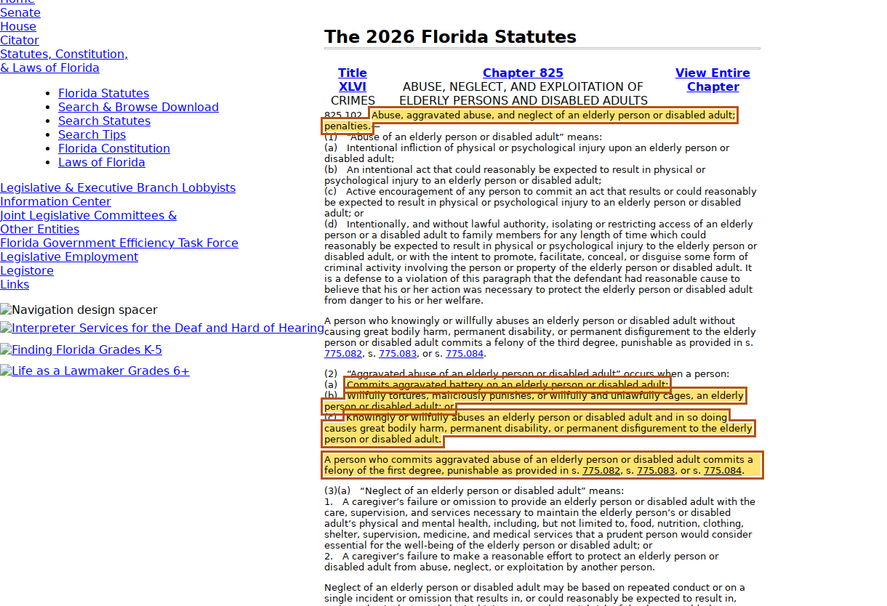
Frame 1. Direct offline rendering of saved official raw HTML; outbound resources blocked; yellow outline is the review annotation. Context around the complete qualification is retained.

Accessible source and provenance
Official source URL: https://www.leg.state.fl.us/statutes/index.cfm?App_mode=Display_Statute&URL=0800-0899/0825/Sections/0825.102.html
Edition: Florida Statutes 2026
Raw HTML retrieved: 2026-09-18T15:56:36.841Z
Parsed evidence retrieved: 2026-09-18T21:20:40.467Z
Raw HTML SHA-256: 6b56aead0da3ad3c9d2f2dea3c6e5b5a89dc0b42943d36dc3c5ae4c829f5f1d9
Normalized source-text SHA-256: 3e10ae58cfc3cb0bac6f33f759cfcabebfd47b4669469d3feab4d028dad80813
identity · matched: Abuse, aggravated abuse, and neglect of an elderly person or disabled adult; penalties
conduct · matched: Commits aggravated battery on an elderly person or disabled adult;
conduct · matched: Willfully tortures, maliciously punishes, or willfully and unlawfully cages, an elderly person or disabled adult; or
conduct · matched: Knowingly or willfully abuses an elderly person or disabled adult and in so doing causes great bodily harm, permanent disability, or permanent disfigurement to the elderly person or disabled adult.
grading · matched: A person who commits aggravated abuse of an elderly person or disabled adult commits a felony of the first degree, punishable as provided in s. 775.082, s. 775.083, or s. 775.084.

Dependencies, defenses, exceptions, and boundaries
Analyst boundary: Scope is exactly subsection (2). Whole current §§ 784.03 and 784.045 together supply the battery and aggravated-battery elements of the expressly incorporated alternative; neither section alone closes that branch, and no generic-name alias is used.
Section | Role | Edition | Retrieved | Content SHA-256 | Validation
§ 825.102 | offense | Florida Statutes 2026 | 2026-09-18T21:20:40.467Z | 3e10ae58cfc3cb0bac6f33f759cfcabebfd47b4669469d3feab4d028dad80813 | validated
§ 825.102 | grading | Florida Statutes 2026 | 2026-09-18T21:20:40.467Z | 3e10ae58cfc3cb0bac6f33f759cfcabebfd47b4669469d3feab4d028dad80813 | validated
§ 825.101 | definition | Florida Statutes 2026 | 2026-09-18T21:20:38.076Z | d17c072dc5d6a9fd01ebba7d209167df5daa51f5f6f7b252d423bc37824fc15c | validated
§ 784.03 | definition | Florida Statutes 2026 | 2026-09-18T21:19:46.108Z | c2683c299ff1785d755e2fadcdc82b5a8935321faac5d614bc68442c09816e20 | validated
§ 784.045 | justification | Florida Statutes 2026 | 2026-09-18T21:19:48.241Z | 088b97218e1d088b7f11641413406be743db049b37a72a6cccb5f5d9b4eb3a85 | validated
§ 775.082 | penalty | Florida Statutes 2026 | 2026-09-18T21:18:58.265Z | ce7d77dd9b8582b3f7e8559aa0784d7798c48dd70f51aff79dbccebe94bedd9c | validated
§ 775.083 | penalty | Florida Statutes 2026 | 2026-09-18T21:19:00.479Z | d4e9a9527ef821de6935f5763bf7ccf7fd6dc0bdc59014b0c9e063611d2768a7 | validated
§ 775.084 | penalty | Florida Statutes 2026 | 2026-09-18T21:19:02.633Z | e2f0ef78192f6448f7552357472ee5e402a791da88c7ca3e64cb1424f9c98d53 | validated

Precise review question
Does Fla. Stat. § 825.102(2) support this record at exactly the proposed scope, rather than a neighboring or broader branch? Do the quoted anchors establish every stated conduct, mental-state, victim/age or harm condition, defense or exception, and grade described in the EN/ES/ZH explanations? Are these dependency roles complete: § 825.102 (offense), § 825.102 (grading), § 825.101 (definition), § 784.03 (definition), § 784.045 (justification), § 775.082 (penalty), § 775.083 (penalty), § 775.084 (penalty)? Is this boundary accurate: Scope is exactly subsection (2). Whole current §§ 784.03 and 784.045 together supply the battery and aggravated-battery elements of the expressly incorporated alternative; neither section alone closes that branch, and no generic-name alias is used. For any “no,” identify the exact text and choose hold, correct, split, reclassify, deduplicate, or remove. A screenshot match is not approval.

Blank decision
☐ publish ☐ hold ☐ correct ☐ split ☐ reclassify ☐ deduplicate ☐ remove
Decision / exact action: __________________________________________________________________
Required notes / exact corrections: ____________________________________________________________
________________________________________________________________________________________
________________________________________________________________________________________
Reviewer: ________________________________________
Date: ____________________
Record hash: d1239e895d66a6266f8f038d343059eb30fedd0caa792c007a794cfd184ce104
Evidence hash: bae61d71e86604dc8a68e4f0c7818d5a3c3e822e153174fb77bcfff9c9343228
Combined decision-binding hash: 1694e7c83897a35486dccc27a6d7ebeb2e7f037c59fa9cf825d9be428f644044

PRIORITY 4 · BATCH F · NO APPROVAL

Abuse, aggravated abuse, and neglect of an elderly person or disabled adult; penalties
Record ID: fl-fs-825-102-3-b-abuse-aggravated-abuse-and-neglect-of-an-elderly-person-or-disabled-adult-penalties
Exact scope: Fla. Stat. § 825.102(3)(b)

Proposed EN / ES / ZH explanations
EN: Willfully or by culpable negligence neglecting an elderly person or disabled adult and thereby causing great bodily harm, permanent disability, or permanent disfigurement. Second-degree felony. Subsection (3)(a) defines neglect, including specified caregiver failures and the required injury or substantial-risk threshold; § 825.101 defines caregiver, elderly person, and disabled adult.
ES: Descuidar deliberadamente o por negligencia culpable a una persona anciana o un adulto con discapacidad y causar así gran daño corporal, discapacidad permanente o desfiguración permanente. Delito grave de segundo grado. El inciso (3)(a) define la negligencia, incluidas las omisiones especificadas del cuidador y el umbral exigido de lesión o riesgo sustancial; el § 825.101 define cuidador, persona anciana y adulto con discapacidad.
ZH: 故意或因有罪过的过失疏忽照料老年人或残障成年人，并由此造成严重身体伤害、永久残疾或永久毁容。 二级重罪。第(3)(a)款界定疏忽照料，包括法定照护者失职以及所要求的伤害或重大风险门槛；第825.101条界定照护者、老年人及残障成年人。
Spanish and Chinese text has no fluent-speaker or attorney approval in this packet.

Exact quoted support and anchor accounting
Matched means one normalized occurrence in the saved snapshot text. It does not mean legally sufficient or approved.
Anchor | Status | Count | Exact quote | Screenshot
identity-1 | matched | 1 | Abuse, aggravated abuse, and neglect of an elderly person or disabled adult; penalties | highlighted in saved raw HTML
conduct-2 | matched | 1 | A person who willfully or by culpable negligence neglects an elderly person or disabled adult and in so doing causes great bodily harm, permanent disability, or permanent disfigurement to the elderly person or disabled adult commits a felony of the second degree, punishable as provided in s. 775.082, s. 775.083, or s. 775.084. | highlighted in saved raw HTML
grading-3 | matched | 1 | A person who willfully or by culpable negligence neglects an elderly person or disabled adult and in so doing causes great bodily harm, permanent disability, or permanent disfigurement to the elderly person or disabled adult commits a felony of the second degree, punishable as provided in s. 775.082, s. 775.083, or s. 775.084. | highlighted in saved raw HTML

Saved-source evidence frames
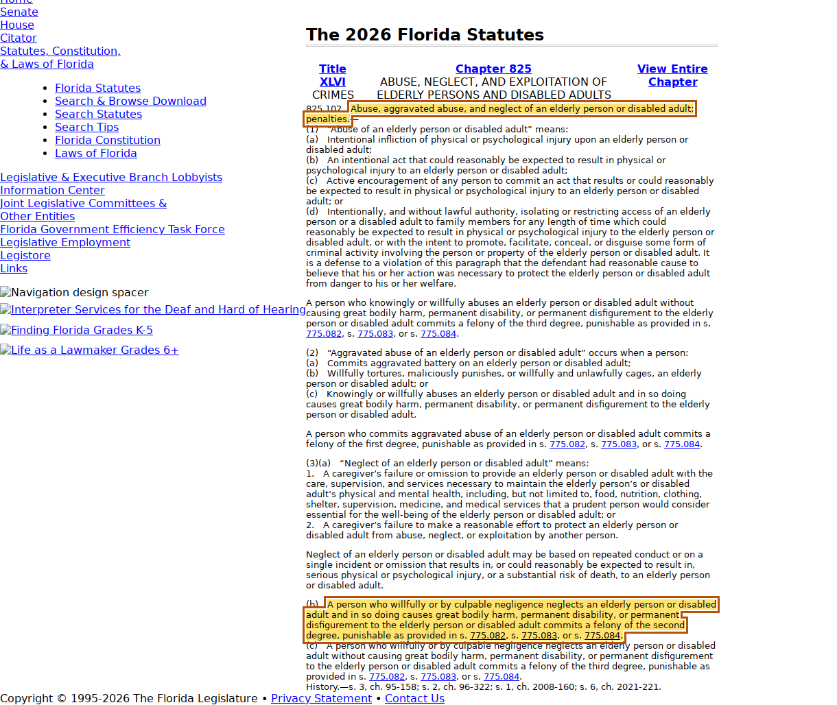
Frame 1. Direct offline rendering of saved official raw HTML; outbound resources blocked; yellow outline is the review annotation. Context around the complete qualification is retained.

Accessible source and provenance
Official source URL: https://www.leg.state.fl.us/statutes/index.cfm?App_mode=Display_Statute&URL=0800-0899/0825/Sections/0825.102.html
Edition: Florida Statutes 2026
Raw HTML retrieved: 2026-09-18T15:56:36.841Z
Parsed evidence retrieved: 2026-09-18T21:20:40.467Z
Raw HTML SHA-256: 6b56aead0da3ad3c9d2f2dea3c6e5b5a89dc0b42943d36dc3c5ae4c829f5f1d9
Normalized source-text SHA-256: 3e10ae58cfc3cb0bac6f33f759cfcabebfd47b4669469d3feab4d028dad80813
identity · matched: Abuse, aggravated abuse, and neglect of an elderly person or disabled adult; penalties
conduct · matched: A person who willfully or by culpable negligence neglects an elderly person or disabled adult and in so doing causes great bodily harm, permanent disability, or permanent disfigurement to the elderly person or disabled adult commits a felony of the second degree, punishable as provided in s. 775.082, s. 775.083, or s. 775.084.
grading · matched: A person who willfully or by culpable negligence neglects an elderly person or disabled adult and in so doing causes great bodily harm, permanent disability, or permanent disfigurement to the elderly person or disabled adult commits a felony of the second degree, punishable as provided in s. 775.082, s. 775.083, or s. 775.084.

Dependencies, defenses, exceptions, and boundaries
Analyst boundary: Paragraph (3)(a)'s complete neglect definition is a same-section supporting dependency. The cited primary remains paragraph (3)(b), and paragraph (3)(c)'s no-great-harm grade is separate.
Section | Role | Edition | Retrieved | Content SHA-256 | Validation
§ 825.102 | offense | Florida Statutes 2026 | 2026-09-18T21:20:40.467Z | 3e10ae58cfc3cb0bac6f33f759cfcabebfd47b4669469d3feab4d028dad80813 | validated
§ 825.102 | grading | Florida Statutes 2026 | 2026-09-18T21:20:40.467Z | 3e10ae58cfc3cb0bac6f33f759cfcabebfd47b4669469d3feab4d028dad80813 | validated
§ 825.102 | definition | Florida Statutes 2026 | 2026-09-18T21:20:40.467Z | 3e10ae58cfc3cb0bac6f33f759cfcabebfd47b4669469d3feab4d028dad80813 | validated
§ 825.101 | definition | Florida Statutes 2026 | 2026-09-18T21:20:38.076Z | d17c072dc5d6a9fd01ebba7d209167df5daa51f5f6f7b252d423bc37824fc15c | validated
§ 775.082 | penalty | Florida Statutes 2026 | 2026-09-18T21:18:58.265Z | ce7d77dd9b8582b3f7e8559aa0784d7798c48dd70f51aff79dbccebe94bedd9c | validated
§ 775.083 | penalty | Florida Statutes 2026 | 2026-09-18T21:19:00.479Z | d4e9a9527ef821de6935f5763bf7ccf7fd6dc0bdc59014b0c9e063611d2768a7 | validated
§ 775.084 | penalty | Florida Statutes 2026 | 2026-09-18T21:19:02.633Z | e2f0ef78192f6448f7552357472ee5e402a791da88c7ca3e64cb1424f9c98d53 | validated

Precise review question
Does Fla. Stat. § 825.102(3)(b) support this record at exactly the proposed scope, rather than a neighboring or broader branch? Do the quoted anchors establish every stated conduct, mental-state, victim/age or harm condition, defense or exception, and grade described in the EN/ES/ZH explanations? Are these dependency roles complete: § 825.102 (offense), § 825.102 (grading), § 825.102 (definition), § 825.101 (definition), § 775.082 (penalty), § 775.083 (penalty), § 775.084 (penalty)? Is this boundary accurate: Paragraph (3)(a)'s complete neglect definition is a same-section supporting dependency. The cited primary remains paragraph (3)(b), and paragraph (3)(c)'s no-great-harm grade is separate. For any “no,” identify the exact text and choose hold, correct, split, reclassify, deduplicate, or remove. A screenshot match is not approval.

Blank decision
☐ publish ☐ hold ☐ correct ☐ split ☐ reclassify ☐ deduplicate ☐ remove
Decision / exact action: __________________________________________________________________
Required notes / exact corrections: ____________________________________________________________
________________________________________________________________________________________
________________________________________________________________________________________
Reviewer: ________________________________________
Date: ____________________
Record hash: 6f99f6e8fe23baf8b3bbee22b80b43025fd07899c445fff06061e13ea64a9cc5
Evidence hash: 8f5dd71610aac7fa7821b05c43047a42a44a45205d3bd9f8ef151005a86fd593
Combined decision-binding hash: 3c2288c8e924c6f9ec9dc173be68b6998bb0a6f10866eda17bdeb407690c2b45

PRIORITY 5 · BATCH F · NO APPROVAL

Abuse, aggravated abuse, and neglect of an elderly person or disabled adult; penalties
Record ID: fl-fs-825-102-3-c-abuse-aggravated-abuse-and-neglect-of-an-elderly-person-or-disabled-adult-penalties
Exact scope: Fla. Stat. § 825.102(3)(c)

Proposed EN / ES / ZH explanations
EN: Willfully or by culpable negligence neglecting an elderly person or disabled adult without causing great bodily harm, permanent disability, or permanent disfigurement. Third-degree felony. Subsection (3)(a) defines neglect, including specified caregiver failures and the required injury or substantial-risk threshold; § 825.101 defines caregiver, elderly person, and disabled adult.
ES: Descuidar deliberadamente o por negligencia culpable a una persona anciana o un adulto con discapacidad sin causar gran daño corporal, discapacidad permanente ni desfiguración permanente. Delito grave de tercer grado. El inciso (3)(a) define la negligencia, incluidas las omisiones especificadas del cuidador y el umbral exigido de lesión o riesgo sustancial; el § 825.101 define cuidador, persona anciana y adulto con discapacidad.
ZH: 故意或因有罪过的过失疏忽照料老年人或残障成年人，但未造成严重身体伤害、永久残疾或永久毁容。 三级重罪。第(3)(a)款界定疏忽照料，包括法定照护者失职以及所要求的伤害或重大风险门槛；第825.101条界定照护者、老年人及残障成年人。
Spanish and Chinese text has no fluent-speaker or attorney approval in this packet.

Exact quoted support and anchor accounting
Matched means one normalized occurrence in the saved snapshot text. It does not mean legally sufficient or approved.
Anchor | Status | Count | Exact quote | Screenshot
identity-1 | matched | 1 | Abuse, aggravated abuse, and neglect of an elderly person or disabled adult; penalties | highlighted in saved raw HTML
conduct-2 | matched | 1 | A person who willfully or by culpable negligence neglects an elderly person or disabled adult without causing great bodily harm, permanent disability, or permanent disfigurement to the elderly person or disabled adult commits a felony of the third degree, punishable as provided in s. 775.082, s. 775.083, or s. 775.084. | highlighted in saved raw HTML
grading-3 | matched | 1 | A person who willfully or by culpable negligence neglects an elderly person or disabled adult without causing great bodily harm, permanent disability, or permanent disfigurement to the elderly person or disabled adult commits a felony of the third degree, punishable as provided in s. 775.082, s. 775.083, or s. 775.084. | highlighted in saved raw HTML

Saved-source evidence frames
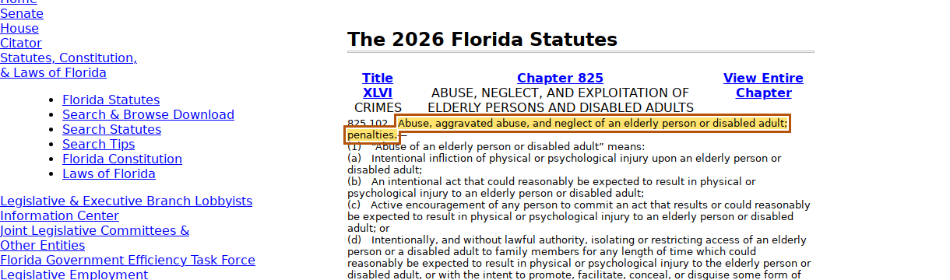
Frame 1. Direct offline rendering of saved official raw HTML; outbound resources blocked; yellow outline is the review annotation. Context around the complete qualification is retained.
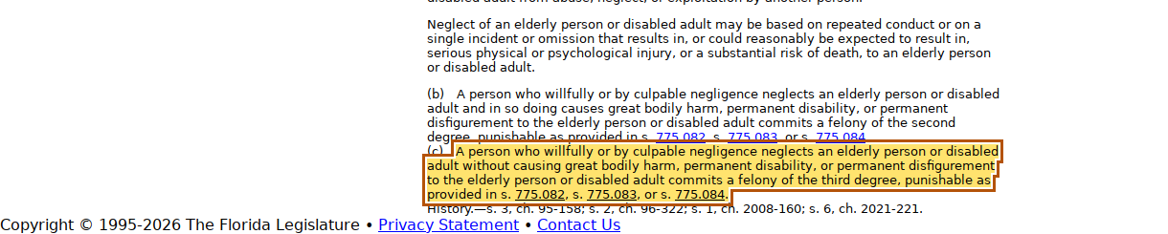
Frame 2. Direct offline rendering of saved official raw HTML; outbound resources blocked; yellow outline is the review annotation. Context around the complete qualification is retained.

Accessible source and provenance
Official source URL: https://www.leg.state.fl.us/statutes/index.cfm?App_mode=Display_Statute&URL=0800-0899/0825/Sections/0825.102.html
Edition: Florida Statutes 2026
Raw HTML retrieved: 2026-09-18T15:56:36.841Z
Parsed evidence retrieved: 2026-09-18T21:20:40.467Z
Raw HTML SHA-256: 6b56aead0da3ad3c9d2f2dea3c6e5b5a89dc0b42943d36dc3c5ae4c829f5f1d9
Normalized source-text SHA-256: 3e10ae58cfc3cb0bac6f33f759cfcabebfd47b4669469d3feab4d028dad80813
identity · matched: Abuse, aggravated abuse, and neglect of an elderly person or disabled adult; penalties
conduct · matched: A person who willfully or by culpable negligence neglects an elderly person or disabled adult without causing great bodily harm, permanent disability, or permanent disfigurement to the elderly person or disabled adult commits a felony of the third degree, punishable as provided in s. 775.082, s. 775.083, or s. 775.084.
grading · matched: A person who willfully or by culpable negligence neglects an elderly person or disabled adult without causing great bodily harm, permanent disability, or permanent disfigurement to the elderly person or disabled adult commits a felony of the third degree, punishable as provided in s. 775.082, s. 775.083, or s. 775.084.

Dependencies, defenses, exceptions, and boundaries
Analyst boundary: Paragraph (3)(a)'s complete neglect definition is a same-section supporting dependency. The cited primary remains paragraph (3)(c), and paragraph (3)(b)'s resulting-great-harm grade is separate.
Section | Role | Edition | Retrieved | Content SHA-256 | Validation
§ 825.102 | offense | Florida Statutes 2026 | 2026-09-18T21:20:40.467Z | 3e10ae58cfc3cb0bac6f33f759cfcabebfd47b4669469d3feab4d028dad80813 | validated
§ 825.102 | grading | Florida Statutes 2026 | 2026-09-18T21:20:40.467Z | 3e10ae58cfc3cb0bac6f33f759cfcabebfd47b4669469d3feab4d028dad80813 | validated
§ 825.102 | definition | Florida Statutes 2026 | 2026-09-18T21:20:40.467Z | 3e10ae58cfc3cb0bac6f33f759cfcabebfd47b4669469d3feab4d028dad80813 | validated
§ 825.101 | definition | Florida Statutes 2026 | 2026-09-18T21:20:38.076Z | d17c072dc5d6a9fd01ebba7d209167df5daa51f5f6f7b252d423bc37824fc15c | validated
§ 775.082 | penalty | Florida Statutes 2026 | 2026-09-18T21:18:58.265Z | ce7d77dd9b8582b3f7e8559aa0784d7798c48dd70f51aff79dbccebe94bedd9c | validated
§ 775.083 | penalty | Florida Statutes 2026 | 2026-09-18T21:19:00.479Z | d4e9a9527ef821de6935f5763bf7ccf7fd6dc0bdc59014b0c9e063611d2768a7 | validated
§ 775.084 | penalty | Florida Statutes 2026 | 2026-09-18T21:19:02.633Z | e2f0ef78192f6448f7552357472ee5e402a791da88c7ca3e64cb1424f9c98d53 | validated

Precise review question
Does Fla. Stat. § 825.102(3)(c) support this record at exactly the proposed scope, rather than a neighboring or broader branch? Do the quoted anchors establish every stated conduct, mental-state, victim/age or harm condition, defense or exception, and grade described in the EN/ES/ZH explanations? Are these dependency roles complete: § 825.102 (offense), § 825.102 (grading), § 825.102 (definition), § 825.101 (definition), § 775.082 (penalty), § 775.083 (penalty), § 775.084 (penalty)? Is this boundary accurate: Paragraph (3)(a)'s complete neglect definition is a same-section supporting dependency. The cited primary remains paragraph (3)(c), and paragraph (3)(b)'s resulting-great-harm grade is separate. For any “no,” identify the exact text and choose hold, correct, split, reclassify, deduplicate, or remove. A screenshot match is not approval.

Blank decision
☐ publish ☐ hold ☐ correct ☐ split ☐ reclassify ☐ deduplicate ☐ remove
Decision / exact action: __________________________________________________________________
Required notes / exact corrections: ____________________________________________________________
________________________________________________________________________________________
________________________________________________________________________________________
Reviewer: ________________________________________
Date: ____________________
Record hash: ba255b476ee87e820ae7ecfe95999c743ab14432b1dfa5d5713418bb9158b399
Evidence hash: dacbcbf76d15a4fe5fe4d61b535f416bfecc123ee7be694962566b8dc38210a9
Combined decision-binding hash: 925c2d6d0068e4c4d159e306b94a4ba39d572dbf707d757f4e35b88d76b906bb

PRIORITY 6 · BATCH F · NO APPROVAL

Abuse, aggravated abuse, and neglect of a child; penalties
Record ID: fl-fs-827-03-2-a-abuse-aggravated-abuse-and-neglect-of-a-child-penalties
Exact scope: Fla. Stat. § 827.03(2)(a)

Proposed EN / ES / ZH explanations
EN: Committing aggravated child abuse by committing aggravated battery on a child; willfully torturing, maliciously punishing, or willfully and unlawfully caging a child; or knowingly or willfully abusing a child and thereby causing great bodily harm, permanent disability, or permanent disfigurement. First-degree felony. Subsection (1)(a) supplies the complete aggravated-child-abuse definition, and § 827.01 defines child as a person under 18. Sections 784.03 and 784.045 together supply the incorporated battery and aggravated-battery elements.
ES: Cometer abuso infantil agravado mediante agresión física agravada contra un menor; torturarlo deliberadamente, castigarlo maliciosamente o enjaularlo deliberada e ilícitamente; o abusar del menor a sabiendas o deliberadamente y causar así gran daño corporal, discapacidad permanente o desfiguración permanente. Delito grave de primer grado. El inciso (1)(a) contiene la definición completa de abuso infantil agravado y el § 827.01 define menor como una persona de menos de 18 años. Los §§ 784.03 y 784.045 contienen conjuntamente los elementos incorporados de la agresión física y la agresión física agravada.
ZH: 通过以下方式实施加重虐待儿童：对儿童实施加重殴打；故意折磨、恶意惩罚或故意且非法地将儿童关入笼中；或者明知或故意虐待儿童并由此造成严重身体伤害、永久残疾或永久毁容。 一级重罪。第(1)(a)款规定加重虐待儿童的完整定义，第827.01条将儿童界定为未满18岁者。第784.03条与第784.045条共同规定所纳入的殴打及加重殴打要件。
Spanish and Chinese text has no fluent-speaker or attorney approval in this packet.

Exact quoted support and anchor accounting
Matched means one normalized occurrence in the saved snapshot text. It does not mean legally sufficient or approved.
Anchor | Status | Count | Exact quote | Screenshot
identity-1 | matched | 1 | Abuse, aggravated abuse, and neglect of a child; penalties | highlighted in saved raw HTML
conduct-2 | matched | 1 | A person who commits aggravated child abuse commits a felony of the first degree, punishable as provided in s. 775.082, s. 775.083, or s. 775.084. | highlighted in saved raw HTML
grading-3 | matched | 1 | A person who commits aggravated child abuse commits a felony of the first degree, punishable as provided in s. 775.082, s. 775.083, or s. 775.084. | highlighted in saved raw HTML

Saved-source evidence frames
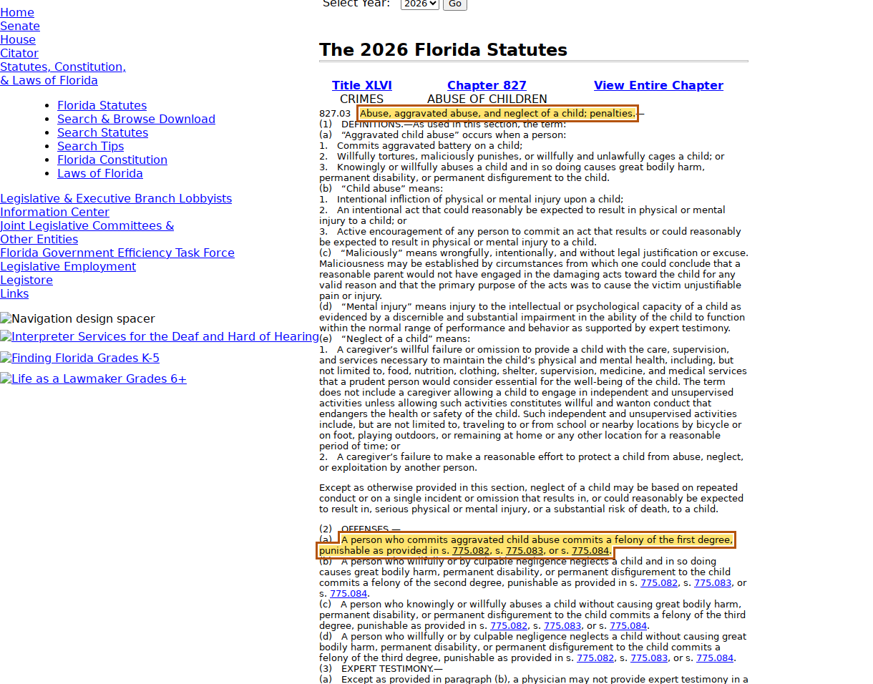
Frame 1. Direct offline rendering of saved official raw HTML; outbound resources blocked; yellow outline is the review annotation. Context around the complete qualification is retained.

Accessible source and provenance
Official source URL: https://www.leg.state.fl.us/statutes/index.cfm?App_mode=Display_Statute&URL=0800-0899/0827/Sections/0827.03.html
Edition: Florida Statutes 2026
Raw HTML retrieved: 2026-09-18T21:20:44.765Z
Parsed evidence retrieved: 2026-09-18T21:20:44.765Z
Raw HTML SHA-256: b40d426ddbfb826e5975991c231936164304aab6612698ac71cfe9357e8764c2
Normalized source-text SHA-256: 5748c55edb59e945328d9eb507d06dc214730e7b64b4b7916f1ebb3c275a8645
identity · matched: Abuse, aggravated abuse, and neglect of a child; penalties
conduct · matched: A person who commits aggravated child abuse commits a felony of the first degree, punishable as provided in s. 775.082, s. 775.083, or s. 775.084.
grading · matched: A person who commits aggravated child abuse commits a felony of the first degree, punishable as provided in s. 775.082, s. 775.083, or s. 775.084.

Dependencies, defenses, exceptions, and boundaries
Analyst boundary: The cited child paragraph relies on the parent section's express aggravated-child-abuse definition. Current §§ 784.03 and 784.045 together are required for the aggravated-battery alternative; neither section alone closes that branch. The other two alternatives remain stated in § 827.03(1)(a).
Section | Role | Edition | Retrieved | Content SHA-256 | Validation
§ 827.03 | offense | Florida Statutes 2026 | 2026-09-18T21:20:44.765Z | 5748c55edb59e945328d9eb507d06dc214730e7b64b4b7916f1ebb3c275a8645 | validated
§ 827.03 | grading | Florida Statutes 2026 | 2026-09-18T21:20:44.765Z | 5748c55edb59e945328d9eb507d06dc214730e7b64b4b7916f1ebb3c275a8645 | validated
§ 827.03 | definition | Florida Statutes 2026 | 2026-09-18T21:20:44.765Z | 5748c55edb59e945328d9eb507d06dc214730e7b64b4b7916f1ebb3c275a8645 | validated
§ 827.01 | definition | Florida Statutes 2026 | 2026-09-18T21:20:42.609Z | b9affea3d8a2aff821678555ece05113167e9af78c36b46534ecea95f79de9b0 | validated
§ 784.03 | definition | Florida Statutes 2026 | 2026-09-18T21:19:46.108Z | c2683c299ff1785d755e2fadcdc82b5a8935321faac5d614bc68442c09816e20 | validated
§ 784.045 | justification | Florida Statutes 2026 | 2026-09-18T21:19:48.241Z | 088b97218e1d088b7f11641413406be743db049b37a72a6cccb5f5d9b4eb3a85 | validated
§ 775.082 | penalty | Florida Statutes 2026 | 2026-09-18T21:18:58.265Z | ce7d77dd9b8582b3f7e8559aa0784d7798c48dd70f51aff79dbccebe94bedd9c | validated
§ 775.083 | penalty | Florida Statutes 2026 | 2026-09-18T21:19:00.479Z | d4e9a9527ef821de6935f5763bf7ccf7fd6dc0bdc59014b0c9e063611d2768a7 | validated
§ 775.084 | penalty | Florida Statutes 2026 | 2026-09-18T21:19:02.633Z | e2f0ef78192f6448f7552357472ee5e402a791da88c7ca3e64cb1424f9c98d53 | validated

Precise review question
Does Fla. Stat. § 827.03(2)(a) support this record at exactly the proposed scope, rather than a neighboring or broader branch? Do the quoted anchors establish every stated conduct, mental-state, victim/age or harm condition, defense or exception, and grade described in the EN/ES/ZH explanations? Are these dependency roles complete: § 827.03 (offense), § 827.03 (grading), § 827.03 (definition), § 827.01 (definition), § 784.03 (definition), § 784.045 (justification), § 775.082 (penalty), § 775.083 (penalty), § 775.084 (penalty)? Is this boundary accurate: The cited child paragraph relies on the parent section's express aggravated-child-abuse definition. Current §§ 784.03 and 784.045 together are required for the aggravated-battery alternative; neither section alone closes that branch. The other two alternatives remain stated in § 827.03(1)(a). For any “no,” identify the exact text and choose hold, correct, split, reclassify, deduplicate, or remove. A screenshot match is not approval.

Blank decision
☐ publish ☐ hold ☐ correct ☐ split ☐ reclassify ☐ deduplicate ☐ remove
Decision / exact action: __________________________________________________________________
Required notes / exact corrections: ____________________________________________________________
________________________________________________________________________________________
________________________________________________________________________________________
Reviewer: ________________________________________
Date: ____________________
Record hash: d76f54564e0a69d551ec300d3ba04c1da57ba9ef39e8421bc4b07aa44363e564
Evidence hash: cb3aab406ec8c94db18331d084bdba9428e7f1714f2760316203679437c4e3d4
Combined decision-binding hash: 75ed33aaeccab0d4f752b1e74cc5c4124f739f7ed2b568c7676dbc0e1abcfffc

PRIORITY 7 · BATCH F · NO APPROVAL

Abuse, aggravated abuse, and neglect of a child; penalties
Record ID: fl-fs-827-03-2-b-abuse-aggravated-abuse-and-neglect-of-a-child-penalties
Exact scope: Fla. Stat. § 827.03(2)(b)

Proposed EN / ES / ZH explanations
EN: Willfully or by culpable negligence neglecting a child and thereby causing great bodily harm, permanent disability, or permanent disfigurement. Second-degree felony. Subsection (1)(e) defines neglect and preserves the independent-activity limitation; § 827.01 defines child and caregiver.
ES: Descuidar deliberadamente o por negligencia culpable a un menor y causar así gran daño corporal, discapacidad permanente o desfiguración permanente. Delito grave de segundo grado. El inciso (1)(e) define la negligencia y conserva la limitación relativa a las actividades independientes; el § 827.01 define menor y cuidador.
ZH: 故意或因有罪过的过失疏忽照料儿童，并由此造成严重身体伤害、永久残疾或永久毁容。 二级重罪。第(1)(e)款界定疏忽照料并保留关于儿童独立活动的限制；第827.01条界定儿童及照护者。
Spanish and Chinese text has no fluent-speaker or attorney approval in this packet.

Exact quoted support and anchor accounting
Matched means one normalized occurrence in the saved snapshot text. It does not mean legally sufficient or approved.
Anchor | Status | Count | Exact quote | Screenshot
identity-1 | matched | 1 | Abuse, aggravated abuse, and neglect of a child; penalties | highlighted in saved raw HTML
conduct-2 | matched | 1 | A person who willfully or by culpable negligence neglects a child and in so doing causes great bodily harm, permanent disability, or permanent disfigurement to the child commits a felony of the second degree, punishable as provided in s. 775.082, s. 775.083, or s. 775.084. | highlighted in saved raw HTML
grading-3 | matched | 1 | A person who willfully or by culpable negligence neglects a child and in so doing causes great bodily harm, permanent disability, or permanent disfigurement to the child commits a felony of the second degree, punishable as provided in s. 775.082, s. 775.083, or s. 775.084. | highlighted in saved raw HTML

Saved-source evidence frames
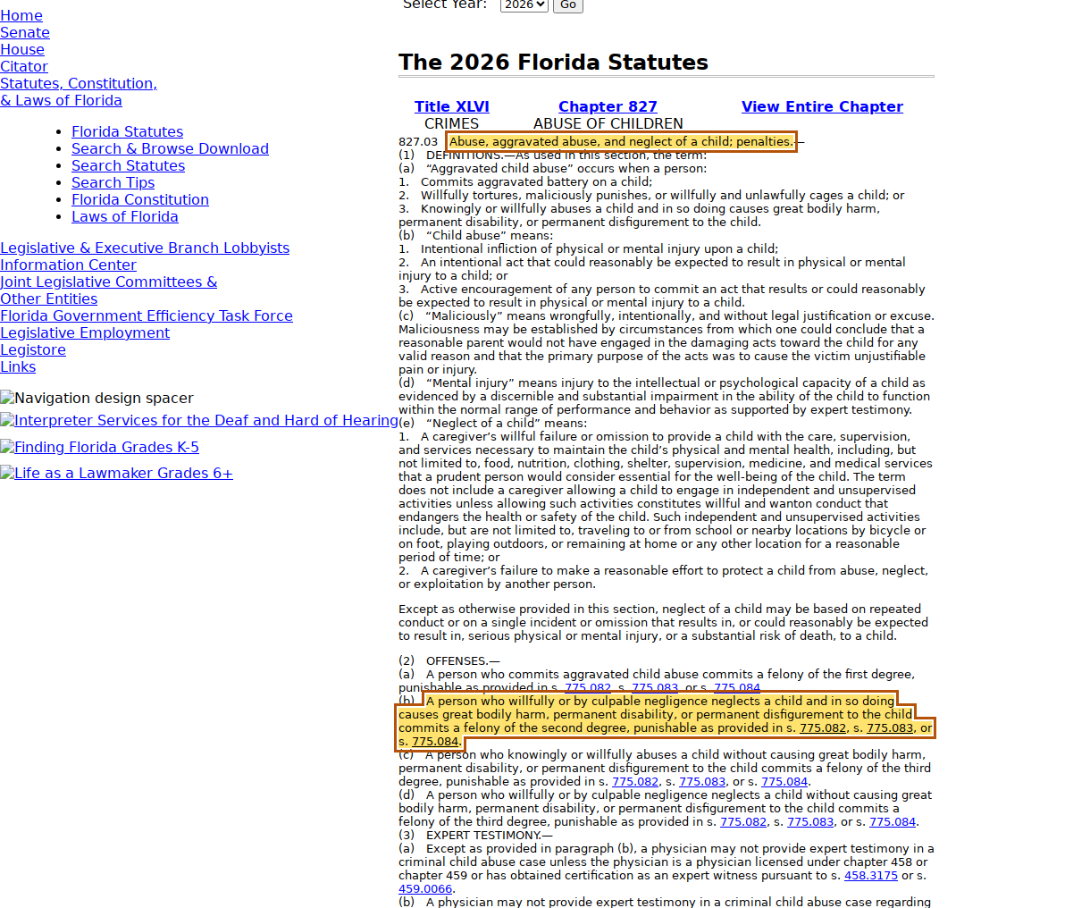
Frame 1. Direct offline rendering of saved official raw HTML; outbound resources blocked; yellow outline is the review annotation. Context around the complete qualification is retained.

Accessible source and provenance
Official source URL: https://www.leg.state.fl.us/statutes/index.cfm?App_mode=Display_Statute&URL=0800-0899/0827/Sections/0827.03.html
Edition: Florida Statutes 2026
Raw HTML retrieved: 2026-09-18T21:20:44.765Z
Parsed evidence retrieved: 2026-09-18T21:20:44.765Z
Raw HTML SHA-256: b40d426ddbfb826e5975991c231936164304aab6612698ac71cfe9357e8764c2
Normalized source-text SHA-256: 5748c55edb59e945328d9eb507d06dc214730e7b64b4b7916f1ebb3c275a8645
identity · matched: Abuse, aggravated abuse, and neglect of a child; penalties
conduct · matched: A person who willfully or by culpable negligence neglects a child and in so doing causes great bodily harm, permanent disability, or permanent disfigurement to the child commits a felony of the second degree, punishable as provided in s. 775.082, s. 775.083, or s. 775.084.
grading · matched: A person who willfully or by culpable negligence neglects a child and in so doing causes great bodily harm, permanent disability, or permanent disfigurement to the child commits a felony of the second degree, punishable as provided in s. 775.082, s. 775.083, or s. 775.084.

Dependencies, defenses, exceptions, and boundaries
Analyst boundary: Subsection (1)(e)'s definition, including the independent-and-unsupervised-activity limitation and injury-or-risk threshold, is required. Paragraph (2)(d)'s no-great-harm grade is separate.
Section | Role | Edition | Retrieved | Content SHA-256 | Validation
§ 827.03 | offense | Florida Statutes 2026 | 2026-09-18T21:20:44.765Z | 5748c55edb59e945328d9eb507d06dc214730e7b64b4b7916f1ebb3c275a8645 | validated
§ 827.03 | grading | Florida Statutes 2026 | 2026-09-18T21:20:44.765Z | 5748c55edb59e945328d9eb507d06dc214730e7b64b4b7916f1ebb3c275a8645 | validated
§ 827.03 | definition | Florida Statutes 2026 | 2026-09-18T21:20:44.765Z | 5748c55edb59e945328d9eb507d06dc214730e7b64b4b7916f1ebb3c275a8645 | validated
§ 827.03 | exception | Florida Statutes 2026 | 2026-09-18T21:20:44.765Z | 5748c55edb59e945328d9eb507d06dc214730e7b64b4b7916f1ebb3c275a8645 | validated
§ 827.01 | definition | Florida Statutes 2026 | 2026-09-18T21:20:42.609Z | b9affea3d8a2aff821678555ece05113167e9af78c36b46534ecea95f79de9b0 | validated
§ 775.082 | penalty | Florida Statutes 2026 | 2026-09-18T21:18:58.265Z | ce7d77dd9b8582b3f7e8559aa0784d7798c48dd70f51aff79dbccebe94bedd9c | validated
§ 775.083 | penalty | Florida Statutes 2026 | 2026-09-18T21:19:00.479Z | d4e9a9527ef821de6935f5763bf7ccf7fd6dc0bdc59014b0c9e063611d2768a7 | validated
§ 775.084 | penalty | Florida Statutes 2026 | 2026-09-18T21:19:02.633Z | e2f0ef78192f6448f7552357472ee5e402a791da88c7ca3e64cb1424f9c98d53 | validated

Precise review question
Does Fla. Stat. § 827.03(2)(b) support this record at exactly the proposed scope, rather than a neighboring or broader branch? Do the quoted anchors establish every stated conduct, mental-state, victim/age or harm condition, defense or exception, and grade described in the EN/ES/ZH explanations? Are these dependency roles complete: § 827.03 (offense), § 827.03 (grading), § 827.03 (definition), § 827.03 (exception), § 827.01 (definition), § 775.082 (penalty), § 775.083 (penalty), § 775.084 (penalty)? Is this boundary accurate: Subsection (1)(e)'s definition, including the independent-and-unsupervised-activity limitation and injury-or-risk threshold, is required. Paragraph (2)(d)'s no-great-harm grade is separate. For any “no,” identify the exact text and choose hold, correct, split, reclassify, deduplicate, or remove. A screenshot match is not approval.

Blank decision
☐ publish ☐ hold ☐ correct ☐ split ☐ reclassify ☐ deduplicate ☐ remove
Decision / exact action: __________________________________________________________________
Required notes / exact corrections: ____________________________________________________________
________________________________________________________________________________________
________________________________________________________________________________________
Reviewer: ________________________________________
Date: ____________________
Record hash: 030d31a97d781d6a6683504e6faede539a87e4746f7c75ba0bf50d3bb2ca76a0
Evidence hash: 1ee07cac784852caf1eee2e39098fe5839b1057f1d326e587e275ce76c050a74
Combined decision-binding hash: 62a33dcc85c2aae328b068673d62fd0fba3f715b585ab8057e5c09cf9323283a

PRIORITY 8 · BATCH F · NO APPROVAL

Abuse, aggravated abuse, and neglect of a child; penalties
Record ID: fl-fs-827-03-2-c-abuse-aggravated-abuse-and-neglect-of-a-child-penalties
Exact scope: Fla. Stat. § 827.03(2)(c)

Proposed EN / ES / ZH explanations
EN: Knowingly or willfully abusing a child without causing great bodily harm, permanent disability, or permanent disfigurement. Third-degree felony. Subsection (1)(b) defines child abuse as intentional injury, an intentional act reasonably expected to cause injury, or active encouragement of an act that causes or could reasonably be expected to cause injury; § 827.01 defines child.
ES: Abusar a sabiendas o deliberadamente de un menor sin causar gran daño corporal, discapacidad permanente ni desfiguración permanente. Delito grave de tercer grado. El inciso (1)(b) define el abuso infantil como lesión intencional, un acto intencional del que razonablemente se espere una lesión, o el aliento activo de un acto que cause o pueda razonablemente esperarse que cause una lesión; el § 827.01 define menor.
ZH: 明知或故意虐待儿童，但未造成严重身体伤害、永久残疾或永久毁容。 三级重罪。第(1)(b)款将虐待儿童界定为故意造成伤害、实施可合理预期导致伤害的故意行为，或积极鼓励实施造成或可合理预期造成伤害的行为；第827.01条界定儿童。
Spanish and Chinese text has no fluent-speaker or attorney approval in this packet.

Exact quoted support and anchor accounting
Matched means one normalized occurrence in the saved snapshot text. It does not mean legally sufficient or approved.
Anchor | Status | Count | Exact quote | Screenshot
identity-1 | matched | 1 | Abuse, aggravated abuse, and neglect of a child; penalties | highlighted in saved raw HTML
conduct-2 | matched | 1 | A person who knowingly or willfully abuses a child without causing great bodily harm, permanent disability, or permanent disfigurement to the child commits a felony of the third degree, punishable as provided in s. 775.082, s. 775.083, or s. 775.084. | highlighted in saved raw HTML
grading-3 | matched | 1 | A person who knowingly or willfully abuses a child without causing great bodily harm, permanent disability, or permanent disfigurement to the child commits a felony of the third degree, punishable as provided in s. 775.082, s. 775.083, or s. 775.084. | highlighted in saved raw HTML

Saved-source evidence frames
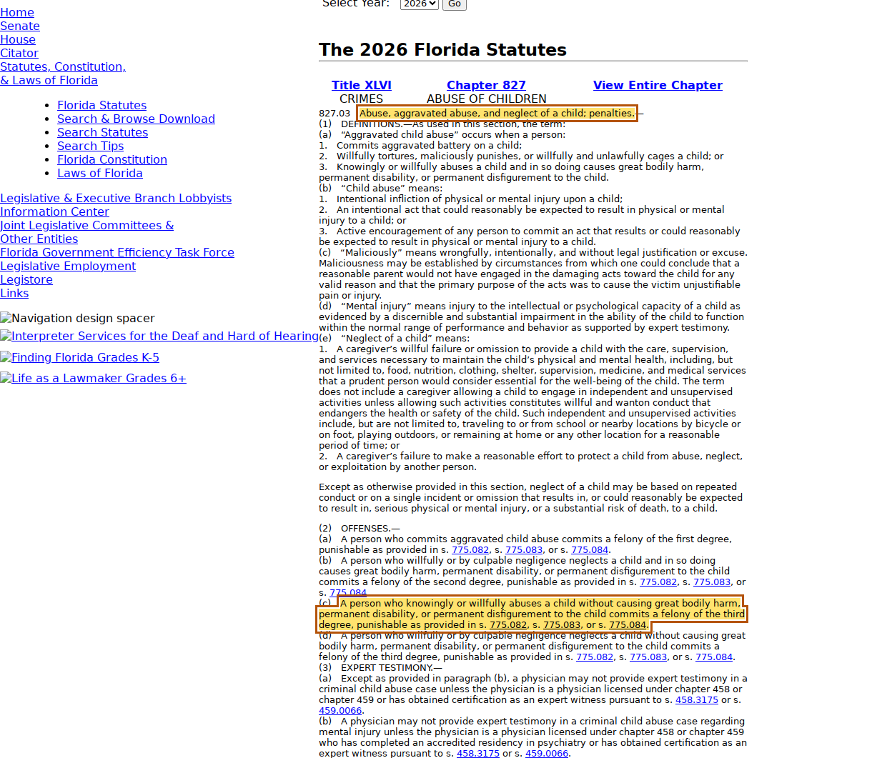
Frame 1. Direct offline rendering of saved official raw HTML; outbound resources blocked; yellow outline is the review annotation. Context around the complete qualification is retained.

Accessible source and provenance
Official source URL: https://www.leg.state.fl.us/statutes/index.cfm?App_mode=Display_Statute&URL=0800-0899/0827/Sections/0827.03.html
Edition: Florida Statutes 2026
Raw HTML retrieved: 2026-09-18T21:20:44.765Z
Parsed evidence retrieved: 2026-09-18T21:20:44.765Z
Raw HTML SHA-256: b40d426ddbfb826e5975991c231936164304aab6612698ac71cfe9357e8764c2
Normalized source-text SHA-256: 5748c55edb59e945328d9eb507d06dc214730e7b64b4b7916f1ebb3c275a8645
identity · matched: Abuse, aggravated abuse, and neglect of a child; penalties
conduct · matched: A person who knowingly or willfully abuses a child without causing great bodily harm, permanent disability, or permanent disfigurement to the child commits a felony of the third degree, punishable as provided in s. 775.082, s. 775.083, or s. 775.084.
grading · matched: A person who knowingly or willfully abuses a child without causing great bodily harm, permanent disability, or permanent disfigurement to the child commits a felony of the third degree, punishable as provided in s. 775.082, s. 775.083, or s. 775.084.

Dependencies, defenses, exceptions, and boundaries
Analyst boundary: Subsection (1)(b)'s three abuse alternatives and § 827.01's child definition are required. This record does not include aggravated abuse or either neglect branch.
Section | Role | Edition | Retrieved | Content SHA-256 | Validation
§ 827.03 | offense | Florida Statutes 2026 | 2026-09-18T21:20:44.765Z | 5748c55edb59e945328d9eb507d06dc214730e7b64b4b7916f1ebb3c275a8645 | validated
§ 827.03 | grading | Florida Statutes 2026 | 2026-09-18T21:20:44.765Z | 5748c55edb59e945328d9eb507d06dc214730e7b64b4b7916f1ebb3c275a8645 | validated
§ 827.03 | definition | Florida Statutes 2026 | 2026-09-18T21:20:44.765Z | 5748c55edb59e945328d9eb507d06dc214730e7b64b4b7916f1ebb3c275a8645 | validated
§ 827.01 | definition | Florida Statutes 2026 | 2026-09-18T21:20:42.609Z | b9affea3d8a2aff821678555ece05113167e9af78c36b46534ecea95f79de9b0 | validated
§ 775.082 | penalty | Florida Statutes 2026 | 2026-09-18T21:18:58.265Z | ce7d77dd9b8582b3f7e8559aa0784d7798c48dd70f51aff79dbccebe94bedd9c | validated
§ 775.083 | penalty | Florida Statutes 2026 | 2026-09-18T21:19:00.479Z | d4e9a9527ef821de6935f5763bf7ccf7fd6dc0bdc59014b0c9e063611d2768a7 | validated
§ 775.084 | penalty | Florida Statutes 2026 | 2026-09-18T21:19:02.633Z | e2f0ef78192f6448f7552357472ee5e402a791da88c7ca3e64cb1424f9c98d53 | validated

Precise review question
Does Fla. Stat. § 827.03(2)(c) support this record at exactly the proposed scope, rather than a neighboring or broader branch? Do the quoted anchors establish every stated conduct, mental-state, victim/age or harm condition, defense or exception, and grade described in the EN/ES/ZH explanations? Are these dependency roles complete: § 827.03 (offense), § 827.03 (grading), § 827.03 (definition), § 827.01 (definition), § 775.082 (penalty), § 775.083 (penalty), § 775.084 (penalty)? Is this boundary accurate: Subsection (1)(b)'s three abuse alternatives and § 827.01's child definition are required. This record does not include aggravated abuse or either neglect branch. For any “no,” identify the exact text and choose hold, correct, split, reclassify, deduplicate, or remove. A screenshot match is not approval.

Blank decision
☐ publish ☐ hold ☐ correct ☐ split ☐ reclassify ☐ deduplicate ☐ remove
Decision / exact action: __________________________________________________________________
Required notes / exact corrections: ____________________________________________________________
________________________________________________________________________________________
________________________________________________________________________________________
Reviewer: ________________________________________
Date: ____________________
Record hash: 8f63d283c456060f16f58171e136d730270f50acfa916697225ccc38daa2f60f
Evidence hash: d2395ce3d8353e82f321e7ce959a3b2d3cf922a061a0da2fc269388ae21a39db
Combined decision-binding hash: 0af4787cc4376f5abe2e78977e0e6912935cf7d4c6f5c6f8655fffb2e89a2e33

PRIORITY 9 · BATCH F · NO APPROVAL

Abuse, aggravated abuse, and neglect of a child; penalties
Record ID: fl-fs-827-03-2-d-abuse-aggravated-abuse-and-neglect-of-a-child-penalties
Exact scope: Fla. Stat. § 827.03(2)(d)

Proposed EN / ES / ZH explanations
EN: Willfully or by culpable negligence neglecting a child without causing great bodily harm, permanent disability, or permanent disfigurement. Third-degree felony. Subsection (1)(e) defines neglect and preserves the independent-activity limitation; § 827.01 defines child and caregiver.
ES: Descuidar deliberadamente o por negligencia culpable a un menor sin causar gran daño corporal, discapacidad permanente ni desfiguración permanente. Delito grave de tercer grado. El inciso (1)(e) define la negligencia y conserva la limitación relativa a las actividades independientes; el § 827.01 define menor y cuidador.
ZH: 故意或因有罪过的过失疏忽照料儿童，但未造成严重身体伤害、永久残疾或永久毁容。 三级重罪。第(1)(e)款界定疏忽照料并保留关于儿童独立活动的限制；第827.01条界定儿童及照护者。
Spanish and Chinese text has no fluent-speaker or attorney approval in this packet.

Exact quoted support and anchor accounting
Matched means one normalized occurrence in the saved snapshot text. It does not mean legally sufficient or approved.
Anchor | Status | Count | Exact quote | Screenshot
identity-1 | matched | 1 | Abuse, aggravated abuse, and neglect of a child; penalties | highlighted in saved raw HTML
conduct-2 | matched | 1 | A person who willfully or by culpable negligence neglects a child without causing great bodily harm, permanent disability, or permanent disfigurement to the child commits a felony of the third degree, punishable as provided in s. 775.082, s. 775.083, or s. 775.084. | highlighted in saved raw HTML
grading-3 | matched | 1 | A person who willfully or by culpable negligence neglects a child without causing great bodily harm, permanent disability, or permanent disfigurement to the child commits a felony of the third degree, punishable as provided in s. 775.082, s. 775.083, or s. 775.084. | highlighted in saved raw HTML

Saved-source evidence frames
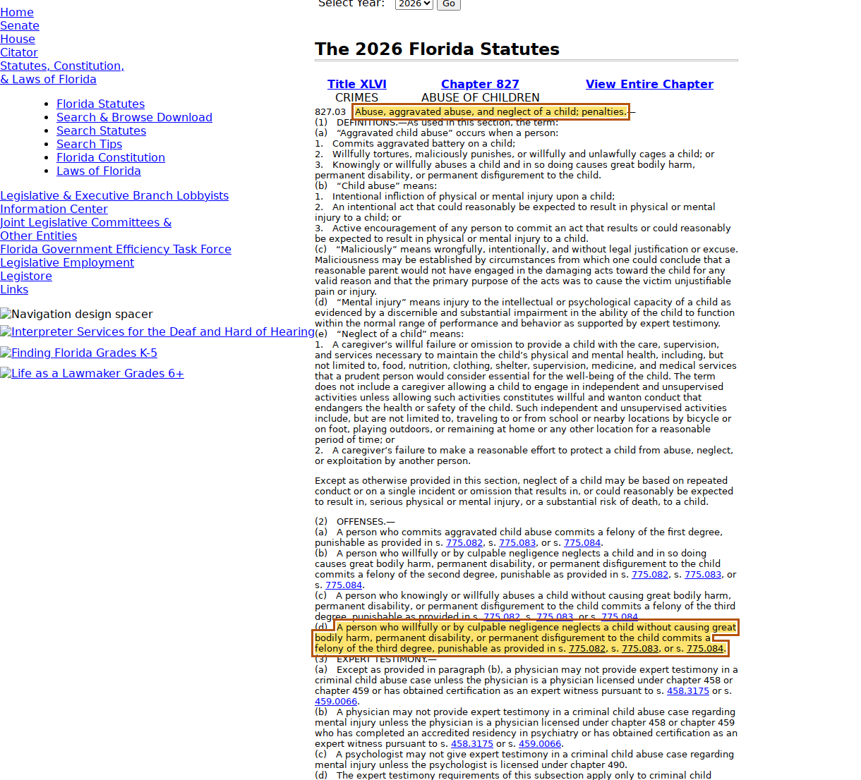
Frame 1. Direct offline rendering of saved official raw HTML; outbound resources blocked; yellow outline is the review annotation. Context around the complete qualification is retained.

Accessible source and provenance
Official source URL: https://www.leg.state.fl.us/statutes/index.cfm?App_mode=Display_Statute&URL=0800-0899/0827/Sections/0827.03.html
Edition: Florida Statutes 2026
Raw HTML retrieved: 2026-09-18T21:20:44.765Z
Parsed evidence retrieved: 2026-09-18T21:20:44.765Z
Raw HTML SHA-256: b40d426ddbfb826e5975991c231936164304aab6612698ac71cfe9357e8764c2
Normalized source-text SHA-256: 5748c55edb59e945328d9eb507d06dc214730e7b64b4b7916f1ebb3c275a8645
identity · matched: Abuse, aggravated abuse, and neglect of a child; penalties
conduct · matched: A person who willfully or by culpable negligence neglects a child without causing great bodily harm, permanent disability, or permanent disfigurement to the child commits a felony of the third degree, punishable as provided in s. 775.082, s. 775.083, or s. 775.084.
grading · matched: A person who willfully or by culpable negligence neglects a child without causing great bodily harm, permanent disability, or permanent disfigurement to the child commits a felony of the third degree, punishable as provided in s. 775.082, s. 775.083, or s. 775.084.

Dependencies, defenses, exceptions, and boundaries
Analyst boundary: Subsection (1)(e)'s definition, including the independent-and-unsupervised-activity limitation and injury-or-risk threshold, is required. Paragraph (2)(b)'s resulting-great-harm grade is separate.
Section | Role | Edition | Retrieved | Content SHA-256 | Validation
§ 827.03 | offense | Florida Statutes 2026 | 2026-09-18T21:20:44.765Z | 5748c55edb59e945328d9eb507d06dc214730e7b64b4b7916f1ebb3c275a8645 | validated
§ 827.03 | grading | Florida Statutes 2026 | 2026-09-18T21:20:44.765Z | 5748c55edb59e945328d9eb507d06dc214730e7b64b4b7916f1ebb3c275a8645 | validated
§ 827.03 | definition | Florida Statutes 2026 | 2026-09-18T21:20:44.765Z | 5748c55edb59e945328d9eb507d06dc214730e7b64b4b7916f1ebb3c275a8645 | validated
§ 827.03 | exception | Florida Statutes 2026 | 2026-09-18T21:20:44.765Z | 5748c55edb59e945328d9eb507d06dc214730e7b64b4b7916f1ebb3c275a8645 | validated
§ 827.01 | definition | Florida Statutes 2026 | 2026-09-18T21:20:42.609Z | b9affea3d8a2aff821678555ece05113167e9af78c36b46534ecea95f79de9b0 | validated
§ 775.082 | penalty | Florida Statutes 2026 | 2026-09-18T21:18:58.265Z | ce7d77dd9b8582b3f7e8559aa0784d7798c48dd70f51aff79dbccebe94bedd9c | validated
§ 775.083 | penalty | Florida Statutes 2026 | 2026-09-18T21:19:00.479Z | d4e9a9527ef821de6935f5763bf7ccf7fd6dc0bdc59014b0c9e063611d2768a7 | validated
§ 775.084 | penalty | Florida Statutes 2026 | 2026-09-18T21:19:02.633Z | e2f0ef78192f6448f7552357472ee5e402a791da88c7ca3e64cb1424f9c98d53 | validated

Precise review question
Does Fla. Stat. § 827.03(2)(d) support this record at exactly the proposed scope, rather than a neighboring or broader branch? Do the quoted anchors establish every stated conduct, mental-state, victim/age or harm condition, defense or exception, and grade described in the EN/ES/ZH explanations? Are these dependency roles complete: § 827.03 (offense), § 827.03 (grading), § 827.03 (definition), § 827.03 (exception), § 827.01 (definition), § 775.082 (penalty), § 775.083 (penalty), § 775.084 (penalty)? Is this boundary accurate: Subsection (1)(e)'s definition, including the independent-and-unsupervised-activity limitation and injury-or-risk threshold, is required. Paragraph (2)(b)'s resulting-great-harm grade is separate. For any “no,” identify the exact text and choose hold, correct, split, reclassify, deduplicate, or remove. A screenshot match is not approval.

Blank decision
☐ publish ☐ hold ☐ correct ☐ split ☐ reclassify ☐ deduplicate ☐ remove
Decision / exact action: __________________________________________________________________
Required notes / exact corrections: ____________________________________________________________
________________________________________________________________________________________
________________________________________________________________________________________
Reviewer: ________________________________________
Date: ____________________
Record hash: 5b4220030fa828db5f6b589c44750917e0ab88a64b5b6cdca671dae05c1fcd7f
Evidence hash: b4f64833a36ca6efb0a6a07da4f39e233cb3281d1b3501919c606e118db7838c
Combined decision-binding hash: 7de180be44c4eeacf9637d776052d53b884dbb032b2b2885fcc684d15a19103d

PRIORITY 10 · BATCH F · NO APPROVAL

Contributing to the delinquency or dependency of a child; penalty
Record ID: fl-fs-827-04-3-contributing-to-the-delinquency-or-dependency-of-a-child-penalty
Exact scope: Fla. Stat. § 827.04(3)

Proposed EN / ES / ZH explanations
EN: A person age 21 or older impregnating a child under age 16. Third-degree felony. The offense applies regardless of whether the person is found to have committed, charged with, or prosecuted for another offense in the same criminal transaction or episode. The victim's lack of chastity and consent are not defenses.
ES: Una persona de 21 años o más que embaraza a una menor de 16 años. Delito grave de tercer grado. El delito se aplica independientemente de que la persona sea declarada autora, acusada o procesada por otro delito en la misma transacción o episodio penal. Ni la falta de castidad ni el consentimiento de la víctima constituyen defensa.
ZH: 年满21岁者使未满16岁的儿童怀孕。 三级重罪。无论该人是否因同一犯罪交易或事件中的其他罪行被认定有罪、受到指控或被起诉，本罪均适用。受害者并非贞洁或曾表示同意均不构成抗辩。
Spanish and Chinese text has no fluent-speaker or attorney approval in this packet.

Exact quoted support and anchor accounting
Matched means one normalized occurrence in the saved snapshot text. It does not mean legally sufficient or approved.
Anchor | Status | Count | Exact quote | Screenshot
identity-1 | matched | 1 | Contributing to the delinquency or dependency of a child; penalty | highlighted in saved raw HTML
conduct-2 | matched | 1 | A person 21 years of age or older who impregnates a child under 16 years of age commits an act of child abuse which constitutes a felony of the third degree, punishable as provided in s. 775.082, s. 775.083, or s. 775.084. | highlighted in saved raw HTML
grading-3 | matched | 1 | A person 21 years of age or older who impregnates a child under 16 years of age commits an act of child abuse which constitutes a felony of the third degree, punishable as provided in s. 775.082, s. 775.083, or s. 775.084. | highlighted in saved raw HTML

Saved-source evidence frames
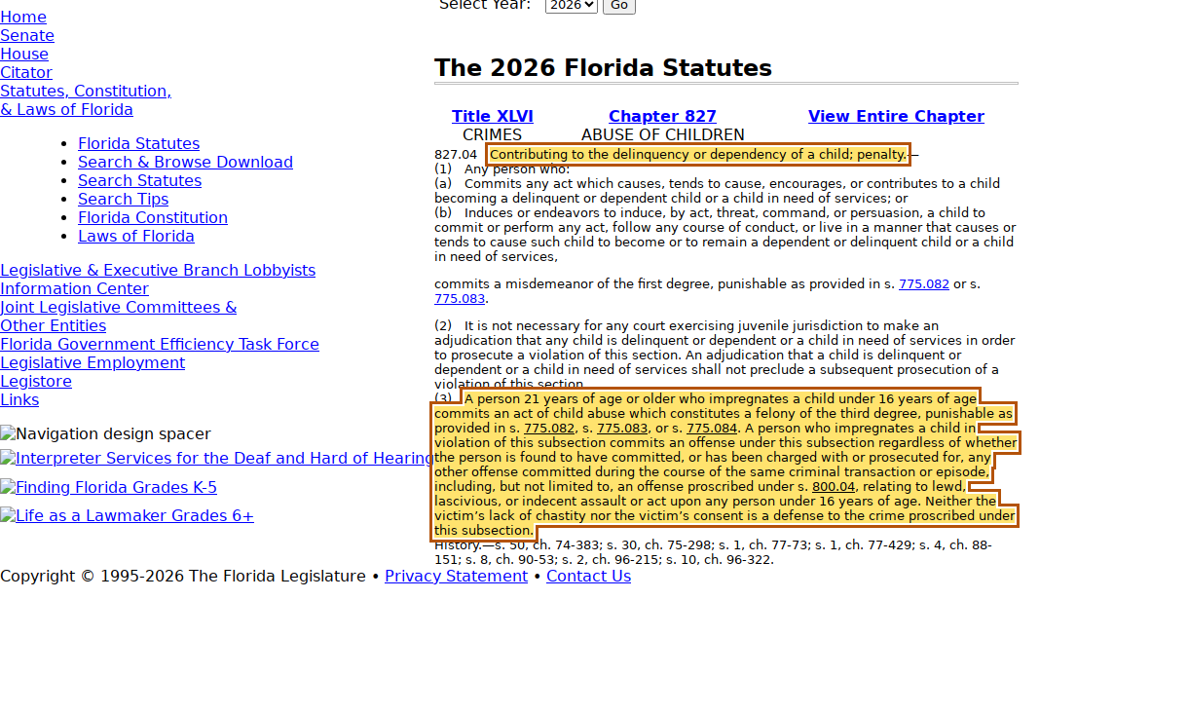
Frame 1. Direct offline rendering of saved official raw HTML; outbound resources blocked; yellow outline is the review annotation. Context around the complete qualification is retained.

Accessible source and provenance
Official source URL: https://www.leg.state.fl.us/statutes/index.cfm?App_mode=Display_Statute&URL=0800-0899/0827/Sections/0827.04.html
Edition: Florida Statutes 2026
Raw HTML retrieved: 2026-09-18T21:20:46.920Z
Parsed evidence retrieved: 2026-09-18T21:20:46.920Z
Raw HTML SHA-256: e7140a57fa59ee75d85aa7ccb798ad82e4c26bd13b7543915d025d1589f4daab
Normalized source-text SHA-256: 763687374ae1d7768bc561a6ef79cced5762ed247e234af826234c7bef1503b1
identity · matched: Contributing to the delinquency or dependency of a child; penalty
conduct · matched: A person 21 years of age or older who impregnates a child under 16 years of age commits an act of child abuse which constitutes a felony of the third degree, punishable as provided in s. 775.082, s. 775.083, or s. 775.084.
grading · matched: A person 21 years of age or older who impregnates a child under 16 years of age commits an act of child abuse which constitutes a felony of the third degree, punishable as provided in s. 775.082, s. 775.083, or s. 775.084.

Dependencies, defenses, exceptions, and boundaries
Analyst boundary: This is the independently complete subsection (3) felony, not subsection (1)'s delinquency/dependency misdemeanor. The same-transaction rule and the express statement that lack of chastity and consent are not defenses are preserved.
Section | Role | Edition | Retrieved | Content SHA-256 | Validation
§ 827.04 | offense | Florida Statutes 2026 | 2026-09-18T21:20:46.920Z | 763687374ae1d7768bc561a6ef79cced5762ed247e234af826234c7bef1503b1 | validated
§ 827.04 | grading | Florida Statutes 2026 | 2026-09-18T21:20:46.920Z | 763687374ae1d7768bc561a6ef79cced5762ed247e234af826234c7bef1503b1 | validated
§ 827.04 | exception | Florida Statutes 2026 | 2026-09-18T21:20:46.920Z | 763687374ae1d7768bc561a6ef79cced5762ed247e234af826234c7bef1503b1 | validated
§ 827.01 | definition | Florida Statutes 2026 | 2026-09-18T21:20:42.609Z | b9affea3d8a2aff821678555ece05113167e9af78c36b46534ecea95f79de9b0 | validated
§ 775.082 | penalty | Florida Statutes 2026 | 2026-09-18T21:18:58.265Z | ce7d77dd9b8582b3f7e8559aa0784d7798c48dd70f51aff79dbccebe94bedd9c | validated
§ 775.083 | penalty | Florida Statutes 2026 | 2026-09-18T21:19:00.479Z | d4e9a9527ef821de6935f5763bf7ccf7fd6dc0bdc59014b0c9e063611d2768a7 | validated
§ 775.084 | penalty | Florida Statutes 2026 | 2026-09-18T21:19:02.633Z | e2f0ef78192f6448f7552357472ee5e402a791da88c7ca3e64cb1424f9c98d53 | validated

Precise review question
Does Fla. Stat. § 827.04(3) support this record at exactly the proposed scope, rather than a neighboring or broader branch? Do the quoted anchors establish every stated conduct, mental-state, victim/age or harm condition, defense or exception, and grade described in the EN/ES/ZH explanations? Are these dependency roles complete: § 827.04 (offense), § 827.04 (grading), § 827.04 (exception), § 827.01 (definition), § 775.082 (penalty), § 775.083 (penalty), § 775.084 (penalty)? Is this boundary accurate: This is the independently complete subsection (3) felony, not subsection (1)'s delinquency/dependency misdemeanor. The same-transaction rule and the express statement that lack of chastity and consent are not defenses are preserved. For any “no,” identify the exact text and choose hold, correct, split, reclassify, deduplicate, or remove. A screenshot match is not approval.

Blank decision
☐ publish ☐ hold ☐ correct ☐ split ☐ reclassify ☐ deduplicate ☐ remove
Decision / exact action: __________________________________________________________________
Required notes / exact corrections: ____________________________________________________________
________________________________________________________________________________________
________________________________________________________________________________________
Reviewer: ________________________________________
Date: ____________________
Record hash: 03b456051df259ba54df3f35f17b447db0ee671f28549bcf425fd9df467a8173
Evidence hash: 3c0be28a766d3f22724a4caf9625ac883adff9af56930f6a9f3f04738f792ded
Combined decision-binding hash: 53fcb4a5e2a3635d208c847f355570766b29e7fd0d97371c7c2c4f2851d57e4b

Appendix A — three blocked branches
Recovered sources are leads only. No branch is approved and none may be cleared from a screenshot or URL alone.

Fla. Stat. § 893.13(3)
Record ID: fl-fs-893-13-3-prohibited-acts-penalties
Specific hold reason: Held. The current medical-marijuana exclusion incorporated through § 893.02(3) has a recovered official 2026 source, but its exact paragraphs, boundaries, nested dependencies, and evidence hashes have not been integrated and reviewed.
Saved official source leads: Fla. Stat. § 381.986: https://www.flsenate.gov/Laws/Statutes/2026/381.986
Review question: Does current § 381.986 resolve every medical-marijuana exclusion applicable to the cannabis-specific § 893.13(3) delivery branch? Identify exact paragraphs, limits, nested definitions, and exceptions; otherwise keep held.
Decision: ____________________
Reviewer / date: ________________________________ / ______________
Notes / exact subdivisions: ____________________________________________________________

Fla. Stat. § 893.147(7)
Record ID: fl-fs-893-147-7-use-possession-manufacture-delivery-transportation-advertisement-or-retail-sale-of-drug-paraphernalia-specified-machines-and-materials
Specific hold reason: Held. All four official source leads were recovered, but narrow subdivision extraction, incorporated federal definitions, registration/compliance conditions, licensing exceptions, hash integration, and legal review remain incomplete. The federal OLRC snapshots represent law only through April 13, 2026 / Pub. L. 119-83.
Saved official source leads: Fla. Stat. § 381.986: https://www.flsenate.gov/Laws/Statutes/2026/381.986 | 21 U.S.C. § 802: https://uscode.house.gov/view.xhtml?req=granuleid:USC-prelim-title21-section802&num=0&edition=prelim | 21 U.S.C. § 822: https://uscode.house.gov/view.xhtml?req=granuleid:USC-prelim-title21-section822&num=0&edition=prelim | 21 U.S.C. § 830: https://uscode.house.gov/view.xhtml?req=granuleid:USC-prelim-title21-section830&num=0&edition=prelim
Review question: Do the saved federal provisions and § 381.986 close every definition, registration/compliance condition, and licensing exception for § 893.147(7)? Identify each exact incorporated scope and edition boundary; do not approve a partial dependency set.
Decision: ____________________
Reviewer / date: ________________________________ / ______________
Notes / exact subdivisions: ____________________________________________________________

Fla. Stat. § 827.04(1)
Record ID: fl-fs-827-04-1-contributing-to-the-delinquency-or-dependency-of-a-child-penalty
Specific hold reason: Held. An official 2026 source was recovered, but the controlling dependent-child definition, relevant alternatives and exclusions, nested-dependency review, and evidence-hash integration remain incomplete. Cached §§ 984.03 and 985.03 did not independently cure the dependency.
Saved official source leads: Fla. Stat. § 39.01: https://www.flsenate.gov/Laws/Statutes/2026/39.01
Review question: Does current § 39.01 supply the controlling dependent-child definition for § 827.04(1), including every relevant condition, alternative, and exception? Identify exact subdivisions and any nested definitions; otherwise keep held.
Decision: ____________________
Reviewer / date: ________________________________ / ______________
Notes / exact subdivisions: ____________________________________________________________

Appendix B — 92 legacy holds
Manifest hold reasons are preserved verbatim. Triage labels organize review only. Record an exact action and note.
# | Record / label | Scope / source | Verbatim reason / triage | Precise question | Blank decision
1 | fl-voluntary-manslaughter  Voluntary Manslaughter | Fla. Stat. § 782.07(1)  https://www.leg.state.fl.us/statutes/index.cfm?App_mode=Display_Statute&URL=0700-0799/0782/Sections/0782.07.html | exact citation/subdivision mismatch  The catalog code does not exactly support every cited Florida statutory section and subdivision. | For Fla. Stat. § 782.07(1), should fl-voluntary-manslaughter be corrected to an exact reviewed subdivision, split into records, held, or removed? Give each exact citation and action. | Decision:  Reviewer:  Date:  Notes:
2 | fl-involuntary-manslaughter  Involuntary Manslaughter | Fla. Stat. § 782.07(1)  https://www.leg.state.fl.us/statutes/index.cfm?App_mode=Display_Statute&URL=0700-0799/0782/Sections/0782.07.html | exact citation/subdivision mismatch  The catalog code does not exactly support every cited Florida statutory section and subdivision. | For Fla. Stat. § 782.07(1), should fl-involuntary-manslaughter be corrected to an exact reviewed subdivision, split into records, held, or removed? Give each exact citation and action. | Decision:  Reviewer:  Date:  Notes:
3 | fl-criminally-negligent-homicide  Criminally Negligent Homicide | Fla. Stat. § 782.07  https://www.leg.state.fl.us/statutes/index.cfm?App_mode=Display_Statute&URL=0700-0799/0782/Sections/0782.07.html | label-to-official-title identity unresolved  The official Florida title "Manslaughter; aggravated manslaughter of an elderly person or disabled adult; aggravated manslaughter of a child; aggravated manslaughter of an officer, a firefighter, an emergency medical technician, or a paramedic" is not an exact or explicitly reviewed mapping for the catalog label. | Does the official provision at Fla. Stat. § 782.07 support the legacy label “Criminally Negligent Homicide” at exactly this scope? If not, choose correct, split, reclassify, deduplicate, hold, or remove and state the exact mapping. | Decision:  Reviewer:  Date:  Notes:
4 | fl-felony-murder  Felony Murder | Fla. Stat. § 782.04(1)(a)2  https://www.leg.state.fl.us/statutes/index.cfm?App_mode=Display_Statute&URL=0700-0799/0782/Sections/0782.04.html | exact citation/subdivision mismatch  The catalog code does not exactly support every cited Florida statutory section and subdivision. | For Fla. Stat. § 782.04(1)(a)2, should fl-felony-murder be corrected to an exact reviewed subdivision, split into records, held, or removed? Give each exact citation and action. | Decision:  Reviewer:  Date:  Notes:
5 | fl-assault-on-peace-officer  Assault on Peace Officer | Fla. Stat. § 784.07  https://www.leg.state.fl.us/statutes/index.cfm?App_mode=Display_Statute&URL=0700-0799/0784/Sections/0784.07.html | label-to-official-title identity unresolved  The official Florida title "Assault or battery of law enforcement officers and other specified personnel; reclassification of offenses; minimum sentences" is not an exact or explicitly reviewed mapping for the catalog label. | Does the official provision at Fla. Stat. § 784.07 support the legacy label “Assault on Peace Officer” at exactly this scope? If not, choose correct, split, reclassify, deduplicate, hold, or remove and state the exact mapping. | Decision:  Reviewer:  Date:  Notes:
6 | fl-menacing  Menacing | Fla. Stat. § 784.011  https://www.leg.state.fl.us/statutes/index.cfm?App_mode=Display_Statute&URL=0700-0799/0784/Sections/0784.011.html | label-to-official-title identity unresolved  The official Florida title "Assault" is not an exact or explicitly reviewed mapping for the catalog label. | Does the official provision at Fla. Stat. § 784.011 support the legacy label “Menacing” at exactly this scope? If not, choose correct, split, reclassify, deduplicate, hold, or remove and state the exact mapping. | Decision:  Reviewer:  Date:  Notes:
7 | fl-sexual-assault-in-the-second-degree  Sexual Battery (by Force) | Fla. Stat. § 794.011(4)  https://www.leg.state.fl.us/statutes/index.cfm?App_mode=Display_Statute&URL=0700-0799/0794/Sections/0794.011.html | exact citation/subdivision mismatch  The catalog code does not exactly support every cited Florida statutory section and subdivision. | For Fla. Stat. § 794.011(4), should fl-sexual-assault-in-the-second-degree be corrected to an exact reviewed subdivision, split into records, held, or removed? Give each exact citation and action. | Decision:  Reviewer:  Date:  Notes:
8 | fl-child-sexual-abuse  Child Sexual Abuse | Fla. Stat. § 800.04  https://www.leg.state.fl.us/statutes/index.cfm?App_mode=Display_Statute&URL=0800-0899/0800/Sections/0800.04.html | label-to-official-title identity unresolved  The official Florida title "Lewd or lascivious offenses committed upon or in the presence of persons less than 16 years of age" is not an exact or explicitly reviewed mapping for the catalog label. | Does the official provision at Fla. Stat. § 800.04 support the legacy label “Child Sexual Abuse” at exactly this scope? If not, choose correct, split, reclassify, deduplicate, hold, or remove and state the exact mapping. | Decision:  Reviewer:  Date:  Notes:
9 | fl-sexual-exploitation-of-minor  Sexual Exploitation of Minor | Fla. Stat. § 827.071  https://www.leg.state.fl.us/statutes/index.cfm?App_mode=Display_Statute&URL=0800-0899/0827/Sections/0827.071.html | label-to-official-title identity unresolved  The official Florida title "Sexual performance by a child; child sexual abuse material; penalties" is not an exact or explicitly reviewed mapping for the catalog label. | Does the official provision at Fla. Stat. § 827.071 support the legacy label “Sexual Exploitation of Minor” at exactly this scope? If not, choose correct, split, reclassify, deduplicate, hold, or remove and state the exact mapping. | Decision:  Reviewer:  Date:  Notes:
10 | fl-petty-theft  Petty Theft | Fla. Stat. § 812.014  https://www.leg.state.fl.us/statutes/index.cfm?App_mode=Display_Statute&URL=0800-0899/0812/Sections/0812.014.html | label-to-official-title identity unresolved  The official Florida title "Theft" is not an exact or explicitly reviewed mapping for the catalog label. | Does the official provision at Fla. Stat. § 812.014 support the legacy label “Petty Theft” at exactly this scope? If not, choose correct, split, reclassify, deduplicate, hold, or remove and state the exact mapping. | Decision:  Reviewer:  Date:  Notes:
11 | fl-theft-by-receiving  Theft by Receiving | Fla. Stat. § 812.019  https://www.leg.state.fl.us/statutes/index.cfm?App_mode=Display_Statute&URL=0800-0899/0812/Sections/0812.019.html | label-to-official-title identity unresolved  The official Florida title "Dealing in stolen property" is not an exact or explicitly reviewed mapping for the catalog label. | Does the official provision at Fla. Stat. § 812.019 support the legacy label “Theft by Receiving” at exactly this scope? If not, choose correct, split, reclassify, deduplicate, hold, or remove and state the exact mapping. | Decision:  Reviewer:  Date:  Notes:
12 | fl-identity-theft  Identity Theft | Fla. Stat. § 817.568  https://www.leg.state.fl.us/statutes/index.cfm?App_mode=Display_Statute&URL=0800-0899/0817/Sections/0817.568.html | label-to-official-title identity unresolved  The official Florida title "Criminal use of personal identification information" is not an exact or explicitly reviewed mapping for the catalog label. | Does the official provision at Fla. Stat. § 817.568 support the legacy label “Identity Theft” at exactly this scope? If not, choose correct, split, reclassify, deduplicate, hold, or remove and state the exact mapping. | Decision:  Reviewer:  Date:  Notes:
13 | fl-credit-card-fraud  Credit Card Fraud | Fla. Stat. § 817.61  https://www.leg.state.fl.us/statutes/index.cfm?App_mode=Display_Statute&URL=0800-0899/0817/Sections/0817.61.html | label-to-official-title identity unresolved  The official Florida title "Fraudulent use of credit cards" is not an exact or explicitly reviewed mapping for the catalog label. | Does the official provision at Fla. Stat. § 817.61 support the legacy label “Credit Card Fraud” at exactly this scope? If not, choose correct, split, reclassify, deduplicate, hold, or remove and state the exact mapping. | Decision:  Reviewer:  Date:  Notes:
14 | fl-embezzlement  Embezzlement | Fla. Stat. § 812.014(2)  https://www.leg.state.fl.us/statutes/index.cfm?App_mode=Display_Statute&URL=0800-0899/0812/Sections/0812.014.html | label-to-official-title identity unresolved  The official Florida title "Theft" is not an exact or explicitly reviewed mapping for the catalog label. | Does the official provision at Fla. Stat. § 812.014(2) support the legacy label “Embezzlement” at exactly this scope? If not, choose correct, split, reclassify, deduplicate, hold, or remove and state the exact mapping. | Decision:  Reviewer:  Date:  Notes:
15 | fl-shoplifting  Shoplifting | Fla. Stat. § 812.015  https://www.leg.state.fl.us/statutes/index.cfm?App_mode=Display_Statute&URL=0800-0899/0812/Sections/0812.015.html | label-to-official-title identity unresolved  The official Florida title "Retail and farm theft; transit fare evasion; mandatory fine; alternative punishment; detention and arrest; exemption from liability for false arrest; resisting arrest; penalties" is not an exact or explicitly reviewed mapping for the catalog label. | Does the official provision at Fla. Stat. § 812.015 support the legacy label “Shoplifting” at exactly this scope? If not, choose correct, split, reclassify, deduplicate, hold, or remove and state the exact mapping. | Decision:  Reviewer:  Date:  Notes:
16 | fl-residential-burglary  Residential Burglary | Fla. Stat. § 810.02(2)  https://www.leg.state.fl.us/statutes/index.cfm?App_mode=Display_Statute&URL=0800-0899/0810/Sections/0810.02.html | exact citation/subdivision mismatch  The catalog code does not exactly support every cited Florida statutory section and subdivision. | For Fla. Stat. § 810.02(2), should fl-residential-burglary be corrected to an exact reviewed subdivision, split into records, held, or removed? Give each exact citation and action. | Decision:  Reviewer:  Date:  Notes:
17 | fl-commercial-burglary  Commercial Burglary | Fla. Stat. § 810.02(3)  https://www.leg.state.fl.us/statutes/index.cfm?App_mode=Display_Statute&URL=0800-0899/0810/Sections/0810.02.html | exact citation/subdivision mismatch  The catalog code does not exactly support every cited Florida statutory section and subdivision. | For Fla. Stat. § 810.02(3), should fl-commercial-burglary be corrected to an exact reviewed subdivision, split into records, held, or removed? Give each exact citation and action. | Decision:  Reviewer:  Date:  Notes:
18 | fl-auto-burglary  Auto Burglary | Fla. Stat. § 810.02(4)  https://www.leg.state.fl.us/statutes/index.cfm?App_mode=Display_Statute&URL=0800-0899/0810/Sections/0810.02.html | exact citation/subdivision mismatch  The catalog code does not exactly support every cited Florida statutory section and subdivision. | For Fla. Stat. § 810.02(4), should fl-auto-burglary be corrected to an exact reviewed subdivision, split into records, held, or removed? Give each exact citation and action. | Decision:  Reviewer:  Date:  Notes:
19 | fl-bank-robbery  Bank Robbery | Fla. Stat. § 18 U.S.C. § 2113  https://www.leg.state.fl.us/statutes/index.cfm?App_mode=Display_Statute&URL=0000-0099/0000/Sections/0000.undefined.html | exact citation/subdivision mismatch  The catalog code does not exactly support every cited Florida statutory section and subdivision. | For Fla. Stat. § 18 U.S.C. § 2113, should fl-bank-robbery be corrected to an exact reviewed subdivision, split into records, held, or removed? Give each exact citation and action. | Decision:  Reviewer:  Date:  Notes:
20 | fl-possession-of-controlled-substance  Possession of Controlled Substance | Fla. Stat. § 893.13(6)  https://www.leg.state.fl.us/statutes/index.cfm?App_mode=Display_Statute&URL=0800-0899/0893/Sections/0893.13.html | exact citation/subdivision mismatch  The catalog code does not exactly support every cited Florida statutory section and subdivision. | For Fla. Stat. § 893.13(6), should fl-possession-of-controlled-substance be corrected to an exact reviewed subdivision, split into records, held, or removed? Give each exact citation and action. | Decision:  Reviewer:  Date:  Notes:
21 | fl-possession-with-intent-to-distribute  Possession with Intent to Distribute | Fla. Stat. § 893.13(1)(a)  https://www.leg.state.fl.us/statutes/index.cfm?App_mode=Display_Statute&URL=0800-0899/0893/Sections/0893.13.html | label-to-official-title identity unresolved  The official Florida title "Prohibited acts; penalties" is not an exact or explicitly reviewed mapping for the catalog label. | Does the official provision at Fla. Stat. § 893.13(1)(a) support the legacy label “Possession with Intent to Distribute” at exactly this scope? If not, choose correct, split, reclassify, deduplicate, hold, or remove and state the exact mapping. | Decision:  Reviewer:  Date:  Notes:
22 | fl-distribution-of-controlled-substance  Distribution of Controlled Substance | Fla. Stat. § 893.13(1)(a)  https://www.leg.state.fl.us/statutes/index.cfm?App_mode=Display_Statute&URL=0800-0899/0893/Sections/0893.13.html | exact citation/subdivision mismatch  The catalog code does not exactly support every cited Florida statutory section and subdivision. | For Fla. Stat. § 893.13(1)(a), should fl-distribution-of-controlled-substance be corrected to an exact reviewed subdivision, split into records, held, or removed? Give each exact citation and action. | Decision:  Reviewer:  Date:  Notes:
23 | fl-manufacturing-controlled-substance  Manufacturing Controlled Substance | Fla. Stat. § 893.13(1)(a)  https://www.leg.state.fl.us/statutes/index.cfm?App_mode=Display_Statute&URL=0800-0899/0893/Sections/0893.13.html | label-to-official-title identity unresolved  The official Florida title "Prohibited acts; penalties" is not an exact or explicitly reviewed mapping for the catalog label. | Does the official provision at Fla. Stat. § 893.13(1)(a) support the legacy label “Manufacturing Controlled Substance” at exactly this scope? If not, choose correct, split, reclassify, deduplicate, hold, or remove and state the exact mapping. | Decision:  Reviewer:  Date:  Notes:
24 | fl-drug-trafficking  Drug Trafficking | Fla. Stat. § 893.135  https://www.leg.state.fl.us/statutes/index.cfm?App_mode=Display_Statute&URL=0800-0899/0893/Sections/0893.135.html | label-to-official-title identity unresolved  The official Florida title "Trafficking; mandatory sentences; suspension or reduction of sentences; conspiracy to engage in trafficking" is not an exact or explicitly reviewed mapping for the catalog label. | Does the official provision at Fla. Stat. § 893.135 support the legacy label “Drug Trafficking” at exactly this scope? If not, choose correct, split, reclassify, deduplicate, hold, or remove and state the exact mapping. | Decision:  Reviewer:  Date:  Notes:
25 | fl-possession-of-drug-paraphernalia  Possession of Drug Paraphernalia | Fla. Stat. § 893.147(1)  https://www.leg.state.fl.us/statutes/index.cfm?App_mode=Display_Statute&URL=0800-0899/0893/Sections/0893.147.html | label-to-official-title identity unresolved  The official Florida title "Use, possession, manufacture, delivery, transportation, advertisement, or retail sale of drug paraphernalia, specified machines, and materials" is not an exact or explicitly reviewed mapping for the catalog label. | Does the official provision at Fla. Stat. § 893.147(1) support the legacy label “Possession of Drug Paraphernalia” at exactly this scope? If not, choose correct, split, reclassify, deduplicate, hold, or remove and state the exact mapping. | Decision:  Reviewer:  Date:  Notes:
26 | fl-maintaining-drug-house  Maintaining Drug House | Fla. Stat. § 893.1351  https://www.leg.state.fl.us/statutes/index.cfm?App_mode=Display_Statute&URL=0800-0899/0893/Sections/0893.1351.html | exact citation/subdivision mismatch  The catalog code does not exactly support every cited Florida statutory section and subdivision. | For Fla. Stat. § 893.1351, should fl-maintaining-drug-house be corrected to an exact reviewed subdivision, split into records, held, or removed? Give each exact citation and action. | Decision:  Reviewer:  Date:  Notes:
27 | fl-felon-in-possession-of-firearm  Felon in Possession of Firearm | Fla. Stat. § 790.23  https://www.leg.state.fl.us/statutes/index.cfm?App_mode=Display_Statute&URL=0700-0799/0790/Sections/0790.23.html | label-to-official-title identity unresolved  The official Florida title "Felons and delinquents; possession of firearms, ammunition, or electric weapons or devices unlawful" is not an exact or explicitly reviewed mapping for the catalog label. | Does the official provision at Fla. Stat. § 790.23 support the legacy label “Felon in Possession of Firearm” at exactly this scope? If not, choose correct, split, reclassify, deduplicate, hold, or remove and state the exact mapping. | Decision:  Reviewer:  Date:  Notes:
28 | fl-possession-of-prohibited-weapon  Possession of Prohibited Weapon | Fla. Stat. § 790.221  https://www.leg.state.fl.us/statutes/index.cfm?App_mode=Display_Statute&URL=0700-0799/0790/Sections/0790.221.html | label-to-official-title identity unresolved  The official Florida title "Possession of short-barreled rifle, short-barreled shotgun, or machine gun; penalty" is not an exact or explicitly reviewed mapping for the catalog label. | Does the official provision at Fla. Stat. § 790.221 support the legacy label “Possession of Prohibited Weapon” at exactly this scope? If not, choose correct, split, reclassify, deduplicate, hold, or remove and state the exact mapping. | Decision:  Reviewer:  Date:  Notes:
29 | fl-wire-fraud  Wire Fraud | Fla. Stat. § 969.256  https://www.leg.state.fl.us/statutes/index.cfm?App_mode=Display_Statute&URL=0900-0999/0969/Sections/0969.256.html | exact citation/subdivision mismatch  The catalog code does not exactly support every cited Florida statutory section and subdivision. | For Fla. Stat. § 969.256, should fl-wire-fraud be corrected to an exact reviewed subdivision, split into records, held, or removed? Give each exact citation and action. | Decision:  Reviewer:  Date:  Notes:
30 | fl-mail-fraud  Mail Fraud | Fla. Stat. § 683.650  https://www.leg.state.fl.us/statutes/index.cfm?App_mode=Display_Statute&URL=0600-0699/0683/Sections/0683.650.html | exact citation/subdivision mismatch  The catalog code does not exactly support every cited Florida statutory section and subdivision. | For Fla. Stat. § 683.650, should fl-mail-fraud be corrected to an exact reviewed subdivision, split into records, held, or removed? Give each exact citation and action. | Decision:  Reviewer:  Date:  Notes:
31 | fl-check-fraud  Check Fraud | Fla. Stat. § 832.05  https://www.leg.state.fl.us/statutes/index.cfm?App_mode=Display_Statute&URL=0800-0899/0832/Sections/0832.05.html | label-to-official-title identity unresolved  The official Florida title "Giving worthless checks, drafts, and debit card orders; penalty; duty of drawee; evidence; costs; complaint form" is not an exact or explicitly reviewed mapping for the catalog label. | Does the official provision at Fla. Stat. § 832.05 support the legacy label “Check Fraud” at exactly this scope? If not, choose correct, split, reclassify, deduplicate, hold, or remove and state the exact mapping. | Decision:  Reviewer:  Date:  Notes:
32 | fl-insurance-fraud  Insurance Fraud | Fla. Stat. § 817.234  https://www.leg.state.fl.us/statutes/index.cfm?App_mode=Display_Statute&URL=0800-0899/0817/Sections/0817.234.html | label-to-official-title identity unresolved  The official Florida title "False and fraudulent insurance claims" is not an exact or explicitly reviewed mapping for the catalog label. | Does the official provision at Fla. Stat. § 817.234 support the legacy label “Insurance Fraud” at exactly this scope? If not, choose correct, split, reclassify, deduplicate, hold, or remove and state the exact mapping. | Decision:  Reviewer:  Date:  Notes:
33 | fl-tax-fraud  Tax Fraud | Fla. Stat. § 213.29  https://www.leg.state.fl.us/statutes/index.cfm?App_mode=Display_Statute&URL=0200-0299/0213/Sections/0213.29.html | exact citation/subdivision mismatch  The catalog code does not exactly support every cited Florida statutory section and subdivision. | For Fla. Stat. § 213.29, should fl-tax-fraud be corrected to an exact reviewed subdivision, split into records, held, or removed? Give each exact citation and action. | Decision:  Reviewer:  Date:  Notes:
34 | fl-computer-fraud  Computer Fraud | Fla. Stat. § 815.06  https://www.leg.state.fl.us/statutes/index.cfm?App_mode=Display_Statute&URL=0800-0899/0815/Sections/0815.06.html | label-to-official-title identity unresolved  The official Florida title "Offenses against users of computers, computer systems, computer networks, and electronic devices" is not an exact or explicitly reviewed mapping for the catalog label. | Does the official provision at Fla. Stat. § 815.06 support the legacy label “Computer Fraud” at exactly this scope? If not, choose correct, split, reclassify, deduplicate, hold, or remove and state the exact mapping. | Decision:  Reviewer:  Date:  Notes:
35 | fl-disorderly-conduct  Disorderly Conduct | Fla. Stat. § 877.03  https://www.leg.state.fl.us/statutes/index.cfm?App_mode=Display_Statute&URL=0800-0899/0877/Sections/0877.03.html | label-to-official-title identity unresolved  The official Florida title "Breach of the peace; disorderly conduct" is not an exact or explicitly reviewed mapping for the catalog label. | Does the official provision at Fla. Stat. § 877.03 support the legacy label “Disorderly Conduct” at exactly this scope? If not, choose correct, split, reclassify, deduplicate, hold, or remove and state the exact mapping. | Decision:  Reviewer:  Date:  Notes:
36 | fl-vandalism  Vandalism | Fla. Stat. § 806.13  https://www.leg.state.fl.us/statutes/index.cfm?App_mode=Display_Statute&URL=0800-0899/0806/Sections/0806.13.html | label-to-official-title identity unresolved  The official Florida title "Criminal mischief; penalties; penalty for minor" is not an exact or explicitly reviewed mapping for the catalog label. | Does the official provision at Fla. Stat. § 806.13 support the legacy label “Vandalism” at exactly this scope? If not, choose correct, split, reclassify, deduplicate, hold, or remove and state the exact mapping. | Decision:  Reviewer:  Date:  Notes:
37 | fl-dui-first-offense  DUI First Offense | Fla. Stat. § 316.193  https://www.leg.state.fl.us/statutes/index.cfm?App_mode=Display_Statute&URL=0300-0399/0316/Sections/0316.193.html | label-to-official-title identity unresolved  The official Florida title "Driving under the influence; penalties" is not an exact or explicitly reviewed mapping for the catalog label. | Does the official provision at Fla. Stat. § 316.193 support the legacy label “DUI First Offense” at exactly this scope? If not, choose correct, split, reclassify, deduplicate, hold, or remove and state the exact mapping. | Decision:  Reviewer:  Date:  Notes:
38 | fl-dui-second-offense  DUI Second Offense | Fla. Stat. § 316.193(2)(a)  https://www.leg.state.fl.us/statutes/index.cfm?App_mode=Display_Statute&URL=0300-0399/0316/Sections/0316.193.html | label-to-official-title identity unresolved  The official Florida title "Driving under the influence; penalties" is not an exact or explicitly reviewed mapping for the catalog label. | Does the official provision at Fla. Stat. § 316.193(2)(a) support the legacy label “DUI Second Offense” at exactly this scope? If not, choose correct, split, reclassify, deduplicate, hold, or remove and state the exact mapping. | Decision:  Reviewer:  Date:  Notes:
39 | fl-dui-third-offense  DUI Third Offense | Fla. Stat. § 316.193(2)(b)1  https://www.leg.state.fl.us/statutes/index.cfm?App_mode=Display_Statute&URL=0300-0399/0316/Sections/0316.193.html | label-to-official-title identity unresolved  The official Florida title "Driving under the influence; penalties" is not an exact or explicitly reviewed mapping for the catalog label. | Does the official provision at Fla. Stat. § 316.193(2)(b)1 support the legacy label “DUI Third Offense” at exactly this scope? If not, choose correct, split, reclassify, deduplicate, hold, or remove and state the exact mapping. | Decision:  Reviewer:  Date:  Notes:
40 | fl-hit-and-run  Hit and Run | Fla. Stat. § 316.061  https://www.leg.state.fl.us/statutes/index.cfm?App_mode=Display_Statute&URL=0300-0399/0316/Sections/0316.061.html | exact citation/subdivision mismatch  The catalog code does not exactly support every cited Florida statutory section and subdivision. | For Fla. Stat. § 316.061, should fl-hit-and-run be corrected to an exact reviewed subdivision, split into records, held, or removed? Give each exact citation and action. | Decision:  Reviewer:  Date:  Notes:
41 | fl-petit-theft  Petit Theft (Under $750) | Fla. Stat. § 812.014(2)(e)  https://www.leg.state.fl.us/statutes/index.cfm?App_mode=Display_Statute&URL=0800-0899/0812/Sections/0812.014.html | exact citation/subdivision mismatch  The catalog code does not exactly support every cited Florida statutory section and subdivision. | For Fla. Stat. § 812.014(2)(e), should fl-petit-theft be corrected to an exact reviewed subdivision, split into records, held, or removed? Give each exact citation and action. | Decision:  Reviewer:  Date:  Notes:
42 | fl-battery  Simple Battery | Fla. Stat. § 784.03  https://www.leg.state.fl.us/statutes/index.cfm?App_mode=Display_Statute&URL=0700-0799/0784/Sections/0784.03.html | label-to-official-title identity unresolved  The official Florida title "Battery; felony battery" is not an exact or explicitly reviewed mapping for the catalog label. | Does the official provision at Fla. Stat. § 784.03 support the legacy label “Simple Battery” at exactly this scope? If not, choose correct, split, reclassify, deduplicate, hold, or remove and state the exact mapping. | Decision:  Reviewer:  Date:  Notes:
43 | fl-domestic-battery  Domestic Battery | Fla. Stat. § 784.03(1)(a)  https://www.leg.state.fl.us/statutes/index.cfm?App_mode=Display_Statute&URL=0700-0799/0784/Sections/0784.03.html | exact citation/subdivision mismatch  The catalog code does not exactly support every cited Florida statutory section and subdivision. | For Fla. Stat. § 784.03(1)(a), should fl-domestic-battery be corrected to an exact reviewed subdivision, split into records, held, or removed? Give each exact citation and action. | Decision:  Reviewer:  Date:  Notes:
44 | fl-driving-with-suspended-license  Driving with a Suspended License (DWLSR) | Fla. Stat. § 322.34  https://www.leg.state.fl.us/statutes/index.cfm?App_mode=Display_Statute&URL=0300-0399/0322/Sections/0322.34.html | label-to-official-title identity unresolved  The official Florida title "Driving while license suspended, revoked, canceled, or disqualified" is not an exact or explicitly reviewed mapping for the catalog label. | Does the official provision at Fla. Stat. § 322.34 support the legacy label “Driving with a Suspended License (DWLSR)” at exactly this scope? If not, choose correct, split, reclassify, deduplicate, hold, or remove and state the exact mapping. | Decision:  Reviewer:  Date:  Notes:
45 | fl-violation-of-probation  Violation of Probation | Fla. Stat. § 948.06  https://www.leg.state.fl.us/statutes/index.cfm?App_mode=Display_Statute&URL=0900-0999/0948/Sections/0948.06.html | label-to-official-title identity unresolved  The official Florida title "Violation of probation or community control; revocation; modification; continuance; failure to pay restitution or cost of supervision" is not an exact or explicitly reviewed mapping for the catalog label. | Does the official provision at Fla. Stat. § 948.06 support the legacy label “Violation of Probation” at exactly this scope? If not, choose correct, split, reclassify, deduplicate, hold, or remove and state the exact mapping. | Decision:  Reviewer:  Date:  Notes:
46 | fl-failure-to-appear  Failure to Appear | Fla. Stat. § 843.15  https://www.leg.state.fl.us/statutes/index.cfm?App_mode=Display_Statute&URL=0800-0899/0843/Sections/0843.15.html | exact citation/subdivision mismatch  The catalog code does not exactly support every cited Florida statutory section and subdivision. | For Fla. Stat. § 843.15, should fl-failure-to-appear be corrected to an exact reviewed subdivision, split into records, held, or removed? Give each exact citation and action. | Decision:  Reviewer:  Date:  Notes:
47 | fl-resisting-arrest  Resisting Arrest / Obstruction | Fla. Stat. § 843.01  https://www.leg.state.fl.us/statutes/index.cfm?App_mode=Display_Statute&URL=0800-0899/0843/Sections/0843.01.html | exact citation/subdivision mismatch  The catalog code does not exactly support every cited Florida statutory section and subdivision. | For Fla. Stat. § 843.01, should fl-resisting-arrest be corrected to an exact reviewed subdivision, split into records, held, or removed? Give each exact citation and action. | Decision:  Reviewer:  Date:  Notes:
48 | fl-protective-order-violation  Violation of Protective Order | Fla. Stat. § 741.31  https://www.leg.state.fl.us/statutes/index.cfm?App_mode=Display_Statute&URL=0700-0799/0741/Sections/0741.31.html | exact citation/subdivision mismatch  The catalog code does not exactly support every cited Florida statutory section and subdivision. | For Fla. Stat. § 741.31, should fl-protective-order-violation be corrected to an exact reviewed subdivision, split into records, held, or removed? Give each exact citation and action. | Decision:  Reviewer:  Date:  Notes:
49 | fl-open-container  Open Container Violation | Fla. Stat. § 316.1936  https://www.leg.state.fl.us/statutes/index.cfm?App_mode=Display_Statute&URL=0300-0399/0316/Sections/0316.1936.html | exact citation/subdivision mismatch  The catalog code does not exactly support every cited Florida statutory section and subdivision. | For Fla. Stat. § 316.1936, should fl-open-container be corrected to an exact reviewed subdivision, split into records, held, or removed? Give each exact citation and action. | Decision:  Reviewer:  Date:  Notes:
50 | fl-false-info-to-police  Providing False Information to Police | Fla. Stat. § 837.05  https://www.leg.state.fl.us/statutes/index.cfm?App_mode=Display_Statute&URL=0800-0899/0837/Sections/0837.05.html | exact citation/subdivision mismatch  The catalog code does not exactly support every cited Florida statutory section and subdivision. | For Fla. Stat. § 837.05, should fl-false-info-to-police be corrected to an exact reviewed subdivision, split into records, held, or removed? Give each exact citation and action. | Decision:  Reviewer:  Date:  Notes:
51 | fl-harassment  Harassment / Stalking | Fla. Stat. § 784.048  https://www.leg.state.fl.us/statutes/index.cfm?App_mode=Display_Statute&URL=0700-0799/0784/Sections/0784.048.html | label-to-official-title identity unresolved  The official Florida title "Stalking; definitions; penalties" is not an exact or explicitly reviewed mapping for the catalog label. | Does the official provision at Fla. Stat. § 784.048 support the legacy label “Harassment / Stalking” at exactly this scope? If not, choose correct, split, reclassify, deduplicate, hold, or remove and state the exact mapping. | Decision:  Reviewer:  Date:  Notes:
52 | fl-contempt-of-court  Contempt of Court | Fla. Stat. § 38.22  https://www.leg.state.fl.us/statutes/index.cfm?App_mode=Display_Statute&URL=0000-0099/0000/Sections/0000.undefined.html | exact citation/subdivision mismatch  The catalog code does not exactly support every cited Florida statutory section and subdivision. | For Fla. Stat. § 38.22, should fl-contempt-of-court be corrected to an exact reviewed subdivision, split into records, held, or removed? Give each exact citation and action. | Decision:  Reviewer:  Date:  Notes:
53 | fl-solicitation  Solicitation / Prostitution | Fla. Stat. § 796.07  https://www.leg.state.fl.us/statutes/index.cfm?App_mode=Display_Statute&URL=0700-0799/0796/Sections/0796.07.html | label-to-official-title identity unresolved  The official Florida title "Prohibiting prostitution and related acts" is not an exact or explicitly reviewed mapping for the catalog label. | Does the official provision at Fla. Stat. § 796.07 support the legacy label “Solicitation / Prostitution” at exactly this scope? If not, choose correct, split, reclassify, deduplicate, hold, or remove and state the exact mapping. | Decision:  Reviewer:  Date:  Notes:
54 | fl-driving-without-insurance  Driving Without Insurance | Fla. Stat. § 316.646  https://www.leg.state.fl.us/statutes/index.cfm?App_mode=Display_Statute&URL=0300-0399/0316/Sections/0316.646.html | exact citation/subdivision mismatch  The catalog code does not exactly support every cited Florida statutory section and subdivision. | For Fla. Stat. § 316.646, should fl-driving-without-insurance be corrected to an exact reviewed subdivision, split into records, held, or removed? Give each exact citation and action. | Decision:  Reviewer:  Date:  Notes:
55 | fl-expired-registration  Driving with Expired Registration | Fla. Stat. § 320.07  https://www.leg.state.fl.us/statutes/index.cfm?App_mode=Display_Statute&URL=0300-0399/0320/Sections/0320.07.html | exact citation/subdivision mismatch  The catalog code does not exactly support every cited Florida statutory section and subdivision. | For Fla. Stat. § 320.07, should fl-expired-registration be corrected to an exact reviewed subdivision, split into records, held, or removed? Give each exact citation and action. | Decision:  Reviewer:  Date:  Notes:
56 | fl-expired-inspection  Driving with Expired/No Inspection | Fla. Stat. § 316.610  https://www.leg.state.fl.us/statutes/index.cfm?App_mode=Display_Statute&URL=0300-0399/0316/Sections/0316.610.html | label-to-official-title identity unresolved  The official Florida title "Safety of vehicle; inspection" is not an exact or explicitly reviewed mapping for the catalog label. | Does the official provision at Fla. Stat. § 316.610 support the legacy label “Driving with Expired/No Inspection” at exactly this scope? If not, choose correct, split, reclassify, deduplicate, hold, or remove and state the exact mapping. | Decision:  Reviewer:  Date:  Notes:
57 | fl-failure-to-pay-child-support  Criminal Nonsupport / Failure to Pay Child Support | Fla. Stat. § 827.06  https://www.leg.state.fl.us/statutes/index.cfm?App_mode=Display_Statute&URL=0800-0899/0827/Sections/0827.06.html | exact citation/subdivision mismatch  The catalog code does not exactly support every cited Florida statutory section and subdivision. | For Fla. Stat. § 827.06, should fl-failure-to-pay-child-support be corrected to an exact reviewed subdivision, split into records, held, or removed? Give each exact citation and action. | Decision:  Reviewer:  Date:  Notes:
58 | fl-noise-violation  Noise Violation / Disturbing the Peace by Noise | Fla. Stat. § 877.03  https://www.leg.state.fl.us/statutes/index.cfm?App_mode=Display_Statute&URL=0800-0899/0877/Sections/0877.03.html | current authority unavailable  Florida Legislature section 386.04 could not be verified. | What current official authority, if any, supports fl-noise-violation at Fla. Stat. § 877.03? Keep held unless the exact current source, edition, and scope are supplied. | Decision:  Reviewer:  Date:  Notes:
59 | fl-indecent-exposure  Indecent Exposure / Public Urination | Fla. Stat. § 800.03  https://www.leg.state.fl.us/statutes/index.cfm?App_mode=Display_Statute&URL=0800-0899/0800/Sections/0800.03.html | label-to-official-title identity unresolved  The official Florida title "Exposure of sexual organs" is not an exact or explicitly reviewed mapping for the catalog label. | Does the official provision at Fla. Stat. § 800.03 support the legacy label “Indecent Exposure / Public Urination” at exactly this scope? If not, choose correct, split, reclassify, deduplicate, hold, or remove and state the exact mapping. | Decision:  Reviewer:  Date:  Notes:
60 | fl-fake-id  Possession of Fake/Fraudulent ID | Fla. Stat. § 322.212  https://www.leg.state.fl.us/statutes/index.cfm?App_mode=Display_Statute&URL=0300-0399/0322/Sections/0322.212.html | label-to-official-title identity unresolved  The official Florida title "Unauthorized possession of, and other unlawful acts in relation to, driver license or identification card" is not an exact or explicitly reviewed mapping for the catalog label. | Does the official provision at Fla. Stat. § 322.212 support the legacy label “Possession of Fake/Fraudulent ID” at exactly this scope? If not, choose correct, split, reclassify, deduplicate, hold, or remove and state the exact mapping. | Decision:  Reviewer:  Date:  Notes:
61 | fl-animal-at-large  Animal at Large / Leash Law Violation | Fla. Stat. § 767.01  https://www.leg.state.fl.us/statutes/index.cfm?App_mode=Display_Statute&URL=0700-0799/0767/Sections/0767.01.html | label-to-official-title identity unresolved  The official Florida title "Dog owner’s liability for damages to persons, domestic animals, or livestock" is not an exact or explicitly reviewed mapping for the catalog label. | Does the official provision at Fla. Stat. § 767.01 support the legacy label “Animal at Large / Leash Law Violation” at exactly this scope? If not, choose correct, split, reclassify, deduplicate, hold, or remove and state the exact mapping. | Decision:  Reviewer:  Date:  Notes:
62 | fl-animal-cruelty-misdemeanor  Animal Cruelty (Misdemeanor) | Fla. Stat. § 828.12(1)  https://www.leg.state.fl.us/statutes/index.cfm?App_mode=Display_Statute&URL=0800-0899/0828/Sections/0828.12.html | label-to-official-title identity unresolved  The official Florida title "Cruelty to animals" is not an exact or explicitly reviewed mapping for the catalog label. | Does the official provision at Fla. Stat. § 828.12(1) support the legacy label “Animal Cruelty (Misdemeanor)” at exactly this scope? If not, choose correct, split, reclassify, deduplicate, hold, or remove and state the exact mapping. | Decision:  Reviewer:  Date:  Notes:
63 | fl-illegal-camping  Illegal Camping / Sleeping in Public | Fla. Stat. § 856.021  https://www.leg.state.fl.us/statutes/index.cfm?App_mode=Display_Statute&URL=0800-0899/0856/Sections/0856.021.html | label-to-official-title identity unresolved  The official Florida title "Loitering or prowling; penalty" is not an exact or explicitly reviewed mapping for the catalog label. | Does the official provision at Fla. Stat. § 856.021 support the legacy label “Illegal Camping / Sleeping in Public” at exactly this scope? If not, choose correct, split, reclassify, deduplicate, hold, or remove and state the exact mapping. | Decision:  Reviewer:  Date:  Notes:
64 | fl-panhandling  Panhandling / Aggressive Solicitation | Fla. Stat. § 856.021  https://www.leg.state.fl.us/statutes/index.cfm?App_mode=Display_Statute&URL=0800-0899/0856/Sections/0856.021.html | label-to-official-title identity unresolved  The official Florida title "Loitering or prowling; penalty" is not an exact or explicitly reviewed mapping for the catalog label. | Does the official provision at Fla. Stat. § 856.021 support the legacy label “Panhandling / Aggressive Solicitation” at exactly this scope? If not, choose correct, split, reclassify, deduplicate, hold, or remove and state the exact mapping. | Decision:  Reviewer:  Date:  Notes:
65 | fl-unregistered-vehicle  Operating Unregistered / Uninsured Vehicle | Fla. Stat. § 320.02  https://www.leg.state.fl.us/statutes/index.cfm?App_mode=Display_Statute&URL=0300-0399/0320/Sections/0320.02.html | label-to-official-title identity unresolved  The official Florida title "Registration required; application for registration; forms" is not an exact or explicitly reviewed mapping for the catalog label. | Does the official provision at Fla. Stat. § 320.02 support the legacy label “Operating Unregistered / Uninsured Vehicle” at exactly this scope? If not, choose correct, split, reclassify, deduplicate, hold, or remove and state the exact mapping. | Decision:  Reviewer:  Date:  Notes:
66 | fl-curfew-violation  Curfew Violation | Fla. Stat. § 877.22  https://www.leg.state.fl.us/statutes/index.cfm?App_mode=Display_Statute&URL=0800-0899/0877/Sections/0877.22.html | label-to-official-title identity unresolved  The official Florida title "Minors prohibited in public places and establishments during certain hours; penalty; procedure" is not an exact or explicitly reviewed mapping for the catalog label. | Does the official provision at Fla. Stat. § 877.22 support the legacy label “Curfew Violation” at exactly this scope? If not, choose correct, split, reclassify, deduplicate, hold, or remove and state the exact mapping. | Decision:  Reviewer:  Date:  Notes:
67 | fl-trespass-after-warning  Trespass After Warning / Return After Ban | Fla. Stat. § 810.09  https://www.leg.state.fl.us/statutes/index.cfm?App_mode=Display_Statute&URL=0800-0899/0810/Sections/0810.09.html | label-to-official-title identity unresolved  The official Florida title "Trespass on property other than structure or conveyance" is not an exact or explicitly reviewed mapping for the catalog label. | Does the official provision at Fla. Stat. § 810.09 support the legacy label “Trespass After Warning / Return After Ban” at exactly this scope? If not, choose correct, split, reclassify, deduplicate, hold, or remove and state the exact mapping. | Decision:  Reviewer:  Date:  Notes:
68 | fl-defective-vehicle-equipment  Defective Vehicle Equipment / Broken Taillight | Fla. Stat. § 316.234  https://www.leg.state.fl.us/statutes/index.cfm?App_mode=Display_Statute&URL=0300-0399/0316/Sections/0316.234.html | exact citation/subdivision mismatch  The catalog code does not exactly support every cited Florida statutory section and subdivision. | For Fla. Stat. § 316.234, should fl-defective-vehicle-equipment be corrected to an exact reviewed subdivision, split into records, held, or removed? Give each exact citation and action. | Decision:  Reviewer:  Date:  Notes:
69 | fl-truancy  Truancy / Chronic Absenteeism | Fla. Stat. § 984.151  https://www.leg.state.fl.us/statutes/index.cfm?App_mode=Display_Statute&URL=0900-0999/0984/Sections/0984.151.html | exact citation/subdivision mismatch  The catalog code does not exactly support every cited Florida statutory section and subdivision. | For Fla. Stat. § 984.151, should fl-truancy be corrected to an exact reviewed subdivision, split into records, held, or removed? Give each exact citation and action. | Decision:  Reviewer:  Date:  Notes:
70 | fl-littering  Littering / Illegal Dumping | Fla. Stat. § 403.413  https://www.leg.state.fl.us/statutes/index.cfm?App_mode=Display_Statute&URL=0400-0499/0403/Sections/0403.413.html | label-to-official-title identity unresolved  The official Florida title "Florida Litter Law" is not an exact or explicitly reviewed mapping for the catalog label. | Does the official provision at Fla. Stat. § 403.413 support the legacy label “Littering / Illegal Dumping” at exactly this scope? If not, choose correct, split, reclassify, deduplicate, hold, or remove and state the exact mapping. | Decision:  Reviewer:  Date:  Notes:
71 | fl-illegal-fireworks  Illegal Discharge of Fireworks | Fla. Stat. § 791.01  https://www.leg.state.fl.us/statutes/index.cfm?App_mode=Display_Statute&URL=0700-0799/0791/Sections/0791.01.html | exact citation/subdivision mismatch  The catalog code does not exactly support every cited Florida statutory section and subdivision. | For Fla. Stat. § 791.01, should fl-illegal-fireworks be corrected to an exact reviewed subdivision, split into records, held, or removed? Give each exact citation and action. | Decision:  Reviewer:  Date:  Notes:
72 | fl-alcohol-in-park  Possession of Alcohol in Park / Prohibited Area | Fla. Stat. § 562.12  https://www.leg.state.fl.us/statutes/index.cfm?App_mode=Display_Statute&URL=0500-0599/0562/Sections/0562.12.html | exact citation/subdivision mismatch  The catalog code does not exactly support every cited Florida statutory section and subdivision. | For Fla. Stat. § 562.12, should fl-alcohol-in-park be corrected to an exact reviewed subdivision, split into records, held, or removed? Give each exact citation and action. | Decision:  Reviewer:  Date:  Notes:
73 | fl-hunting-fishing-no-license  Fishing / Hunting Without a License | Fla. Stat. § 379.354  https://www.leg.state.fl.us/statutes/index.cfm?App_mode=Display_Statute&URL=0300-0399/0379/Sections/0379.354.html | label-to-official-title identity unresolved  The official Florida title "Recreational licenses, permits, and authorization numbers; fees established" is not an exact or explicitly reviewed mapping for the catalog label. | Does the official provision at Fla. Stat. § 379.354 support the legacy label “Fishing / Hunting Without a License” at exactly this scope? If not, choose correct, split, reclassify, deduplicate, hold, or remove and state the exact mapping. | Decision:  Reviewer:  Date:  Notes:
74 | fl-criminal-attempt  Criminal Attempt | Fla. Stat. § MPC § 5.01 / FL attempt statute  https://www.leg.state.fl.us/statutes/index.cfm?App_mode=Display_Statute&URL=0000-0099/0000/Sections/0000.undefined.html | exact citation/subdivision mismatch  The catalog code does not exactly support every cited Florida statutory section and subdivision. | For Fla. Stat. § MPC § 5.01 / FL attempt statute, should fl-criminal-attempt be corrected to an exact reviewed subdivision, split into records, held, or removed? Give each exact citation and action. | Decision:  Reviewer:  Date:  Notes:
75 | fl-conspiracy  Criminal Conspiracy | Fla. Stat. § MPC § 5.03 / FL conspiracy statute  https://www.leg.state.fl.us/statutes/index.cfm?App_mode=Display_Statute&URL=0000-0099/0000/Sections/0000.undefined.html | exact citation/subdivision mismatch  The catalog code does not exactly support every cited Florida statutory section and subdivision. | For Fla. Stat. § MPC § 5.03 / FL conspiracy statute, should fl-conspiracy be corrected to an exact reviewed subdivision, split into records, held, or removed? Give each exact citation and action. | Decision:  Reviewer:  Date:  Notes:
76 | fl-aiding-and-abetting  Aiding and Abetting / Accomplice Liability | Fla. Stat. § MPC § 2.06 / FL accomplice statute  https://www.leg.state.fl.us/statutes/index.cfm?App_mode=Display_Statute&URL=0000-0099/0000/Sections/0000.undefined.html | exact citation/subdivision mismatch  The catalog code does not exactly support every cited Florida statutory section and subdivision. | For Fla. Stat. § MPC § 2.06 / FL accomplice statute, should fl-aiding-and-abetting be corrected to an exact reviewed subdivision, split into records, held, or removed? Give each exact citation and action. | Decision:  Reviewer:  Date:  Notes:
77 | fl-accessory-after-the-fact  Accessory After the Fact | Fla. Stat. § MPC § 2.07 / FL accessory statute  https://www.leg.state.fl.us/statutes/index.cfm?App_mode=Display_Statute&URL=0000-0099/0000/Sections/0000.undefined.html | exact citation/subdivision mismatch  The catalog code does not exactly support every cited Florida statutory section and subdivision. | For Fla. Stat. § MPC § 2.07 / FL accessory statute, should fl-accessory-after-the-fact be corrected to an exact reviewed subdivision, split into records, held, or removed? Give each exact citation and action. | Decision:  Reviewer:  Date:  Notes:
78 | fl-attempted-murder  Attempted Murder | Fla. Stat. § FL attempted murder statute / MPC § 5.01  https://www.leg.state.fl.us/statutes/index.cfm?App_mode=Display_Statute&URL=0000-0099/0000/Sections/0000.undefined.html | exact citation/subdivision mismatch  The catalog code does not exactly support every cited Florida statutory section and subdivision. | For Fla. Stat. § FL attempted murder statute / MPC § 5.01, should fl-attempted-murder be corrected to an exact reviewed subdivision, split into records, held, or removed? Give each exact citation and action. | Decision:  Reviewer:  Date:  Notes:
79 | fl-attempted-robbery  Attempted Robbery | Fla. Stat. § FL attempted robbery statute / MPC § 5.01  https://www.leg.state.fl.us/statutes/index.cfm?App_mode=Display_Statute&URL=0000-0099/0000/Sections/0000.undefined.html | exact citation/subdivision mismatch  The catalog code does not exactly support every cited Florida statutory section and subdivision. | For Fla. Stat. § FL attempted robbery statute / MPC § 5.01, should fl-attempted-robbery be corrected to an exact reviewed subdivision, split into records, held, or removed? Give each exact citation and action. | Decision:  Reviewer:  Date:  Notes:
80 | fl-attempted-sexual-assault  Attempted Sexual Assault | Fla. Stat. § FL attempted sexual assault statute / MPC § 5.01  https://www.leg.state.fl.us/statutes/index.cfm?App_mode=Display_Statute&URL=0000-0099/0000/Sections/0000.undefined.html | exact citation/subdivision mismatch  The catalog code does not exactly support every cited Florida statutory section and subdivision. | For Fla. Stat. § FL attempted sexual assault statute / MPC § 5.01, should fl-attempted-sexual-assault be corrected to an exact reviewed subdivision, split into records, held, or removed? Give each exact citation and action. | Decision:  Reviewer:  Date:  Notes:
81 | fl-criminal-solicitation  Criminal Solicitation | Fla. Stat. § MPC § 5.02 / FL solicitation statute  https://www.leg.state.fl.us/statutes/index.cfm?App_mode=Display_Statute&URL=0000-0099/0000/Sections/0000.undefined.html | exact citation/subdivision mismatch  The catalog code does not exactly support every cited Florida statutory section and subdivision. | For Fla. Stat. § MPC § 5.02 / FL solicitation statute, should fl-criminal-solicitation be corrected to an exact reviewed subdivision, split into records, held, or removed? Give each exact citation and action. | Decision:  Reviewer:  Date:  Notes:
82 | fl-gang-enhancement  Criminal Street Gang Enhancement | Fla. Stat. § FL gang enhancement statute  https://www.leg.state.fl.us/statutes/index.cfm?App_mode=Display_Statute&URL=0000-0099/0000/Sections/0000.undefined.html | exact citation/subdivision mismatch  The catalog code does not exactly support every cited Florida statutory section and subdivision. | For Fla. Stat. § FL gang enhancement statute, should fl-gang-enhancement be corrected to an exact reviewed subdivision, split into records, held, or removed? Give each exact citation and action. | Decision:  Reviewer:  Date:  Notes:
83 | fl-hate-crime-enhancement  Hate Crime Enhancement | Fla. Stat. § FL hate crime statute  https://www.leg.state.fl.us/statutes/index.cfm?App_mode=Display_Statute&URL=0000-0099/0000/Sections/0000.undefined.html | exact citation/subdivision mismatch  The catalog code does not exactly support every cited Florida statutory section and subdivision. | For Fla. Stat. § FL hate crime statute, should fl-hate-crime-enhancement be corrected to an exact reviewed subdivision, split into records, held, or removed? Give each exact citation and action. | Decision:  Reviewer:  Date:  Notes:
84 | fl-recidivist-enhancement  Prior Felony / Recidivist Sentencing Enhancement | Fla. Stat. § FL habitual offender / recidivist statute  https://www.leg.state.fl.us/statutes/index.cfm?App_mode=Display_Statute&URL=0000-0099/0000/Sections/0000.undefined.html | exact citation/subdivision mismatch  The catalog code does not exactly support every cited Florida statutory section and subdivision. | For Fla. Stat. § FL habitual offender / recidivist statute, should fl-recidivist-enhancement be corrected to an exact reviewed subdivision, split into records, held, or removed? Give each exact citation and action. | Decision:  Reviewer:  Date:  Notes:
85 | fl-firearm-in-felony-enhancement  Use of a Firearm in Commission of a Felony | Fla. Stat. § FL firearm enhancement statute  https://www.leg.state.fl.us/statutes/index.cfm?App_mode=Display_Statute&URL=0000-0099/0000/Sections/0000.undefined.html | exact citation/subdivision mismatch  The catalog code does not exactly support every cited Florida statutory section and subdivision. | For Fla. Stat. § FL firearm enhancement statute, should fl-firearm-in-felony-enhancement be corrected to an exact reviewed subdivision, split into records, held, or removed? Give each exact citation and action. | Decision:  Reviewer:  Date:  Notes:
86 | fl-drug-school-zone-enhancement  Drug Offense in a School Zone (Proximity Enhancement) | Fla. Stat. § FL drug-free school zone statute  https://www.leg.state.fl.us/statutes/index.cfm?App_mode=Display_Statute&URL=0000-0099/0000/Sections/0000.undefined.html | exact citation/subdivision mismatch  The catalog code does not exactly support every cited Florida statutory section and subdivision. | For Fla. Stat. § FL drug-free school zone statute, should fl-drug-school-zone-enhancement be corrected to an exact reviewed subdivision, split into records, held, or removed? Give each exact citation and action. | Decision:  Reviewer:  Date:  Notes:
87 | fl-rico-organized-crime  RICO / Organized Crime (Racketeering) | Fla. Stat. § FL organized crime / racketeering statute  https://www.leg.state.fl.us/statutes/index.cfm?App_mode=Display_Statute&URL=0000-0099/0000/Sections/0000.undefined.html | exact citation/subdivision mismatch  The catalog code does not exactly support every cited Florida statutory section and subdivision. | For Fla. Stat. § FL organized crime / racketeering statute, should fl-rico-organized-crime be corrected to an exact reviewed subdivision, split into records, held, or removed? Give each exact citation and action. | Decision:  Reviewer:  Date:  Notes:
88 | fl-money-laundering  Money Laundering | Fla. Stat. § FL money laundering statute  https://www.leg.state.fl.us/statutes/index.cfm?App_mode=Display_Statute&URL=0000-0099/0000/Sections/0000.undefined.html | exact citation/subdivision mismatch  The catalog code does not exactly support every cited Florida statutory section and subdivision. | For Fla. Stat. § FL money laundering statute, should fl-money-laundering be corrected to an exact reviewed subdivision, split into records, held, or removed? Give each exact citation and action. | Decision:  Reviewer:  Date:  Notes:
89 | fl-juvenile-delinquency-felony  Juvenile Delinquency Adjudication (Felony-Level Act) | Fla. Stat. § 985.03(9)  https://www.leg.state.fl.us/statutes/index.cfm?App_mode=Display_Statute&URL=0900-0999/0985/Sections/0985.03.html | label-to-official-title identity unresolved  The official Florida title "Definitions" is not an exact or explicitly reviewed mapping for the catalog label. | Does the official provision at Fla. Stat. § 985.03(9) support the legacy label “Juvenile Delinquency Adjudication (Felony-Level Act)” at exactly this scope? If not, choose correct, split, reclassify, deduplicate, hold, or remove and state the exact mapping. | Decision:  Reviewer:  Date:  Notes:
90 | fl-juvenile-delinquency-misdemeanor  Juvenile Delinquency Adjudication (Misdemeanor-Level Act) | Fla. Stat. § 985.03(9)  https://www.leg.state.fl.us/statutes/index.cfm?App_mode=Display_Statute&URL=0900-0999/0985/Sections/0985.03.html | label-to-official-title identity unresolved  The official Florida title "Definitions" is not an exact or explicitly reviewed mapping for the catalog label. | Does the official provision at Fla. Stat. § 985.03(9) support the legacy label “Juvenile Delinquency Adjudication (Misdemeanor-Level Act)” at exactly this scope? If not, choose correct, split, reclassify, deduplicate, hold, or remove and state the exact mapping. | Decision:  Reviewer:  Date:  Notes:
91 | fl-juvenile-transfer-adult-court  Juvenile Transfer to Adult Court (Waiver Hearing) | Fla. Stat. § FL Juvenile Court Act — transfer / waiver provisions  https://www.leg.state.fl.us/statutes/index.cfm?App_mode=Display_Statute&URL=0000-0099/0000/Sections/0000.undefined.html | exact citation/subdivision mismatch  The catalog code does not exactly support every cited Florida statutory section and subdivision. | For Fla. Stat. § FL Juvenile Court Act — transfer / waiver provisions, should fl-juvenile-transfer-adult-court be corrected to an exact reviewed subdivision, split into records, held, or removed? Give each exact citation and action. | Decision:  Reviewer:  Date:  Notes:
92 | fl-juvenile-firearm-possession  Juvenile Firearm Possession | Fla. Stat. § FL juvenile firearm possession statute  https://www.leg.state.fl.us/statutes/index.cfm?App_mode=Display_Statute&URL=0000-0099/0000/Sections/0000.undefined.html | exact citation/subdivision mismatch  The catalog code does not exactly support every cited Florida statutory section and subdivision. | For Fla. Stat. § FL juvenile firearm possession statute, should fl-juvenile-firearm-possession be corrected to an exact reviewed subdivision, split into records, held, or removed? Give each exact citation and action. | Decision:  Reviewer:  Date:  Notes:

