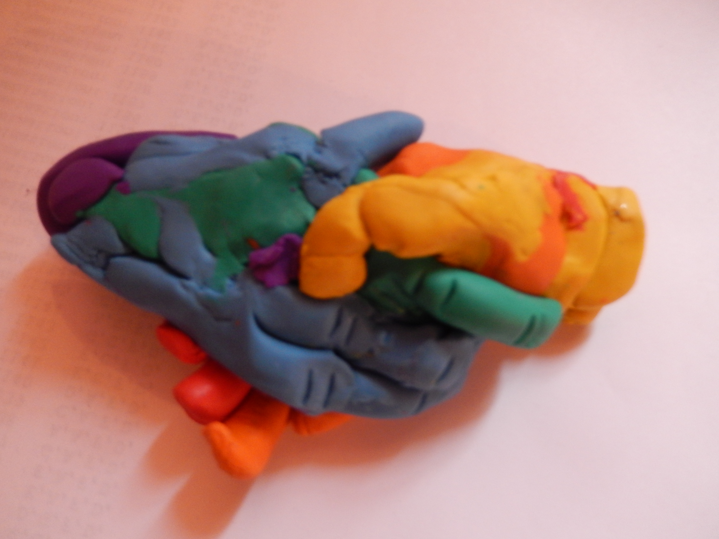
Share-And-Share-Alike
(Logo - needs brushing up.)
Overview.

The Share-And-Share-Alike License is a license for all kinds of content or work(s).

It was designed for the sharing of intellectual property.

It aims to prevent the stifling of innovation through the sharing of patents, copyrighted
material manufacturing rights, and/or designs.

Basics.

'I hereby grant you, an exclusive, free of charge, royalty-free license, to make, use, and sell, all previous patented, copyrighted and/or industrial design right protected intellectual property owned by me, but only whilst you license all of your patented, copyrighted and/or industrial design right protected intellectual property to everyone under a libre license'

Why not use another existing license format?

GNU General Public License :
* Though hopefully, and highly unlikely, the Free Software Foundation are able to release a proprietary enabling license in future, and then copyrighted material could in theory, be taken and made non-libre.
* Cannot be used as a template for other licenses.
* Applies (I believe) to the time stated on the copyright notice.

Creative Commons Attribution-ShareAlike license:
* Though hopefully, and highly unlikely, if the creative-commons accepts a non-libre BY-SA license as a compatible license, your work could be adapted and made non-libre.
* Has attribution.
* Does not apply to patents and manufacturing rights.
* Applies (I believe) to the time on the copyright notice.

Neither of the above have the requirement to license all prior works you own to everybody,s under a libre license in order to share the material or share adapted material.

(The license starts on the next page, notes or things that really need looking at are highlighted in red)

Share-And-Share-Alike International Public License

I used https://creativecommons.org/licenses/by-sa/4.0/legalcode as a template for this, should be okay! (Wanted to use the GNU General Public License but it itself is licensed).

By exercising the Licensed Rights (defined below), You accept and agree to be bound by the terms and conditions of this Share-And-Share-Alike International Public License ("Public License"). To the extent this Public License may be interpreted as a contract, You are granted the Licensed Rights in consideration of Your acceptance of these terms and conditions, and the Licensor grants You such rights in consideration of benefits the Licensor receives from making the Licensed Material available under these terms and conditions.

Section 1 – Definitions.

a. Adapted Material means material subject to Copyright and Similar Rights that is derived from or based upon the Licensed Material and in which the Licensed Material is translated, altered, arranged, transformed, or otherwise modified in a manner requiring permission under the Copyright and Similar Rights held by the Licensor. For purposes of this Public License, where the Licensed Material is a musical work, performance, or sound recording, Adapted Material is always produced where the Licensed Material is synched in timed relation with a moving image.
b. Adapter's License means the license You apply to Your Copyright and Similar Rights in Your contributions to Adapted Material in accordance with the terms and conditions of this Public License.
c. Copyright and Similar Rights means copyright and/or similar rights closely related to copyright including, without limitation, performance, broadcast, sound recording, and Sui Generis Database Rights, without regard to how the rights are labeled or categorized. For purposes of this Public License, the rights specified in Section 2(b)(1)-(2) are not Copyright and Similar Rights.
d. Effective Technological Measures means those measures that, in the absence of proper authority, may not be circumvented under laws fulfilling obligations under Article 11 of the WIPO Copyright Treaty adopted on December 20, 1996, and/or similar international agreements.
e. Exceptions and Limitations means fair use, fair dealing, and/or any other exception or limitation to Copyright and Similar Rights that applies to Your use of the Licensed Material.
f. Licensed Material means the artistic or literary work, database, or other material to which the Licensor applied this Public License.
g. Licensed Rights means the rights granted to You subject to the terms and conditions of this Public License, which are limited to all Copyright and Similar Rights that apply to Your use of the Licensed Material and that the Licensor has authority to license.
h. Licensor means the individual(s) or entity(ies) granting rights under this Public License.
i. Share means to provide material to the public by any means or process that requires permission under the Licensed Rights, such as reproduction, public display, public performance, distribution, dissemination, communication, or importation, and to make material available to the public including in ways that members of the public may access the material from a place and at a time individually chosen by them.
j. Sui Generis Database Rights means rights other than copyright resulting from Directive 96/9/EC of the European Parliament and of the Council of 11 March 1996 on the legal protection of databases, as amended and/or succeeded, as well as other essentially equivalent rights anywhere in the world.
k. You means the individual or entity exercising the Licensed Rights under this Public License. Your has a corresponding meaning.

Section 2 – Scope.

a. License grant.
1. Subject to the terms and conditions of this Public License, the Licensor hereby grants You a worldwide, royalty-free, non-sublicensable, non-exclusive, irrevocable license to exercise the Licensed Rights in the Licensed Material to:
A. reproduce and Share the Licensed Material, in whole or in part; and
B. produce, reproduce, and Share Adapted Material.
2. Exceptions and Limitations. For the avoidance of doubt, where Exceptions and Limitations apply to Your use, this Public License does not apply, and You do not need to comply with its terms and conditions.
3. Term. The term of this Public License is specified in Section 6(a).
4. Media and formats; technical modifications allowed. The Licensor authorizes You to exercise the Licensed Rights in all media and formats whether now known or hereafter created, and to make technical modifications necessary to do so. The Licensor waives and/or agrees not to assert any right or authority to forbid You from making technical modifications necessary to exercise the Licensed Rights, including technical modifications necessary to circumvent Effective Technological Measures. For purposes of this Public License, simply making modifications authorized by this Section 2(a)(4) never produces Adapted Material.
5. Downstream recipients.
A. Offer from the Licensor – Licensed Material. Every recipient of the Licensed Material automatically receives an offer from the Licensor to exercise the Licensed Rights under the terms and conditions of this Public License.
B. Additional offer from the Licensor – Adapted Material. Every recipient of Adapted Material from You automatically receives an offer from the Licensor to exercise the Licensed Rights in the Adapted Material under the conditions of the Adapter’s License You apply.
C. No downstream restrictions. You may not offer or impose any additional or different terms or conditions on, or apply any Effective Technological Measures to, the Licensed Material if doing so restricts exercise of the Licensed Rights by any recipient of the Licensed Material.
6. No endorsement. Nothing in this Public License constitutes or may be construed as permission to assert or imply that You are, or that Your use of the Licensed Material is, connected with, or sponsored, endorsed, or granted official status by, the Licensor or others designated to receive attribution.

b. Other rights.
1. Moral rights, such as the right of integrity, are not licensed under this Public License, nor are publicity, privacy, and/or other similar personality rights; however, to the extent possible, the Licensor waives and/or agrees not to assert any such rights held by the Licensor to the limited extent necessary to allow You to exercise the Licensed Rights, but not otherwise.
2. To the extent possible, the Licensor waives any right to collect royalties from You for the exercise of the Licensed Rights, whether directly or through a collecting society under any voluntary or waivable statutory or compulsory licensing scheme. In all other cases the Licensor expressly reserves any right to collect such royalties.

Section 3 – License Conditions.

Your exercise of the Licensed Rights is expressly made subject to the following conditions.

a. Label.
1. If You Share the Licensed Material (including in modified form), You must indicate the Licensed Material is licensed under this Public License, and include the text of, or the URI or hyperlink to, this Public License.
2. If You Share the Licensed Material (including in modified form), You must indicate the time and date the Licensed Material was licensed, in a labelled, human readable plaintext format..
b. Share.
1. In order for this license to apply to You, You must license all of Your patented, copyrighted and manafacturing right protected works to everyone, without exception, under this licence or a license compatible with this licence(see todo, note 1)
c. ShareAlike.
In addition to the conditions in Sections 3(a) and 3(b), if You Share Adapted Material You produce, the following conditions also apply.
1. The Adapter's License You apply must be this license.
2. You may not offer or impose any additional or different terms or conditions on, or apply any Effective Technological Measures to, Adapted Material that restrict exercise of the rights granted under the Adapter's License You apply.

Section 4 – Sui Generis Database Rights.

Where the Licensed Rights include Sui Generis Database Rights that apply to Your use of the Licensed Material:

a. for the avoidance of doubt, Section 2(a)(1) grants You the right to extract, reuse, reproduce, and Share all or a substantial portion of the contents of the database;
b. if You include all or a substantial portion of the database contents in a database in which You have Sui Generis Database Rights, then the database in which You have Sui Generis Database Rights (but not its individual contents) is Adapted Material, including for purposes of Section 3(b); and
c. You must comply with Sections 3(a) and 3(b) if You Share all or a substantial portion of the contents of the database.

For the avoidance of doubt, this Section 4 supplements and does not replace Your obligations under this Public License where the Licensed Rights include other Copyright and Similar Rights.

Section 5 – Disclaimer of Warranties and Limitation of Liability.

a. Unless otherwise separately undertaken by the Licensor, to the extent possible, the Licensor offers the Licensed Material as-is and as-available, and makes no representations or warranties of any kind concerning the Licensed Material, whether express, implied, statutory, or other. This includes, without limitation, warranties of title, merchantability, fitness for a particular purpose, non-infringement, absence of latent or other defects, accuracy, or the presence or absence of errors, whether or not known or discoverable. Where disclaimers of warranties are not allowed in full or in part, this disclaimer may not apply to You.
b. To the extent possible, in no event will the Licensor be liable to You on any legal theory (including, without limitation, negligence) or otherwise for any direct, special, indirect, incidental, consequential, punitive, exemplary, or other losses, costs, expenses, or damages arising out of this Public License or use of the Licensed Material, even if the Licensor has been advised of the possibility of such losses, costs, expenses, or damages. Where a limitation of liability is not allowed in full or in part, this limitation may not apply to You. What does this mean?

c. The disclaimer of warranties and limitation of liability provided above shall be interpreted in a manner that, to the extent possible, most closely approximates an absolute disclaimer and waiver of all liability.

Section 6 – Term and Termination.

a. This Public License applies for the term of the Copyright and Similar Rights licensed here not sure what this means?. However, if You fail to comply with this Public License, then Your rights under this Public License terminate automatically.
b. Where Your right to use the Licensed Material has terminated under Section 6(a), it reinstates:

1. automatically as of the date the violation is cured, provided it is cured within 30 days of Your discovery of the violation; or

2. upon express reinstatement by the Licensor.
For the avoidance of doubt, this Section 6(b) does not affect any right the Licensor may have to seek remedies for Your violations of this Public License.
c. For the avoidance of doubt, the Licensor may also offer the Licensed Material under separate terms or conditions I think this is OK, as long as they share as mentioned in Section 3(b) or stop distributing the Licensed Material at any time; however, doing so will not terminate this Public License.
d. Sections 1, 5, 6, 7, and 8 survive termination of this Public License.

(Can be terminated at any time by the licensee for all future/present releases but not for works that have already been licensed under this license).
Section 7 – Other Terms and Conditions.

a. The Licensor shall not be bound by any additional or different terms or conditions communicated by You unless expressly agreed.
b. Any arrangements, understandings, or agreements regarding the Licensed Material not stated herein are separate from and independent of the terms and conditions of this Public License.

Section 8 – Interpretation.

a. For the avoidance of doubt, this Public License does not, and shall not be interpreted to, reduce, limit, restrict, or impose conditions on any use of the Licensed Material that could lawfully be made without permission under this Public License.
b. To the extent possible, if any provision of this Public License is deemed unenforceable, it shall be automatically reformed to the minimum extent necessary to make it enforceable. If the provision cannot be reformed, it shall be severed from this Public License without affecting the enforceability of the remaining terms and conditions.
c. No term or condition of this Public License will be waived and no failure to comply consented to unless expressly agreed to by the Licensor.
d. Nothing in this Public License constitutes or may be interpreted as a limitation upon, or waiver of, any privileges and immunities that apply to the Licensor or You, including from the legal processes of any jurisdiction or authority.

Todo:
NOTE1: License compatibility - Previous works should be allowed to be licensed under the GNU General Public license or any license compatible with the GNU General Public License (but I don't really want to be explicitly mentioning other licenses, hopefully there is a way around this!).

- Patents and industrial design rights - Patented and industrial design right protected material should be licensed under this Public License as opposed to just copyright.
- Availability of source data - Where a final work has been obtained through the compilation or processing of a source file or multiple source files, all underlying source data (where availible) should be available alongside the work itself under the same conditions. This can be the score of a musical composition, the models used in a 3D scene, the data of a scientific publication, the source code of a computer application, or any other such information.
- Make sure it applies for the time stated by the licensor, to the indefinate future.
- Use of a free format - For digital files, the format in which the work is made available should not be protected by patents, unless a world-wide, unlimited and irrevocable royalty-free grant is given to make use of the patented technology. While non-free formats may sometimes be used for practical reasons, a free format copy must be available for the work to be considered free.
- No technical restrictions - The work must be available in a form where no technical measures are used to limit the freedoms enumerated above.
- Number definitions.
- No other restrictions or limitations - The work itself must not be covered by legal restrictions (patents, contracts, etc.) or limitations which would impede the freedoms enumerated above. A work may make use of existing legal exemptions to copyright (in order to cite copyrighted works), though only the portions of it which are unambiguously free constitute a free work. ← I think this may have been covered?
- Checking the license is water-tight.
- Fomatting of this document.

