Gardening Logbook

Day 1 - Saturday 14th February 2015

Wore Wellington boots.
Prepared the garden by digging and turning over soil using a spade.
Spread compost on top beforehand and also after, using a pitch fork.
Washed tools.
Oiled tools.

Compost was dug into a wheelbarrow and transported by another person.
Took approximately 4 and a half hours. ~1800 ml of water drunk.
This is very hard work.

It may be worth investigating no-dig gardening due to the great amount of manual labour involved. https://en.wikipedia.org/wiki/No-dig_gardening
Maximising distance between plants for maximum crop size is a good idea. It may be worth investigating.

Day 2 - Sunday 15th February

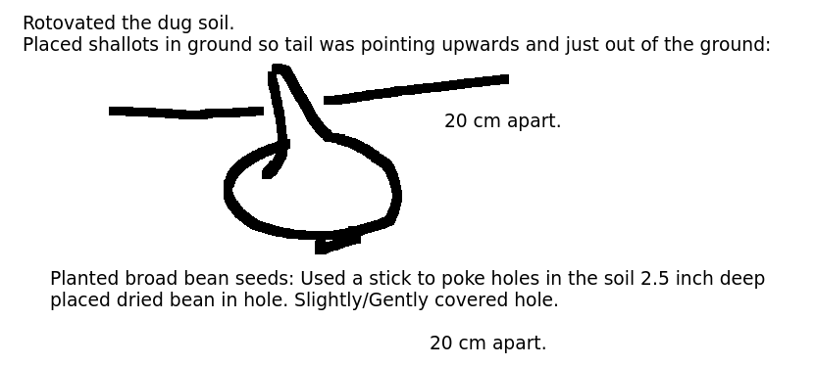
Day Between Day 2 Day and Day 3

Rotavated the ground.

Day 3 – Saturday 14th March

Raked mud lots to break it up. This apparently should be done when the mud is 'half' dry.
Once raked, used back of rake to smooth surface.
Drew small ditches in the mud using a stick, approximately 5x the seed size deep.
Sowed 2 seeds (a little bit apart so they could be seperated), then measured the appropiate distance then sowed 2 more, down the ditch.
The very small seeds needed sprinkling instead. (carrot and spring onion)
Then watered each ditch.
Used the rake, the right way round to gently rake along the ditch (not across the ditch), which ligthly covers the seed.
Planted like this the following:
Chard
Carrot
Beetroot
Spring onion
Spinich

I then decided to sow some in the polytunnel.
Mixed very dry compost with water.
Filled trays.
Made holes 5x seed size with dibber in each.
Sowed 2 seeds per hole.
Gently covered hole.
Planted like this for the following:
Parsely
Lettuce
Rocket
Leaks

Found two pots for Chamomile and St. Johns Wort
Mixed very dry compost with water
Sprinkled a pinch of seed on top
Then sprinkled some dirt on top of that.

Date between day 3 and day 4.
Checked on plants in polytunnel every 1-2 days to see if they needed watering, watered them if so. This needs to be repeated from now until they
are transplanted.

Day 4 – 4th of April 2015

Outside pollytunnel:
made a 3inch trench using the hoe for the peas. planted the seeds, two at a time.
planted beetroot, more broadbeans, two at a time for the beetroot, one at a time for the
broad beans.
sprinkled cress, radish, turnip and flax.
sprinkled chives at the end of the bed.

Inside pollytunnel:
sowed spearmint into a round pot by sprinkling.
sowed brussel sprouts into round pot by making 1&1/2 cm holes 1 inch apart.

Day 5 – 5th April 2015

transplanted small saint johns wort plants with 1 ft gaps

Day 6 – 18th April 2015

Used hoe to get rid of many of the weeds. By scraping between the rows (large hoe) and inbetween plants (small hoe).

Sowed outside rocket, brocolli, kale and more lettuce by making line(s) in the ground with stick, sprinking, gently raking along the line and
watering (because dry).

Day 7 - Friday 24th April

Planted potatoes in a line, using a hand plough.

Bought some tomato plants from garden centre and put in polytunnel.

Day 8 – Monday 4th May

planted beetroot, carrots using stick/line in ground
transplanted some rocket and lettuce outside as a test to see if they'd survive
planted some flax and chives seeds in two different pots in polytunnel as they were not growing outdoors at all.
planted 8x runnerbeans and 8x corgette seeds, one in each little pot.

Day 9 – 10th May 2015

Transplanted Rocket Parsely and Lettuce outside.

Sowed some spring onions from seed.

Day 10 – Sunday 17th May 2015

Transplanted chamomile outside.
Transplanted tomato plants that we got from garden centre 3 weeks ago (~Day 7) from polytunnel, to outside.

Day 11 – Thursday 24th May

Harvested spinach by picking biggest leaves from plant(s).

This can then be repeated. Future picking of spinach won't be documented, so long as they dont go to seed, they should be eadible.

Day 12 – Thursday 25th May

Made a mound around the potato plants, used grass clippings too.

Day 13 - Saturday 6th June

transplanted brussel sprouts, kale, corgette, broccoli, and runner beans outdoors.

Day 14 – Sunday 7th June

Picked rocket, picked a lettuce, picked radish.

Note that the radish plant had gone to seed and also the radishes wern't very big.

The rocket almost went to seed but we picked off where the seed grows to get the leaves to grow bigger instead and to prevent it going bad.

Future picking of remaining rocket and lettuce won't be documented. So long as they don't go to seed, they are ready to eat.

Day 15 – 21st June 2015

Removed spinach plants and composted because they were going to seed and were turning bad to eat.
Started picking chard.

Day 16 – Friday 10th July

Pulled up flowering rocket which was going to seed.
Punched holes in the ground 6 inches deep and planted the leeks outside 6 inches apart (where the rocket was).
Picked chamomile.

Day 17 – Monday 13 July

Picked peas, these can continue to be picked from now on

Day 18 – Thursday 6th August

Picked shallots, and left in the poly tunnel for the mud and outer layers to dry.
Picked St. Johns wort (cut off at base with a knife), and left in the poly tunnel to dry.
Put spearmint and chives and flax outside. (These should have been planted in ground (bar spearmint because invasive), they did not get enough water, as on holiday).
Picked some courgettes, these can be picked from now on or continue to grow into marrows.
Dug up some potatoes (by gently putting fork in below the potatoes and lifting, collecting ALL potatoes, not leaving any so they don't grow again).

Day 19 – Sunday 16th August 2015

Did some weeding.
Made small mounds around the leeks so more of the leek would be edible.

Day 20 – Thursday 20th August

Picked runner beans.
Picked flax seeds (were pods).

Day 21 – Thursday 3rd September

Picked dried pea pods for seeds, this should have been ideally picked a little earlier.

Day 22 – Sunday 20th September

Schythed down the chard. Removed the peas, and broad beans. Did lots of weeding. Hung tomatoes in polytunnel upsidedown. Dug up rest of potatoes for storage. Dug up rest of turnips for storage. Dug up rest of beetroot for storage.
Day 23 - ~20th December

Harvested leeks.

Notes

We had to cover some plants from birds.
The peas had to grow up sticks.
The radishes partly got eaten by flea beetle.
Deer ate some of the beans, so we put up a fence around them with CDs tied on to reflect and scare them.
Slugs ate some of the plants a bit, almost had to put down traps.
The lettuces went to seed quickly and as of such we didn't eat as many as we could/should have done.
The spinach got pulled up before we let it go to seed, so we couldn't harvest any seeds.
The rocket grown in the greenhouse first, and then transplanted outside went to seed to quickly, and quicker than the rocket planted straight outside.
Plants need lots of water to make nice big leaves.
The tops can be picked off if they go to seed to early, to encourage the growth of leaves.
Had to make a wigwam for the runner-beans to climb up.
The flax dried up a bit as not enough water (so did some other plants). And the flax blew over once put outside. It didn't start outdoors and didn't make enough flax to make a decent amount of fibre.
The broccoli got caterpillars from butterflies laying eggs, so did the kale. The kale got completely eaten as did not act quickly enough.
We did not leave enough pods to go to seed on the broad beans for next year.
The grass cuttings on the potatoes as a mulch fell down some in the rain and exposed some of the potatoes, making bits of them green and inedible.

