Waste Hierarchy
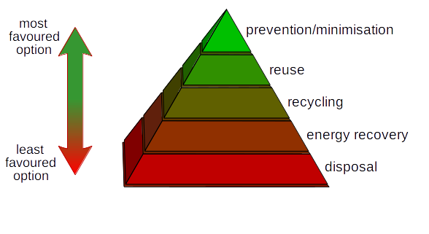

Prevention/Minimisation:
Preventing and minimising waste generation.

Reuse:
Giving the products a second life before they become waste.

Recycling:
Any recovery operation by which waste materials are reprocessed into products, materials or substances whether for the original or other purposes. It includes composting and does not include incineration.

Energy Recovery:
The recovery of energy via non-environmentally polluting methods.

Disposal:
Other forms of disposal which are best avoided if possible, for instance; landfill.

