How to use OpenBI

1. You can start from your spread sheet, save as a CSV file.

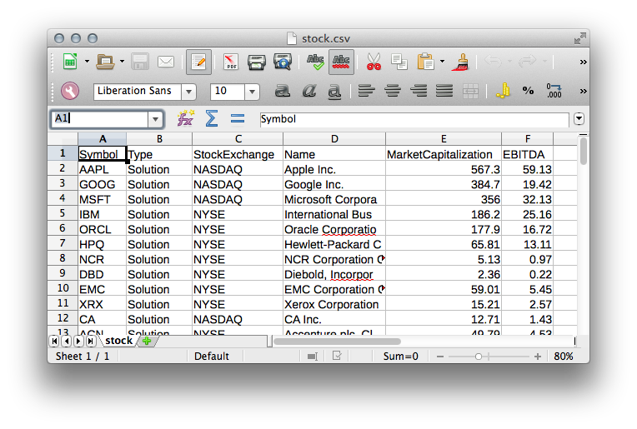

2. Create a new document and upload the CSV file.

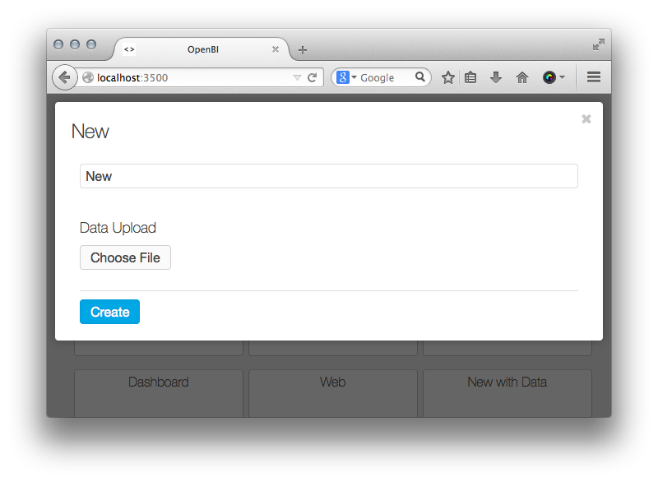

3. Click to add new charts, adjust the size and position, then click settings

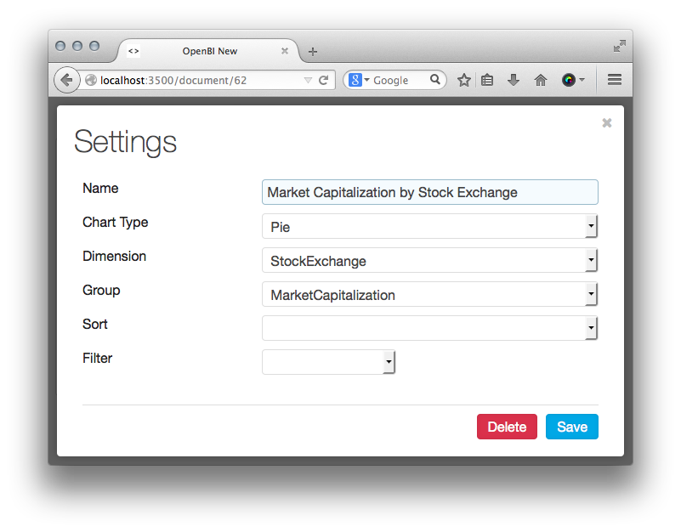

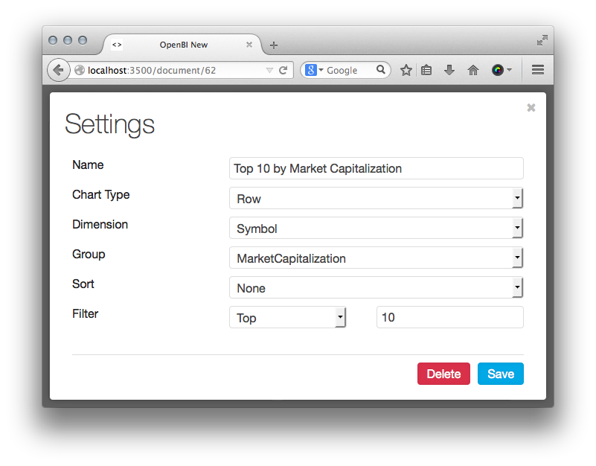

4. Done

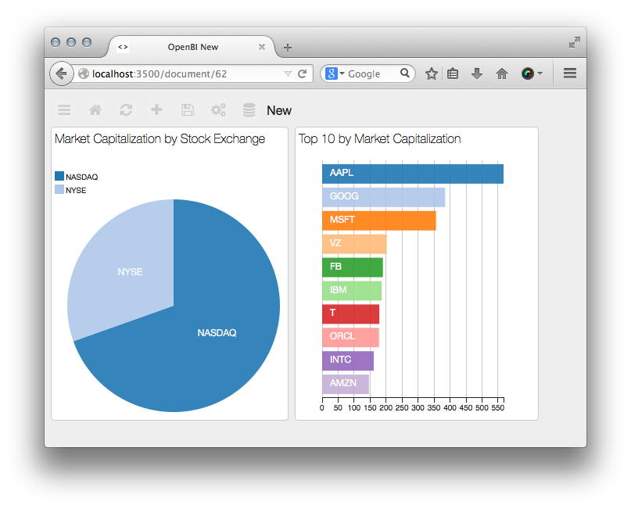

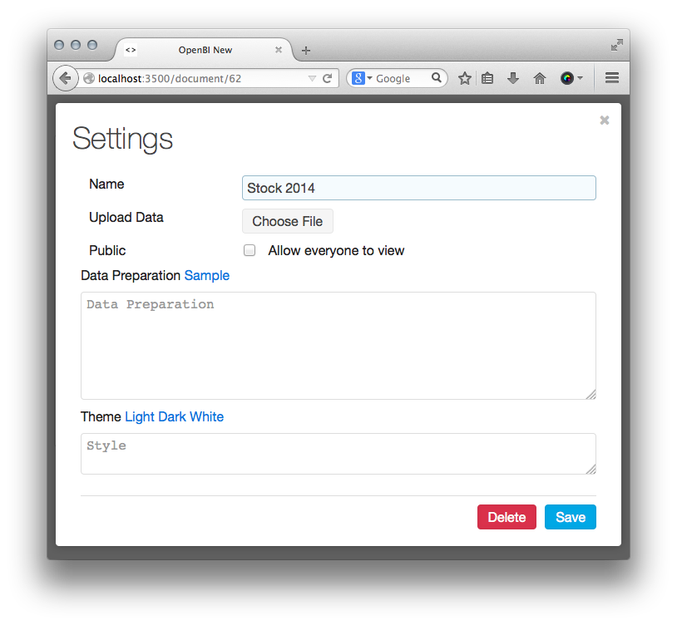
5. Click to change the document settings, theme or upload new data.

