

**Cambridge IGCSE™**



|  |  |  |  |  |  |  |  |
| --- | --- | --- | --- | --- | --- | --- | --- |
|  | |  |  |  |  |  | | --- | --- | --- | --- | --- | |  |  |  |  |  | |  |
| **BIOLOGY** | | **0610/42** |
| Paper 4 Theory (Extended) | | **October/November2022** |

|  |  |
| --- | --- |
| You must answer on the question paper. No additional materials are needed.  This document has **20** pages. Any  DC (RW/SW) 303222/4 © UCLES 2022 | **1 hour 15 minutes**  blank pages are indicated.  **[Turn over** |

|  |  |
| --- | --- |
| **INSTRUCTIONS** | |
| ● | Answer **all** questions. |
| ● | Use a black or dark blue pen. You may use an HB pencil for any diagrams or graphs. |
| ● | Write your name, centre number and candidate number in the boxes at the top of the page. |
| ● | Write your answer to each question in the space provided. |
| ● | Do **not** use an erasable pen or correction fluid. |
| ● | Do **not** write on any bar codes. |
| ● | You may use a calculator. |
| ● | You should show all your working and use appropriate units. |
| **INFORMATION** | |
| ● | The total mark for this paper is 80. |
| ● | The number of marks for each question or part question is shown in brackets [ ]. |

**2**   
**BLANK PAGE**

© UCLES 2022 0610/42/O/N/22

**3**   
**1**  Phytoplankton consist of many species of single‑celled and many‑celled algae.

**(a)** Algae are classified in the Protoctist kingdom. All algae contain one or more chloroplasts.

State the name of another kingdom that contains organisms which have chloroplasts. ............................................................................................................................................. [1] A student investigated the species composition of the phytoplankton in a lake.

Fig. 1.1 shows some of the phytoplankton collected by the student.

|  |  |
| --- | --- |
|  | **X** |

**Fig. 1.1**   
**(b)** The actual length of alga **X** is 0.19 mm.

Convert the actual length of alga **X** to micrometres.

..................................................... μm [1]

|  |  |  |
| --- | --- | --- |
| © UCLES 2022 | 0610/42/O/N/22 | **[Turn over** |

**4**   
**(c)** The student made careful drawings of seven types of alga found in the samples of lake water. The drawings are shown in Fig. 1.2.

|  |  |  |  |
| --- | --- | --- | --- |
| **A** |  | **B** |  |
| **C** |  | **D** |  |

|  |  |  |  |
| --- | --- | --- | --- |
| **E** |  | **F** |  |

|  |  |  |
| --- | --- | --- |
| **G** |  | not to scale |

**Fig. 1.2**

© UCLES 2022 0610/42/O/N/22

**5**   
Use the key to identify each of the species **A** to **G**. Write the letter of each species in the correct box beside the key.

|  |  |  |  |
| --- | --- | --- | --- |
| 1 | alga has four spine‑like extensions | go to 2 |  |
| alga does not have four spine‑like extensions | go to 3 |  |
| 2 | alga has spine‑like extensions that are all the same length | *Scenedesmus communis* |  |
| alga has spine‑like extensions that are different lengths | *Ceratium hirundinella* |  |
| 3 | alga has a round shape | *Micrasterias radiosa* |  |
| alga does not have a round shape | go to 4 |  |
| 4 | alga narrows towards the ends | go to 5 |  |
| alga does not narrow towards the ends | go to 6 |  |
| 5 | algal cell is semi‑circular in shape | *Closterium dianae* |  |
| algal cell is not semi‑circular in shape | *Navicula radiosa* |  |
| 6 | alga is branched | *Chaetophora incrassata* |  |
| alga is not branched | *Zygnema* sp. |  |

[5] **(d)** Phytoplankton are photosynthetic organisms.

Describe the importance of phytoplankton in the food web of lake ecosystems.

................................................................................................................................................... ................................................................................................................................................... ................................................................................................................................................... ................................................................................................................................................... ................................................................................................................................................... ................................................................................................................................................... ................................................................................................................................................... ............................................................................................................................................. [3] [Total: 10]

|  |  |  |
| --- | --- | --- |
| © UCLES 2022 | 0610/42/O/N/22 | **[Turn over** |

**6**

|  |  |
| --- | --- |
| **2** | Fig. 2.1 is a diagram of the human alimentary canal and associated organs.  7  63  4  5  1  2 |

**Fig. 2.1**

**(a)** Table 2.1 shows enzymes, the organs that secrete these enzymes, their substrates and products.

Complete Table 2.1.

**Table 2.1**

|  |  |  |  |  |
| --- | --- | --- | --- | --- |
| enzyme | organ that secretes the enzyme | number  identifying the organ on Fig. 2.1 | substrate | product or products |
| amylase |  | 1 |  |  |
|  |  | 3 | protein |  |
| lipase |  | 4 |  |  |
| maltase |  |  |  |  |

[4]

**7**   
**(b)** Explain the role of hydrochloric acid in the alimentary canal.

...................................................................................................................................................

...................................................................................................................................................

...................................................................................................................................................

...................................................................................................................................................

...................................................................................................................................................

...................................................................................................................................................

............................................................................................................................................. [3] **(c)** State a function of the region of the alimentary canal labelled 6 in Fig. 2.1.

...................................................................................................................................................

...................................................................................................................................................

............................................................................................................................................. [1] **(d)** Describe how food eaten by humans is reduced to smaller pieces **and** explain how this makes chemical digestion more efficient.

You may refer to Fig. 2.1 in your answer.

...................................................................................................................................................

...................................................................................................................................................

...................................................................................................................................................

...................................................................................................................................................

...................................................................................................................................................

...................................................................................................................................................

...................................................................................................................................................

...................................................................................................................................................

...................................................................................................................................................

...................................................................................................................................................

...................................................................................................................................................

...................................................................................................................................................

............................................................................................................................................. [6] [Total: 14]

|  |  |  |
| --- | --- | --- |
| © UCLES 2022 | 0610/42/O/N/22 | **[Turn over** |

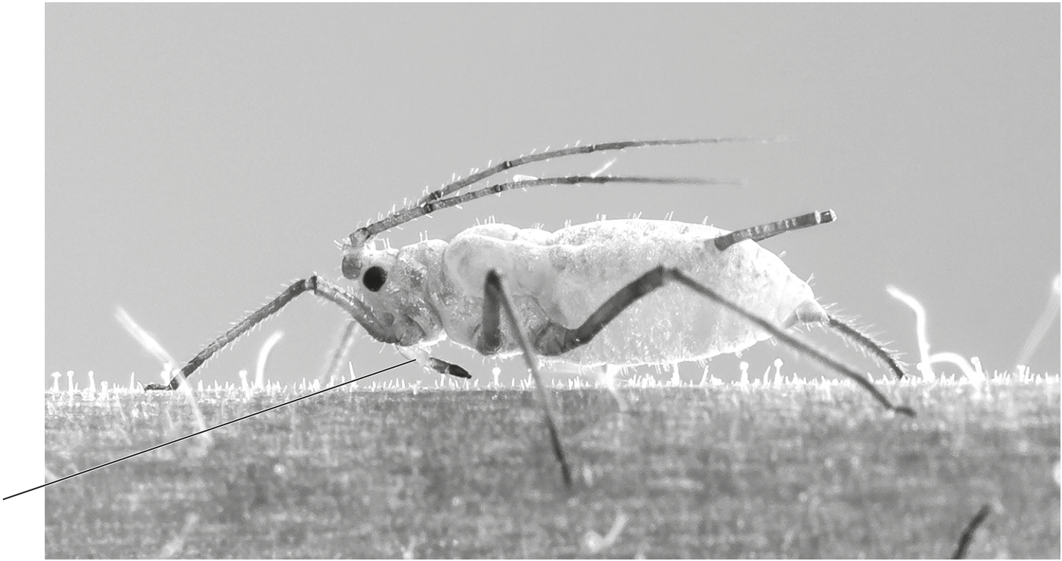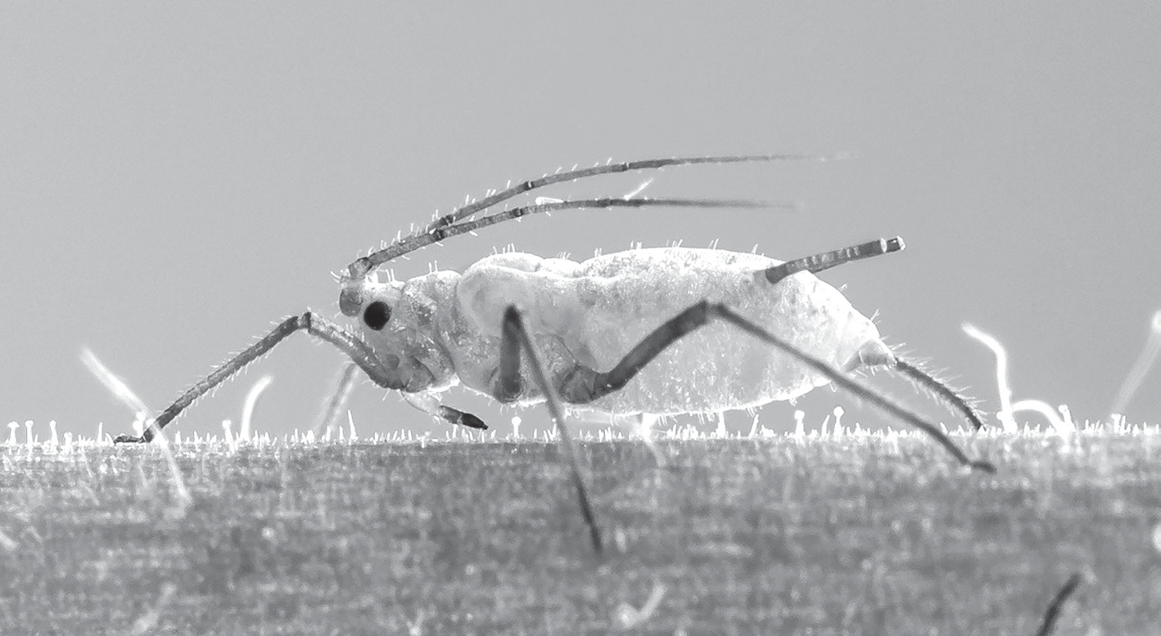

**8**   
**3**  Aphids are insects that feed on phloem sap by inserting their mouthparts into phloem tissue. Fig. 3.1 shows an aphid feeding on phloem tissue in a leaf.

mouthparts

**Fig. 3.1**   
**(a) (i)** State **two** features **visible in Fig. 3.1** that identify this animal as an insect.   
 1 ........................................................................................................................................ 2 ........................................................................................................................................

[2] **(ii)** Aphids can transmit viral pathogens when they feed on a plant.

Suggest how a severe infestation of aphids on crop plants can be avoided.

........................................................................................................................................... ........................................................................................................................................... ........................................................................................................................................... ........................................................................................................................................... ..................................................................................................................................... [2] **(iii)** The aphid shown in Fig. 3.1 is feeding on phloem tissue in a leaf.

State the names of **two** tissues in the leaf that the mouthparts of the aphid pass through to reach the phloem.

1 ........................................................................................................................................ 2 ........................................................................................................................................

[2]

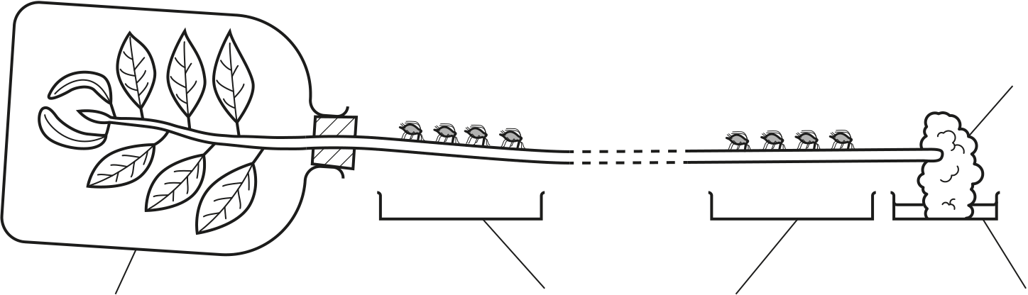

**9**

**(b)** Aphids have been used to investigate the translocation of sucrose in phloem tissue. While they are feeding on phloem sap aphids excrete a sucrose‑rich fluid known as honeydew.

In an investigation, two groups of four aphids were placed at intervals along the stem of a young willow plant, as shown in Fig. 3.2.

|  |  |  |  |
| --- | --- | --- | --- |
| glass chamber filled with | group **A** | group **B** | damp cotton |
| wool |
| Petri dishes for collecting honeydew | | Petri dish |
| carbon dioxide gas containing 14C | with water |

**Fig. 3.2**

The leaves were enclosed in an airtight glass chamber. A special form of carbon dioxide gas that contained radioactive carbon‑14 (14C) was supplied to the leaves for a short period of time.

Samples of honeydew were collected at intervals from the groups of aphids. The time taken for sucrose containing 14C to travel the distance between group **A** and group **B** was recorded.

The investigation was repeated twice using a fresh stem and different groups of aphids for each trial. The results are shown in Table 3.1.

**(i)** Complete Table 3.1 by calculating the rate of movement of 14C in trial 3.

**Table 3.1**

|  |  |  |  |
| --- | --- | --- | --- |
| trial | distance between  group **A** and group **B** on the stem / mm | time taken for 14C to travel between  group **A** and group **B** / minutes | rate of movement of 14C / mm per hour |
| 1 | 650 | 120 | 325 |
| 2 | 340 | 75 | 272 |
| 3 | 630 | 150 |  |

[1]

|  |  |  |
| --- | --- | --- |
| © UCLES 2022 | 0610/42/O/N/22 | **[Turn over** |

**10**   
**(ii)** Outline how 14C in carbon dioxide gas becomes incorporated into the sucrose molecules that are translocated in the phloem.

...........................................................................................................................................

...........................................................................................................................................

...........................................................................................................................................

...........................................................................................................................................

...........................................................................................................................................

...........................................................................................................................................

..................................................................................................................................... [3] **(c)** Sucrose travels from the stem to other parts of the plant known as sinks, where it is used. **(i)** State **two** parts of a plant that are sinks for sucrose.

1 ........................................................................................................................................

2 ........................................................................................................................................

[2] **(ii)** Sucrose is used in the cells of the sinks in a plant.

Describe the uses of sucrose by sinks.

...........................................................................................................................................

...........................................................................................................................................

...........................................................................................................................................

...........................................................................................................................................

...........................................................................................................................................

...........................................................................................................................................

..................................................................................................................................... [3] [Total: 15]

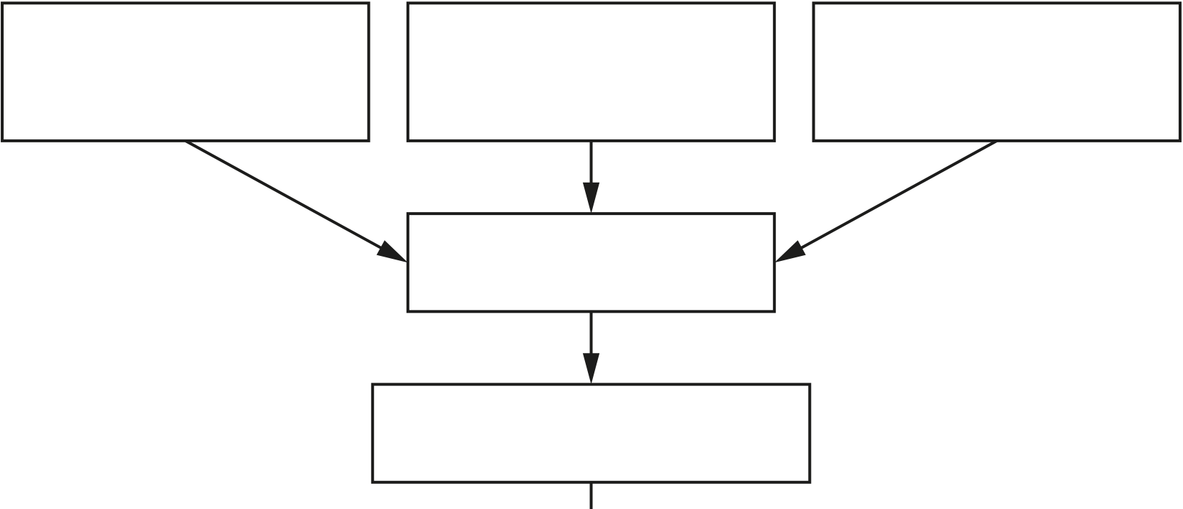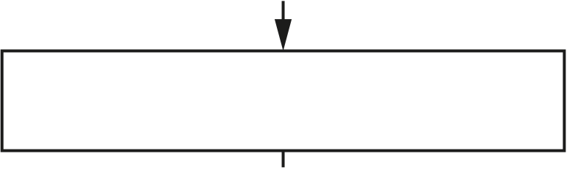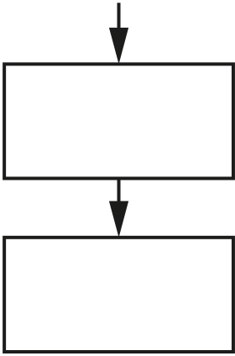

**11**

|  |  |  |  |
| --- | --- | --- | --- |
| **4** | **(a)** Fig. 4.1 is a flow chart showing some of the processes that occur in a biofuels power plant. | | |
| crop waste | forestry waste | the giant reed plant, *Arundo donax*,  is grown for biomass |

pretreatment   
of biomass

complex carbohydrates   
released from biomass

breakdown by enzymes

release of sugars, including glucose

fermentation by yeast

ethanol

biofuel

**Fig. 4.1**

**(i)** The fermentation stage shown in Fig. 4.1 requires yeast.

Complete the balanced chemical equation to show how ethanol is produced by yeast respiration.

.......................................

 ....................................... + .......................................

[2]

**(ii)** Using the information in Fig. 4.1, suggest the environmental advantages of using ethanol as a fuel.

........................................................................................................................................... ........................................................................................................................................... ........................................................................................................................................... ........................................................................................................................................... ........................................................................................................................................... ........................................................................................................................................... ..................................................................................................................................... [3]

**12**   
**(iii)** Farmers grow giant reed plants as monocultures.

Describe the disadvantages of growing giant reed plants to provide biomass for the production of biofuels.

...........................................................................................................................................

...........................................................................................................................................

...........................................................................................................................................

...........................................................................................................................................

..................................................................................................................................... [2] **(b)** One problem with using biomass in the process shown in Fig. 4.1 is that the breakdown stage produces a sugar called xylose and ethanoic acid. Yeast cannot use xylose, and ethanoic acid is toxic to yeast.

Scientists genetically engineered a type of yeast that can use xylose and ethanoic acid.

Fig. 4.2 shows the results of one of the trial experiments done by the scientists using their new genetically engineered yeast.

|  |  |  |  |  |
| --- | --- | --- | --- | --- |
| 100  80   |  |  | | --- | --- | | concentration of xylose or ethanol /g per dm3 | 60 |   40  20  0 | **Key:** | concentration of xylose  concentration of ethanoic acid concentration of ethanol |
| 2.5  1.0  0.0  0.5  of ethanoic acid  /g per dm3  2.0  1.5  concentration  0 10 20 30 40 50 60 70 80 90  time/hours | |

**Fig. 4.2**

**13**   
**(i)** Describe the results shown in Fig. 4.2.

........................................................................................................................................... ........................................................................................................................................... ........................................................................................................................................... ........................................................................................................................................... ........................................................................................................................................... ........................................................................................................................................... ..................................................................................................................................... [3] **(ii)** The experiment was done at 30 °C.

The scientists repeated the experiment at 20 °C.

Predict the results that you would expect for the concentration of ethanol.

........................................................................................................................................... ........................................................................................................................................... ..................................................................................................................................... [1] [Total: 11]

**14**   
**BLANK PAGE**

**15**

|  |  |
| --- | --- |
| **5** | Fig. 5.1 shows Mackinlay’s cuckoo‑dove, *Macropygia mackinlayi*, which is found on most of the islands in the south‑west of the Pacific Ocean. |

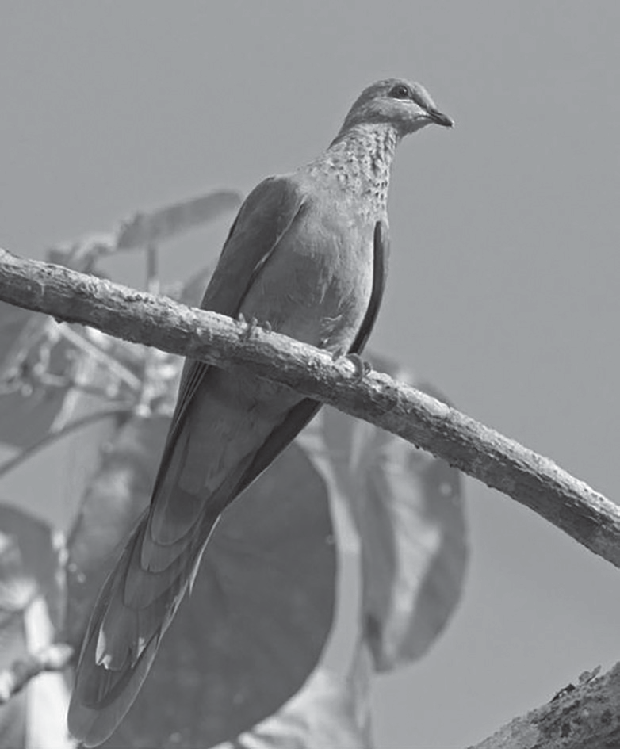

**Fig. 5.1**   
**(a)** Karkar Island is one island where Mackinlay’s cuckoo‑dove is found. This species is part of many communities that are adapted to the different habitats on the island.

**(i)** Define the term community.

...........................................................................................................................................

...........................................................................................................................................

..................................................................................................................................... [1] **(ii)** Complete the passage with the most appropriate word or phrase.

Adaptation is sometimes defined as the process resulting from .....................................

..................................... , by which populations become more suited to their

|  |  |
| --- | --- |
| ..................................... over many generations. | [2] |

**16**   
**(b)** The highest point on Karkar Island is 1800 m above sea level.

In 1969, a researcher surveyed the bird species on Karkar Island. He recorded the vertical distribution of the birds between sea level and 1600 m.

In 2013, other researchers repeated the survey.

Fig. 5.2 shows the ranges of four species, as recorded in the two surveys. The vertical lines represent the range of heights where the birds were seen on the island.

|  |  |  |  |  |  |  |  |  |
| --- | --- | --- | --- | --- | --- | --- | --- | --- |
| 1800 | | |  | | | | **Key:** | 2013 |
| 1600 | | |
| 1400 | | | 1969 |
| height  above sea level/m | 1200 1000 | |
| 800 | | |
| 600 | | |
| 400 | | |
| 200 | | |
| sea level | | 0 |
| **A**  Meyer’s | **B**  Mackinlay’s | **C**  island thrush | **D**  island leaf |
| goshawk | cuckoo-dove | warbler | |

bird species

**Fig. 5.2**   
**(i)** Compare the range in 1969 with the range in 2013 for each of the bird species shown in Fig. 5.2.

**A** ........................................................................................................................................

...........................................................................................................................................

**B** ........................................................................................................................................

...........................................................................................................................................

**C** ........................................................................................................................................

...........................................................................................................................................

**D** ........................................................................................................................................

...........................................................................................................................................

[4]

**17**   
**(ii)** Using the information in Fig. 5.2, suggest reasons for the change in the range of the island thrush (**C**) on Karkar Island.

...........................................................................................................................................

...........................................................................................................................................

...........................................................................................................................................

...........................................................................................................................................

...........................................................................................................................................

...........................................................................................................................................

..................................................................................................................................... [3] **(c)** Small oceanic islands are often inhabited by species of birds that are found nowhere else. Many of these species have decreasing populations and are often endangered.

Explain the risks to these species of birds that have decreasing populations.

...................................................................................................................................................

...................................................................................................................................................

...................................................................................................................................................

...................................................................................................................................................

...................................................................................................................................................

...................................................................................................................................................

............................................................................................................................................. [3] [Total: 13]

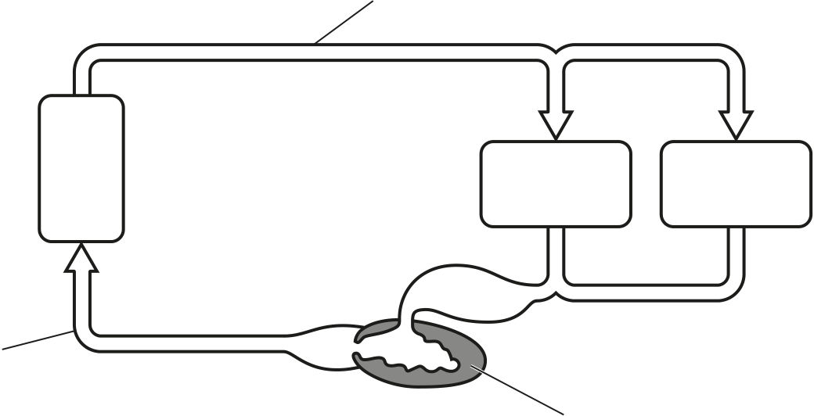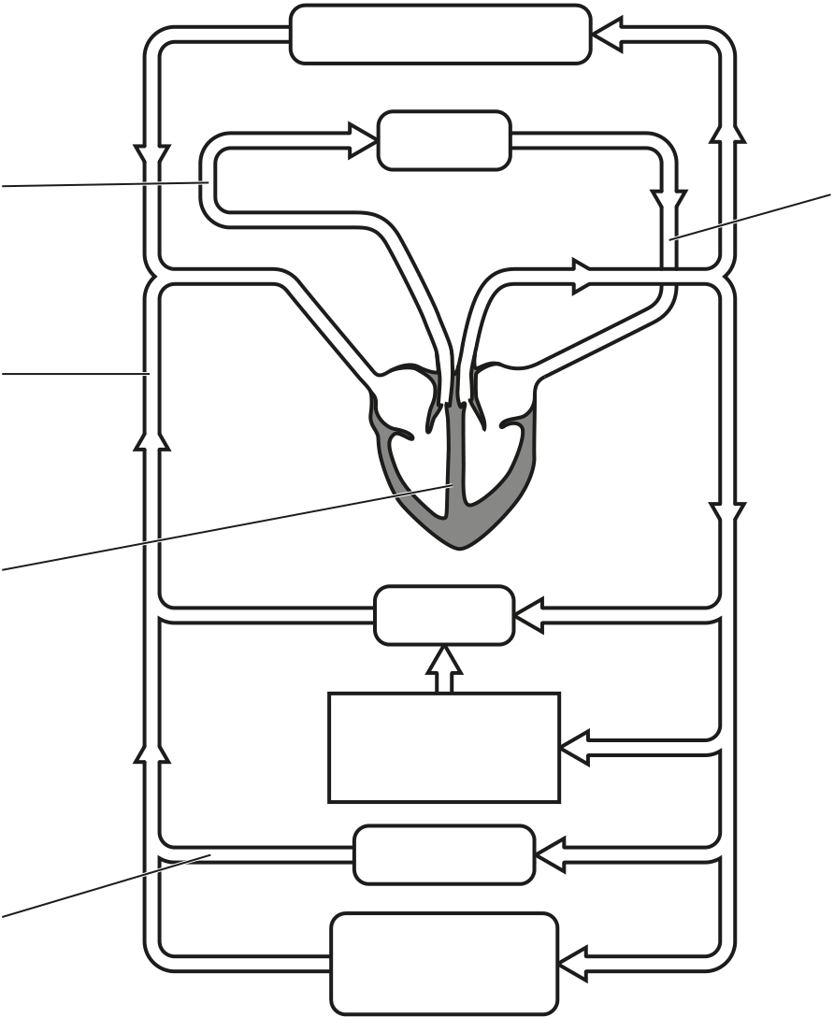

**18**   
**6**  **(a)** Fig. 6.1 shows diagrams of the circulatory systems of a fish and a mammal. The arrows show the direction of blood flow through the circulatory systems.

**P**   
fish

|  |  |  |
| --- | --- | --- |
| gills | liver and  intestine | muscle  tissue |

**R**   
 **Q**

|  |  |  |  |
| --- | --- | --- | --- |
| mammal | **X** | head and arms | **S** |
| lungs |

**W**

|  |  |
| --- | --- |
| **V** | liver |

alimentary   
canal   
kidneys

|  |  |
| --- | --- |
| **T** | lower body  and legs |

**Fig. 6.1**   
**(i)** State the names of the structures labelled **Q**, **T**, **W** and **X**.

**Q** ....................................................................................................................................... **T** ........................................................................................................................................ **W** ....................................................................................................................................... **X** ........................................................................................................................................

[4]

**19**   
**(ii)** State the name of structure **V** on Fig. 6.1 **and** describe its function.

........................................................................................................................................... ........................................................................................................................................... ........................................................................................................................................... ........................................................................................................................................... ..................................................................................................................................... [2] **(iii)** Fig. 6.1 shows that fish and mammals have different types of circulation.

State why the fish circulation is called a single circulation.

........................................................................................................................................... ........................................................................................................................................... ..................................................................................................................................... [1] **(iv)** Explain the advantages of the double circulation of the mammal.

........................................................................................................................................... ........................................................................................................................................... ........................................................................................................................................... ........................................................................................................................................... ........................................................................................................................................... ........................................................................................................................................... ..................................................................................................................................... [3] **(b)** The blood vessels that supply the heart muscle can become blocked.

**(i)** State the name of the blood vessels that supply the heart muscle.

..................................................................................................................................... [1] **(ii)** State **one** way in which blockages in these blood vessels can be treated.

..................................................................................................................................... [1]

**20**

**(c)** Substances move between blood and tissues at various sites in the circulatory system of mammals.

**(i)** Oxygen is absorbed into the blood as it passes through the lungs.

State the structures in the lungs where oxygen passes into the blood from the air.

..................................................................................................................................... [1]

**(ii)** State the site of filtration of blood in the kidneys.

..................................................................................................................................... [1]

**(iii)** State the name of the process in which products of digestion move into cells and are used to become part of the cells.

..................................................................................................................................... [1]

**(iv)** State the name of the process in which excess amino acids are broken down in liver cells to produce ammonia.

..................................................................................................................................... [1]

**(v)** State the name of the organ that releases oestrogen into the blood.

..................................................................................................................................... [1]

[Total: 17]

Permission to reproduce items where third‑party owned material protected by copyright is included has been sought and cleared where possible. Every reasonable effort has been made by the publisher (UCLES) to trace copyright holders, but if any items requiring clearance have unwittingly been included, the publisher will be pleased to make amends at the earliest possible opportunity.

To avoid the issue of disclosure of answer‑related information to candidates, all copyright acknowledgements are reproduced online in the Cambridge Assessment International Education Copyright Acknowledgements Booklet. This is produced for each series of examinations and is freely available to download at www.cambridgeinternational.org after the live examination series.

Cambridge Assessment International Education is part of Cambridge Assessment. Cambridge Assessment is the brand name of the University of Cambridge Local Examinations Syndicate (UCLES), which is a department of the University of Cambridge.