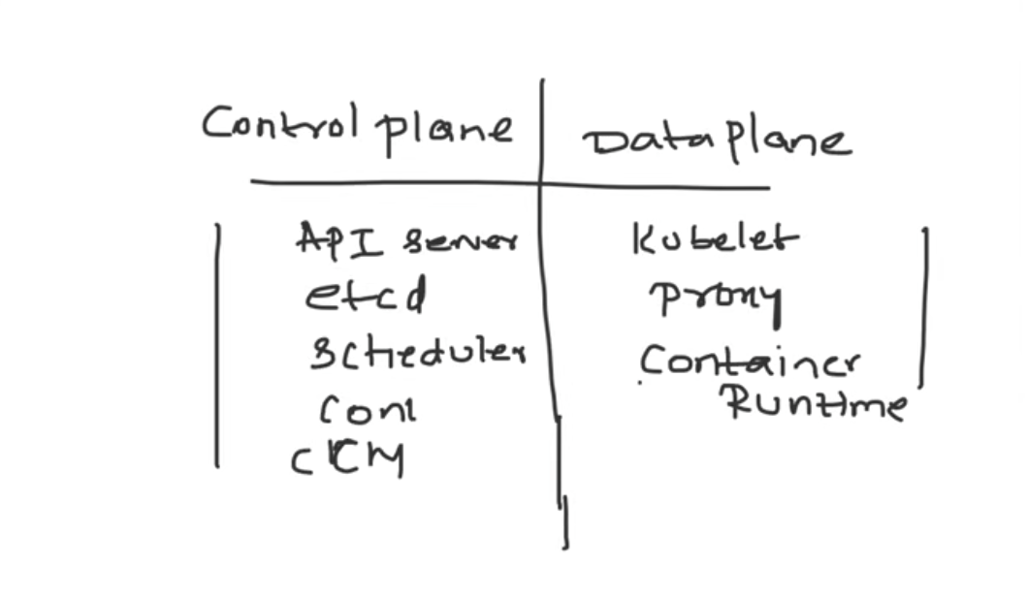

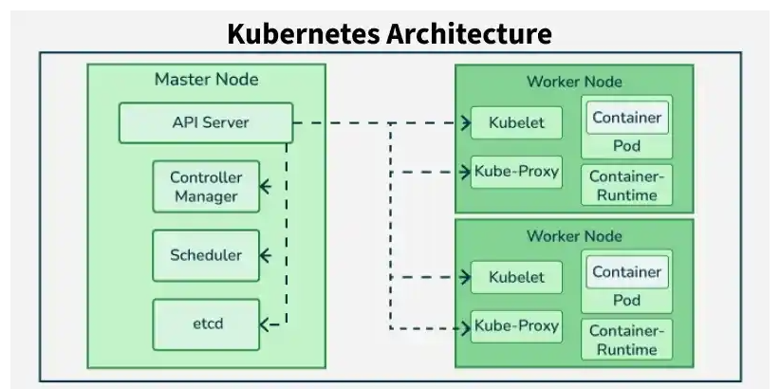

Worker node contains (Data plane): 1)kube-proxy ,2)kubelet , 3)container-runtime 4) Pod
Control plane ( master node ): 1)api server, 2)scheduler, 3)etcd,4) controller

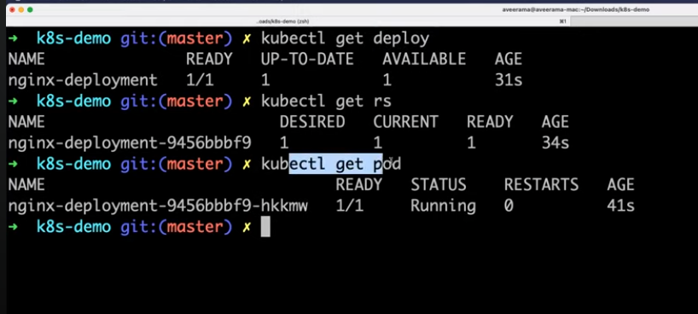
Command reference :
Minikube ssh
kubectl get all
kubectl get all –A
kubectl get pods -w
kubectl get pods -o wide
kubectl get pods –v=7
kubectl get pods -o wide

Service create : 1) cluster ip ( Discovery and load balancer inside kubernetes cluster)
2) Node port ( allow app to be accessible inside organization)
3) Load balancer ( Expose to app external world,does not work in minikube )

What is namespace : a logical isolation
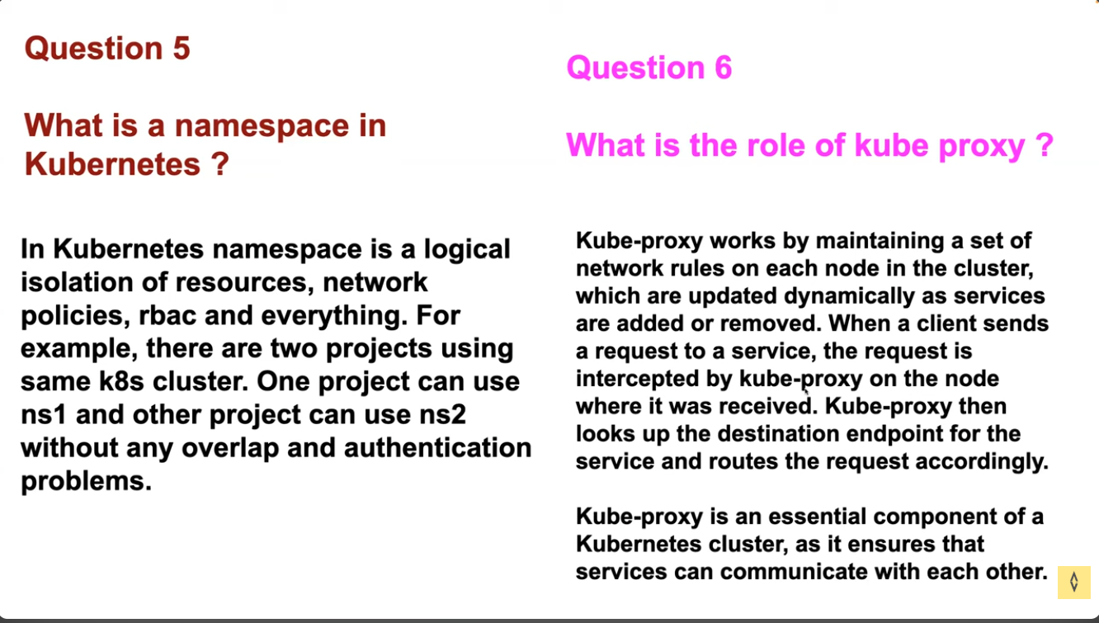
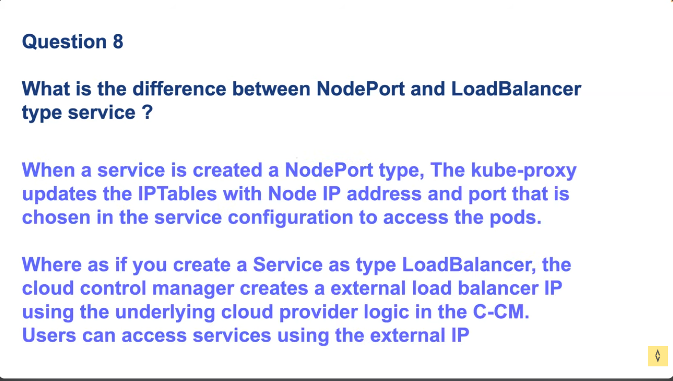

Making app available :
Config file :
apiVersion: v1
kind: Service
metadata:
name: nginx-service
spec:
selector:
app: nginx
ports:
- port: 80
targetPort: 80
nodePort: 30000
type: NodePort

Running command below
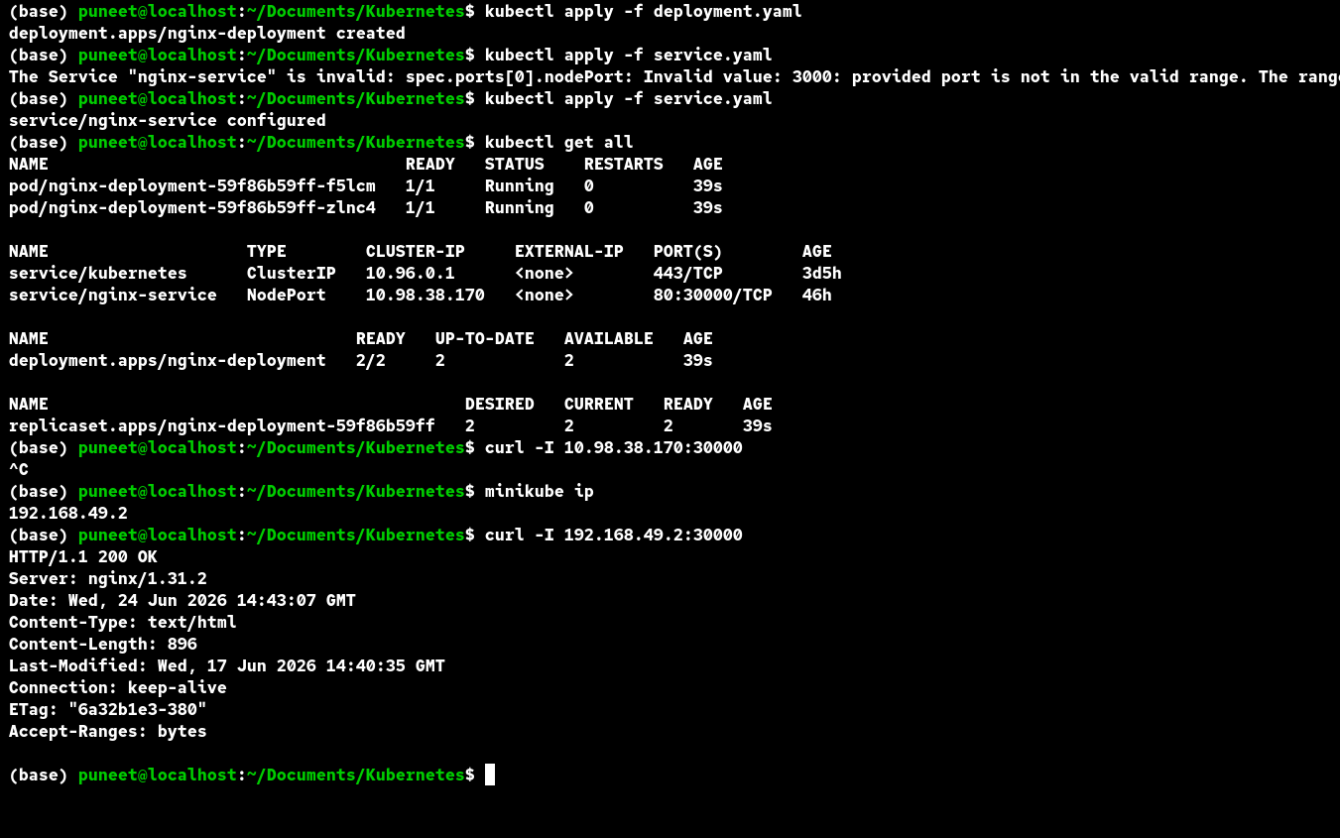

Edit service :kubectl edit svc nginx-service
Below is output and we can edit

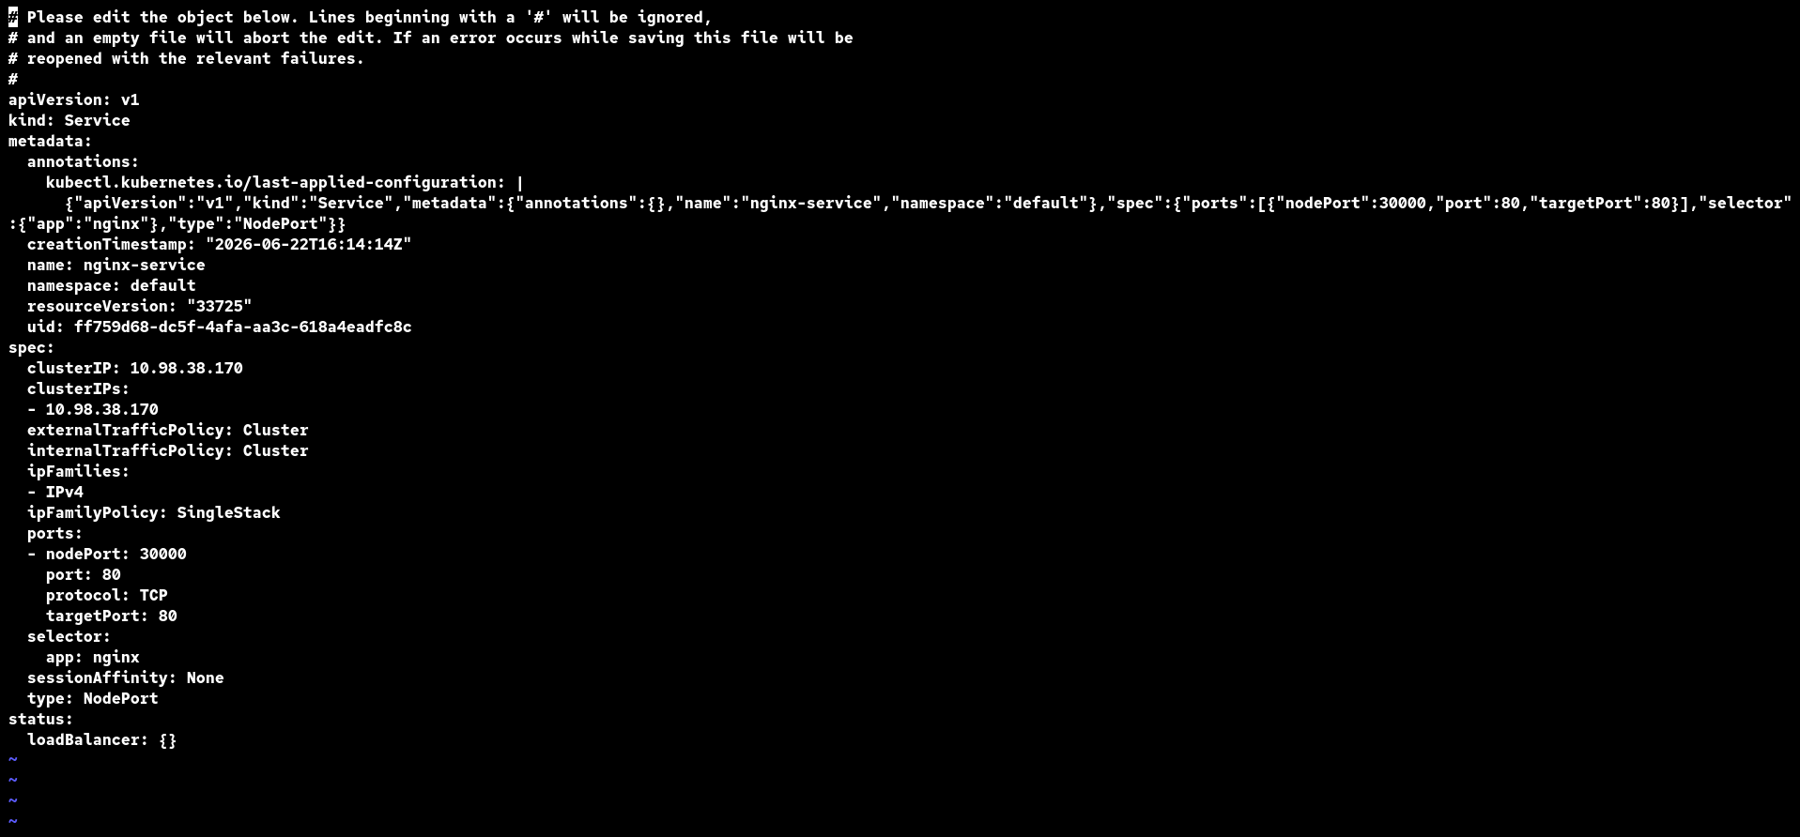

What if WordPress is in another namespace?
Suppose
WordPress → frontend namespace
MySQL → database namespace
Now if WordPress asks
mysql
DNS looks for
mysql.frontend.svc.cluster.local
That doesn't exist.
Connection fails.
Instead you must use
mysql.database
or
mysql.database.svc.cluster.local
This is an important concept when applications are split across namespaces.

Access Modes
There are three common access modes.

1. ReadWriteOnce (RWO)
One volume
↓
One node can mount it for read/write
This is the most common mode.
Examples:
- AWS EBS
- Azure Managed Disk
- GCE Persistent Disk
Think of it like a USB drive.
You can plug the USB drive into one computer.
You can't plug the same USB drive into two different computers at the same time.

2. ReadOnlyMany (ROX)
Many pods can read.
Nobody can write.
Pod A ---> Read
Pod B ---> Read
Pod C ---> Read
Useful for static content.

3. ReadWriteMany (RWX)
This is what most beginners expect.
Pod A
Pod B
Pod C
Pod D
↓
All Read
All Write
This requires a storage system designed for shared access, such as:
- NFS
- Amazon EFS
- CephFS
- Azure Files

##############################################################################

So for WordPress...
WordPress
Deployment ✅
Because any WordPress pod can serve requests.

For MySQL...
MySQL
StatefulSet ✅
Because:
- Identity matters
- Storage matters
- Ordering matters
- Each instance has its own persistent data

This is the guarantee StatefulSet provides

Each pod has:
- ✅ Stable name
- ✅ Stable network identity
- ✅ Stable storage
- ✅ Ordered deployment and deletion
This is why databases love StatefulSets.

Now let's compare everything you've learned
Resource | Purpose | Example
Pod | Smallest deployable unit | One WordPress container
ReplicaSet | Maintains desired number of Pods | Keep 4 Pods running
Deployment | Manages ReplicaSets and rolling updates | WordPress
Service | Stable network endpoint and load balancing | wordpress-service
ConfigMap | Non-sensitive configuration | DB_HOST=mysql
Secret | Sensitive configuration | DB_PASSWORD
PVC | Request for persistent storage | 20Gi disk
PV | Actual storage | Disk/EBS/NFS
StatefulSet | Stable identity and storage | MySQL, Kafka, ZooKeeper

