# Linux/Hadoop commands task

**Task 1 :**

Create a file in Edge Node --file name -- file1.txt

Fill the file with zeyobron

Create hdfs directory /user/cloudera/hdfstarget

Put file1.txt to hdfstarget

Create another file file2.txt have analytics word

Find a way to overwrite edgenode's file2.txt content to hadoop's file1.txt

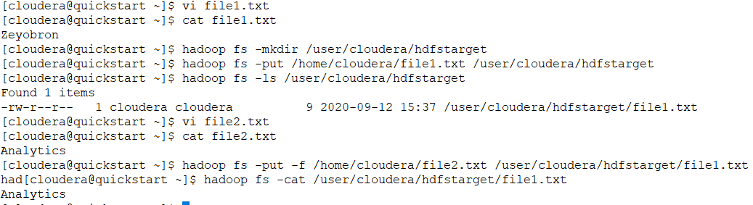

**Task 2 :**

Create a file in Edge Node --file name -- file3.txt

Fill the file with zeyobron

Create hdfs directory /user/cloudera/hdfstarget1

Put file3.txt to hdfstarget1

Create another file file4.txt have analytics word

Find a way to overwrite edgenode's file4.txt content to hadoop's file3.txt

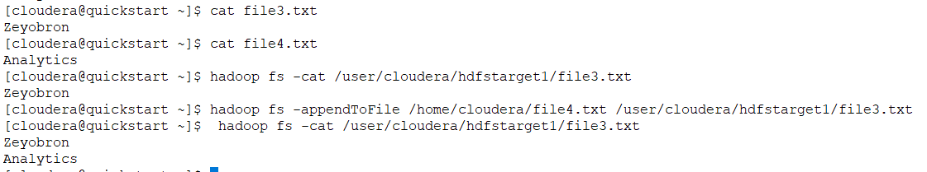

**Task 3 :**

Find how files present and how many folder and what is the memory of /user/cloudera using hadoop command

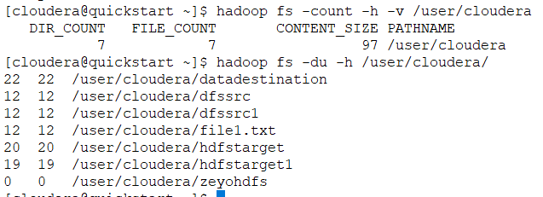

**Task 4 :**

**Create a directory in HDFS.**

**Create an empty file in that directory**

**Find a way to remove the non empty directory using hadoop command**

