**Task 01: [22 Marks]**

a) Create a new user named Jamil using useradd command.



b) View the contents of the files /etc/passwd and /etc/shadow

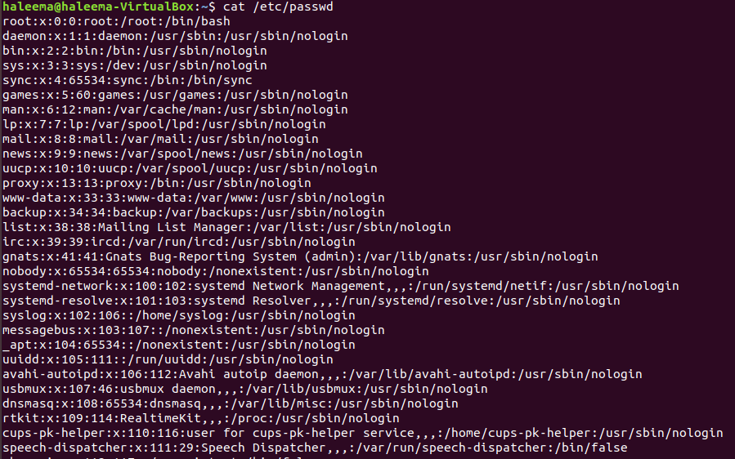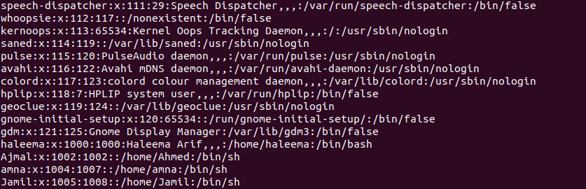

c) Now assign him a password “123456”

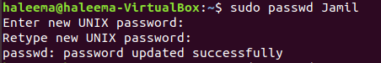

d) View the contents of the files /etc/passwd and /etc/shadow after creation of the account

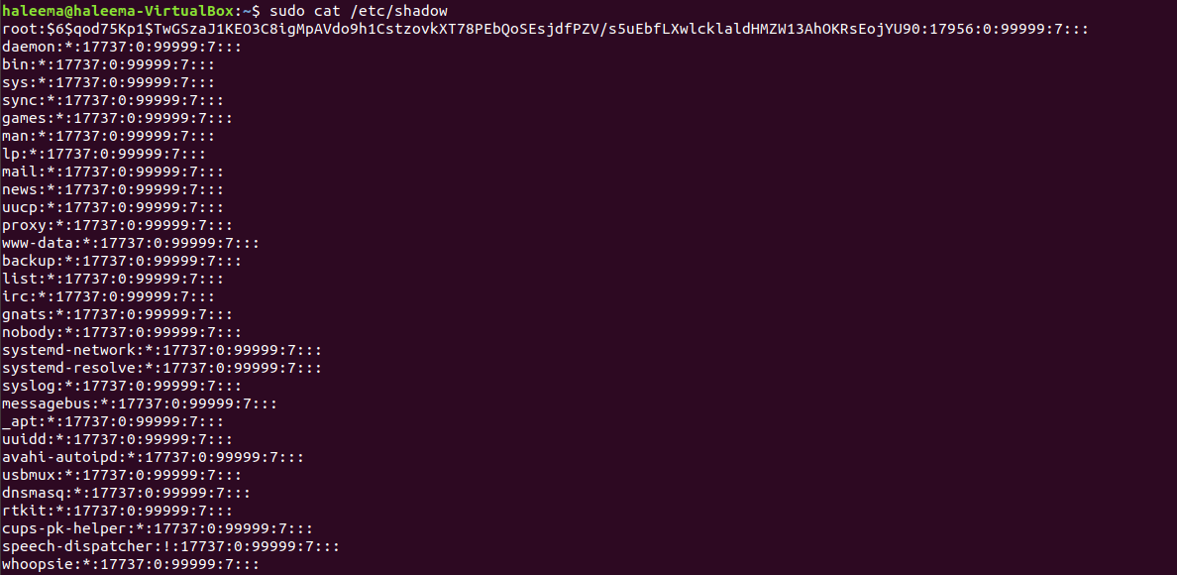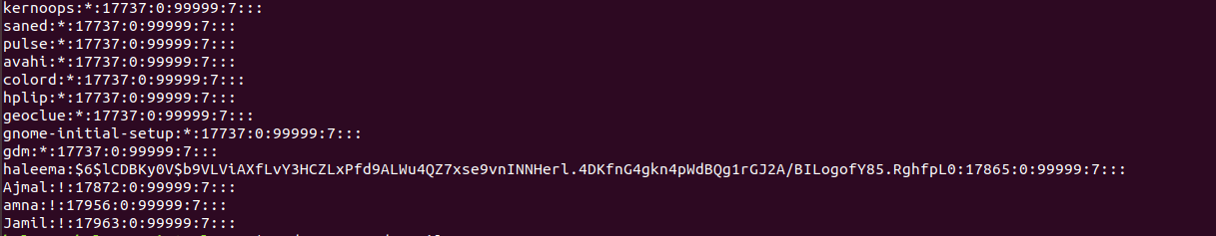

e) Now try logging as this user from another console.

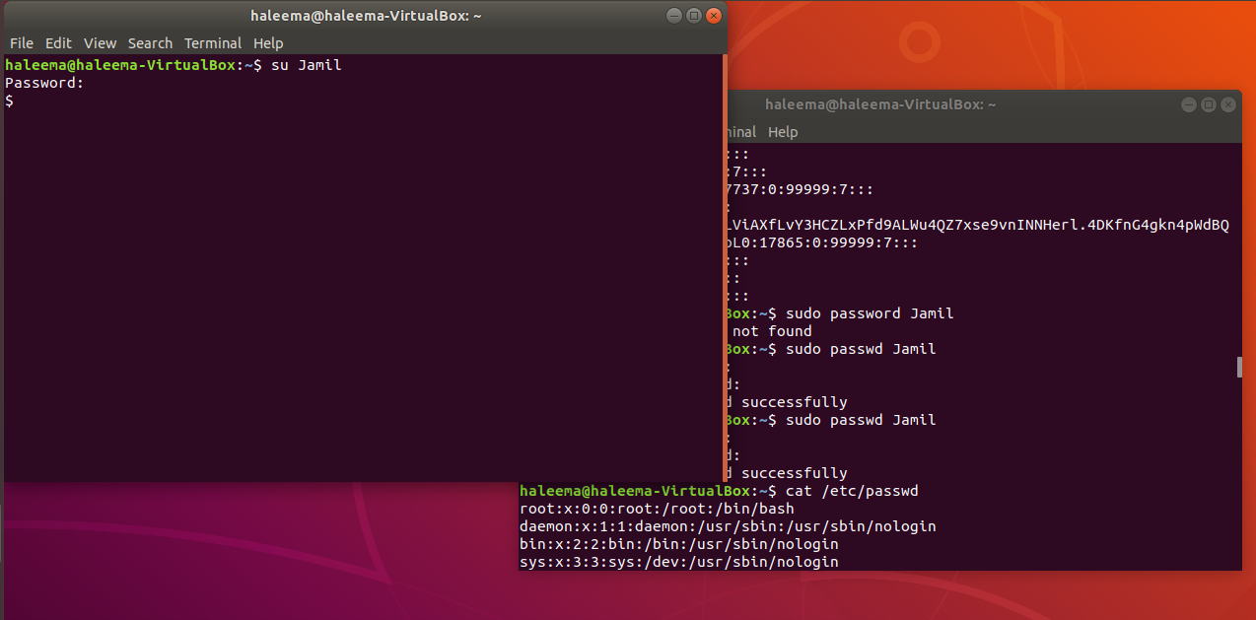

f) Display the default settings that will be given to a user when you create a new user with the useradd command

//you said not to answer

g) View the contents of the file /etc/default/useradd

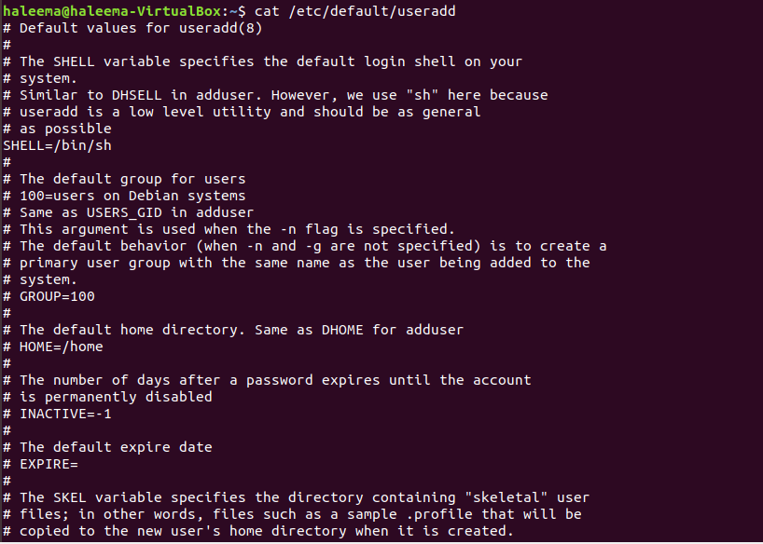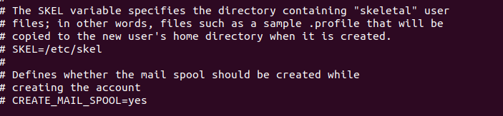

h) Login as root and try changing the password of Jamil from “123456” to “1” and try logging in again.

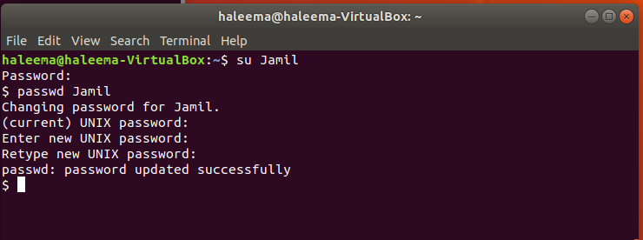

i) Login as Jamil and try changing his own password from “1” to “12345”or “Jamil”. What happened?

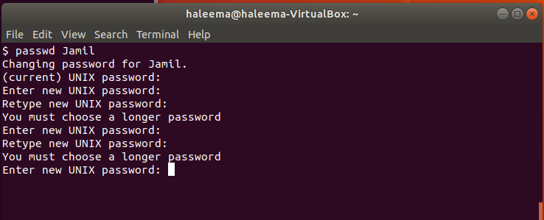

j) Change the personal information of Jamil using the chfn command. (Do it as root and then do it as Jamil (note the diff).

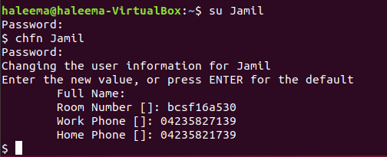

k) Now view the contents of /etc/passwd file

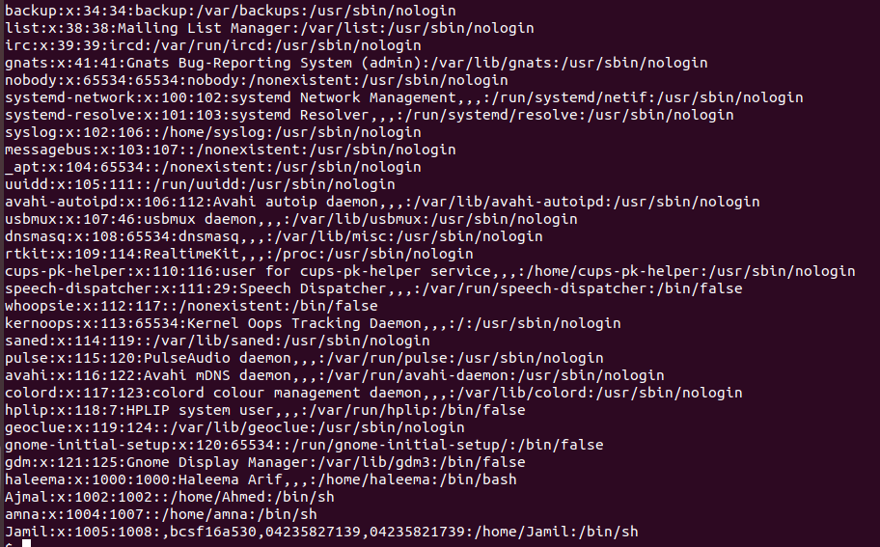

**Task 02: [22 Marks]**

a) Write a command to lock the account of Jamil. (Confirm by trying to log in as Jamil, also view the contents of the file /etc/shadow).

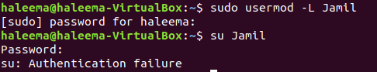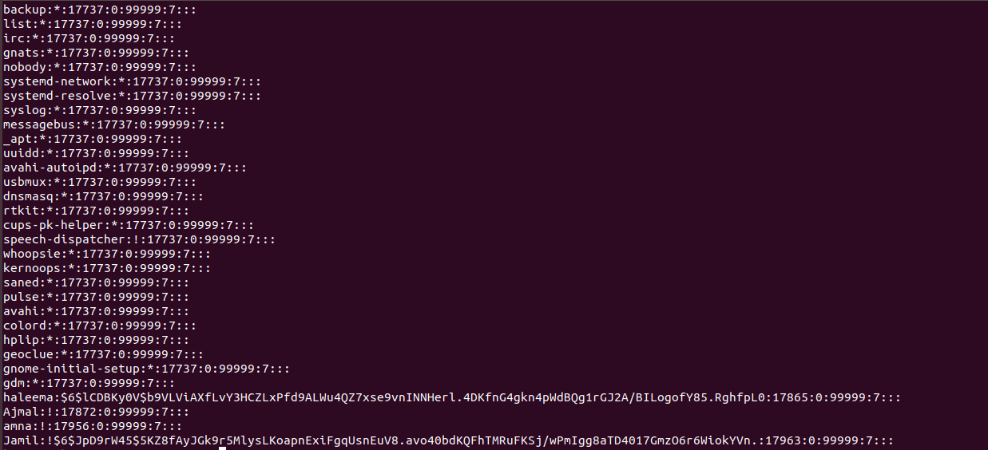

b) Now unlock Jamil. Confirm by trying to log in as Jamil, also view the contents of the file /etc/shadow.

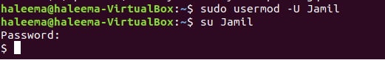

c) Delete the user Jamil, and then try logging in as Jamil.

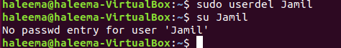

d) Check the home directory of Jamil in **/home**.

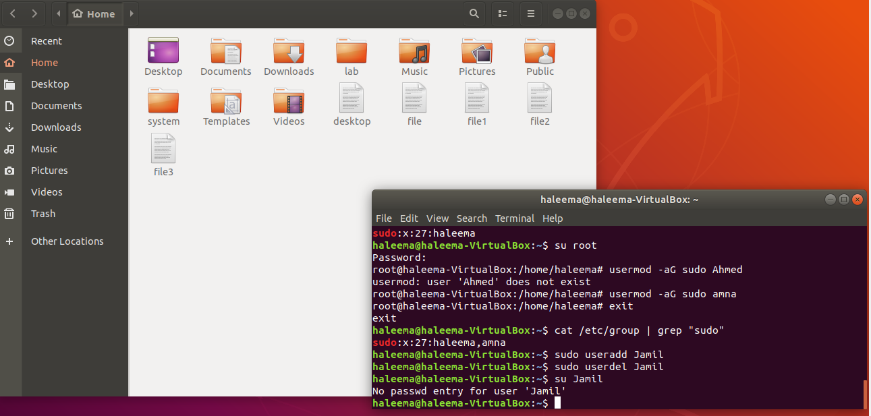

e) View the contents of /etc/passwd, /etc/shadow, and /etc/group files.

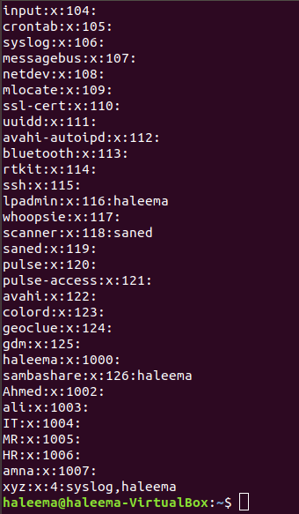

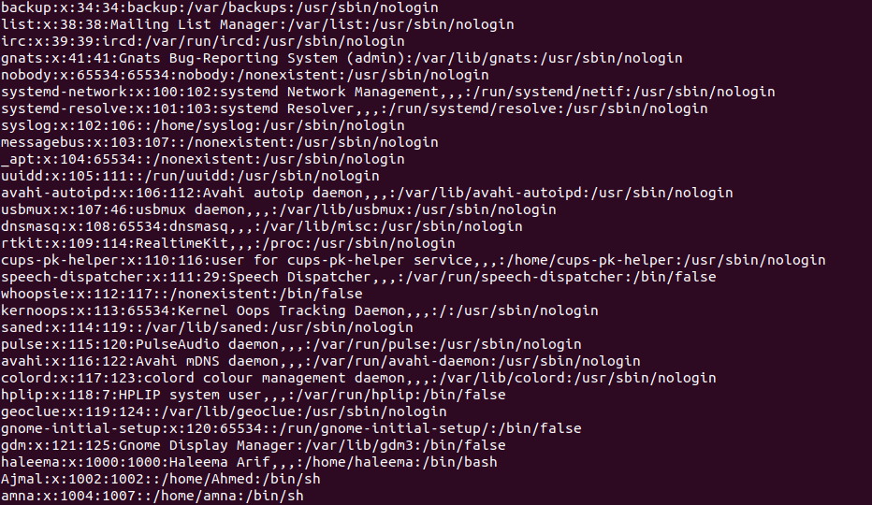

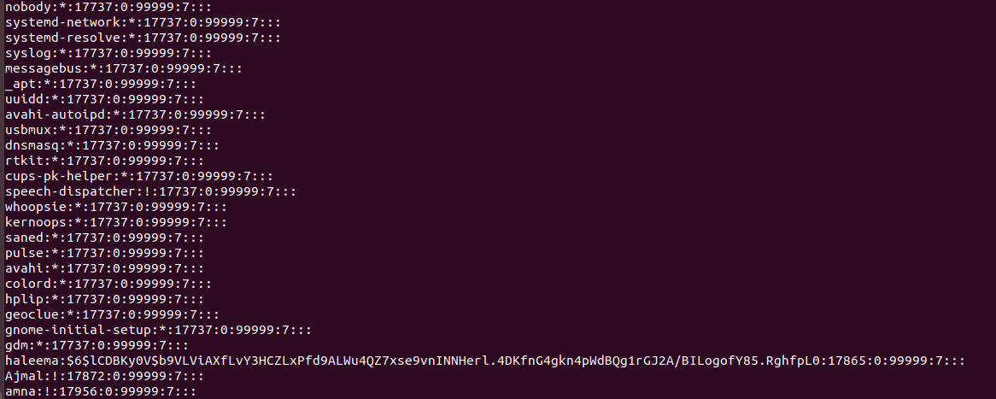

f) Change the name of user Jamil to Farhan.



g) Try logging in as Jamil and then try to log on as Farhan. Use pwd command to check his home directory.

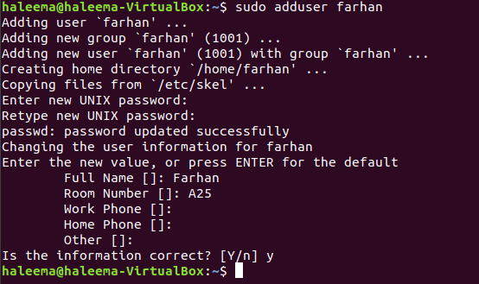

h) Log in as root and check the home directory of Farhan in **/home**.

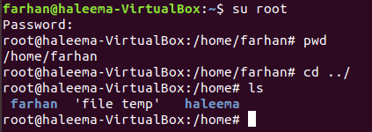

i) View the contents of /etc/passwd, /etc/shadow and /etc/group

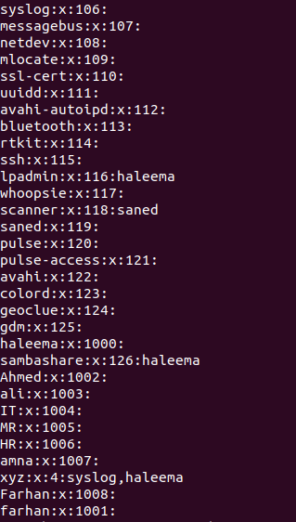

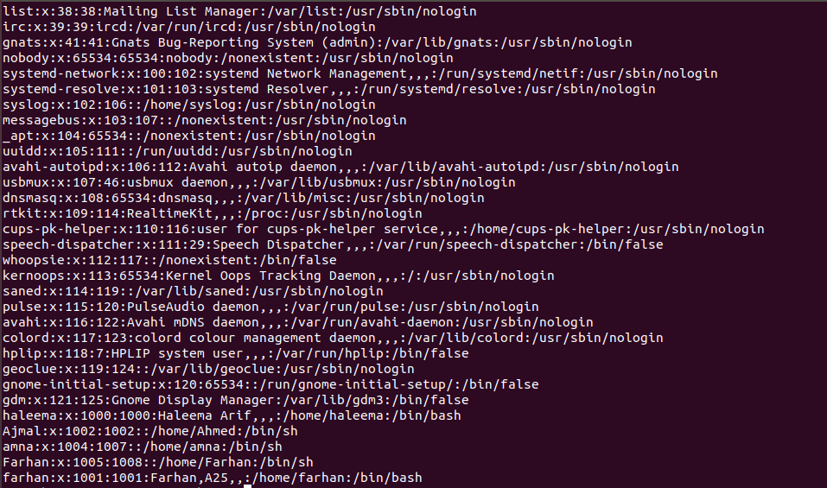

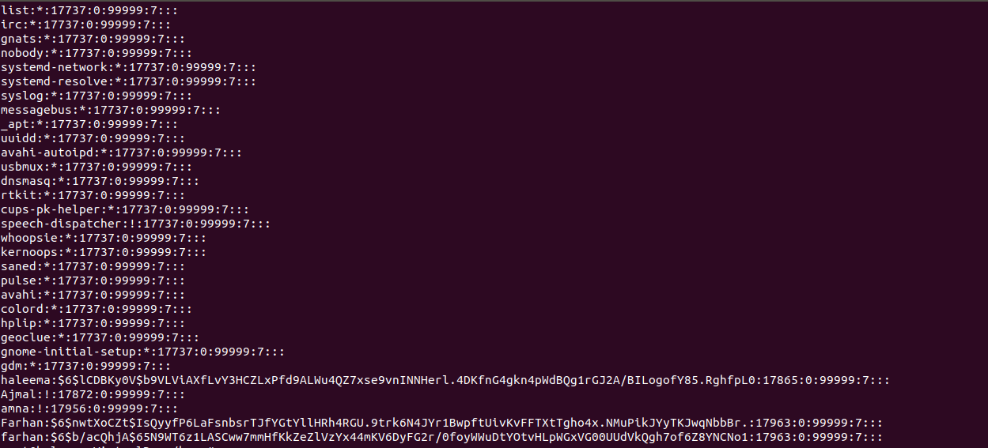

j) Delete the user Farhan by using the -r option you have created. After deletion check his home directory.

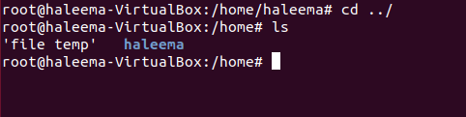

k) View the contents of /etc/passwd, /etc/shadow and /etc/group.

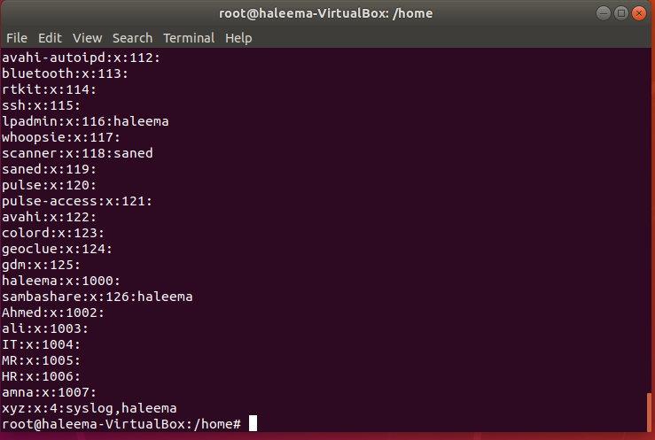

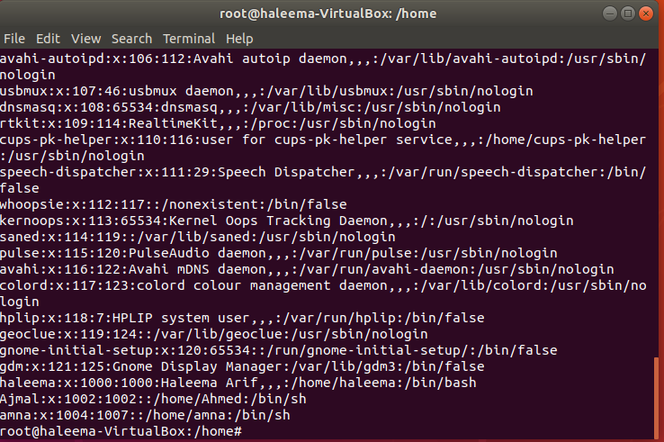

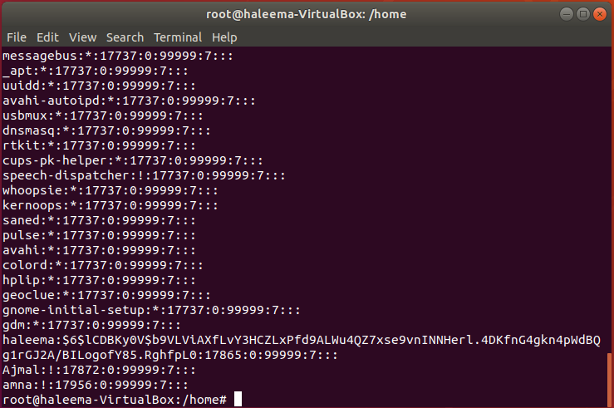

**Task 03: [12 Marks]**

a) Create a user Mansoor and assign him a password.

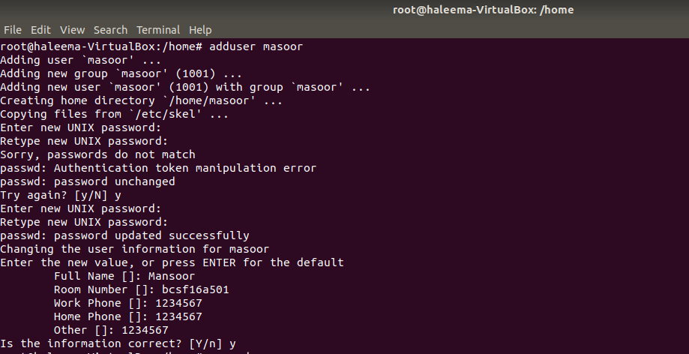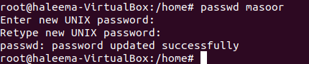

b) Now again try creating another user with the same name Mansoor. See what happens?



c) To avoid this, make it your habit that before creating a new user checkup whether a user with the same name already exists in the system.

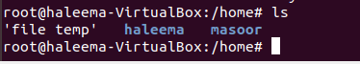

d) A user’s password related information is kept in /etc/shadow file. When you create a new user he is given the default password policies as per the configuration file /etc/login.defs. (View the file’s contents).

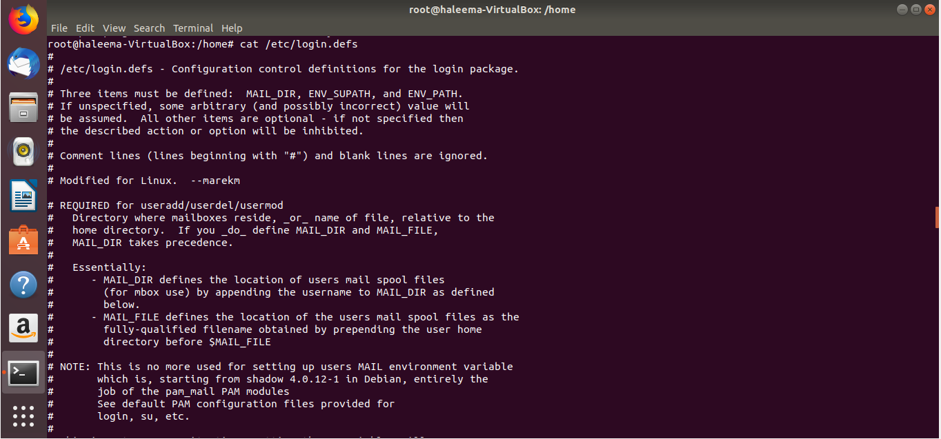

e) Now create a new user Jamal.

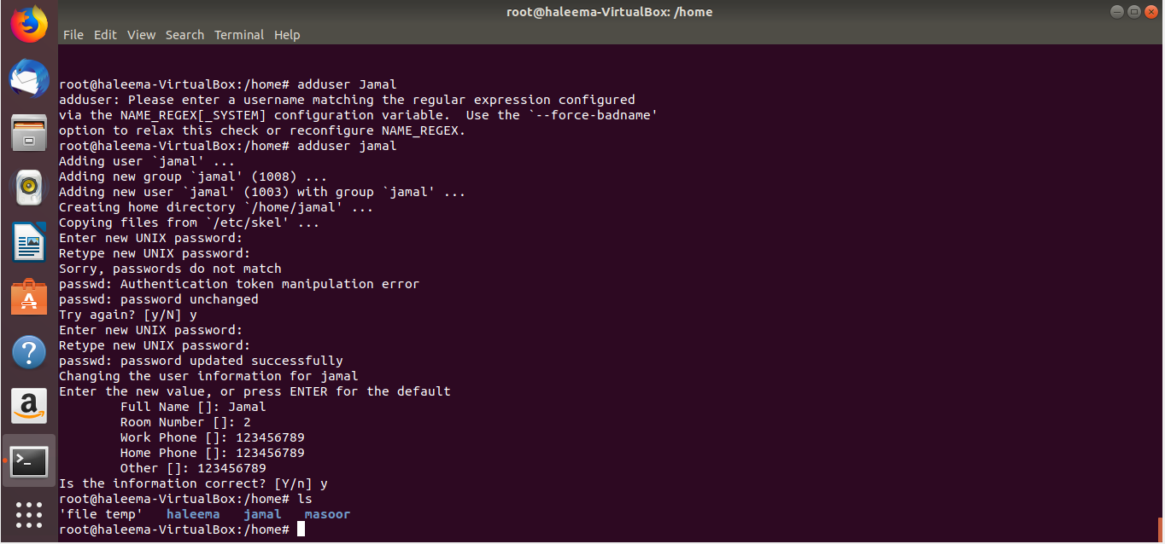

f) Display just the line associated with Jamal in the /etc/shadow file.

//same as did before many times

**Task 04: [34 Marks]**

a) Create a group with the names of sales and view the contents of /etc/group file after creating the group

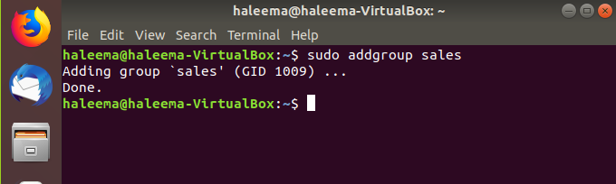

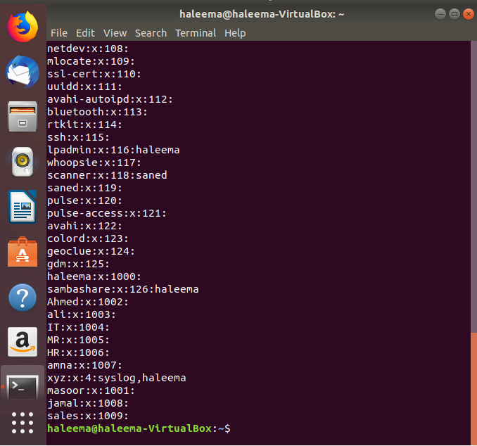

b) Change the name of the group to marketing and again view the /etc/groupfile

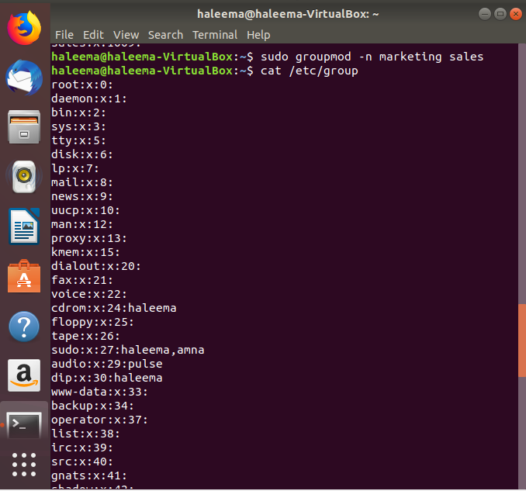

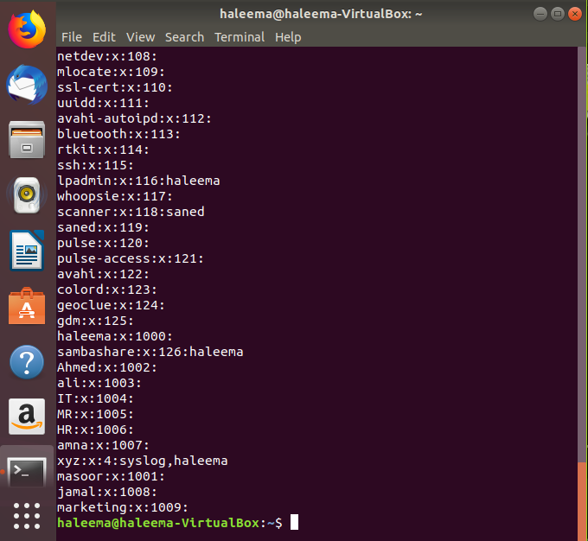

c) Delete the group and again view the /etc/groupfile.

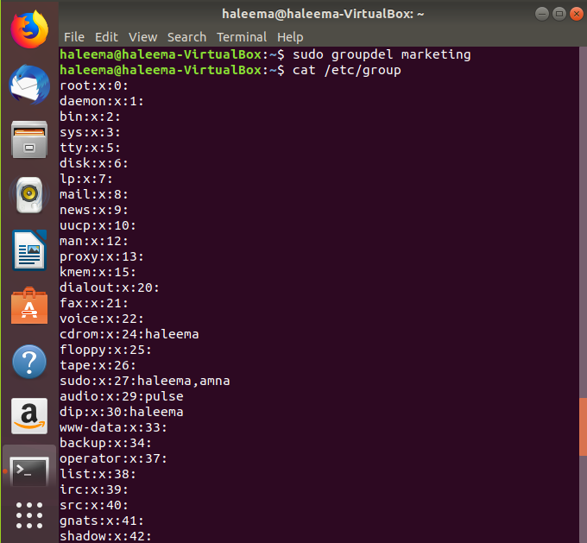

d) Create a new user named user1 and view the contents of /etc/passwd and /etc/group

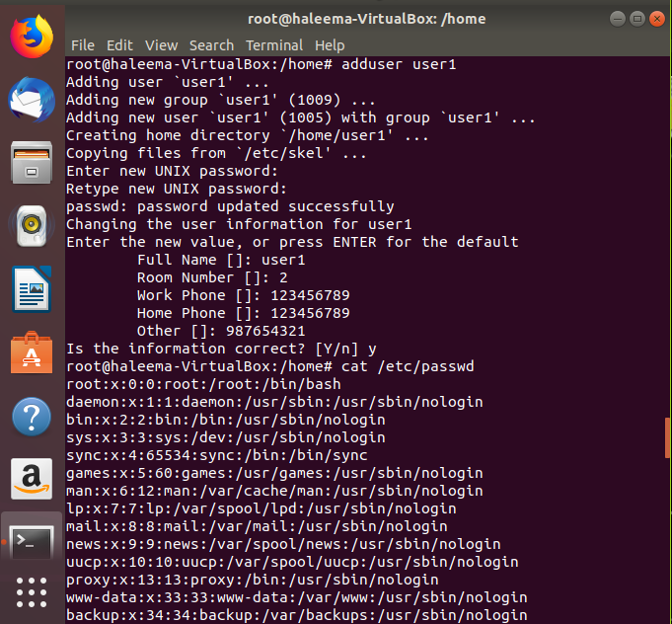

e) Try deleting the group user1; Oops! What happened & why it happened.

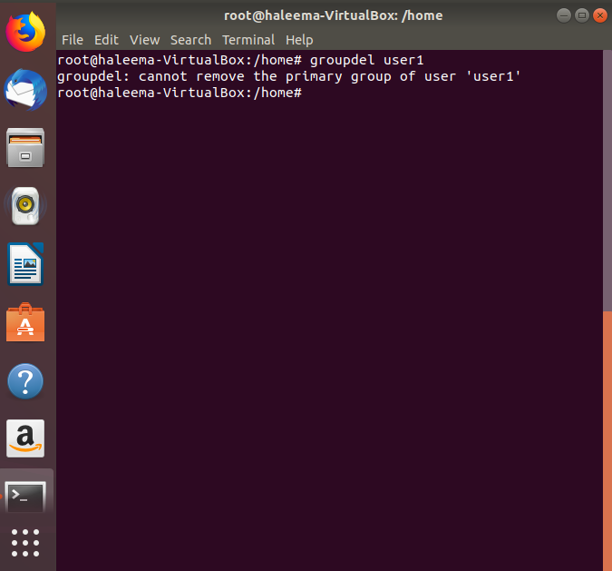

f) Create a group technology (view contents of /etc/group after creating group)

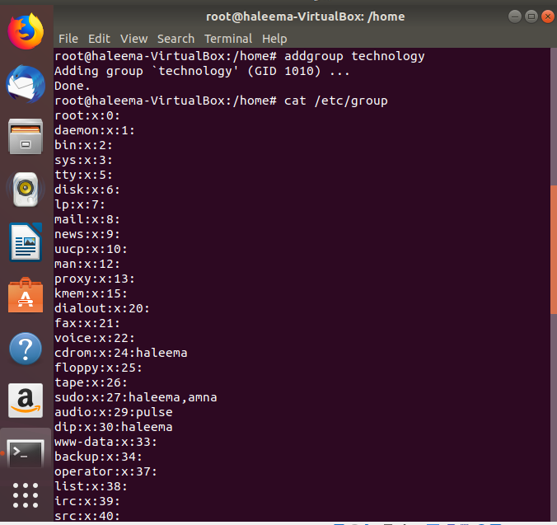

g) Create a new user Hadeed and after creation check his group information using id command

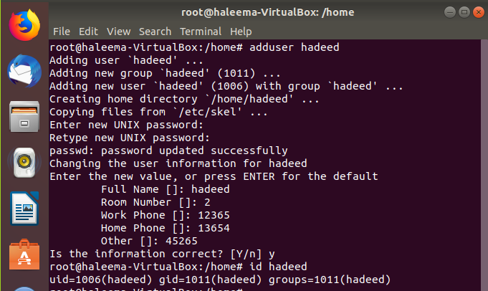

h) Make Hadeed a member of technology group. It should be his secondary group. (View contents of /etc/group again)

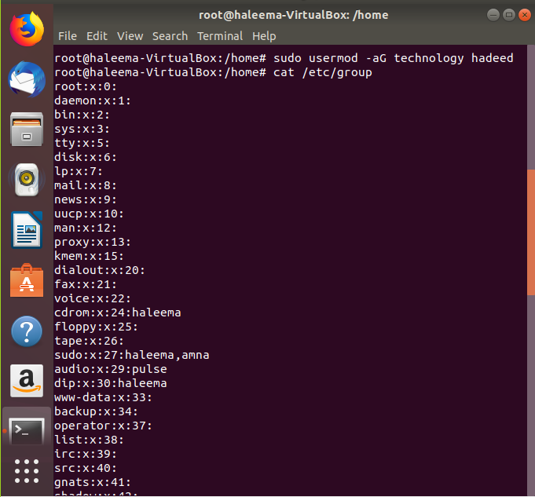

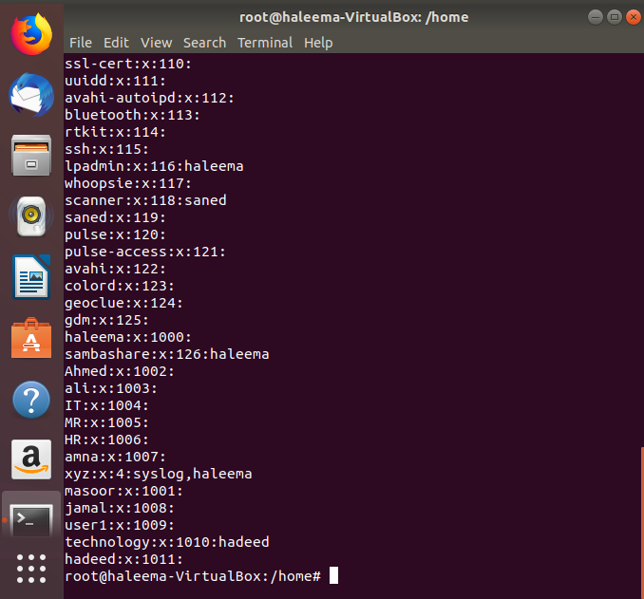

i) Now try deleting the group technology.

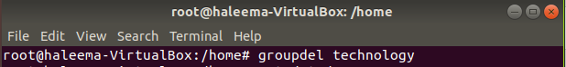

j) Create another user named Maaz.

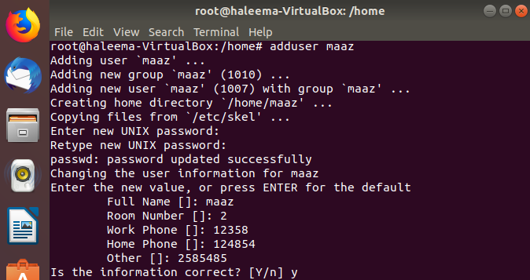

k) Make Maaz a member of technology group. It should be his primary group (view contents of /etc/group). Also confirm using the id command.

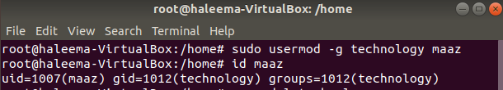

l) Now try deleting the group technology. Observe the difference.

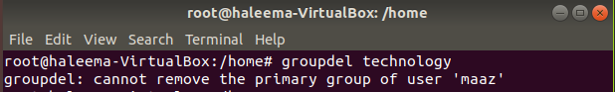

Note: You cannot delete the primary group of an existing user. You must remove the user before you remove the group.

m) Create three groups with the names of cs, mkt, sales.

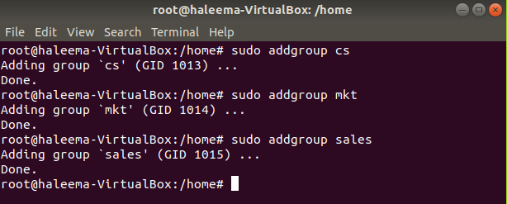

n) Create a user xyz with default settings. (Do confirm that a user with this name does not already exist in the system).

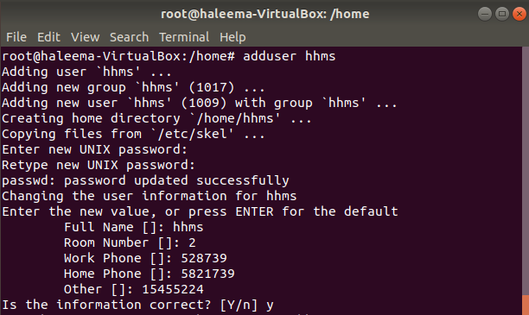

o) After creating this user check his group info.



p) Now make xyz a member of cs and mkt groups. (Note that these should be the secondary groups of xyz and his primary group should be xyz).



q) Now change the primary group of xyz to sales and confirm again.

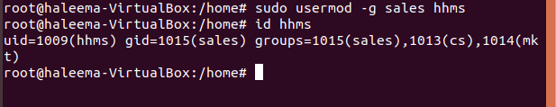

**Task 05: [24 Marks]**

a) Login as root and create three users Tariq, Khanand Jamil and assign them passwords.

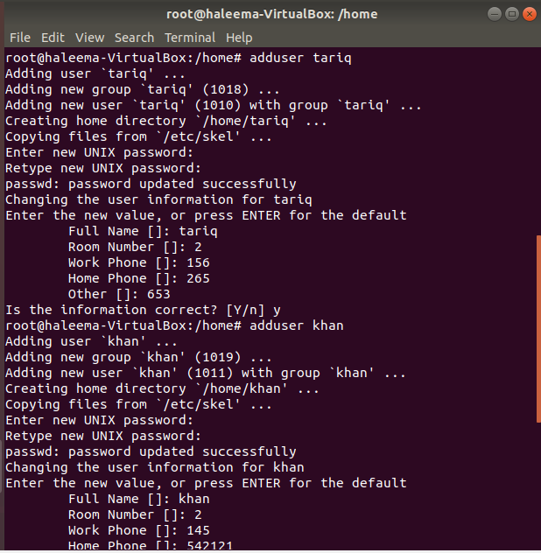

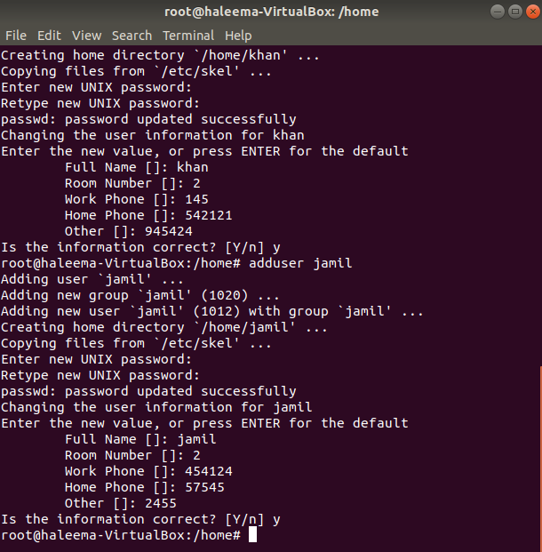

b) Login as khan and create a directory ~/dir1 and a file ~/dir1/file1 and check its permissions.

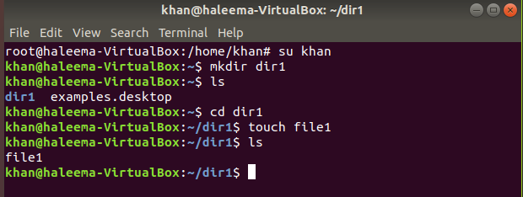

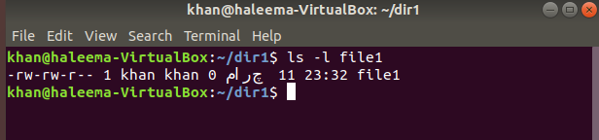

c) Login as Tariq or Jamil and try to access the home directory of khan. What happens?

