**PUNJAB UNIVERSITY COLLEGE OF INFORMATION & TECHNOLOGY**



**OS LAB 02**

**Submitted By:**

M. Hamza Azeem

**Roll Number:**

BSEF15M517

**TASK # 01**

**(a)**

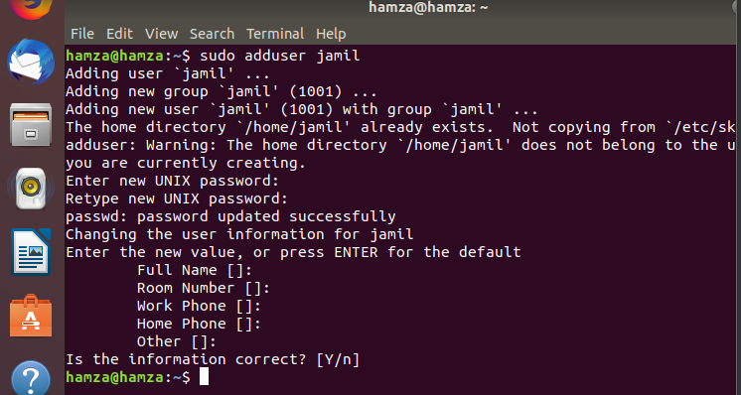

**(b)**

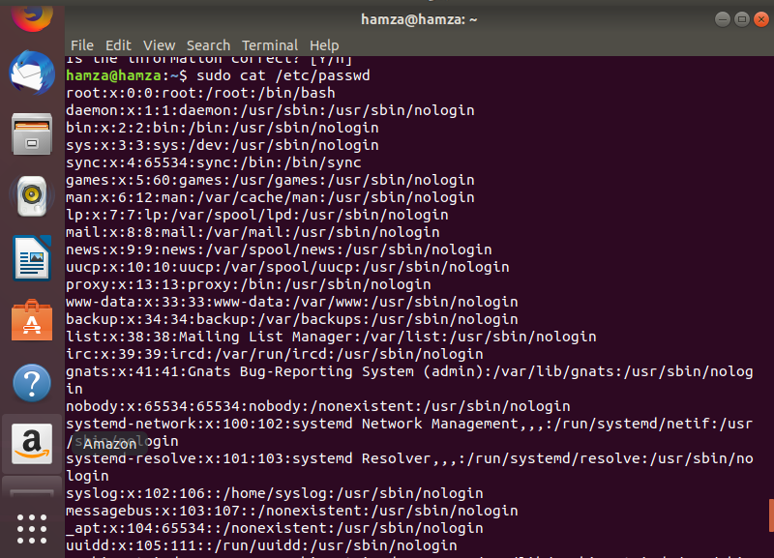

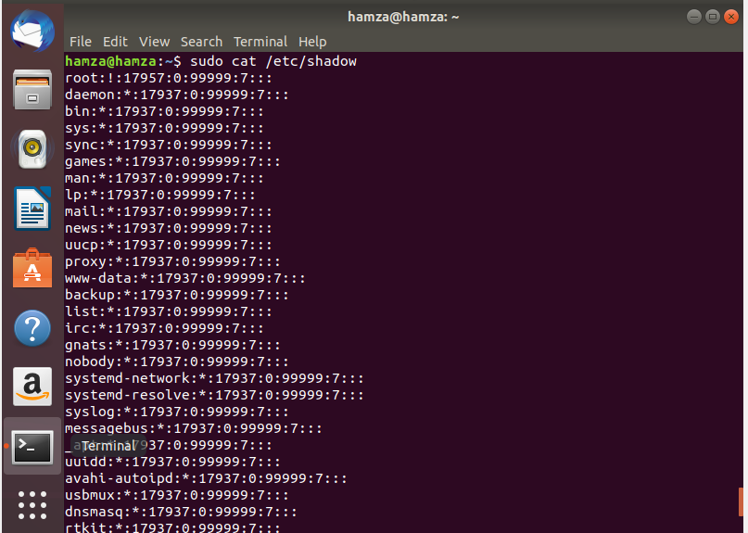

**(c)**

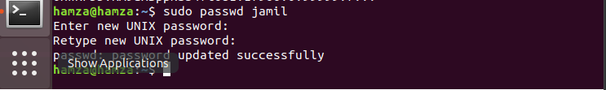

**(d)**





**(e)**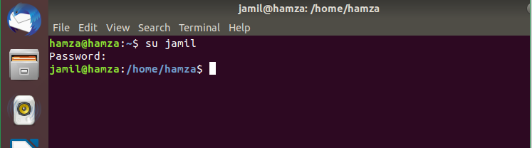

**(f)**

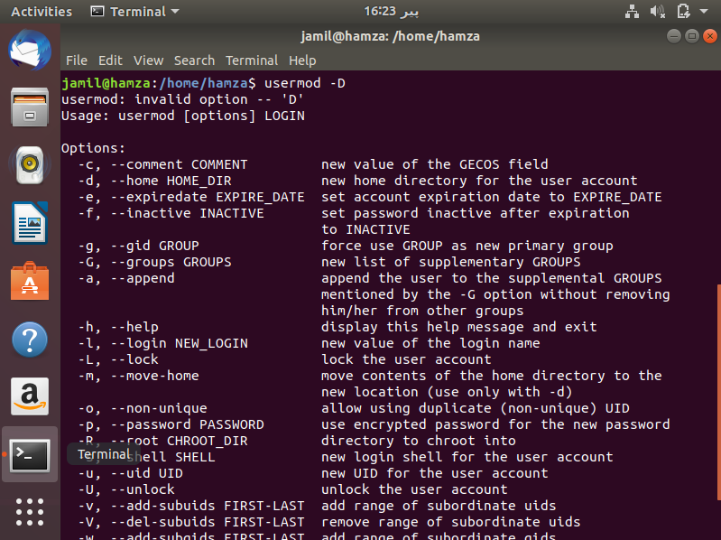

**(g)**

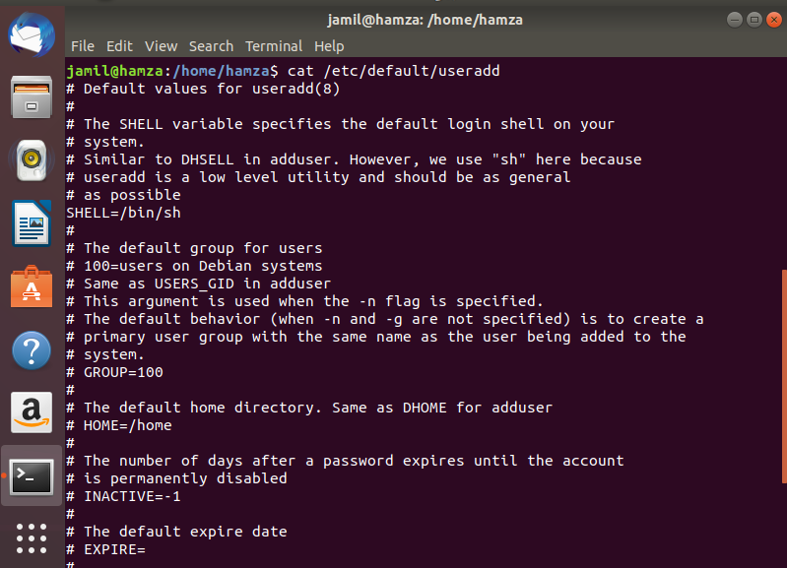

**(h)**

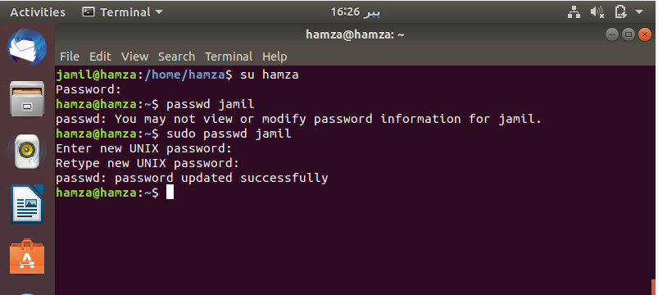

**(i)**

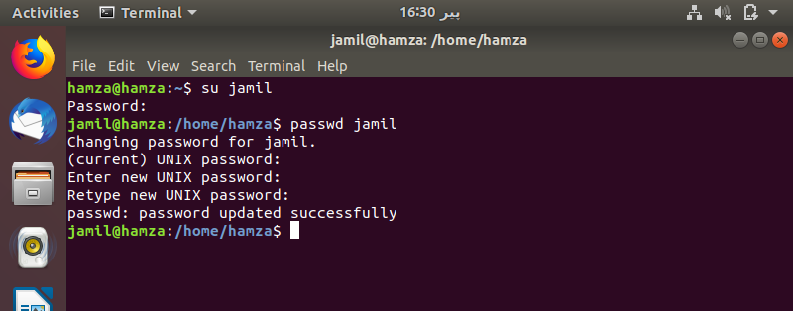

**(j)**

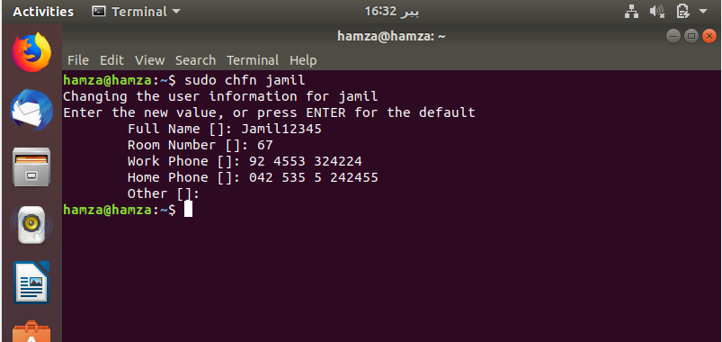

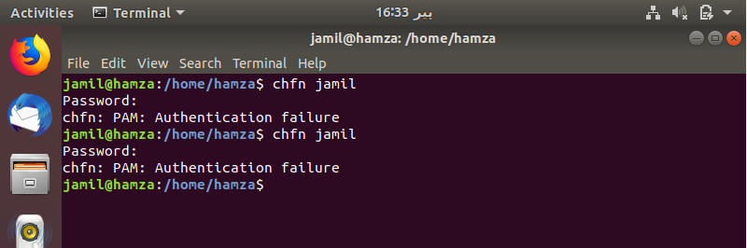

**(k)**



**TASK # 02**

**(a)**

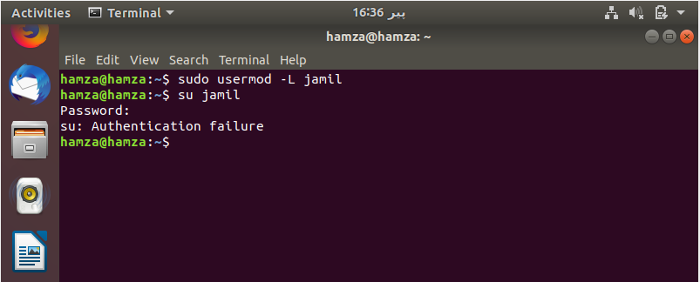



**(b)**

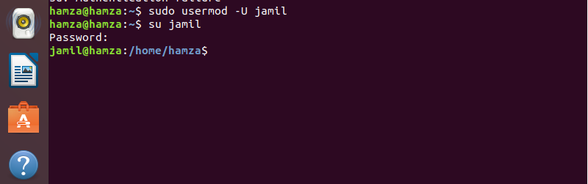



**(c)**

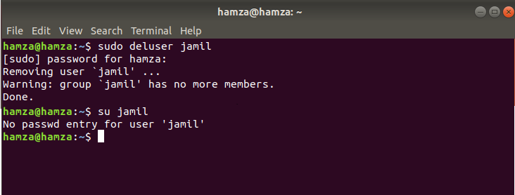

**(d)**

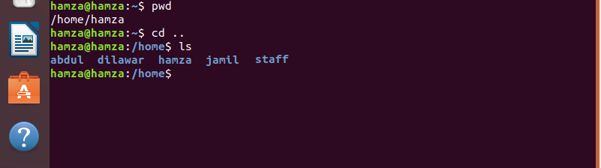

**(e)**





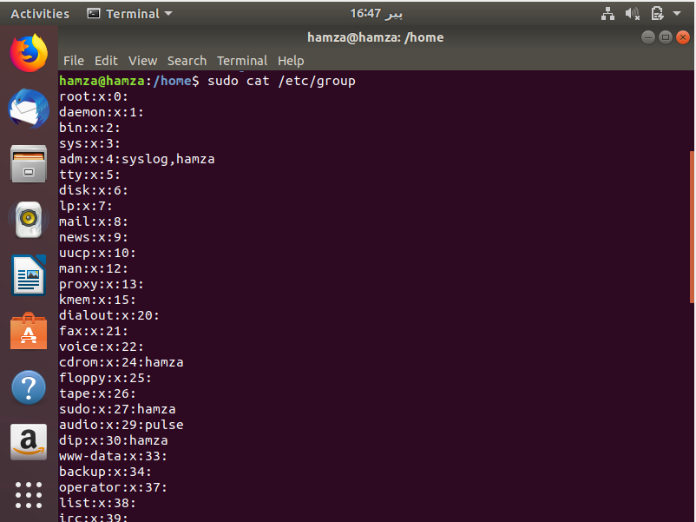

**(f)**

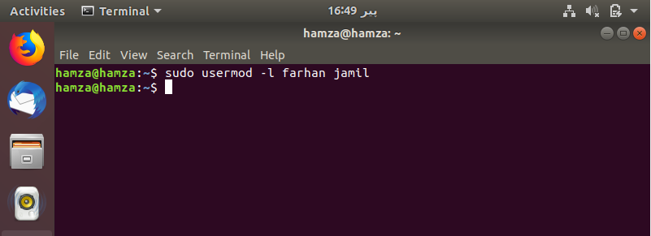

**(g)**

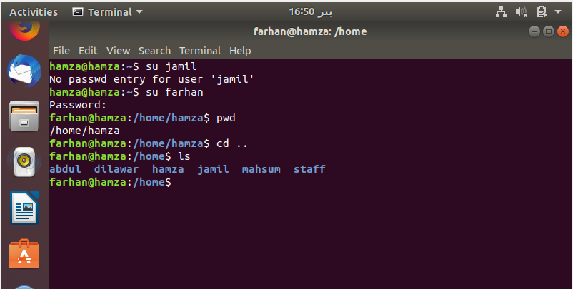

**(h)**

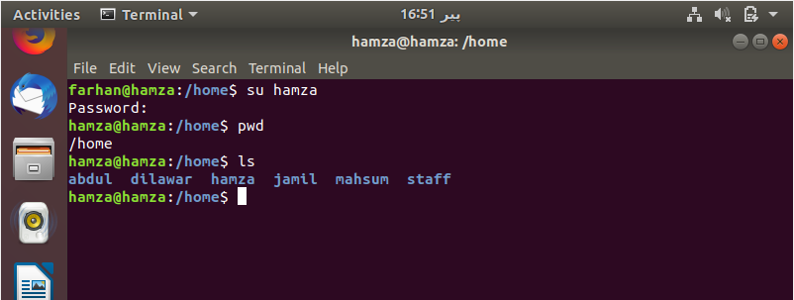

**(i)**





**(j)**

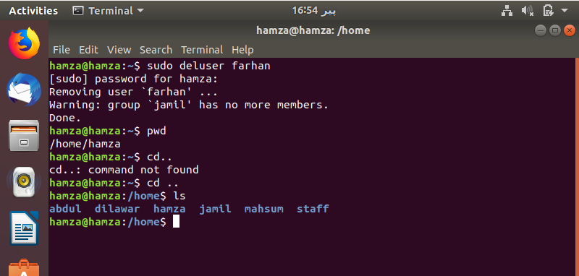

**(k)**







**TASK # 03**

**(a)**

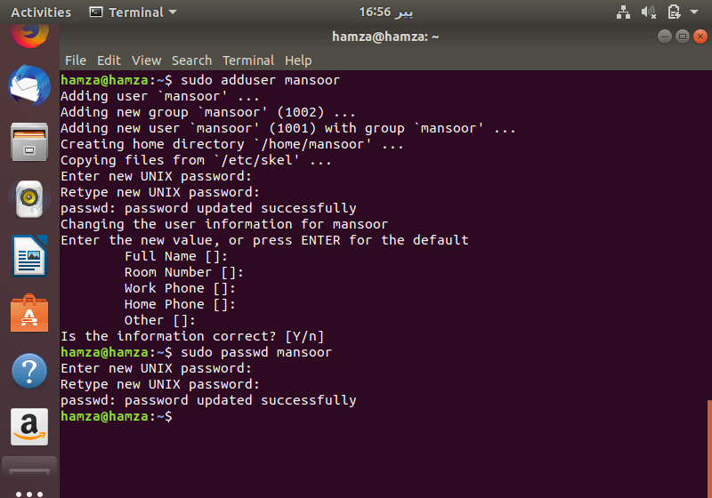

**(b)**

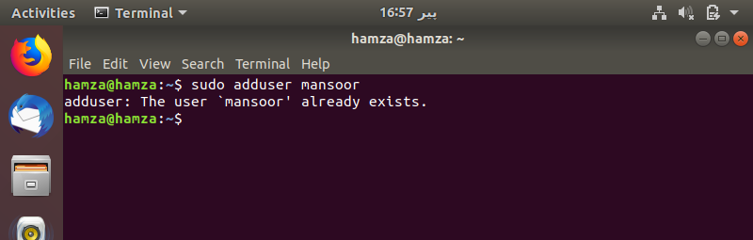

**(c)**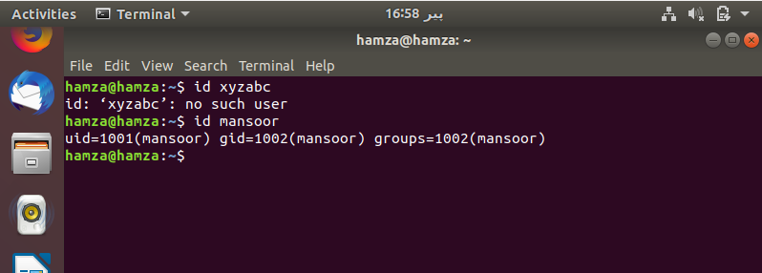

**(d)**

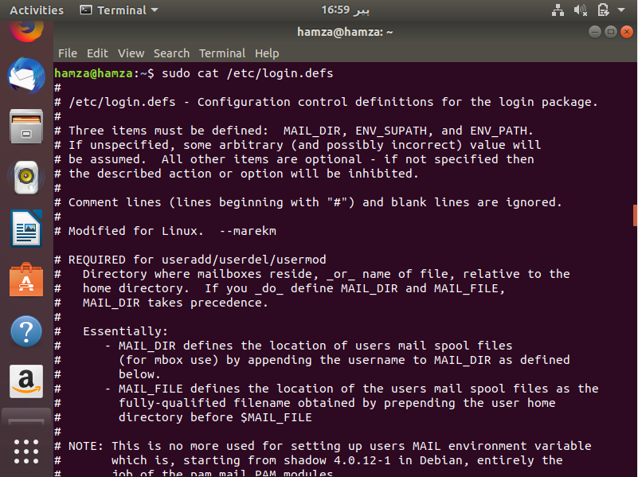

**(e)**

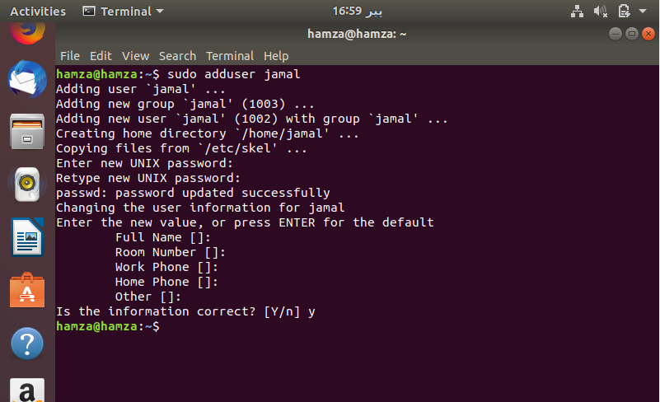

**(f)**

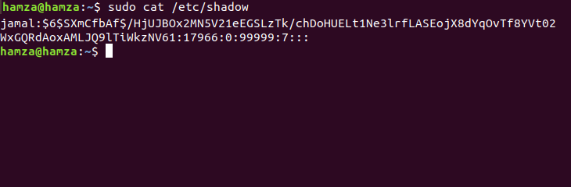

**TASK # 04**

**(a)**

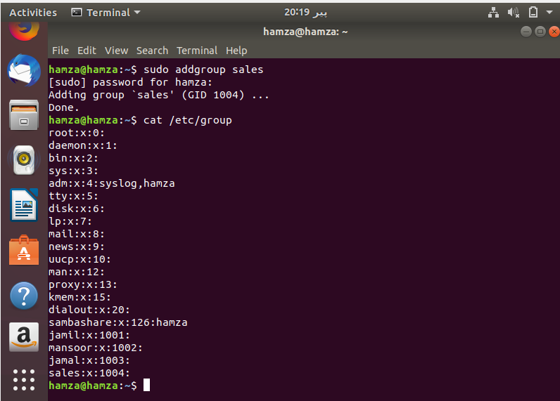

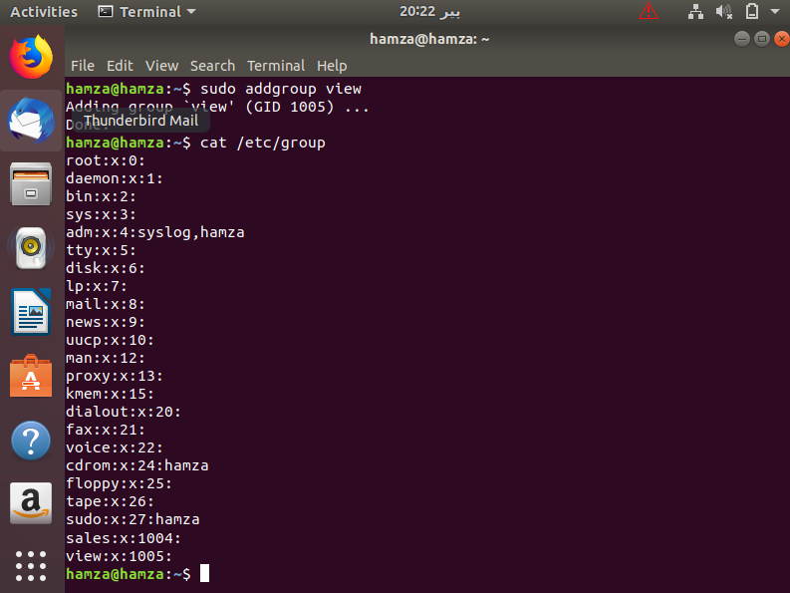

**(b)**

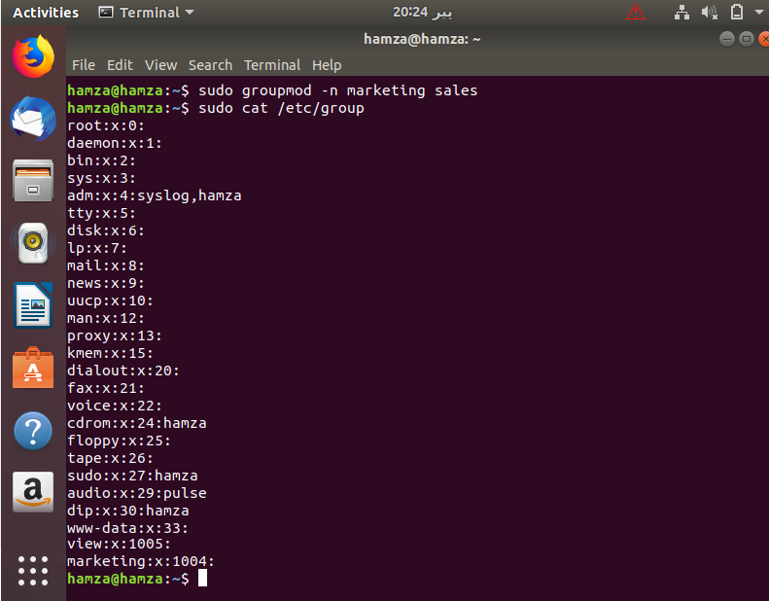

**(c)**

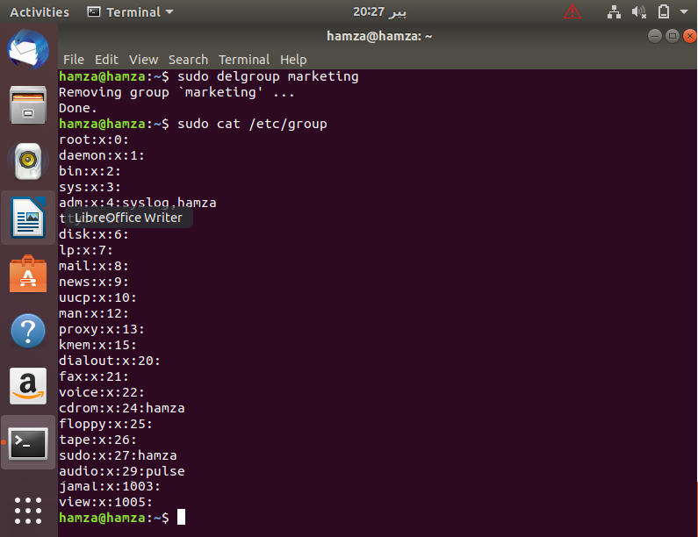

**(d)**

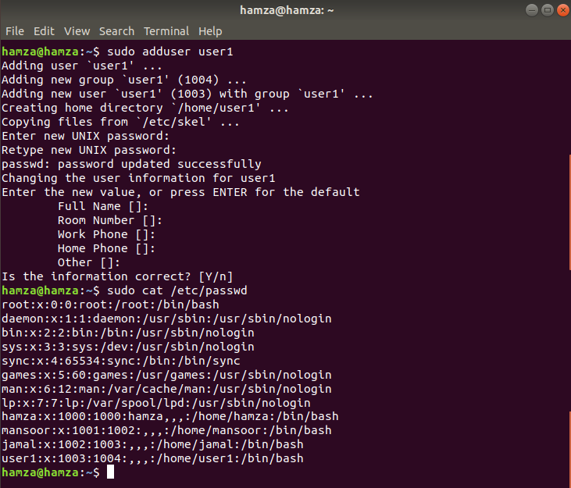

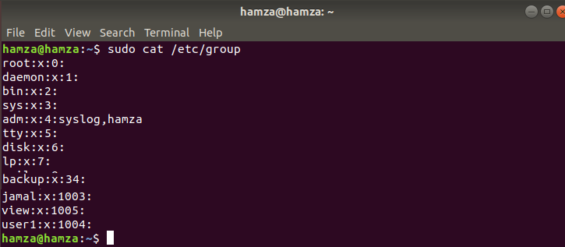

**(e)**

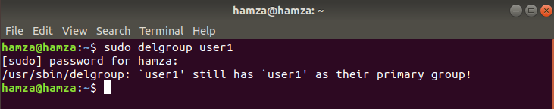

**(f)**

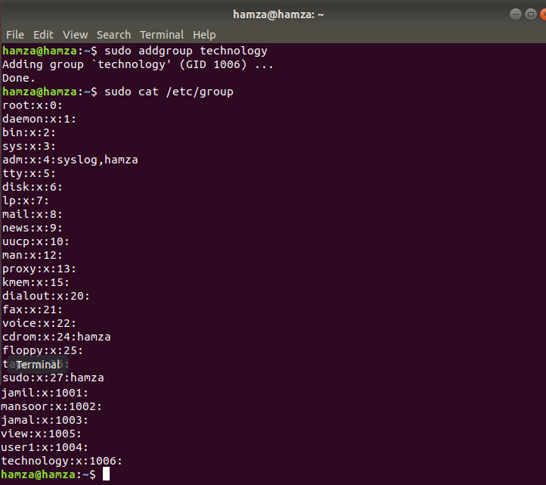

**(g)**

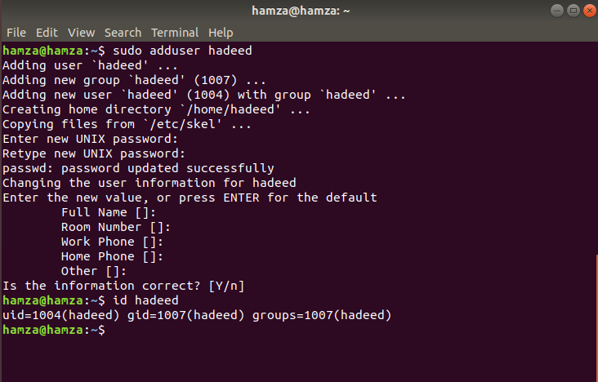

**(h)**

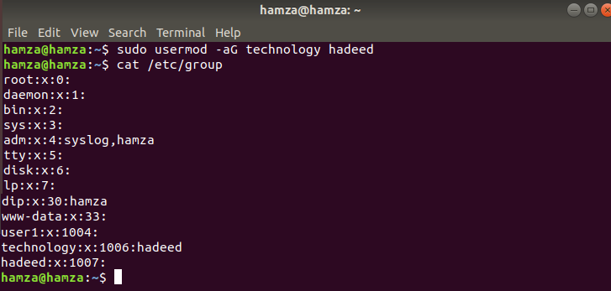

**(i)**

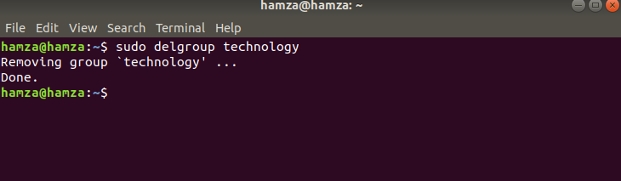

**(j)**

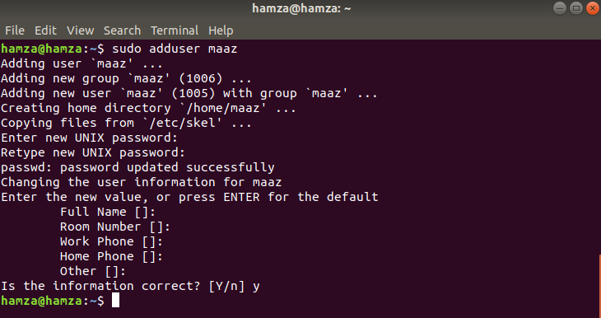

**(k)**

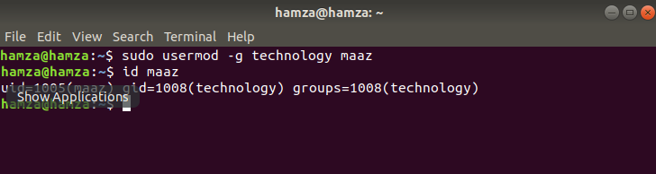

**(l)**

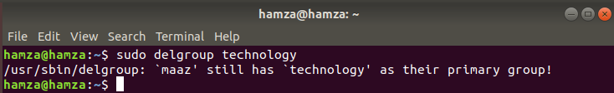

**(m)**

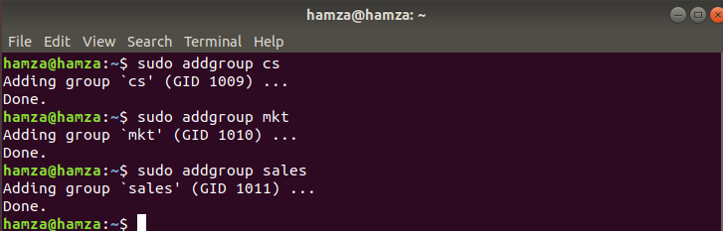

**(n)**

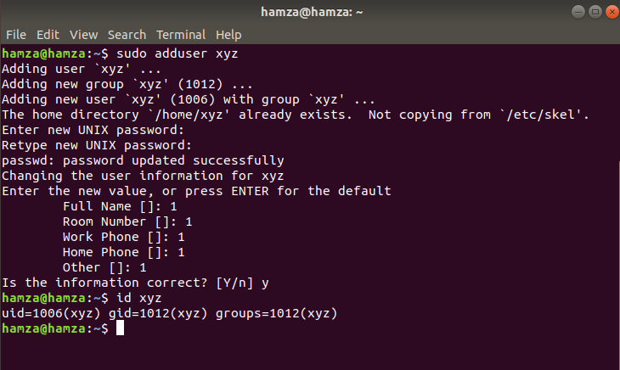

**(o)**

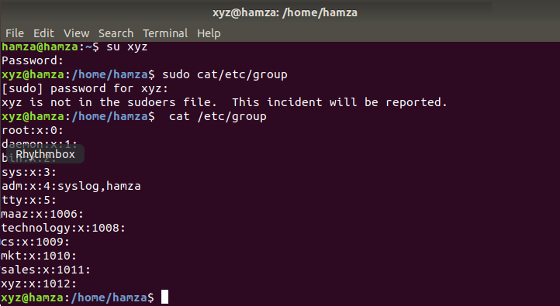

**(p)**

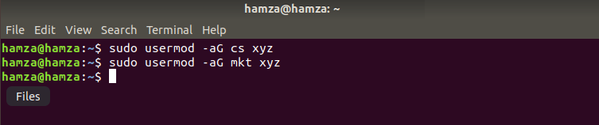

**TASK # 05**

**(a)**

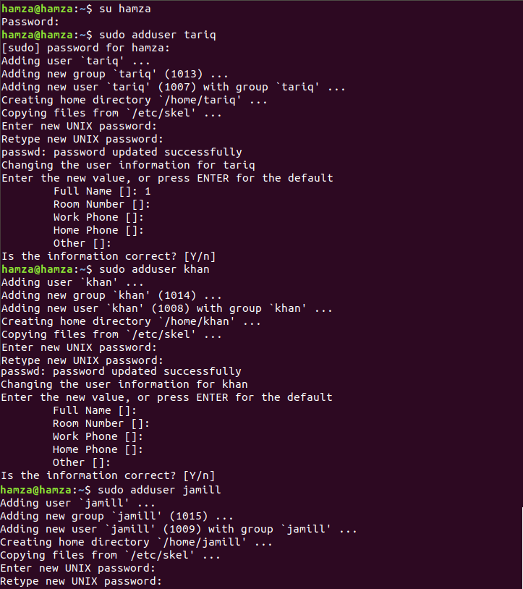

**(b)**

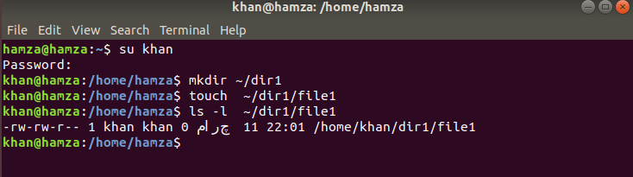

**(c)**

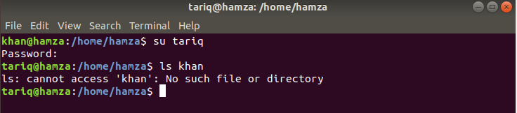

**(d)**

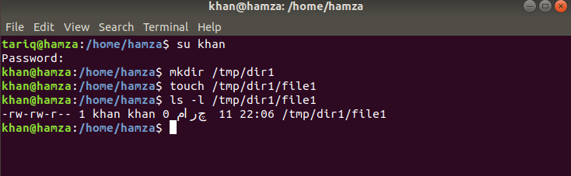

**(e)**

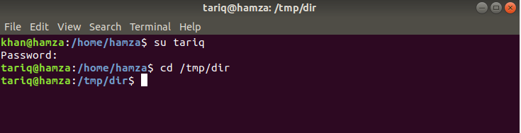

**(f)**

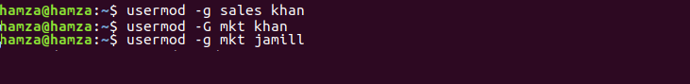

**(g)**

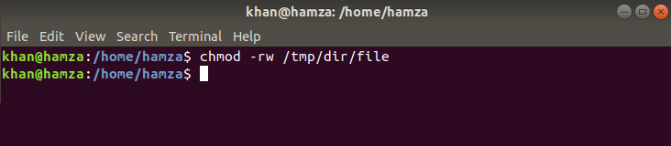

**(h)**

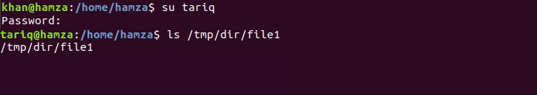

**(i)**

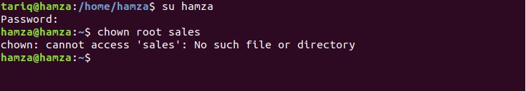

**(j)**

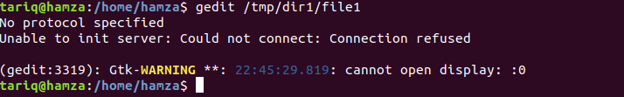

**TASK # 06**

**(a)**

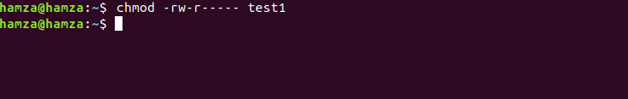

**(b)**

**b - Part (a)**

***chmod 740 courses***

chmod 740 set read, write and execute permission to owner of course, set read, write permission to group of course and only read permission to others of course.

**b - Part (b)**

***chmod u=rwx courses***

It gives read, write and execute permission to the owner of course.

**b - Part (c)**

***chmod 700 ~***

It sets permissions so that owner can read write and execute but group and others cannot read, write and execute.

**b - Part (d)**

***chmod ugo-rw sample***

It does not give read, write and execute permission to owner, group and others.

**b - Part (e)**

***chmod a-rw sample***

It takes every permission that will be given to sample by default or some other way.

**b - Part (f)**

***chmod a+x sample***

It gives execute permission to owner, group and others of sample.

**b - Part (g)**

***chmod g=u sample***

It will remove write permission from group of sample.

**b - Part (h)**

***chmod go= sample***

It will remove permissions from group and others.

**b - Part (i)**

***chmod 776 ~/lab5***

It gives read, write and execute permissions to owner and groups and only read, write permission to others.

**b - Part (j)**

***chmod 751 ~/lab***

It will remove read permission from group.

**(c)**

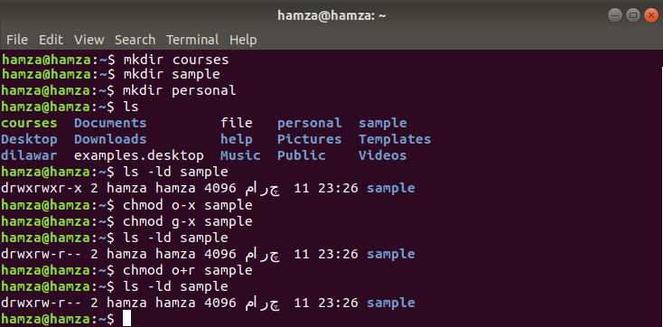  
**(d)**

chmod 700 gives read, write and execute permissions to only owner. So after using this command only owner can read the file but group and others cannot read it.