**TASK 1**

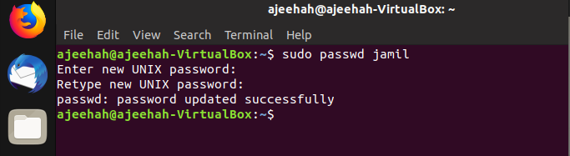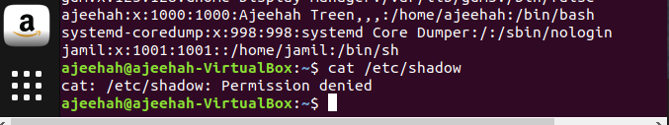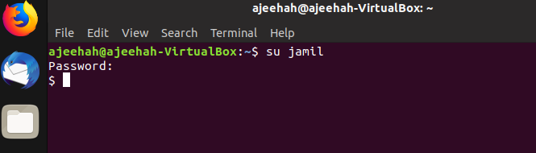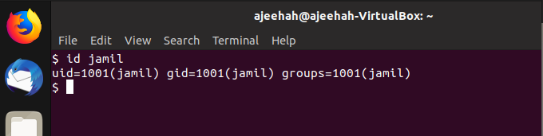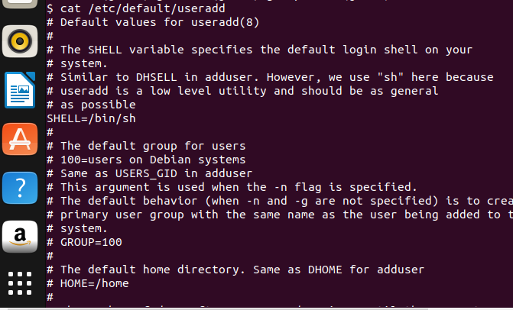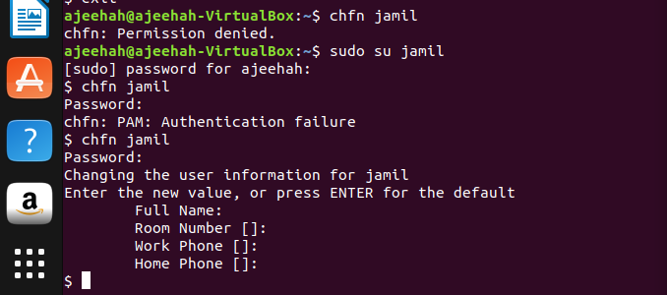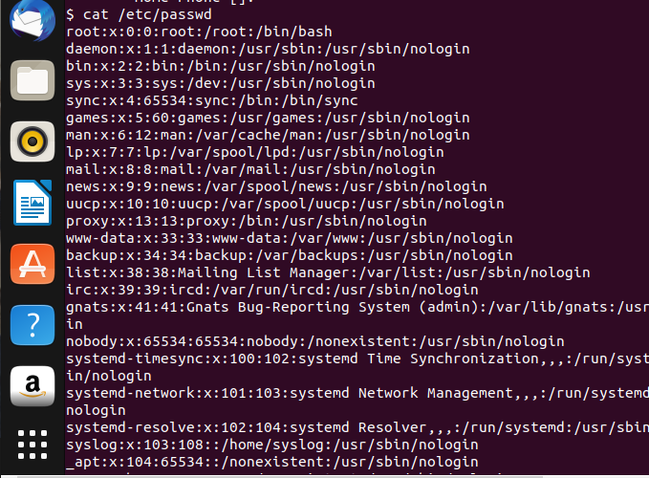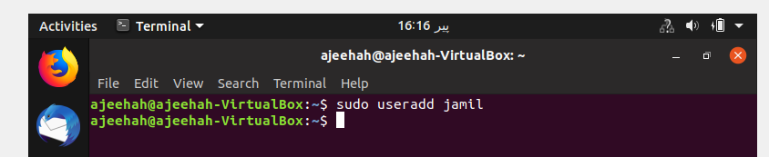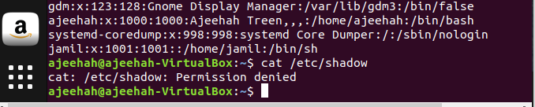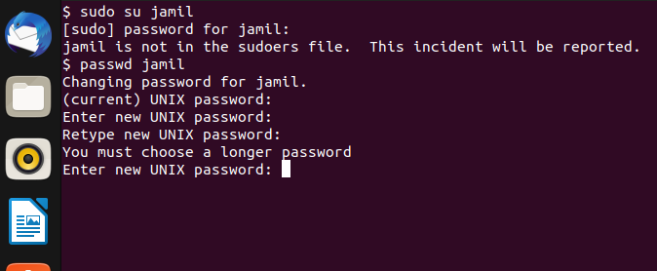

**TASK 2**

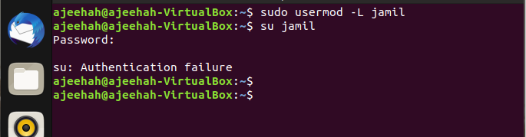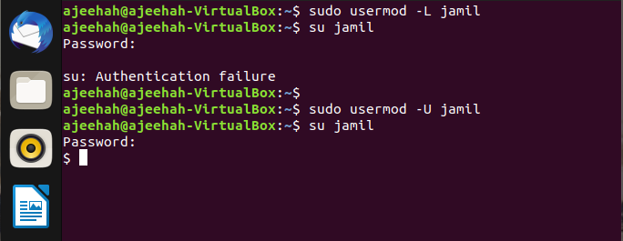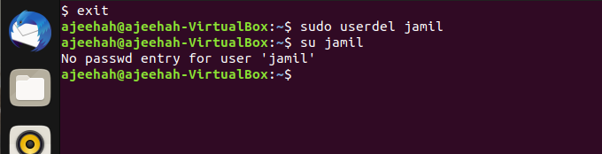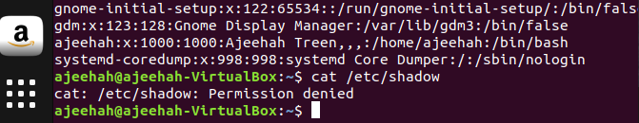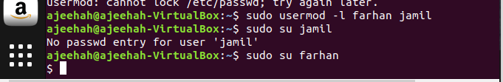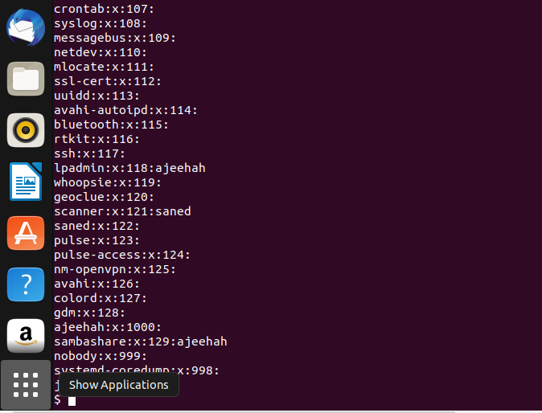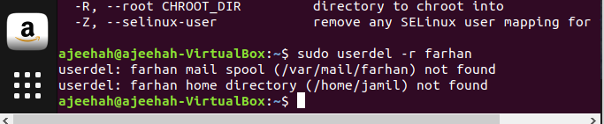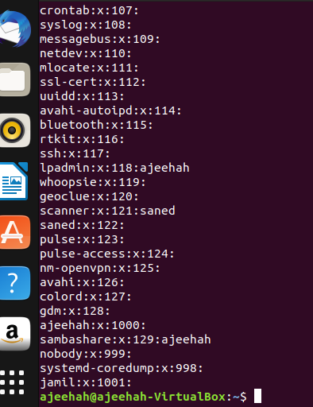

**TASK 3**

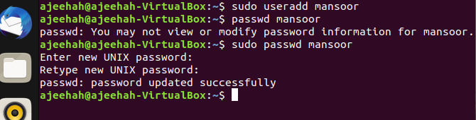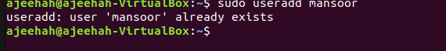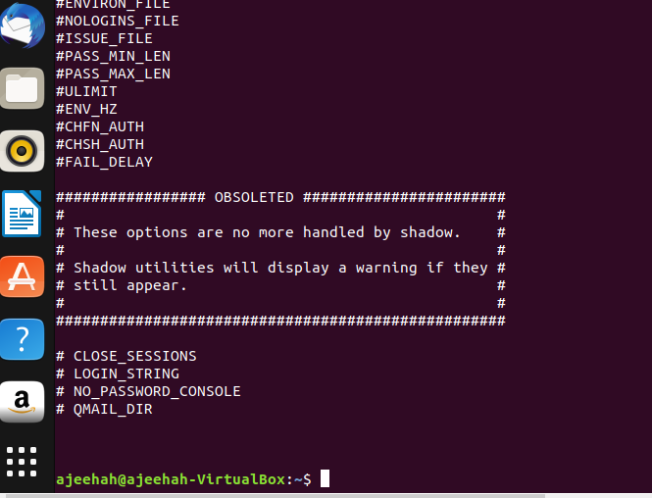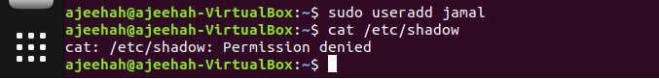

**TASK 4**

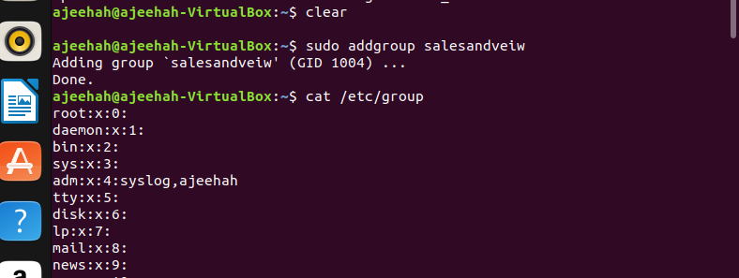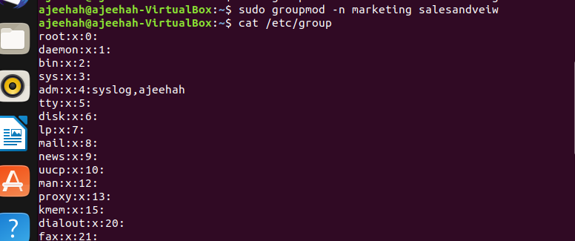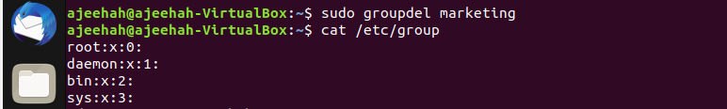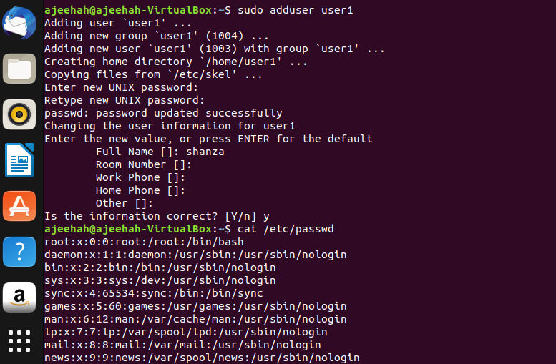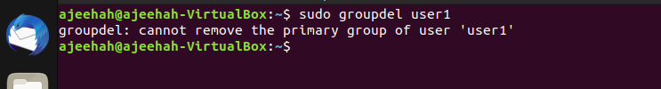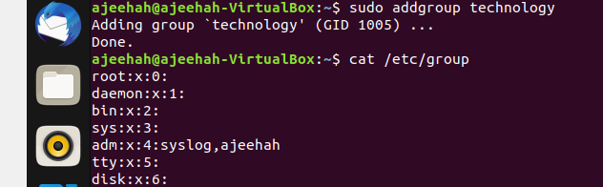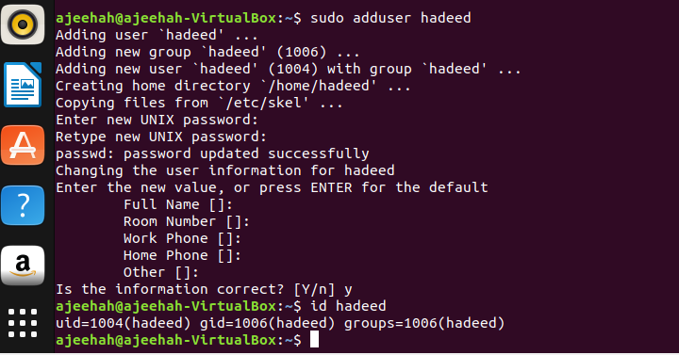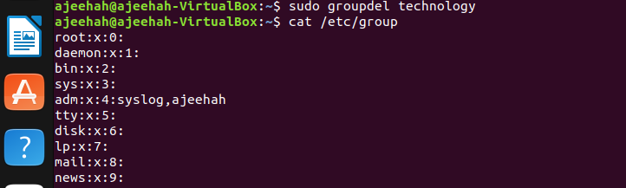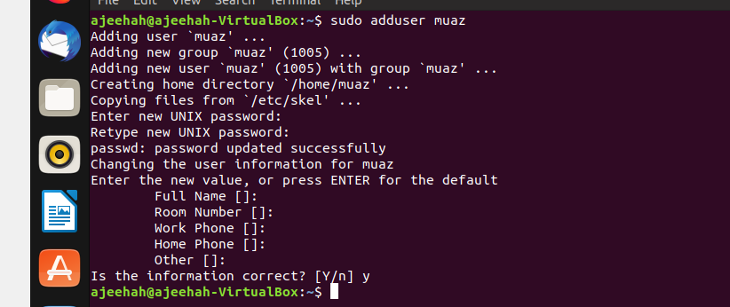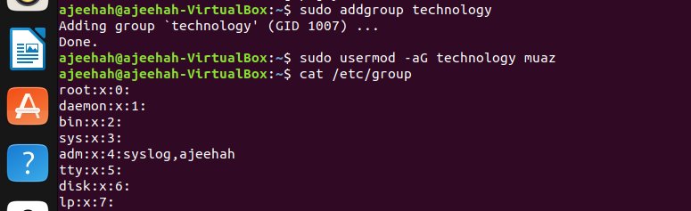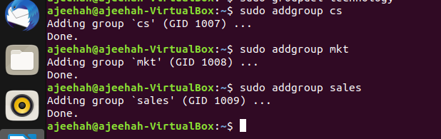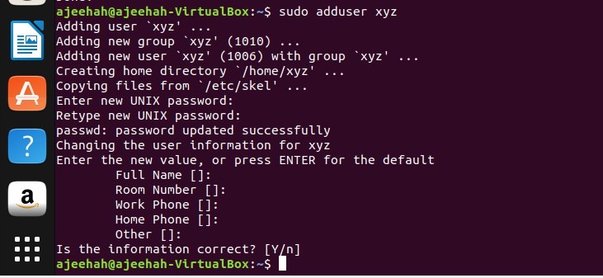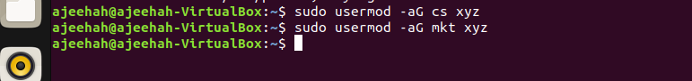

**TASK 5**

**a) Sudo su**

**adduser tariq**

**adduser khan**

**adduser jamil**

**b) Su khan**

**Mkdir dir1**

**touch dir1/file1**

**ls dir1/file1**

**c) Su tariq**

**Cd tmp/khan/home**

**d) Su khan**

**Cd tmp/dir1**

**Touch tmp/dir1/file1**

**Ls -l tmp/dir1/file1**

**e) Su tariq**

**Cd tmp/dir1**

**f) Sudo su**

**Sudo addgroup sales**

**Sudo addgroup mkt**

**Sudo usermod -g sales tariq**

**Sudo usermod -g sales khan**

**Sudo usermod -aG mkt khan**

**Sudo usermod -aG mkt jamil**

**g) Sudo su khan**

**Chmod 755 /tmp/dir1/file1**

**h) Sudo su tariq**

**Cat /tmp/dir1/file1**

**Ls -l /tmp/dir1/file1**

**i) Sudo su khan**

**Su chown sales file1**

**j) Sudo su khan**

**Gedit tmp/dir1/file1**

**k) Sudo su jamil**

**Gedit tmp/dir1/file1**

**l) Sudo su root**

**Sudo usermod -aG sales jamil**

**Sudo su jamil**

**Cat /tmp/dir1/file1**

**TASK 6**

**a) Chmod 740**

**b) a. rwx-r------ permission to file/directory courses**

**b. users = rwx permission to file/directory courses**

**c. rwx------ permission to ~ directory**

**d. user group and others eliminate read write access of file sample**

**e.all eliminate read write access to file sample**

**g. group access gets equal to user’s access**

**h. others and group access of same gets = ---**

**i. rwxrwxrw- for file/directory named lab**

**j. rwxr-x—x for file/directory named lab**

**c) mkdir course sample personal**

**chmod 740 sample**

**ls -l**

**chmod o+r sample**

**ls -l**

**d) main folder not accessible**