**TASK 01**

1.

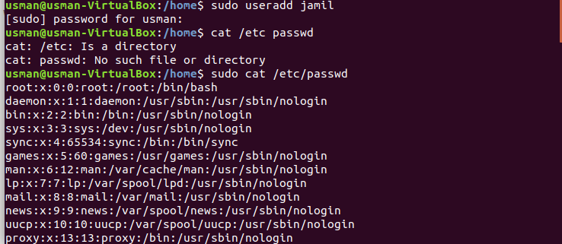

2.

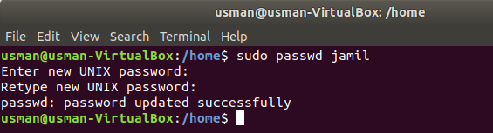

3.

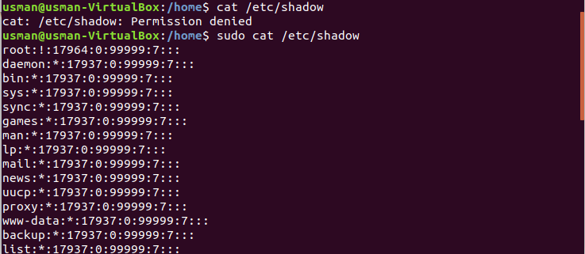

4.

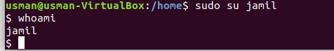

5+6.

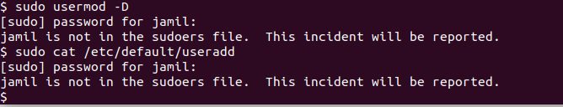

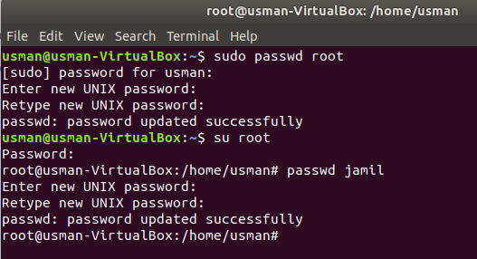

7.

8.

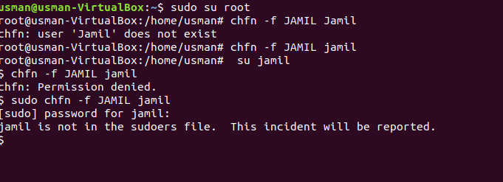

**Task2**

1.

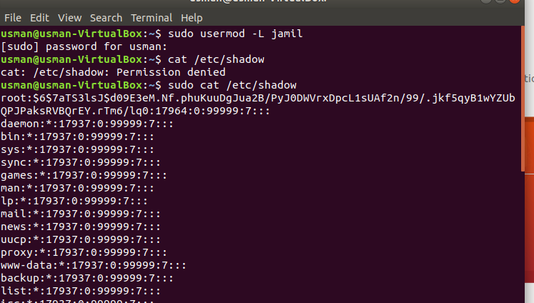

2.

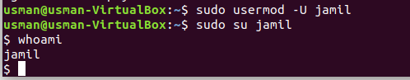

3.

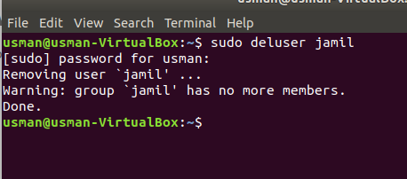

4.

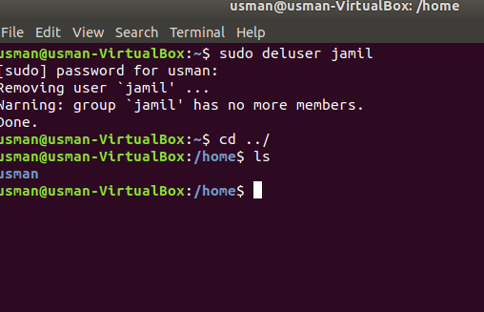

5+6.

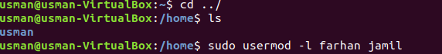

7.

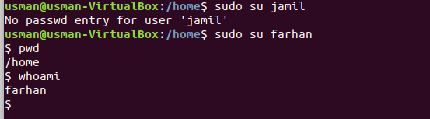

8.

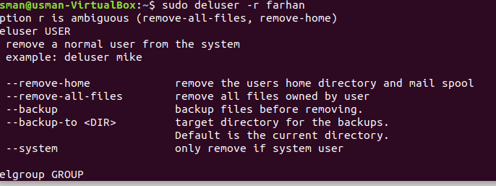

**Task 3**

1+2+3+4.

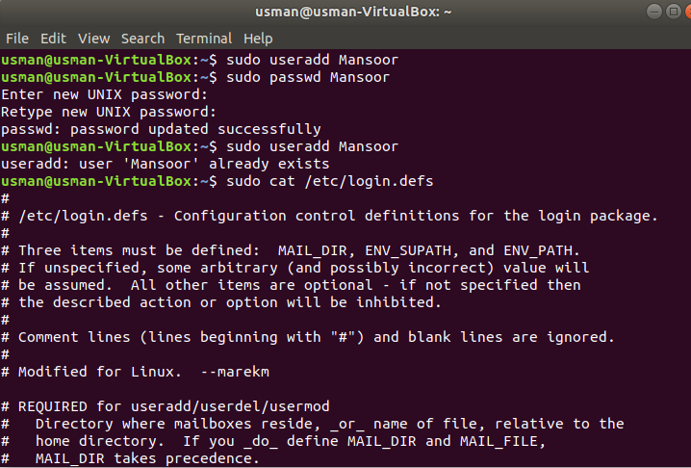

5.



Permission denied

**Task 4.**

1.

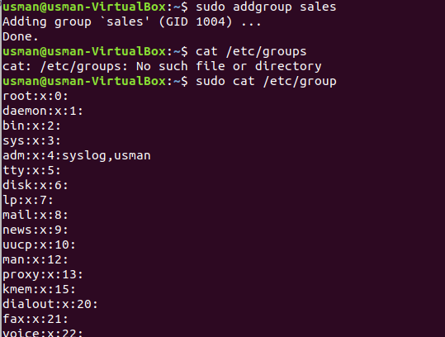

2.



3.

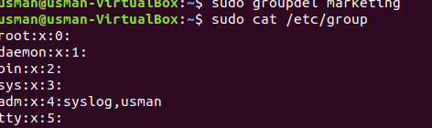

4.

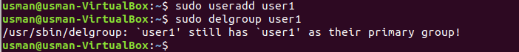

5.

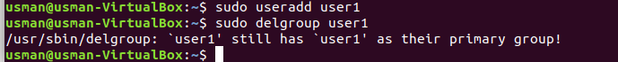

6+7.

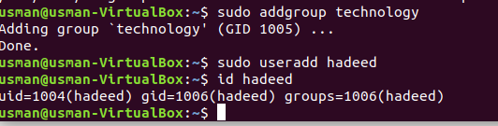

8.

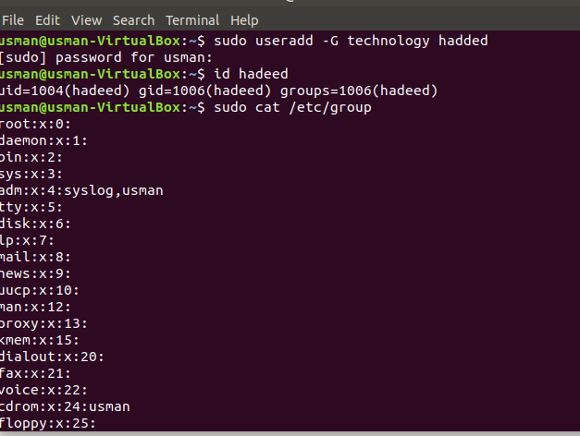

9.

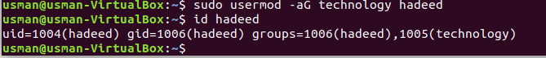

10.

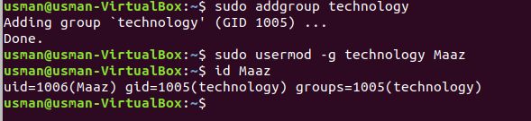

11.

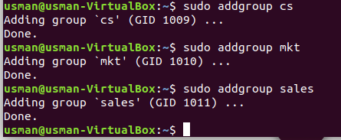

12.

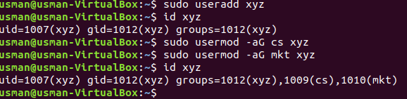

13+14.

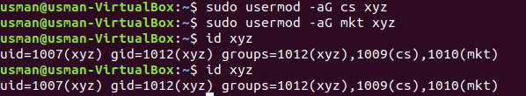

**Task 5**

1.

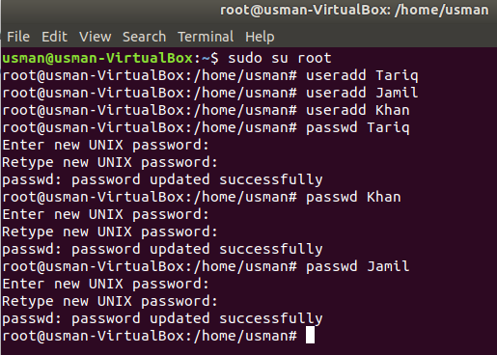

2+3.

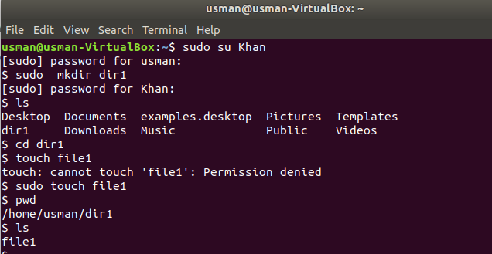

4+5.

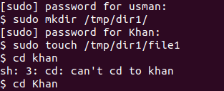

6.

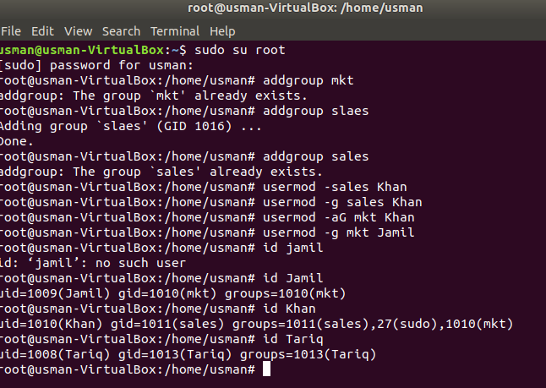

7.

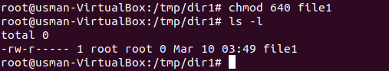

8.

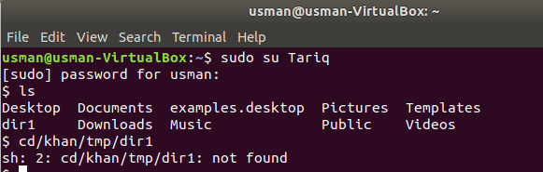

9.

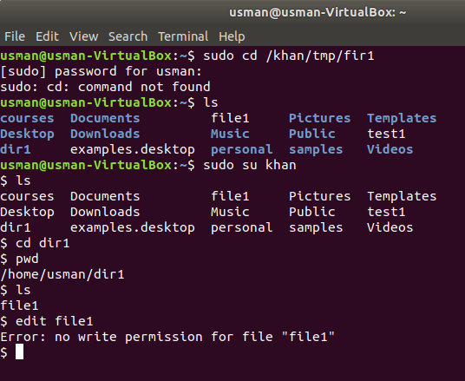

10.



**Task 06**

1.

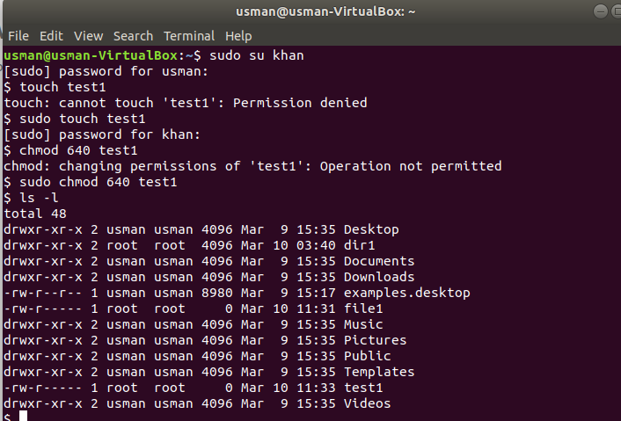

2.

a = rwx-r------ permission to file/directory courses

b= users = rwx permission to file/directory courses

c= rwx------ permission to ~ directory

d= user group and others eliminate read write access of file sample

e=all eliminate read write access to file sample

f= all add execution access to file sample

g=group access gets equal to user’s access

h= others and group access of same gets = ---

i=rwxrwxrw- for file/directory lab5

j=rwxr-x—x for file/directory named lab

3.

