**컴퓨터네트워킹 과제**

**HW#4**

**강좌 명: 컴퓨터네트워킹**

**교수님: 안종석 교수님**

**학과: 컴퓨터공학과**

**학번: 2017112138**

**이름: 정여준**

**P1. Consider the network below**

**a. Show the forwarding table in router A, such that all traffic destined to host H3 is forwarded through interface 3.**

**b. Can you write down a forwarding table in router A, such that all traffic from H1 destined to host H3 is forwarded through interface 3, while all traffic from H2 destined to host H3 is forwarded through interface 4? (Hint: This is a trick questions)**

a) H3으로 전송되는 데이터는 인터페이스 3을 통해 전달된다.

|  |  |
| --- | --- |
| **Destination address** | **Link interface** |
| H3 | #3 |

b) No (전달규칙은 대상 주소에만 기반으로 하고 소스 주소는 기반으로 하지 않기 때문이다.)

**P5. Consider a datagram network using 32-bit host addresses. Suppose a router has four links, numbered 0 through 3, and packets are to be forwarded to the link interfaces as follows:**

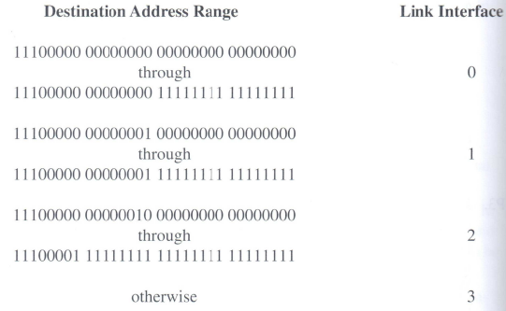

**a. Provide a forwarding table that has five entries, uses longest prefix matching, and forwards packets to the correct link interfaces.**

**b. Describe how your forwarding table determines the appropriate link interface for datagrams with destination addresses:**

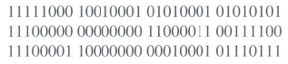

a)

|  |  |
| --- | --- |
| **Prefix Match** | **Link interface** |
| 11100000 00000000 | 0 |
| 11100000 00000001 | 1 |
| 1110000 | 2 |
| 1110001 | 3 |
| otherwise | 3 |

b) 11111000 10010001 01010001 01010101

prefix match 5번째 항목 otherwise에 해당한다. 따라서 link interface 3

11100000 00000000 110000011 00111100

prefix match 1번째 항목 11100000 00000000에 해당한다. 따라서 link interface 0

11100001 10000000 00010001 01110111

prefix match 3번째 항목 1110000에 해당한다. 따라서 link interface 2

**P14. Consider sending a 1,600-byte datagram into a link that has an MTU of 500 bytes. Suppose the original datagram is stamped with the identification number 291. (a) How many fragments are generated? (b) What are the values in the various fields in the IP datagram(s) generated related to fragmentation?**

(a) number of fragments = ┌ $\frac{Datagram-IPheader}{MTU-IPheader}$ ┐ = ┌ $\frac{1600-20}{500-20}$ ┐= 4

(b) 각 fragment는 식별번호 291이 있다. 마지막 조각을 제외한 각 fragment의 크기는 500 byte이다. 마지막 datagram은 160 byte이다. fragment 4개의 offset은 0, 60, 120, 180이 된다. 처음 3개의 fragment는 flag=1이고 마지막 fragment는 flag=0이다.

**P20. Consider again the SDN OpenFlow network shown in Figure 4.30. Suppose that the desired forwarding behavior for datagrams arriving from hosts h3 or h4 at s2 is as follows:**

* **any datagrams arriving from host h3 and destined for h1, h2, h5 or h6 should be forwarded in a clockwise direction in the network:**
* **any datagrams arriving from host h4 and destined for h1, h2, h5 or h6 should be forwarded in a counter-clockwise direction in the network:**

**Specify the flow table entries in s2 that implement this forwarding behavior.**

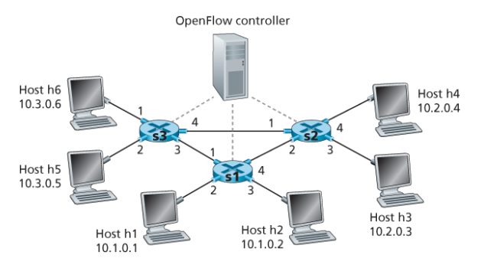

|  |  |
| --- | --- |
| **S2 Flow Table** | |
| **Match** | **Action** |
| **Ingress Port = 3; IP Dst = 10.1.*.\***  **Ingress Port = 3; IP Dst = 10.3.*.\*** | **Forward(2)**  **Forward(2)** |
| **Ingress Port = 4; IP Dst = 10.1.*.\***  **Ingress Port = 4; IP Dst = 10.3.*.\*** | **Forward(1)**  **Forward(1)** |