**Description**

HCV dataset is the dataset containing laboratory values and information such as demography, sex of several blood donors and Hepatitis C patients. The main objective of this dataset is to identify whether an observation represents blood donor, suspect blood donor, hepatitis, fibrosis or cirrhosis. There are 10 laboratory values affecting the result and demographic information like age, sex and id or no of the patient in the dataset.

The features in the dataset are discussed below:

* Patient ID/ No
* Age
* Sex
* ALB
* ALP
* AST
* BIL
* CHE
* CHOL
* CREA
* GGT
* PROT

According to such features, the class category of the patient which should be classifies are listed out below:

1. Class 0 representing Blood Donor
2. Class 0’s representing suspect Blood Donor
3. Class 1 representing hepatitis
4. Class 2 representing Fibrosis
5. Class 3 representing Cirrhosis

The main objective in this dataset is to classify patient to above classes according to thier demographic data like age, sex and laboratry data such as ALB, ALP and os on.

**Data Preparation**

The dataset was downloaded from the UCI ML repository website and loaded using the read.table method in R. First ten observations of the data are shown below.

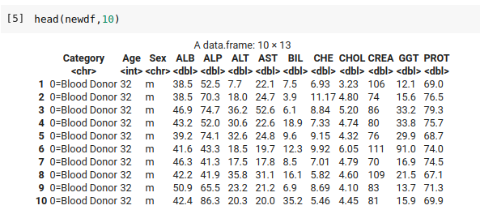

Fig: Screenshot showing first 10 observations of HCV dataset

**Data Preprocessing**

Following processes were involved in the data preprocessing step:

* Convert non numeric data to numeric

The category column values are represented as “0=Blood Donor”. However, for classification, we should convert it into numeric form. Thus, initially, such non numeric columns are converted in numeric form. For this a new column, class is added which has the numeric representation of the category class and category class is removed. The column “Sex” is also converted to numeric form by replacing the “m” value with 0 and “f” value with 1.

* Balancing the dataset

Number of data representing each category is not equal and an imbalanced dataset leads to poor classification. Thus, to balance the dataset, we remove certain data from category 0 as a process of undersampling.

* Removing null values

While checking the null values in the dataset, there were 19 observations containing null values. Such null values were dropped.

After performing above steps in the dataset in R, the first ten observations of the dataset are shown below:

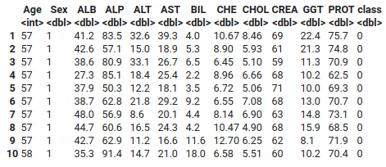

Fig: Screenshot representing first 10 instances of data after preprocessing

**Data Analysis**

* **Correlation Plot**

Initially, we evaluate the correlation between the columns in the dataset. Following correlation plot is obtained.

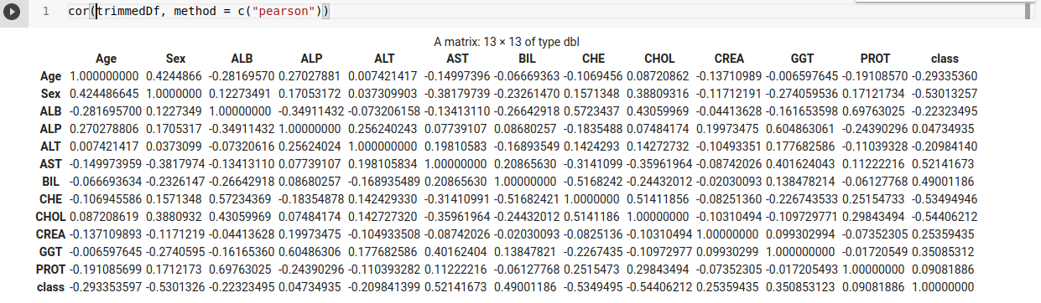

Fig: Correlation plot of the different categorical variables with the response variable

The correlation plot is obtained using the “corrr” package of R. This plot is the Pearson correlation plot of each and every categorical variables in the dataset. The correlation coefficient indicates the level of linear relationship between the two variables. The correlation coefficient close to -1 indicates strong negative linear relationship whereas close to +1 indicates strong positive linear relationship. From above correlation plot, we can deduce that the features “AST” and “BIL” have moderate positive linear relationship with the class column. Similarly, features like “Sex” and “CHE” have moderate negative relationship with the class column. We can also deduce the similar features from the correlation plot. We can deduce that features like “PROT” and “ALB” are highly correlated and columns like “ALP” and “GGT” are also highly correlated. These similar features can be discarded in the feature selection step. Thus from correlation plot evaluation, we discard features like “ALB” and “GGT”.

* **Scatter Plot**

Scatter plot is generated for the dataset using the pairs.panels function from the “psych” package in R. This feature is used to produce a matrix scatter plot with bivariate scatter plots below the diagonal, histograms on the diagonal, and the correlation of Pearson above the diagonal. Following scatter plot is obtained using this package.

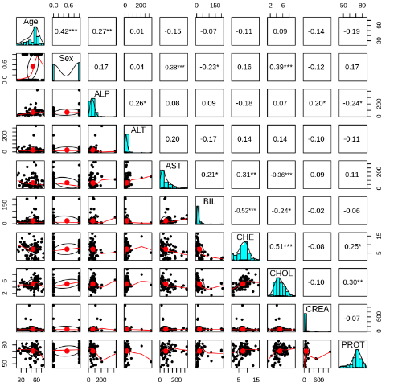

Fig: Scatter plot of the feature selected HVC dataset

Summary of the trimmed dataframe is also generated using summary() method in R. Following is the summary generated.

From the above scatter plot, we can evaluate that features such as “Sex” follows binomial distribution whereas features like “PROT”, “CHE”, “CHOL”, “Age” follows normal distribution.

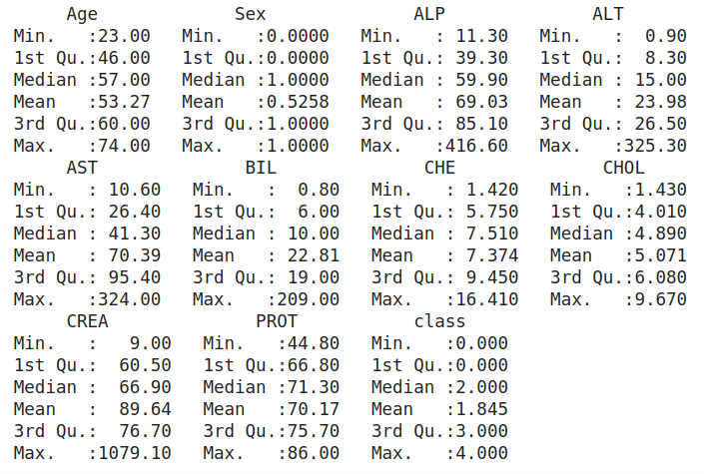

Fig: Summary of the trimmed dataset

**Classification**

The major task in this dataset is to classify the patient whether they belong to “Blood Donor” or “Suspect Blood Donor” or “Hepatitis” or “Fibrosis” or “Cirrhosis”. To develop a classification model, extreme gradient boosting is used. The extreme gradient boosting is done through the use of “xgboost” package in R. Initially the cleaned and preprocessed to a train test split of ratio 0.75: train and 0.25: test. After the train test split, the xgb.DMatrix is prepared for the entire dataset separately for training and testing data. The xgb model developed using this package is subjected to fitting the training dataset and also a k fold cross validation with k =5. After the training of the model and validating model with 5 fold cross validation, out-of-fold `prediction errors were assessed. After assessing such errors, the out-of-fold prediction were obtained as follows:

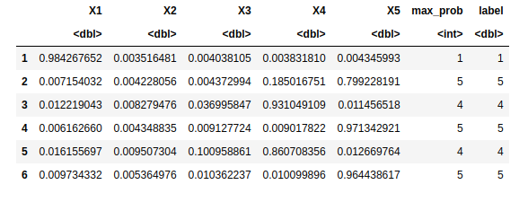

Fig: Out-of-fold prediction errors obtained from xgboost 5 fold cross validation

For the evaluation of the multi-class classification model, confusion matrix and other evaluation metrics were generated from the model subjecting the model with actual test data and the predictions generated from the model from xgboost classification model. Following classification results were obtained from the model:

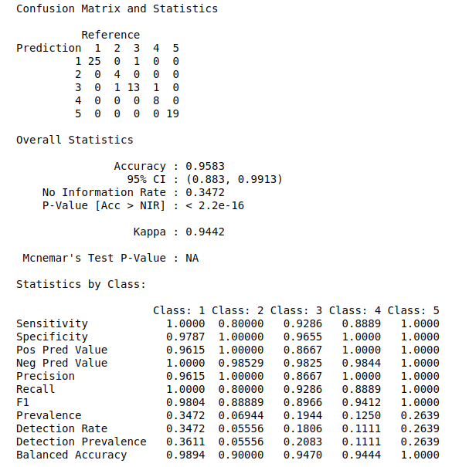

Fig: Classification report for the test data in HCV dataset

Thus, using the xgboost classification technique for this dataset, we achieved an overall accuracy of 95.8% in this dataset. The F1 score of the classification model is very high for three classes whereas around 0.88 F_score was obtained for the other two classes.