**Chinmayee**

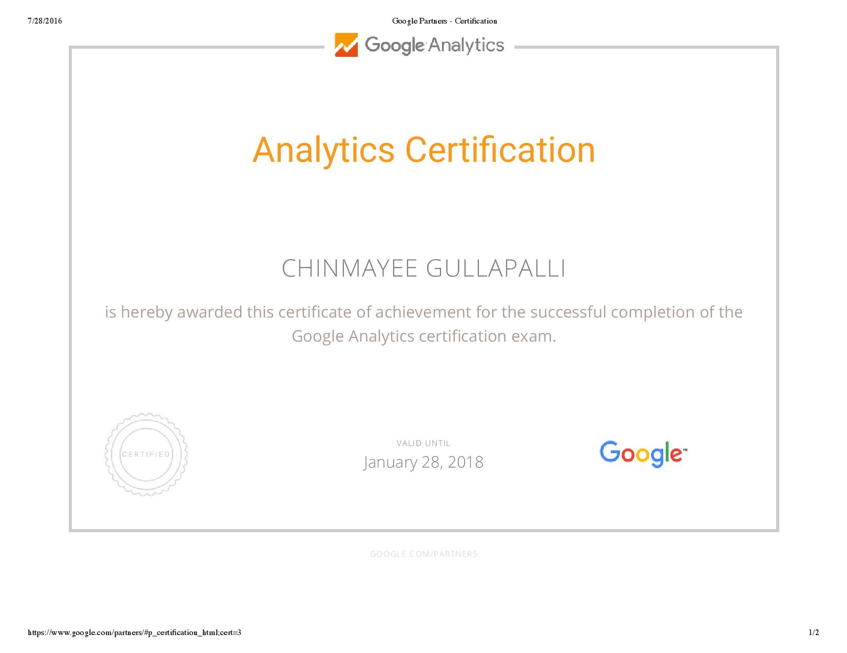

**\*Google Analytics Certified\***

**SUMMARY**

* An eloquent Developer with **7+ years of experience** in CMS and analytics, with an innate appetite for learning new concepts and a strong passion to work in challenging environment with promising excellence.
* Self-motivated with capability of managing multiple projects at a time.
* Experience in Retail Management Systems, Payment Gateway, E-commerce, Marketing, Networking, Manufacturing and Retail Platform.
* Strong experience in working with PHP, LINUX, MYSQL, Oracle, APACHE, HTML, JQuery, XML, CSS, JavaScript, databases.
* Good understanding of Object Oriented Programming& strong knowledge in MVC architecture and NoSQL DB like MongoDB.
* Extensive experience in creating and maintaining databases which includes configuration, query optimization and de-normalization using MySQL, Oracle.
* Responsible for theming responsive web pages and implemented site optimization, site building and used debugging tools for front end and backend in compliance to the web accessibility standards.
* Strong experience working with version control -SVN and Git.
* Experience with custom modules and contributed modules of Drupal and worked with LAMP and WAMP stack.
* Strong knowledge of caching and load balancing in Drupal and have experience in different versions of Drupal.
* Responsible for providing best available Drupal solution for any specific requirement.
* Good knowledge on Section 508 and ADA compliancy.
* Strong Knowledge of connectivity layers, service calls, transaction control and code reviewing.
* Strong knowledge of Template Integration for CMS, CRM& E-commerce web applications.
* Wrote complex queries, indexes, triggers and implemented CRUD operations in the back end using MySQL, Oracle and SQL server.
* Strong experience in Google Analytics, Adobe analytics, Double click, Google web master tools and web metrics.
* Worked with funnel conversion concept of Google Analytics and eVar, props, success events of Adobe analytics.
* Extensive experience in conducting Market Research, Feasibility Studies, Gap Analysis, Risk Identification, Risk Analysis, customer survey and web data analysis to understand customer and business needs.
* Experience on Pricing Strategy, SEO strategy developing and Omni Channel marketing campaign using Google Analytics, Facebook, Microsoft Ad Center and LinkedIn Ads.
* Well versed with debugging tools like Charles, Firebug &amp; WASP and data mining techniques like regression methods, decision trees, MBR.
* Contributed to all phases of Software Development Lifecycle including requirements gathering, analysis, design and development, testing and maintenance.
* Exposure in working with Agile Methodologies & participating with Sprint meetings, daily Scrum meetings, sprint review meetings.
* Working experience in integration of REST & SOAP Web Service that includes calling external web service using JSON and XML & developing internal service to integrate with mobile applications.
* Expertise in broad range of technologies, including business process tools such as MicrosoftProject, MS Excel, MS Access, MS Word, MS Visio.
* Performed Unit testing, Integration Testing, multivariate& A/B testing after the functionality is achieved.

**TECHNICAL SKILLS:**

|  |  |
| --- | --- |
| **Programming Languages:** | C++, C#, JAVA, UNIX (Shell scripting), DHTML, XML, XSL, JSP, HTML5, PHP4/5, Python, ASP.NET, C#.NET |
| **Scripting Languages:** | JavaScript, JQuery, ASP, UNIX Shell Scripting, PL/SQL |
| **Frameworks:** | JQuery, Zend, Code Igniter, CakePHP, Symphony, Bootstrap, Spring core & MVC, Struts, JMS, Hibernate |
| **Web technologies:** | HTML 4/5, CSS 2/3, LESS, SOAP, Web Services, AJAX, OOCSS, XML, XSLT, DOM, REST, JSP, react js |
| **CMS**: | Drupal 7 & 8, WordPress, Joomla |
| **Software/IDE:** | Dreamweaver, WAMP Server, Microsoft Visual Studio, NetBeans, IntelliJ |
| **Methodologies:** | Agile, Scrum, Waterfall. |
| **Tools:** | Microsoft Office, MS Visio, MySQL, ClearQuest, Selenium, Charles, Omnibug, WASP, Firebug, Bugzilla, Jira, Jenkins |
| **Analysis:** | SAS EM, Google Analytics, Google Trends, Omniture, R, Tableau, Site Catalyst Google Webmaster tools |
| **Database:** | MySQL 5.2, Oracle 10G/9i, SQL SERVER 2005/2008 |
| **OS:** | Android, IOS, Windows, Unix, OSX |
| **Cloud:** | AWS, SAAS, PAAS, IAAS, MS Azure |

**PROFESSIONAL EXPERIENCE**

**COPART, Dallas, TX . June 14 - Present**

**Sr. PHP/ Drupal Developer .**

Copart, Inc., headquartered in Dallas, Texas, is a provider of online vehicle auction and remarketing services in many countries including the United States. Copart provides vehicle sellers with a range of services to process and sell salvage and clean title vehicles over the Internet using its patented virtual auction technology. Our project concentrates on building websites, targeting different users asCopart's buyers are used vehicle dealers, dismantlers, rebuilders, exporters and, at some facilities, the public. and analyzing the user flow.

* Closely worked with business analyst to understand the requirements to ensure that right set of UI modules been built.
* Wrote application level code to perform client side validation using JQUERY and JavaScript.
* Designed the front-end applications, user interactive (UI) web pages using web technologies like HTML, XHTML, and CSS.
* Implemented custom modules in Drupal, PHP 5.6 and worked with themes, Panels.
* Extensively involved in modifying the views based on the user status.
* Wrote JQUERY function while implementing various UI Screens across the whole web application (both consumer facing as well as internal application).
* Implemented the presentation layer with HTML, XHTML, JavaScript (node js), react js, Ajax, and CSS, jQuery other libraries.
* Implemented Object Oriented design patterns and Analysis, SOA principles, system testing with analytical and diagnostic skills.
* Experience with PHP 7 and SimpleDB, DynamoDB, SOLR and application performance tuning with New Relic.
* Prepared a Test plan which specified the testing approach and strategy and the scope of testing.
* Used CSS3 to develop Rich Graphic UI Components such as Accordions and Modal Windows using CSS3.
* Utilized Modernizer extensively to build HTML3/CSS3 based page layouts that are cross-browser compatible.
* Worked with SASS for developing layouts using variables, functions, and other features for generating style sheets with CSS3 properties.
* Developed compatible User Interface functionality using jQuery, Ajax, JavaScript & other libraries.
* Developed RESTful services in Laravel 5 MVC architecture and implemented OAuth and SAML for authentication.
* Wrote scripts in PHP for web page elements which involve user data, sanitized and validated the external data.
* Created Drupal modules for Active log sessions and Service Reporting System.
* Maintained groups of multiple users using Drupal.
* Worked with search pages, range queries, faceted search of **Apache Solr module** after integrating with Drupal.
* Implemented sessions and cookies with PHP to maintain personalized web page for the user.
* Worked with **Memcache** for a dynamic database driven website and to provide robust security.
* Created tables, functions, triggers, cursors in the back end using MySQL(with ER diagrams)for connection pooling and PL/SQL.
* Implemented google analytics to know the user flow, goal flow and goal conversion.
* Participated in meetings related to website design, functionality and **Marketing monetization**.
* Computed **ROI and PPC** based on web conversions and social media metrics to place a monetary value on social benchmarks to communicate social growth to clients.
* Implemented **eVars, props, and events** in adobe analytics and designed websites which areOIC compliant.
* Implemented A/B testing to get a better understanding of which web page version receives the more user flow.
* Used **Omniture** to check the website performance and Charles, Omnibug as the debugging proxy.

**Environment: Drupal7& 8, Travis, Behat, PHP 5, MySQL 5.1/5.3, HTML4/5, XHTML, CSS3, JavaScript, AJAX, JQuery,Bootstrap, modernizer, Linux, Drush, Memcache, Varnish, Agile, Adobe Analytics, Charles, Omniture, Google web master tools, web metrics.**

**MACY’S, Atlanta, GA. July12-June 14**

**Drupal/PHP Developer .** Macy's, Inc. is an American holding company headquartered in Cincinnati, Ohio. It specializes in the sales of clothing, footwear, accessories, bedding, furniture, jewelry, beauty products, and housewares. The project was to fathom the user flow, goal flow and to increase the ROI by making sure that the conversion goals are attained. I contributed to the front-end development with Drupal, CSS, PHP and REST as the web service and implemented analytics for the data.

* Contributed to the BRD, FRD design and assisted the Business Analyst for requirement gathering
* Provided inputs to the team based on my analysis of data and best web practices, responsive design to be followed.
* Contributed to the front end designing for the project using PHP using CMS(Drupal) and Oracle in the backend.
* Implemented the core, custom modules of Drupal by extending them and was responsible for theming using Zen and many other themes besides Panels and views.
* Used JavaScript, HTML 5, CSS3 properties for customizing the theme and OIC compliant web development.
* Worked with views module and the hook system of Drupal.
* Integrated the custom modules with web services like REST.
* Responsible for developing custom modules and used PHP filter module to incorporate PHP scripts in Drupal.
* Created forms and validated them using PHP and used the combination of Drupal and CSS for the front end.
* Created hooks and upgraded them to implement enhanced features for the nodes.
* Held an active role in integrating different applications like payment gateway.
* Interacted with stakeholders and made documentation how contributed as well as custom module is implemented.
* Provided monthly and weekly reporting based on the data collected from Google Analytics and SEO with the help of Tag manager.
* Participated in meetings related to website design, functionality and Marketing monetization.
* Played an active role in Unit Testing, Performance testing, functional testing & A/B Testing.
* Always took part in scrum meetings held to address any issues that arose during the implementation
* Assisted the test team in creating test cases and keeping track of bugs with IBM ClearQuest
* Used datasets to create various models in SAS enterprise miner and R studio.
* Used Tableau for data reporting.
* Worked with MS Azure to implement cloud deployment models.
* Created web traffic analytics reports, with Google analytics and web Trends, using "tagging" with JavaScript code for web page elements, in addition to report the hits on the general web pages; created dozens of analytics reports / profiles, scheduled to generate daily, weekly, monthly and ad hoc reports, for both public and internal web sites.
* Worked with debugging tools like Charles, Firebug & WASP and data mining techniques like regression methods, decision trees, MBR.

**Environment: Drupal 7, Zen, Code Igniter, Oracle**10G**, XML, HTML, CSS, JavaScript, AJAX, JQuery, Jenkins, REST, DOM, Agile, SVN, SAS EM, Omnibug, R, ClearQuest, Tableau, web trends, Optimizely, WASP, Firebug, Charles, Google Analytics, KissMetrics, MS Azure, IIS.**

**NIKE, Portland, Oregon . Jan 11- July 12 PHP/Drupal Developer****.**

Nike, Inc. is an American multinational corporation that is engaged in the design, development, manufacturing and worldwide marketing and sales of footwear, apparel, equipment, accessories and services. As a team member, I built webpages by extending themes in Drupal, adding blocks to the web pages, authorizing the users and keeping track of the e-commerce site, implemented tags and variables in the data Layer using DTM and GTM.

* Involved in designing the front end with Drupal and migrating to Drupal 7 and worked with CKEditor in Drupal.
* Extensively worked on user permissions to authenticate the user’s authorization and to grant them permission on the web page enabling it to be edited by anyone.
* Hand-coded HTML, CSS, and JavaScript in compliance with UI and W3C web standards which require understanding of current browser technologies, XML, JavaScript, object-oriented programming, databases, and project development methodologies.
* Proactively increased efficiencies of websites and web-based applications using style sheets and JavaScript.
* Worked with MySQL in the backend and implemented CURD operations with ACID properties.
* Involved in design of efficient database for various modules by following normalization concepts, wrote complex SQL statements and stored procedures by using indexes in stored procedures.
* Worked with triggers, indexes and cursors in the database to ensure data integrity.
* Implemented the same web page on no-CMS platform and have strong knowledge of responsive design and cross browser compatibility.
* Increased lead volume while lowering PPC Cost Per Click and Cost per Lead.
* Active participant in creating and modifying data for SEO optimization efforts
* Implemented Google Analytics event tracking on website to monitor and analyze quality traffic through Google Analytics.
* Test and streamline keyword bids, ad copy, and landing pages to maximize ROI.
* Manage campaign expenses, staying on budget, estimating monthly costs.
* Performed ongoing keyword discovery, expansion, and optimization.

**Environment: Drupal 7,Object Oriented Programming, CakePHP, XML, JavaScript, Agile, Oracle**10G**, XML, HTML, CSS, JavaScript, AJAX, Git, JQuery, SAS EM, Omnibug, R, Google AdWords, Tableau, web trends, Optimizely, WASP, Firebug, Charles, Google Analytics, DoubleClick, GTM, DTM, test & target.**

**INTEL, Dallas, TX July 09-Jan 11**

**Web/PHP Developer**

Intel Corporation is an American multinational technology company headquartered in Santa Clara, California. Our project designed web pages which involve server side validations. I worked specifically with sanitizing and validating the client data and external data entered. I also worked with code minimization and reusability, error handling and cookie tampering.

* Extensively made use of PHP 5.2 version to develop financial application.
* Used Sigma front-end template engine for developing web pages with HTML5 standards.
* Extensively worked with symphony framework.
* Implemented OOPs concepts to create generic class files and made it available to be used by other programmers.
* Performed client side Validation using JavaScript. Generated user interface with CSS to accommodate the design and logic.
* Optimized website to accelerate page load times by using techniques including caching (data, page, fragment and dynamic) and code minification or minimization.
* Followed best standards and practices for development for sanitizing user input, for preventing web application from attacks such as SQL injection, cross-site scripting (XSS), cross-site request forgery(CSRF), and cookie tampering.
* Implemented exception handling for error checking.
* Participated in monthly scrums, code reviews, and deployment of code to the production environment.
* Used GIT for version controlling and maintaining the application source code.
* Used UNIX shell scripting, UNIX commands for distribution of Content.
* Integrated Google Analytics to monitor client web traffic and user statistics.
* Extensively worked to retrieve data from dashboards of Google Analytics and represented trough Data visualization tools like Tableau.
* Worked to increase the user flow, goal flow and made changes to the applications by implementing A/B testing through Optimizely tool.
* Execute tests, collect and analyze data, identify trends and insights using Google Analytics to achieve maximum ROI in paid search campaigns.
* Implemented new data sources and consumer tools into existing client databases.
* Conducted data analysis using basic statistics and database management to identify key trends in client-specific data.
* Monitored and enhanced risk metrics and developed metrics to promote better business results.

**Environment: Drupal 7, Data visualization, UNIX shell scripting, CSS, XSS, CSRF, symphony, JavaScript, SQL, Optimizely, Web metrics, SEO strategies.**

**EDUCATION:**

Osmania University (Hyderabad, India)

*Bachelors of Technology in Information Technology*