Chrystain R

# Open to Relocation

# Currently in Pennslyvania Chrispgmr11@gmail.com

# Professional Summary

* 7+ Years of Information Technology Experience
* 5+ Years of Software Development Experience
* 4+ Years of iOS Engineering Experience
* Skilled in the entire SDLC including: requirements gathering, wireframing/prototyping, UI/UX design, application development, project management, etc
* Expert in Object Oriented Programming in languages such as Objective-C, Java, and many more
* Familiar with Data Structures & Algorithms including memory management, multi-threaded applications, etc.
* Team Oriented Leader with experience working with onshore teams, solo development, and offshore and hybrid teams
* Commensurate experience with code base management including versioning, subversioning, and Git/Github and repository management
* Expertise in MVC/MVVM design architecture, Cocoa design patterns and iOS Human Interface Guidelines  
  • Experience in handling multithreading and concurrency using Grand Central Dispatch(GCD), Operation Queue  
  • Developed rich user interface by using Xib, Storyboard, Autolayout, adaptive layout and Cocoa Bindings  
  • Worked with frameworks like WebKit, Core Graphics, Core animation  
  • Worked on Apple Push Notification Services (APNS) and Local Push Notification  
  • Exposure to framework and SDK development, designing APIs and performance analysis  
  • Experience in parsing XML/JSON and Web Services Integration  
  • Sound knowledge of provision profile management and app submission to app store.  
  • Experience in working with UNIX environment and knowledge on Shell Scripting  
  • Proficient in Unit Testing (XCTest), Automated UI Tests(XCTestUI), Code Coverage and Test Driven Development (TDD)  
  • Expertise in source control with GitHub, SVN  
  • Strong debugging and performance optimization experience.  
  • Experience using CocaoPods for Dependency Management  
  • Collaborated with QA leads, graphic design leads, project managers, and other stakeholders to effectively develop applications  
  • Hands on experience working with software development methodologies like Waterfall model, Agile and Scrum  
  • Excellent organizational skills, attention to detail and the ability to meet tight deadlines

# Technical Skills

**Programming Languages**: Objective-C, Swift, C, C#, C++, Python, Scala, Java, Swift, MySql, HTML 5, CSS, JavaScript

**Operating Systems:** iOS, Android Windows (primarily versions 8.1 and 10), Mac OS X

**Software:** Xcode 8, Android Studio, Visual Studio 2012, Github/Bitbucket,

**Web Services:** RESTful, SOAP, XML

**Frameworks:** SCRUM, Agile, MVC,GoogleFirebase

# iOS Engineering Experience

**iOS Software Engineer at Comcast/Xfinity Philadelphia, PA June, 17 – Present**

[**https://itunes.apple.com/us/app/xfinity-my-account/id776010987?mt=8**](https://itunes.apple.com/us/app/xfinity-my-account/id776010987?mt=8)

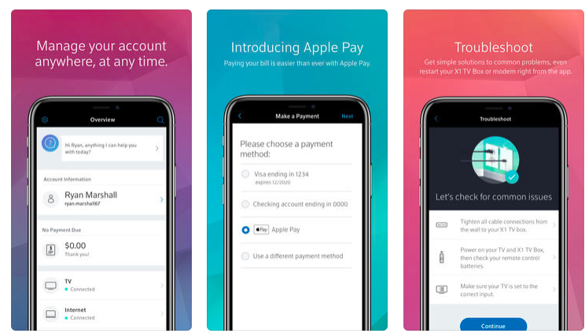

* Worked as a Software Engineer to as part of the 8 person Mobile App & Comcast Interactive Media iOS team
* Collaborated with other mobile, web and embedded systems developers, designers, testers, tech-operators and business managers on a daily basis
* Worked to get the app approved for release in the App Store ensuring guideline submissions were closely followed
* Primarily responsible for developing features for existing iOS apps as well as building new iOS apps from scratch
* Worked on building/operating mobile applications dependent on large-scale (>1MM users) platforms with high availability
* Integrated Apple Pay technology for account management by users to seamlessly pay bill and account balances as needed
* Removed the need for customers to re-authenticate when visiting My Account from the app.
* Lead the upgrade of application to be compatible and bug free with the release of iPhone X and all extended features
* Developed the UI/UX and storyboards for There’s a new connection status screen that displays all details related to an outage, including estimated time of resolution (when available) and information about recently resolved outages.
* Developed Application Support for TouchID for authentication to view your bill if logged in after 30 mins
* Integrated the Ability to AirPrint the PDF version of your bill

**iOS Engineer - American Eagle Outfitters Pittsburg, PA Feb, 2016, - May, 2017**

[**https://itunes.apple.com/us/app/ae-aerie/id467738064?mt=8**](https://itunes.apple.com/us/app/ae-aerie/id467738064?mt=8)

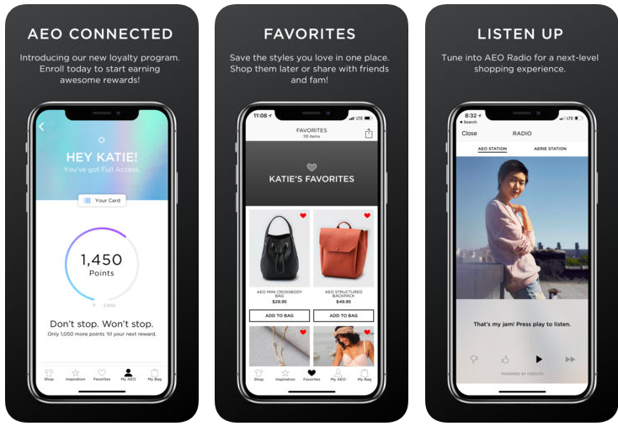

* Lead effort in front/back end for Mobile applications foriOS platform.
* Performing the role of scrum master, leading the daily standups, sprint planning sessions, showcases and retrospectives.
* Collaborating with project management to align on milestones and deliverables, as well as with architects and user experience teams to address ongoing design questions as they arise.
* Managing product backlog and ensuring that the development team is meeting velocity goals and can deliver the scoped backlog.
* Translated design and UX specs into fully functioning ios app
* Developed app using Swift and Cocoa Pods
* Worked to develop Apple Watch application
* Integrated the option to add your AEO Connected card to Apple Wallet
* Developed the ability to access the app in a snap with 3D Touch for iPhone 6 and later models

**Mobile Software Developer – Evolve IP Wayne, PA Jan 2015 – Jan-2016**

[**https://itunes.apple.com/us/app/evolved-office-uc-one/id885514027?mt=8**](https://itunes.apple.com/us/app/evolved-office-uc-one/id885514027?mt=8)

* Took lead on ensuring compatibility with iOS 9
* Worked as one of the original mobile developers and on a small team of only 3
* Took charge of feature development for the following: Instant Messaging, Group Chat, Phone and Calendar Presence
* Lead the design of the app and all design patterns and storyboarding working closely with the design team
* Video Calling, Audio Conferencing, Corporate Directory, VoIP Calling, Access to Call History and more.
* Ensured proper OOP principles, clean coding, and scalable application architecture was put in place to support rapid user growth

**iOS Developer – Scholly Philadelphia, PA Jan 2014 – Dec 2014**

[**https://itunes.apple.com/us/app/scholly/id1048625540?mt=8**](https://itunes.apple.com/us/app/scholly/id1048625540?mt=8)

* #1 in the iOS App store for several weeks, several cities and states(Memphis, Montana, Philly, etc) purchasing the app for their students, being chosen as one of Inc. Magazine’s Top College Start Ups
* Designed and implemented all of Scholly’s development style, design, QA, and documentation guidelines and hired a team to utilize them.
* Scholly maintained on-time, quick releases while maintaining a <1% crash rate on ios app
* Developed custom RESTful API to communicate with database and ensure fast search speeds
* Worked on improving connectivity to ensure fast connection
* Fixed bugs and commonly reported sign-in issues
* Integrated Faebook SDK for facebook connection and login/sign-up from users

# Other Work Experience

**Computer Science Teaching Assistant – Grove CC Jan 2013 – December 2013**

* Analyzed and scored student submissions for the Data Structures and Algorithms class
* Reviewed student code which included conducting checks for language appropriate syntax, use of standard programming conventions, and code functionality

**Technical Support Representative - OfficeMax May 2012 – December 2012**

* Created and maintained a more efficient warehouse organizational system
* Monitored and corrected errors in product inventory system, resulting in better product fulfillment
* Provided outstanding customer service and resolved computer related issues for guests

# Education

**Grove City College**

* Bachelors of Science
* Computer Science
* 2013
* Association of Computing Machinery (ACM) Member

**Technician Class Amateur Telecommunications Operator**

* I am licensed as a technician class amateur radio operator.