1、

1.1 Convert "signif.txt" to "signif.csv", then read the data by R

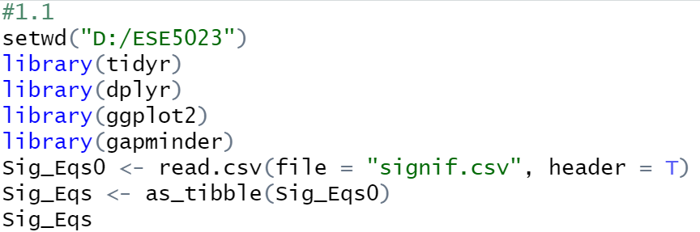

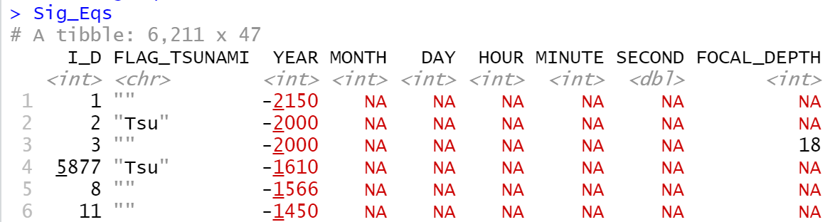

1.2 Compute the total number of deaths caused by earthquakes since 2150 B.C. in each country

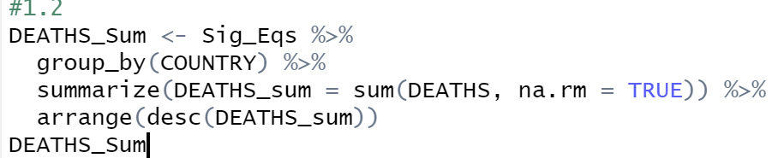

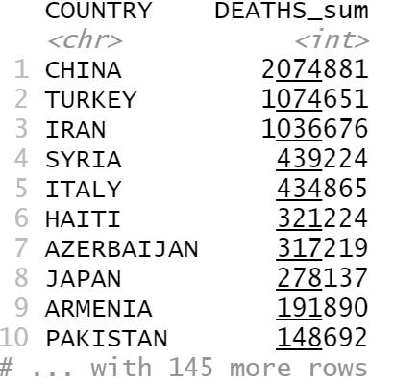

1.3 The total number of earthquakes with magnitude larger than 6.0 worldwide each year is increasing. It is said that the world has entered a geologically active period.

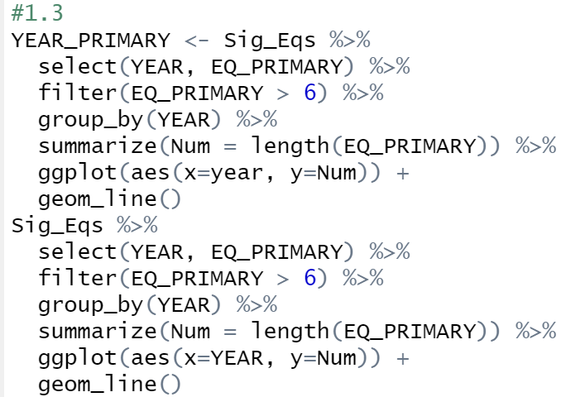

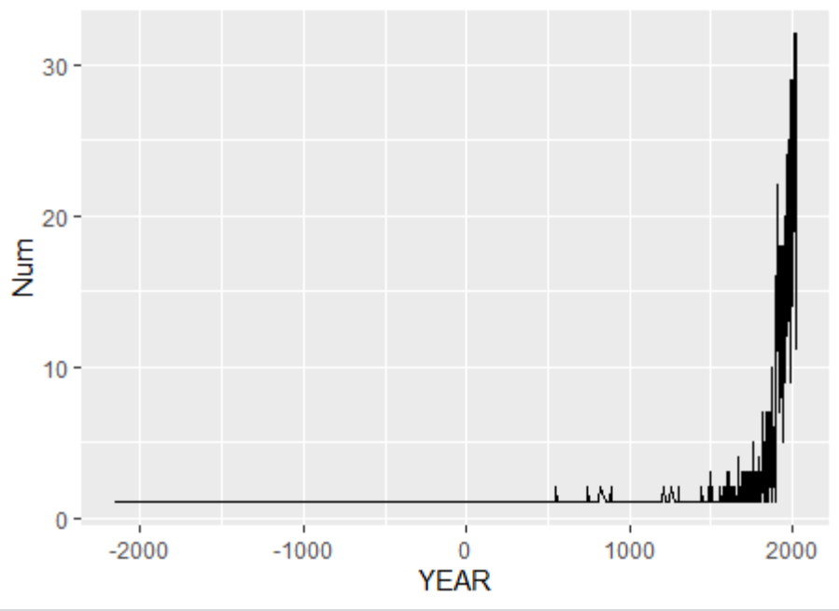

1.4

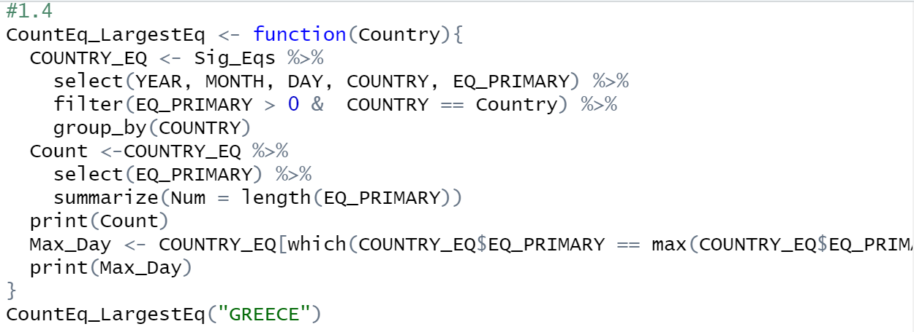

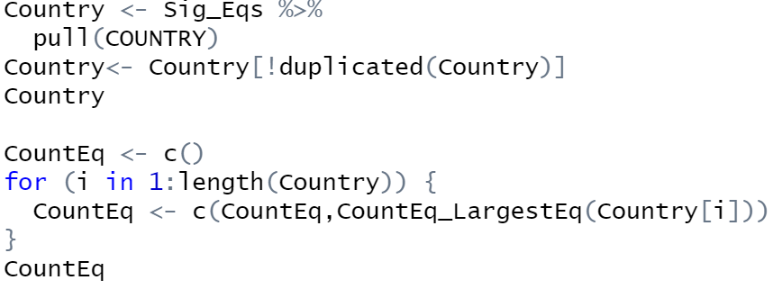

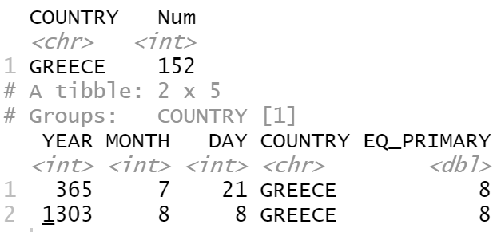

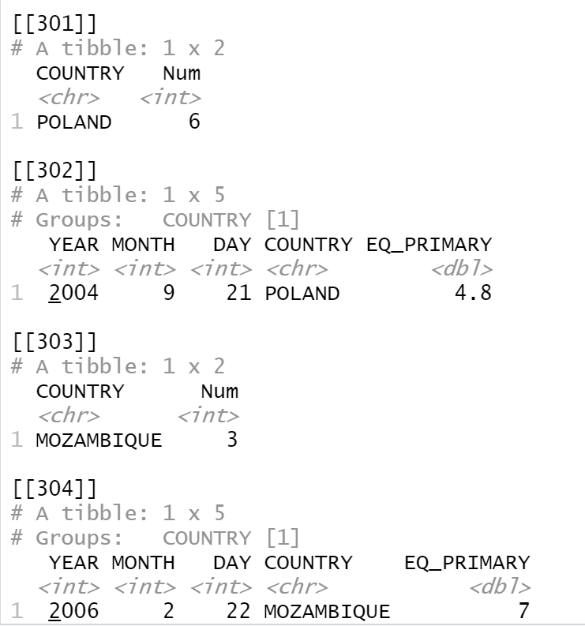

2、There isn’t a obviously trend in monthly averaged wind speed within the past 10 years

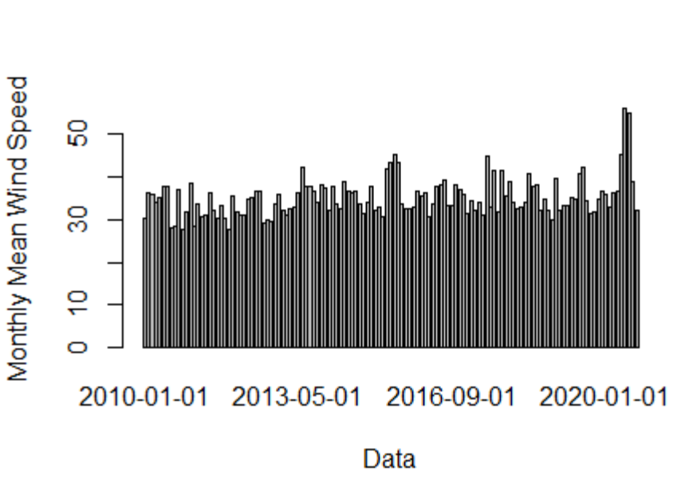

3、

