PS4 Report

蒲东川 12049029

**1.**

(1)

Select the InsectSprays data from R,which shows the number of insects when using different insecticides.

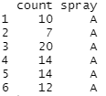

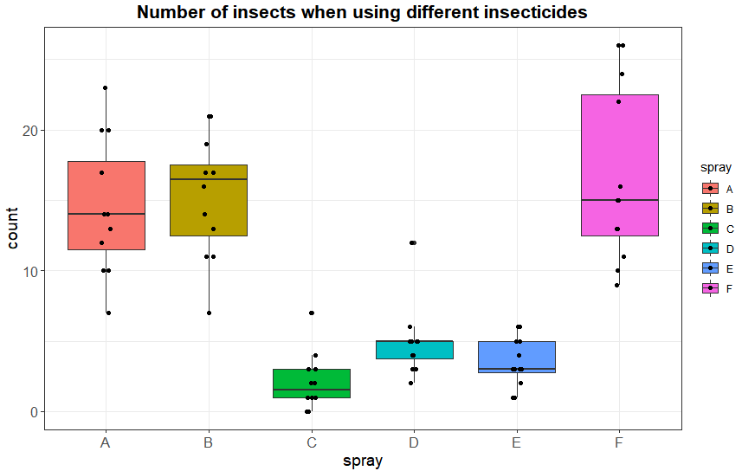

(2)Select the airquality data from R

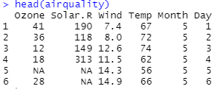

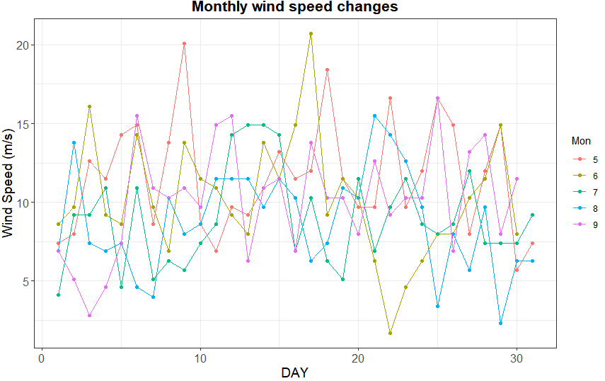

1. Select the airquality data from R



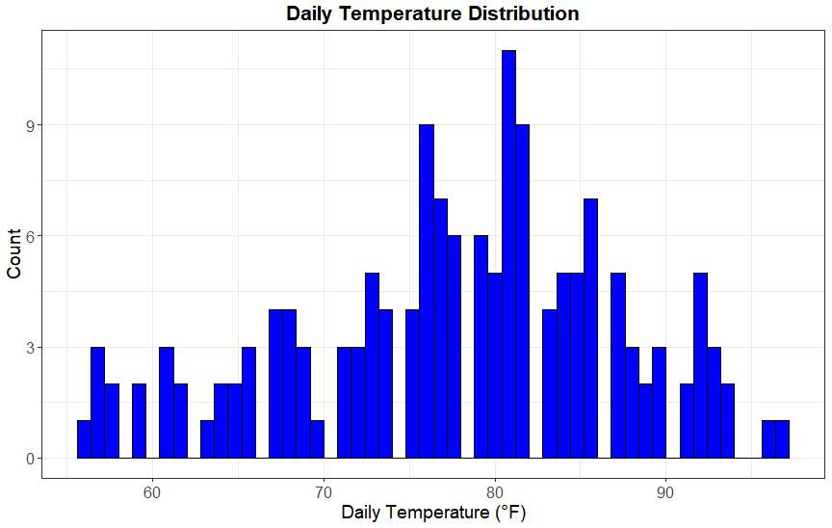

(4)Select the airquality data from R



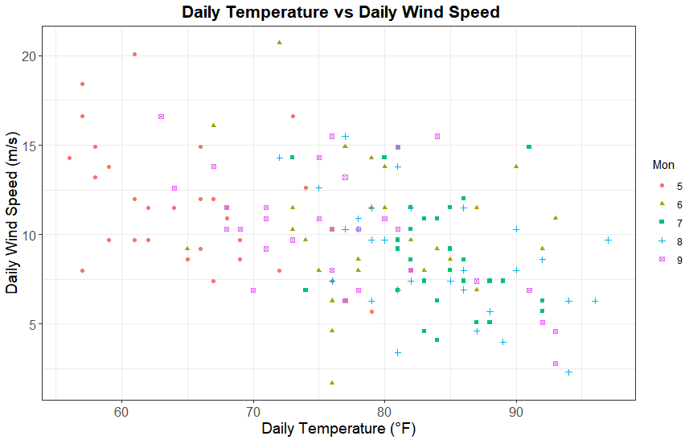

(5)

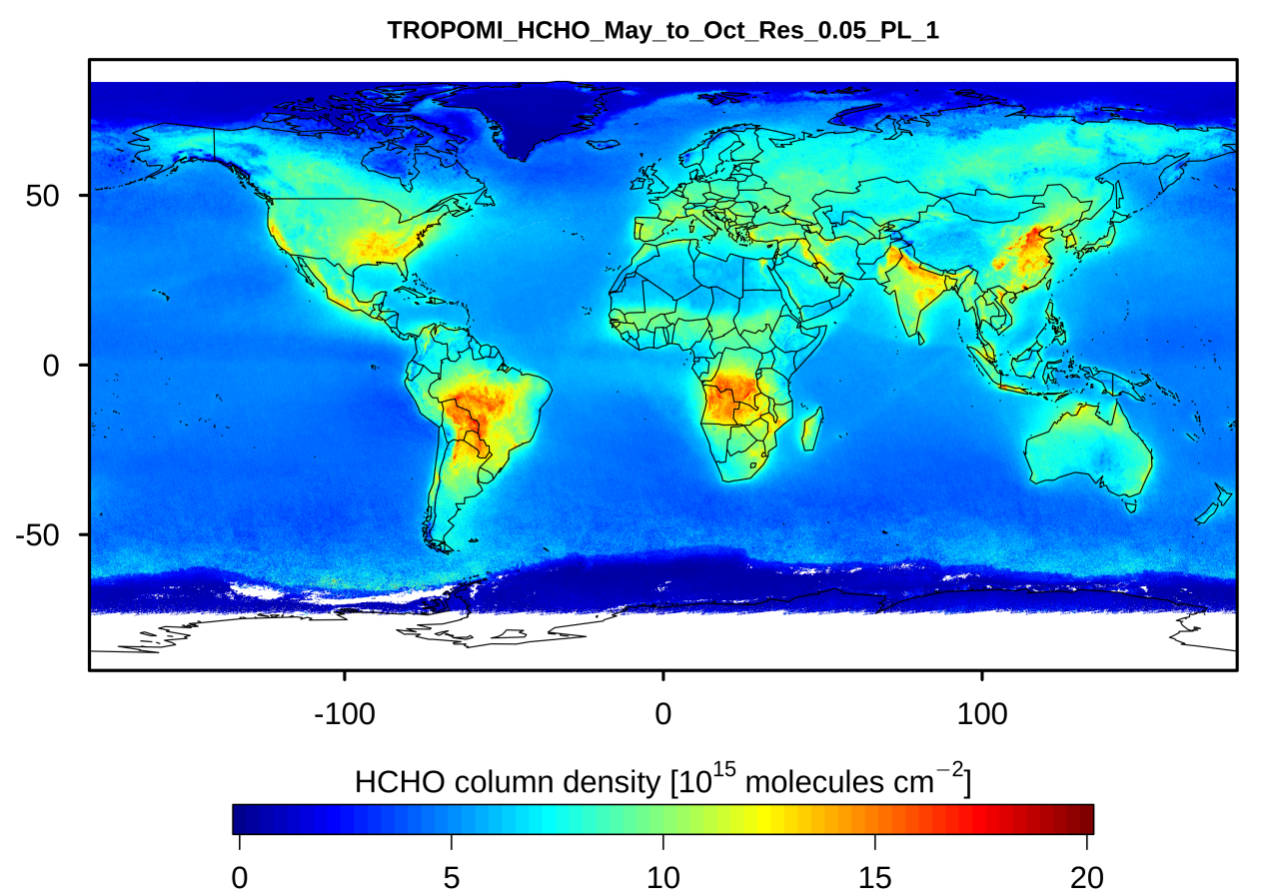

**2.**

**2.1**

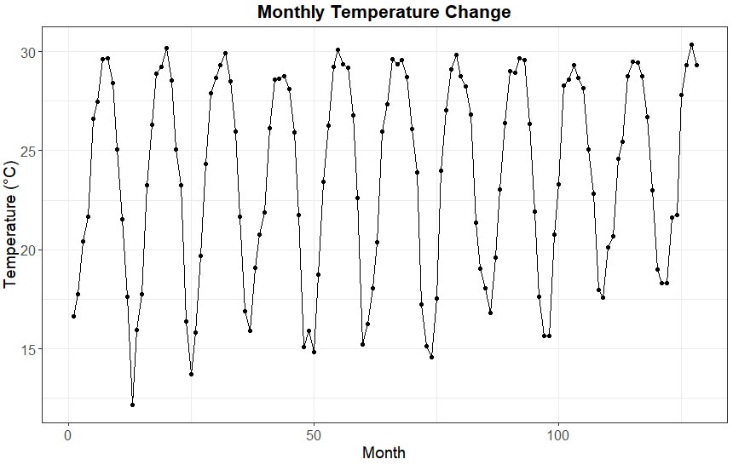

**2.2：**Decompose the time series using the decompose function. It can be seen that the noise satisfies the normal distribution

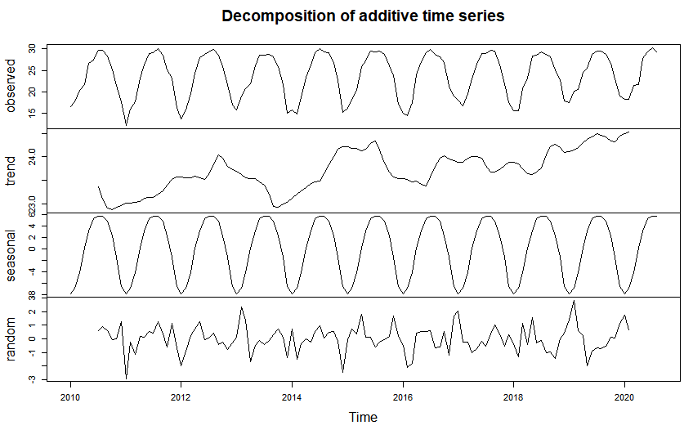

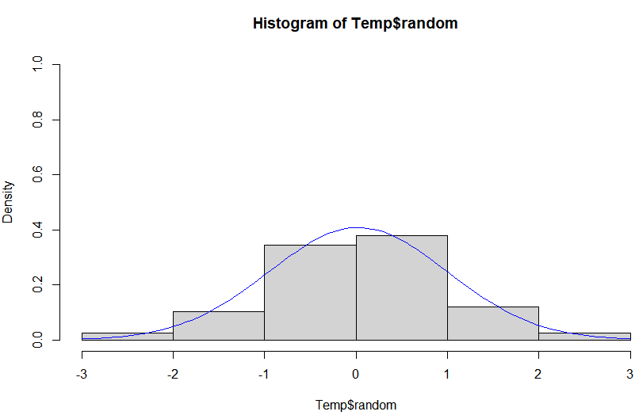

**2.3：**Use auto.arima function directly for fitting ARIMA model. This function can directly solve the ARIMA question.

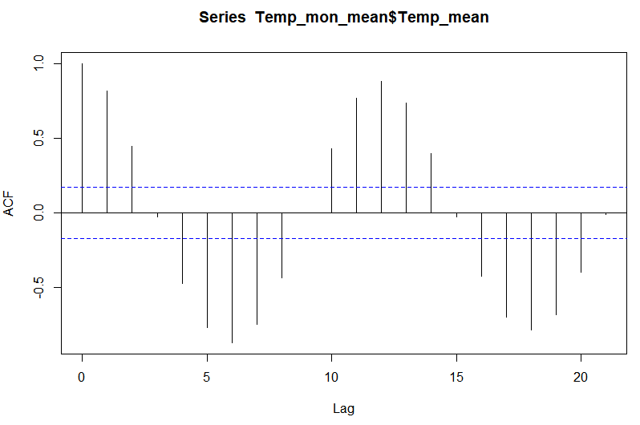

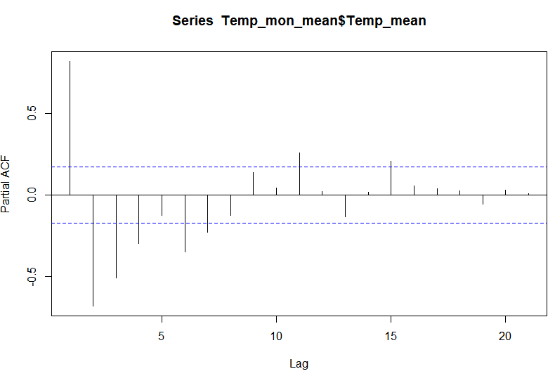

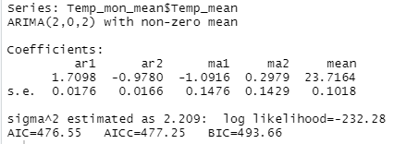

**2.4：**

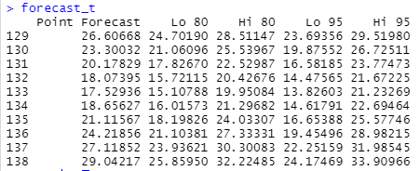

Forecast results for September and October:

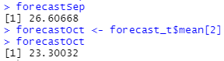

Actual value in September:

