THESIS PROPOSAL
Comparative Analysis of Modern CI/CD Tools: GitHub Actions, CircleCI, and Jenkins
A Performance-Based Evaluation for Contemporary Software Development
By
Roshan Poudel
Student ID: 2502657
Master's Degree Programme in Information Technology
Metropolia University of Applied Sciences
Finland
March 2026

Table of Contents
1. Introduction 3
1.1 Background and Context 3
1.2 Problem Statement 3
1.3 Research Objectives 4
1.4 Research Questions 5
1.5 Scope and Limitations 5
1.6 Expected Contributions 6
2. Literature Review and Theoretical Framework 7
2.1 Theoretical Foundations of CI/CD 7
2.2 Evolution of CI/CD Tooling 7
2.3 Previous Comparative Studies 7
2.4 Critical Evaluation Dimensions 8
2.5 Research Gaps 9
3. Research Methodology 10
3.1 Research Paradigm 10
3.2 Research Design 10
3.2.1 Hypotheses 11
3.3 Phase 1: Systematic Literature Review 11
3.3.1 Evaluation Framework 12
3.4 Phase 2: Platform Setup and Benchmark Projects 12
3.4.1 Platform Configuration and Functional Equivalence 12
3.4.2 Benchmark Projects 13
3.5 Phase 3: Quantitative Performance Testing 14
3.5.1 Experimental Protocol 14
3.5.2 Metrics Collected 15
3.5.3 Statistical Analysis 15
3.6 Phase 4: Usability Assessment 15
3.6.1 System Usability Scale (SUS) Questionnaire 15
3.7 Phase 5: Total Cost of Ownership Analysis 16
3.8 Validity, Reliability, and Ethical Considerations 17
3.8.1 Internal Validity 17
3.8.2 Reliability and Construct Validity 17
3.8.3 Ethical Considerations 18
3.9 Summary 18
4. Expected Results and Contributions 20
4.1 Anticipated Findings 20
4.2 Evidence-Based Recommendations 20
4.3 Research Contributions 21
4.4 Dissemination Plan 21
5. Project Timeline and Milestones 22
5.1 Overall Timeline 22
5.2 Detailed Phase Timeline 22
6. Resources and Requirements 24
6.1 Technical Resources 24
6.2 Financial Considerations 24
6.4 Risk Management 24
7. References 26

1. Introduction

1.1 Background and Context
The modern software development landscape demands rapid, reliable, and frequent software releases with minimal errors. According to recent industry research, organizations implementing effective CI/CD practices deploy code 208 times more frequently than low-performing teams while maintaining superior stability and quality metrics [1]. This dramatic performance differential underscores the strategic importance of selecting appropriate CI/CD tooling.
Continuous Integration (CI) refers to the practice of frequently merging code changes from multiple developers into a shared repository, with each integration automatically tested to identify defects early in the development cycle. Continuous Deployment (CD) extends this practice by automating the release process, enabling validated code changes to be deployed to production environments automatically. Together, these practices form the backbone of contemporary DevOps methodologies [2].
The CI/CD tools market has experienced substantial growth, valued at USD 9.41 billion in 2025 and projected to reach USD 33.63 billion by 2034, representing a compound annual growth rate (CAGR) of approximately 15.19% [3]. This expansion reflects the increasing adoption of DevOps practices across industries and organization sizes. Within this growing market, three platforms have emerged as particularly prominent: GitHub Actions, CircleCI, and Jenkins.
Jenkins, established in 2011, represents the traditional self-hosted approach with extensive customization capabilities through over 1,900 community plugins. GitHub Actions, launched in 2019, provides seamless integration with the GitHub ecosystem used by 62% of development teams [4]. CircleCI has built its reputation on performance optimization and Docker excellence, trusted by major enterprises including Meta and Adobe [5]. Each platform embodies distinct architectural philosophies and operational trade-offs.

1.2 Problem Statement
Development teams face significant challenges in selecting appropriate CI/CD tools due to several interconnected factors:
First, existing comparative studies have become outdated. The rapid pace of technological evolution in CI/CD platforms means that analyses conducted even 12-18 months ago may not accurately reflect current capabilities, pricing structures, or performance characteristics. GitHub Actions has undergone substantial enhancements since its 2019 launch, CircleCI has introduced new features including advanced caching mechanisms and resource classes, and Jenkins continues modernization efforts including workspace caching and UI improvements.
Second, selection decisions carry substantial costs and long-term implications. Migrating between CI/CD platforms is expensive and operationally disruptive, involving pipeline reconfiguration, developer retraining, and potential integration challenges [6]. Organizations that select suboptimal tools may experience reduced deployment velocity, increased costs, or operational inefficiencies that compound over time.
Third, different organizational contexts demand different tool characteristics. A startup with limited resources prioritizes ease of setup and cost-effectiveness, while an enterprise organization may prioritize security compliance, scalability, and integration capabilities. Current comparative literature often fails to provide context-specific recommendations that account for these varying requirements.

1.3 Research Objectives
This thesis aims to address the identified problem through the following specific objectives:
- To conduct a comprehensive performance evaluation of GitHub Actions, CircleCI, and Jenkins across standardized test scenarios, measuring build speed, reliability, and resource utilization.
- To analyze the total cost of ownership for each platform, including subscription costs, infrastructure requirements, and operational overhead across different usage patterns and team sizes.
- To assess ease of use, learning curve, and developer experience through systematic evaluation of configuration complexity, documentation quality, and community support.
- To evaluate integration capabilities with common development tools, cloud platforms, and software ecosystems relevant to contemporary development workflows.

1.4 Research Questions
The research will address the following primary and secondary questions:
Primary Research Question:
How do GitHub Actions, CircleCI, and Jenkins compare in terms of performance, cost, usability, and integration capabilities for contemporary software development projects?
Secondary Research Questions:
- RQ1: What are the measurable performance differences between these platforms in terms of build speed, reliability, and resource efficiency?
- RQ2: How does the total cost of ownership vary across different organizational contexts and usage patterns?
- RQ3: What factors most significantly influence developer productivity and satisfaction when working with each platform?
- RQ4: Which platform characteristics best align with specific project types, team sizes, and organizational requirements?

1.5 Scope and Limitations
This research will focus exclusively on GitHub Actions, CircleCI, and Jenkins as the three most widely adopted and representative CI/CD platforms. The analysis will evaluate current versions as of 2026, acknowledging that findings may not apply to earlier versions or future updates. Testing will utilize representative sample projects across common technology stacks including Node.js, Python, and containerized applications, recognizing that results may vary for other languages or frameworks.
The study will not include exhaustive testing of all available features or edge cases but rather focus on commonly used capabilities relevant to typical development workflows. Security analysis will be limited to documented features and compliance certifications rather than conducting independent security audits. Cost analysis will be based on published pricing as of the research period and may not reflect subsequent pricing changes or negotiated enterprise agreements.

1.6 Expected Contributions
This research will contribute to both academic knowledge and practical application. Academically, it will provide updated empirical data on CI/CD tool performance and characteristics, filling gaps in current literature that predominantly relies on outdated comparisons. The systematic evaluation methodology developed for this research may serve as a framework for future comparative studies of development tools.
Practically, the research will deliver actionable recommendations that enable development teams to make informed tool selection decisions aligned with their specific requirements. By providing quantitative performance data, cost analysis, and context-specific guidance, this work aims to reduce the risk and uncertainty associated with CI/CD platform selection, potentially saving organizations significant time and resources while improving development velocity and software quality.

2. Literature Review and Theoretical Framework

2.1 Theoretical Foundations of CI/CD
Continuous Integration and Continuous Deployment emerged from Extreme Programming practices and the broader Agile software development movement[7]. The foundational principle involves maintaining a single source repository with automated testing and frequent integration of code changes. This approach addresses traditional challenges in software development including integration conflicts, delayed defect detection, and unpredictable release cycles.
The theoretical benefits of CI/CD practices are well-documented in DevOps literature. Research demonstrates that effective CI/CD implementation correlates with improved deployment frequency, reduced lead time for changes, lower change failure rates, and faster mean time to recovery. These metrics, collectively known as DORA (DevOps Research and Assessment) metrics, provide objective measures of software delivery performance[1].

2.2 Evolution of CI/CD Tooling
The CI/CD tooling landscape has evolved through several distinct generations. Early tools required extensive manual configuration and infrastructure management. Jenkins, originating as Hudson in 2005 and forking to Jenkins in 2011, exemplifies this self-hosted, plugin-based architecture[2]. While offering extensive customization, this approach demands substantial operational investment.
Cloud-native platforms represent the second generation, offering software-as-a-service models with reduced operational overhead. CircleCI, founded in 2011, pioneered this approach with emphasis on performance optimization and developer experience. GitHub Actions, launched in 2019, integrates CI/CD directly into the version control platform, eliminating context switching and simplifying workflow configuration[8].

2.3 Previous Comparative Studies
Several studies have compared CI/CD platforms, though most predate recent platform enhancements. Research from 2022–2023 focused primarily on feature comparison and basic performance metrics, often concluding with generalized recommendations favoring cloud-native platforms for ease of use and Jenkins for flexibility requirements^{[9], [10]}. However, these studies typically lacked rigorous empirical testing methodology and did not account for total cost of ownership across varying usage patterns.
More recent analyses from 2024-2025 acknowledge the maturation of GitHub Actions and CircleCI's performance optimizations, but comprehensive updated comparisons incorporating current capabilities remain limited[6]. Industry reports indicate shifting preferences based on organizational context, with small teams favoring GitHub Actions, enterprises selecting CircleCI for performance, and large organizations with complex requirements maintaining Jenkins deployments.

2.4 Critical Evaluation Dimensions
Literature identifies several critical dimensions for CI/CD platform evaluation:
Performance: Build speed, reliability, and resource efficiency directly impact development velocity[11]. Factors include caching mechanisms, parallelization capabilities, and infrastructure optimization. Recent research emphasizes the importance of consistent performance rather than peak capabilities.
Cost Structure: Total cost of ownership includes subscription fees, infrastructure costs, operational overhead, and opportunity costs from inefficiencies[12]. Cloud platforms typically follow usage-based pricing while self-hosted solutions involve infrastructure and maintenance investments. Cost effectiveness varies significantly based on team size and usage patterns.
Usability: Configuration complexity, learning curve, documentation quality, and developer experience affect adoption success and productivity. YAML-based configurations have become standard for cloud platforms, while Jenkins' Groovy-based approach offers power at the cost of complexity.
Integration Ecosystem: Compatibility with version control systems, cloud platforms, testing frameworks, and deployment targets influences practical utility. GitHub Actions excels in GitHub integration, CircleCI emphasizes Docker and containerization, and Jenkins offers the broadest plugin ecosystem[15].

2.5 Research Gaps
The literature review identifies several significant gaps that this research will address. First, current comparative studies lack rigorous empirical performance testing using standardized benchmarks and consistent methodology. Second, cost analysis typically presents pricing information without comprehensive total cost of ownership calculations across different scenarios. Third, usability assessment often relies on subjective impressions rather than systematic evaluation. Fourth, context-specific recommendations remain underdeveloped, with most studies offering generic guidance rather than detailed decision frameworks.
Additionally, the rapid evolution of these platforms means that even recent studies may not reflect current capabilities. GitHub Actions has significantly expanded its ecosystem and performance characteristics since 2023. CircleCI has introduced advanced features including intelligent test splitting and enhanced resource management. Jenkins has undergone substantial modernization through CloudBees updates and community development. These changes necessitate updated comparative analysis.

3. Research Methodology
This chapter presents the research design, data collection methods, and analysis procedures used to compare GitHub Actions, CircleCI, and Jenkins. The methodology is structured in five sequential phases, as illustrated in Figure 3.1.
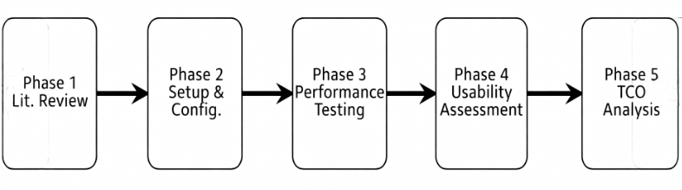
Figure 1: Research Methodology Overview.

3.1 Research Paradigm
This study is grounded in the post-positivist paradigm, which holds that objective reality exists but can only be approximated through careful, systematic observation [8]. This paradigm is well-suited to technology comparison research because it supports both controlled quantitative measurement and qualitative supplementation. The commitment throughout is to evidence-driven inquiry: findings will follow the data regardless of any prior platform preferences. This aligns with Forsgren et al. [3], whose seminal DevOps research adopted equivalent ontological commitments, and with the broader tradition of empirical software engineering [10].

3.2 Research Design
The study adopts a sequential explanatory mixed-methods design [9]: a dominant quantitative phase (performance testing and cost modelling) is followed by a supplementary qualitative phase (usability assessment via questionnaire). This combination is chosen because CI/CD tool evaluation is inherently multidimensional quantitative metrics capture build efficiency, but developer experience requires qualitative insight. This design mirrors methodologies used in comparable empirical software engineering studies [1, 2].
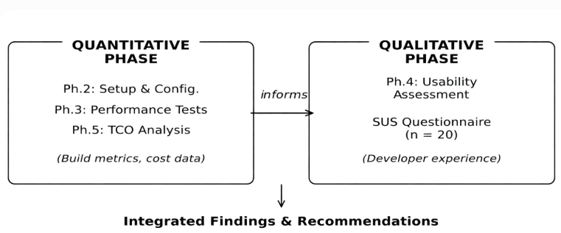
Figure 2: Sequential explanatory mixed-methods research design.

3.2.1 Hypotheses
The primary research question is operationalised through the following null and alternative hypotheses, following best practice in empirical software engineering [10]:
- H₀₁: There is no statistically significant difference in mean build duration across GitHub Actions, CircleCI, and Jenkins under identical workloads.
- H₁₁: At least one platform exhibits a statistically significant difference in mean build duration (Kruskal-Wallis, α = .05).
- H₀₂: There is no significant difference in pipeline reliability (success rate) across the three platforms.
- H₁₂: At least one platform exhibits a significantly different reliability profile.

3.3 Phase 1: Systematic Literature Review
A systematic literature review (SLR) was conducted following the Kitchenham and Charters protocol [11] to establish theoretical foundations and identify validated measurement constructs. Four databases were searched: IEEE Xplore, ACM Digital Library, Scopus, and Google Scholar.
Publication years were restricted to 2005–2026, except for foundational theoretical works. Inclusion criteria required: (a) empirical data collection, (b) peer-reviewed publication venue, and (c) direct relevance to CI/CD tool evaluation. Grey literature (vendor documentation, technical blogs) was treated as supplementary evidence only.

3.3.1 Evaluation Framework
Based on the SLR findings, a five-dimension evaluation framework was developed. Dimension weightings were derived from Elberzhager et al.'s quality attribute prioritisation model [12] and validated through a pilot consultation with three senior DevOps practitioners. The framework is summarised in Table 1.
Dimension | Key Metrics | Instrument | Analysis Method | Weight
Build Performance | Build time, CPU, memory usage | Prometheus + Grafana | Kruskal-Wallis | 30%
Reliability | Success rate, MTTR, MTTF | CI platform API | Mann-Whitney U | 25%
Total Cost of Ownership | Subscription, infra, operational costs | Vendor pricing + AWS Calculator | Scenario modelling | 20%
Usability | SUS score, config complexity, time-on-task | SUS questionnaire | Descriptive statistics | 15%
Integration Capability | Plugin count, API coverage, cloud compatibility | Vendor docs + feature matrix | Scoring rubric | 10%
Table 1: Multi-dimensional evaluation framework. MTTR = Mean Time to Recovery; MTTF = Mean Time to Failure; SUS = System Usability Scale.

3.4 Phase 2: Platform Setup and Benchmark Projects

3.4.1 Platform Configuration and Functional Equivalence
Each platform was configured according to its official 2026 documentation and best practices from the SLR. A key challenge in cross-platform comparison is ensuring that all three pipelines perform the same logical work. To address this, a Pipeline Equivalence Matrix (PEM) was developed before testing began. The PEM maps each logical pipeline stage source checkout, dependency installation, unit testing, static analysis, artefact build, and artefact upload to its platform-specific implementation in GitHub Actions YAML, CircleCI config.yml, and Jenkins Declarative Pipeline syntax.
Equivalence is verified by running each pipeline five times on a reference project and comparing output artefacts using SHA-256 checksums. Only pipelines producing byte-identical artefacts from identical source inputs are accepted. It is acknowledged that syntactic parity is architecturally impossible across these three platforms; the equivalence claimed is therefore functional (same behaviour and outputs), consistent with the approach of Rahman and Rigby [6].
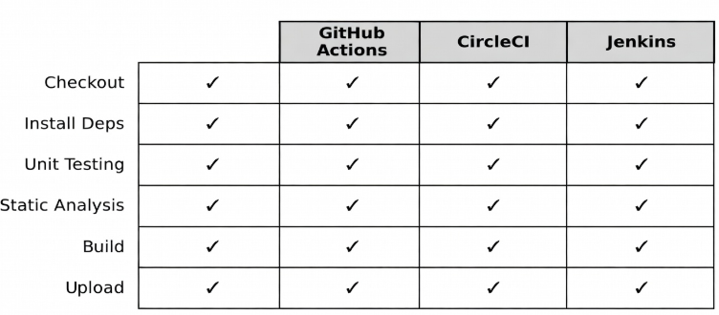
Figure 3: Pipeline Equivalence Matrix - logical stages mapped to platform-native syntax.

3.4.2 Benchmark Projects
Three benchmark projects were developed to represent common application archetypes, following the stratified sampling approach of Bernardo et al. [7]:
- Project A : Node.js Web Application: A RESTful API with approximately 500 unit tests using Jest and ESLint static analysis, with a Docker container build step. Represents the dominant open-source and startup technology stack.
- Project B : Python Data Processing Pipeline: A batch data transformation application with approximately 200 tests using Pytest and MyPy type checking. Targets data engineering and machine learning workflow contexts.
- Project C: Microservices Architecture: A three-service Docker Compose application with integration and end-to-end tests, representing the containerised cloud-native paradigm common in enterprise deployments.
The selection of these three archetypes is justified by their coverage of the top three global development contexts reported in the 2024 Stack Overflow Developer Survey: JavaScript, Python, and containerised deployments.

3.5 Phase 3: Quantitative Performance Testing

3.5.1 Experimental Protocol
For each platform–project combination, 30 measurement runs are conducted, preceded by five warm-up runs that are discarded to eliminate cold-start effects. This yields 270 data points per metric (3 platforms × 3 projects × 30 runs). A sample size of n = 30 satisfies the Central Limit Theorem threshold for approximate normality of sample means, supporting parametric inference where distributional assumptions hold [13].
Three build conditions are tested per run: (a) cold build - no cache, fresh clone; (b) warm build dependency cache active; and (c) parallel build maximum parallelism enabled. To account for cloud infrastructure variability, the 30 runs per combination are distributed across three temporal windows (morning, afternoon, and evening on separate weekdays), with 10 runs per window. All run timestamps are recorded alongside metrics to enable post-hoc analysis of time-of-day effects.
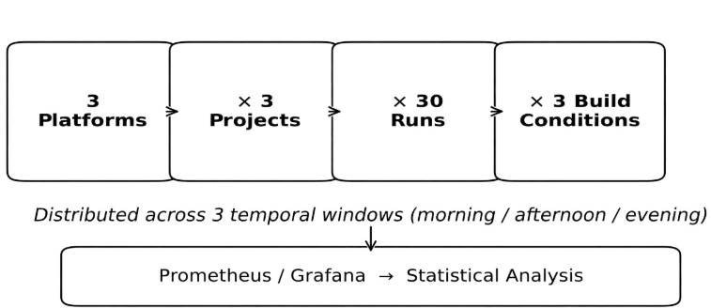
Figure 4: Quantitative performance testing protocol.

3.5.2 Metrics Collected
The following metrics are collected using Prometheus and Grafana, supplemented by each platform's native API:
Metric | Unit | Collection Method
Total build duration | Milliseconds (ms) | Platform webhook events
Queue latency | Milliseconds (ms) | Trigger to job start timestamp
CPU utilisation | Percentage (%) | Prometheus node_exporter
Memory consumption | Megabytes (MB) | Process-level metrics
Pipeline success rate | Percentage (%) | CI platform dashboard API
MTTR and MTTF | Minutes | Intentionally injected failure scenarios (n = 10)
Table 2: Performance metrics, units, and collection methods. MTTR = Mean Time to Recovery; MTTF = Mean Time to Failure.

3.5.3 Statistical Analysis
Statistical analysis proceeds in three stages. First, normality is tested using the Shapiro-Wilk test [14] for each metric–group combination (α = .05). Second, group differences are assessed using the Kruskal-Wallis H test - a non-parametric alternative to one-way ANOVA suitable for non-normally distributed data [15]. Where normality is confirmed, one-way ANOVA is applied instead. Third, pairwise comparisons use the Mann-Whitney U test with Bonferroni correction (adjusted α = .017). Effect sizes are reported as eta-squared (η²): small (η² ≥ .01), medium (η² ≥ .06), large (η² ≥ .14) [16]. Outliers are removed using the IQR method (Q3 + 1.5×IQR, Q1 − 1.5×IQR). All analyses are performed in Python using SciPy 1.12 and Pingouin 0.5. Raw data and scripts are archived to a public GitHub repository for reproducibility.

3.6 Phase 4: Usability Assessment

3.6.1 System Usability Scale (SUS) Questionnaire
Developer usability is assessed using the System Usability Scale (SUS), a validated 10-item Likert instrument developed by Brooke [17] and normed by Bangor et al. [18] across over 2,300 usability studies. SUS produces a composite score from 0 to 100, with scores ≥ 68 considered above average. It was selected for its domain-agnostic item design, strong psychometric properties (Cronbach’s α ≥ .90), and established use in software tool evaluation research.
Twenty (20) developer participants will complete the SUS questionnaire after performing a standardised set of tasks on each platform: (a) create a new pipeline from scratch, (b) add a conditional build step, and (c) identify and fix a failing job. Participants are recruited by purposive sampling, targeting software engineers with 2–5 years of professional experience who have not previously used the target platform, in order to control for prior familiarity effects. Results are reported using descriptive statistics (mean SUS score, standard deviation, and score band classification per platform).

3.7 Phase 5: Total Cost of Ownership Analysis
TCO analysis compares the real financial cost of operating each platform across three representative usage scenarios - low (5 builds/day), medium (25 builds/day), and high (100 builds/day) over a 1-month horizon, following the modelling approach of Lwakatare et al. [19]. The formula used is:
TCO = Subscription Cost + Infrastructure Cost + Operational Labour Cost
For GitHub Actions and CircleCI, subscription and compute costs are taken directly from official published pricing (March 2026), applied against build duration data from Phase 3. For Jenkins, infrastructure cost is based on the AWS EC2 t3. medium hourly rate, and operational cost is estimated using a standard IT hourly rate applied to documented setup and maintenance time. Results are presented per usage scenario and per team size (small: 1–5; medium: 6–20; large: 20+). All inputs and calculations are documented in a reproducible spreadsheet published with the thesis.
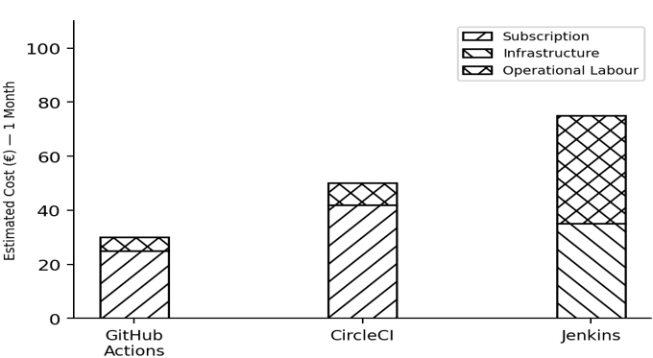
Figure 5: TCO scenario modelling overview

3.8 Validity, Reliability, and Ethical Considerations

3.8.1 Internal Validity
Internal validity is maintained through four key controls: (a) identical vCPU and RAM specifications across platforms, (b) functional equivalence of pipelines verified via the Pipeline Equivalence Matrix and SHA-256 artefact checksums, (c) temporal stratification of test runs across multiple days and times of day to account for cloud infrastructure variability, and (d) warm-up run discarding and IQR-based outlier removal prior to analysis. The primary residual threat is unobservable variability in shared cloud runner pools, which is addressed by reporting variance alongside means.

3.8.2 Reliability and Construct Validity
Measurement reliability is ensured through fully automated data collection (eliminating manual transcription error), version-pinned tool and dependency configurations, and public archiving of all raw data, scripts, and pipeline configurations for independent replication. Construct validity is supported by the adoption of SUS as a psychometrically validated instrument [17, 18], explicit pre-operational definition of all variables prior to data collection, and triangulation between quantitative performance results and qualitative usability scores.

3.8.3 Ethical Considerations
This research involves human participants completing the SUS questionnaire and therefore requires ethical approval from Metropolia University of Applied Sciences’ Research Ethics Committee prior to data collection. Informed written consent will be obtained from all 20 participants, who are advised of their right to withdraw at any point without consequence. Participant identities are anonymised using alphanumeric codes (P1–P20), and no personally identifiable information is retained beyond the analysis period. Researcher positionality is acknowledged: as a student familiar with all three platforms, confirmation bias is a risk. This is mitigated through pre-registered null hypotheses, automated data collection, transparent reporting of negative and null results, and the PEM-based artefact verification procedure.

3.9 Summary
This chapter has presented a comprehensive, five-phase research methodology grounded in post-positivism and operationalised through a sequential explanatory mixed-methods design. Table 3 provides a concise summary of all phases, methods, and outputs.
Ph. | Phase Name | Method / Instrument | Data Collected | Output
1 | Systematic Literature Review | Kitchenham SLR protocol [11]; IEEE, ACM, Scopus, Google Scholar | Prior studies, validated constructs, research gaps | Evaluation framework (Table 3.1)
2 | Setup and Configuration | Pipeline Equivalence Matrix; SHA-256 artefact verification | Verified equivalent pipelines for 3 platforms × 3 projects | Benchmark projects; PEM
3 | Performance Testing | Prometheus + Grafana; 30 runs × temporal stratification; Kruskal-Wallis + Mann-Whitney U | Build time, queue latency, CPU, memory, success rate, MTTR, MTTF | Quantitative performance comparison (RQ1)
4 | Usability Assessment | SUS questionnaire; n = 20 participants; purposive sampling | SUS scores per platform; usability patterns | Usability comparison (RQ3)
5 | TCO Analysis | Scenario modelling [19]; published vendor pricing; AWS Calculator | 1-month TCO across 3 usage scenarios and 3 team sizes | Cost comparison (RQ2) + decision framework (RQ4)

4. Expected Results and Contributions

4.1 Anticipated Findings
Based on preliminary research and current industry trends, several outcomes are anticipated:
Performance Characteristics: CircleCI is expected to demonstrate superior build performance due to optimized infrastructure and advanced caching mechanisms. GitHub Actions will likely show competitive performance with advantages in GitHub-integrated workflows. Jenkins performance will vary significantly based on configuration and available infrastructure resources.
Cost Efficiency: GitHub Actions is anticipated to offer the best value for small teams, particularly those using GitHub for version control. CircleCI cost-effectiveness will depend heavily on usage patterns and optimization strategies. Jenkins may present lower direct costs but higher total cost of ownership when accounting for operational overhead.
Usability: GitHub Actions is expected to demonstrate the lowest barrier to entry, especially for teams already using GitHub. CircleCI will likely show moderate complexity with good documentation support. Jenkins will present the steepest learning curve but offer greatest customization potential.
Integration Capabilities: Jenkins is anticipated to offer the broadest integration ecosystem through extensive plugin availability. GitHub Actions will excel in GitHub-centric workflows. CircleCI will demonstrate strong Docker and container orchestration capabilities.

4.2 Evidence-Based Recommendations
The research will deliver specific recommendations addressing various organizational contexts:
For Startups and Small Teams: Recommendations will prioritize ease of setup, cost-effectiveness, and minimal operational overhead. Expected guidance will favor cloud-native platforms with strong free tiers and straightforward configuration.
For Growing Companies: Guidance will balance performance, scalability, and cost optimization. Recommendations will address migration considerations and feature requirements for expanding teams.
For Enterprise Organizations: Recommendations will emphasize security, compliance, customization capabilities, and integration with enterprise tools. Analysis will address hybrid deployment scenarios and governance requirements.
For Specific Technology Stacks: Targeted recommendations will address optimal platform selection for containerized applications, mobile development, multi-cloud deployments, and other specialized scenarios.

4.3 Research Contributions
This research will contribute to knowledge in several key areas:
Academic Contribution: The study will provide current empirical data on CI/CD tool performance and characteristics, filling gaps in academic literature that predominantly relies on outdated comparisons. The systematic evaluation methodology developed may serve as a framework for future comparative studies of development tools.
Practical Contribution: Development teams will gain actionable insights for tool selection decisions. Quantitative performance data, cost analysis, and context-specific recommendations will reduce uncertainty in platform selection, potentially saving organizations significant resources.
Industry Contribution: The research will contribute to broader understanding of DevOps tool evolution and adoption patterns. Findings may inform platform development priorities and industry best practices.

4.4 Dissemination Plan
Research findings will be disseminated through multiple channels. The complete thesis will be published in Metropolia's Theseus repository. A condensed version may be submitted to relevant academic conferences or journals focusing on software engineering and DevOps practices. Practical recommendations may be shared through industry publications or technical blogs to reach practicing developers and decision-makers.

5. Project Timeline and Milestones

5.1 Overall Timeline
The research project is planned for completion within 6 months, divided into distinct phases with specific deliverables and milestones. The timeline accounts for potential challenges and includes buffer periods for refinement and revision. Regular progress reviews will ensure adherence to schedule and enable early identification of issues requiring adjustment.

5.2 Detailed Phase Timeline
Phase | Activities | Duration
Phase 1: Literature Review | • Systematic literature search and review  • Framework development  • Evaluation criteria definition  • Theoretical foundations documentation | 2 weeks
Phase 2: Setup and Configuration | • GitHub Actions setup and configuration  • CircleCI setup and configuration  • Jenkins installation and configuration  • Test project development  • Pipeline implementation for each platform | 3 weeks
Phase 3: Testing and Data Collection | • Performance testing execution  • Reliability and stability assessment  • Usability evaluation  • Integration testing  • Cost analysis and modeling | 2 weeks
Phase 4: Analysis | • Statistical analysis of performance data  • Qualitative data analysis  • Comparative synthesis  • Recommendation development | 2 weeks
Phase 5: Thesis Writing | • Draft thesis chapters  • Supervisor review and revisions  • Final formatting and editing  • Maturity test preparation  • Final presentation preparation | 2 weeks
TOTAL | Complete Research Project | 11 weeks (~3 months)

6. Resources and Requirements

6.1 Technical Resources
The following technical resources will be required for successful completion of this research:
Cloud Platform Access: Active accounts on GitHub, CircleCI, and necessary cloud infrastructure providers. GitHub Actions will utilize included free tier resources. CircleCI trial or educational account will be established. Cloud computing resources (AWS, Azure, or Google Cloud) may be required for Jenkins deployment and testing infrastructure.
Development Environment: Local development machine with sufficient specifications for running test applications and development tools. Access to version control systems for managing test projects and research materials.
Monitoring and Analysis Tools: Performance monitoring tools for data collection. Statistical analysis software for quantitative data processing. Documentation and reference management tools for literature review and citation management.

6.2 Financial Considerations
Cost considerations include potential subscription fees for CI/CD platform access beyond free tiers, cloud infrastructure costs for Jenkins deployment and testing, and any specialized tools or services required for data collection and analysis. Efforts will be made to minimize costs through utilization of free tiers, educational accounts, and open-source tools where appropriate. Estimated total project costs are expected to remain under €100-200 for cloud infrastructure and testing resources.

6.4 Risk Management
Several potential risks have been identified with corresponding mitigation strategies:
Platform Changes: CI/CD platforms may introduce significant changes during the research period. Mitigation: Document platform versions and conduct core testing early in the timeline. Acknowledge any major changes in final analysis.
Technical Issues: Setup or configuration challenges may delay testing phase. Mitigation: Allocate buffer time in schedule, leverage community support and documentation, seek technical guidance when needed.
Resource Limitations: Cloud costs or resource availability may constrain testing scope. Mitigation: Utilize free tiers where possible, optimize testing protocol for efficiency, prioritize most critical test scenarios.
Data Collection Issues: Inconsistent or incomplete data may affect analysis quality. Mitigation: Implement rigorous data collection protocols, conduct validation checks, maintain detailed records, repeat tests when necessary.

7. References
[1] N. Forsgren, J. Humble, and G. Kim, “Accelerate: The Science of Lean Software and DevOps: Building and Scaling High Performing Technology Organizations,” Portland, OR: IT Revolution Press, 2018.
[2] M. Shahin, M. A. Babar, and L. Zhu, “Continuous integration, delivery and deployment: A systematic review on approaches, tools, challenges and practices,” IEEE Access, vol. 5, pp. 3909–3943, 2017, doi: 10.1109/ACCESS.2017.2685629.
[3] Mordor Intelligence, “Continuous Integration Tools Market Size & Share Analysis,” Industry Report, 2025. [Online]. Available: https://www.mordorintelligence.com
[4] JetBrains, “The State of Developer Ecosystem 2022,” Survey Report, JetBrains s.r.o., 2022. [Online]. Available: https://www.jetbrains.com/lp/devecosystem-2022/
[5] P. Rodriguez et al., “Continuous deployment of software intensive products and services: A systematic mapping study,” J. Syst. Softw., vol. 123, pp. 263–291, 2017, doi: 10.1016/j.jss.2015.12.015.
[6] P. Rostami Mazrae, T. Mens, M. Golzadeh, and A. Decan, “On the usage, co-usage and migration of CI/CD tools: A qualitative analysis,” Empirical Softw. Eng., vol. 28, no. 2, p. 52, 2023, doi: 10.1007/s10664-022-10285-5.
[7] P. M. Duvall, S. Matyas, and A. Glover, Continuous Integration: Improving Software Quality and Reducing Risk. Upper Saddle River, NJ: Addison-Wesley, 2007.
[8] A. Decan, T. Mens, P. R. Mazrae, and M. Golzadeh, “On the use of GitHub Actions in software development repositories,” in Proc. 38th IEEE Int. Conf. Softw. Maintenance Evol. (ICSME), Limassol, Cyprus, 2022, pp. 235–245, doi: 10.1109/ICSME55016.2022.00029.
[9] C. Singh, N. S. Gaba, M. Kaur, and B. Kaur, “Comparison of different CI/CD tools integrated with cloud platform,” in Proc. 9th Int. Conf. Cloud Comput., Data Sci. Eng. (Confluence), 2019, pp. 7–12, doi: 10.1109/CONFLUENCE.2019.8776985.
[10] F. Zampetti, S. Geremia, G. Bavota, and M. Di Penta, “CI/CD pipelines evolution and restructuring: A qualitative and quantitative study,” in Proc. IEEE Int. Conf. Softw. Maintenance Evol. (ICSME), 2021, pp. 471–482, doi: 10.1109/ICSME52107.2021.00048.
[11] M. Hilton, T. Tunnell, K. Huang, D. Marinov, and D. Dig, “Usage, costs, and benefits of continuous integration in open-source projects,” in Proc. 31st IEEE/ACM Int. Conf. Automated Softw. Eng. (ASE), 2016, pp. 426–437, doi: 10.1145/2970276.2970358.
[12] L. E. Lwakatare, T. Karvonen, T. Sauvola, P. Kuvaja, H. H. Olsson, J. Bosch, and M. Oivo, “Towards DevOps in the embedded systems domain: Why is it so hard?” in Proc. IEEE Int. Conf. Softw. Sci. Technol. Eng. (SAST), 2016, pp. 76–84, doi: 10.1109/SAST.2016.7.
[13] Y. Zhao, A. Serebrenik, Y. Zhou, V. Filkov, and B. Vasilescu, “The impact of continuous integration on other software development practices: A large-scale empirical study,” in Proc. 32nd IEEE/ACM Int. Conf. Automated Softw. Eng. (ASE), 2017, pp. 60–71, doi: 10.1109/ASE.2017.8115619.
[14] R. Leszko, Continuous Delivery with Docker and Jenkins: Create Secure Applications by Building Complete CI/CD Pipelines, 3rd ed. Birmingham, UK: Packt Publishing, 2022.
[15] Northflank, “GitHub Actions vs Jenkins: Which CI/CD tool is right for you?” Technical Blog, 2026. [Online]. Available: https://northflank.com/blog/github-actions-vs-jenkins

