Name: Pudhuyugan

Roll No: 18IM30017

Term Project Report: Optimization of Bank Lending decision using Genetic Algorithm and Simulated Annealing and comparing both.

Problem Statement:

The loan size, loan interest rate and expected loan loss data is given for 10 customers.

Our task is to create a fitness function that maximizes the profit and based upon it, suggest the bank on whom to provide loan and whom to not. The problem has been solved using Genetic Algorithm and Simulated annealing in python and a comparison is made.

Genetic Algorithm Approach:

Fitness function provided in the research paper was used:

*Fx*=θ+π−β− λ

Crossover probability, mutation probability, population size and no: of iterations were fixed. At 0.8,0.06,60 and 200 respectively.

Proportionate selection was applied to choose the pool of parents. One-point crossover and bit-wise mutation was performed to get the children which become the parents for the next iteration.

Graph of fitness vs no: of iterations:

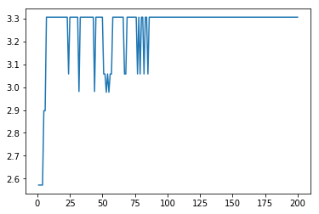

Inference and Result:

As we can clearly see from the graph, fitness value fluctuates initially but after 100 iterations it saturates and a maximum fitness value of 3.306 is achieved.

The strings that correspond to maximum fitness are:

[1 1 1 1 0 1 1 1 1 1] , [1 1 1 1 1 1 1 1 1 1]

All customers except the 5th customer (or) All customers must be given loan

Simulated Annealing Approach:

Fitness function provided in the research paper was used:

*Fx*=θ+π−β− λ

Initial Temperature was calculated using the average fitness of 5 randomly chosen strings.

Number of neighbourhood solutions to be generated at iteration was set at 10 and decrement of temperature after each iteration was set as 0.002

Neighbourhood Solutions were generated by swapping adjacent indices of the string. A decrease in fitness was accepted with a probability.

Graph of fitness vs number of iterations:

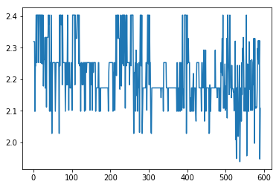

Inference and Result:

The fitness value keeps fluctuating and doesn’t converge at a point. The best fitness that was achieved was 2.404 after 600 iterations.

Comparison and Conclusion:

Since fitness value converges at a point for GA and the final fitness achieved is better than that of SA, we can conclude that Genetic Algorithm is better at optimizing bank lending decision.