**PTMS (Products-Transaction-Management-System)**

Pre-request for this PTMS Software to Develop and run application. Need to Install the following Softwares**.**

1)Java 1.8

2)Spring-boot 2.02

3)Kafka_2.12-2.7.1

4)PostgreSQL 12.3

5)Eclipse

**Installing Apache Kafka and Creating Topic:**

Installing Apache Kafka in windows.

Download Kafka using the below link.

https://kafka.apache.org/downloads

**Installing Apache Kafka :**

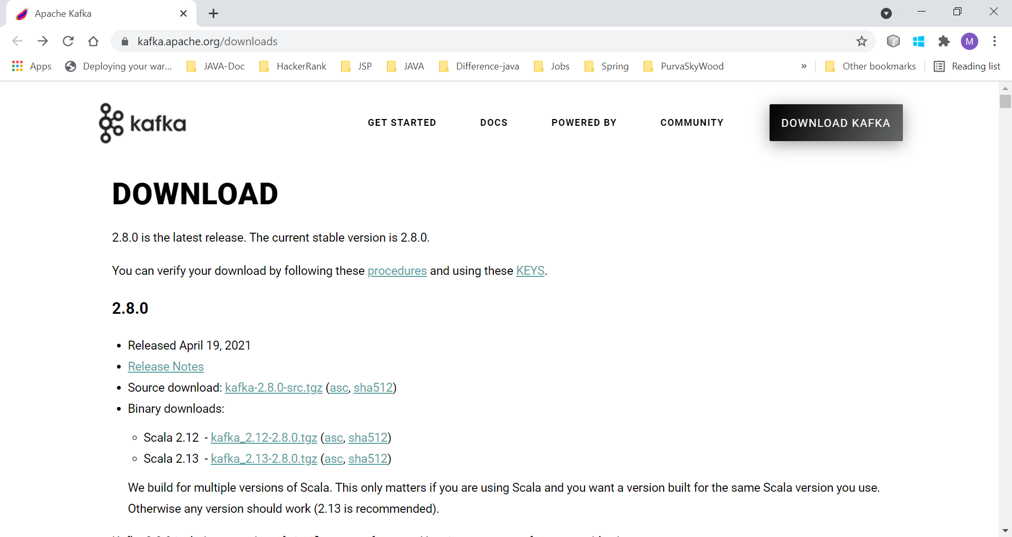

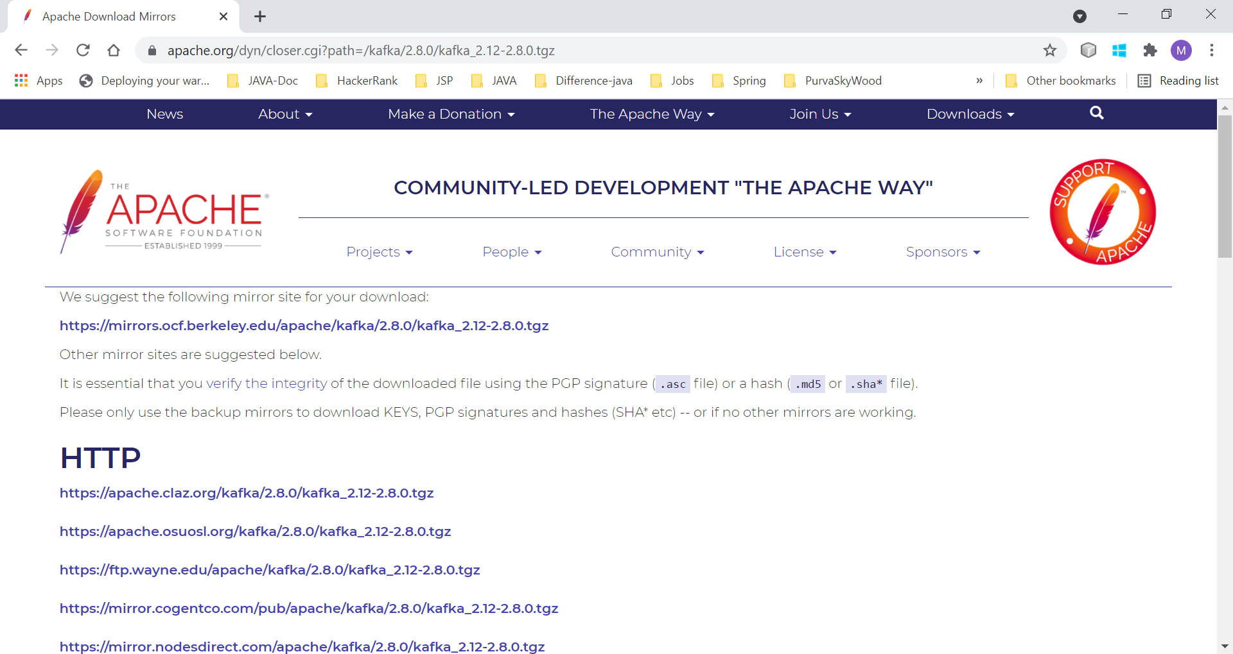

Note :(for beginners) – Create directory **C:\data\kafka** and keep all folder inside the Kafka folder from the download directory, to avoid error while running Kafka related command (for example you may get input command is a too long error).For example, I have downloaded and extracted apache kafka as below.

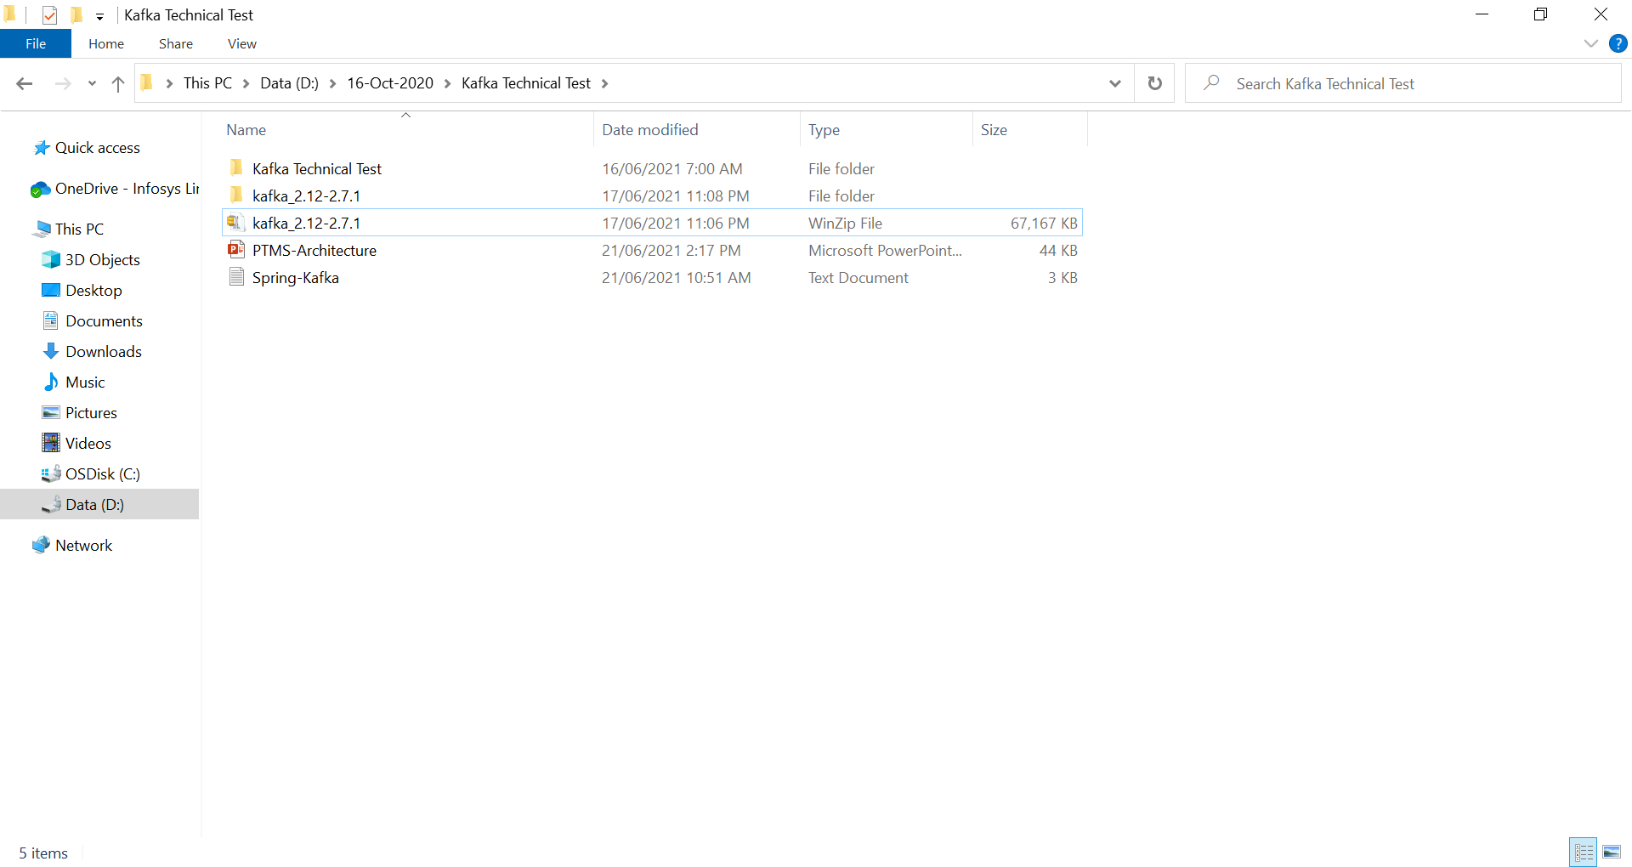

Copied all content and paste to **C:\data\kafka**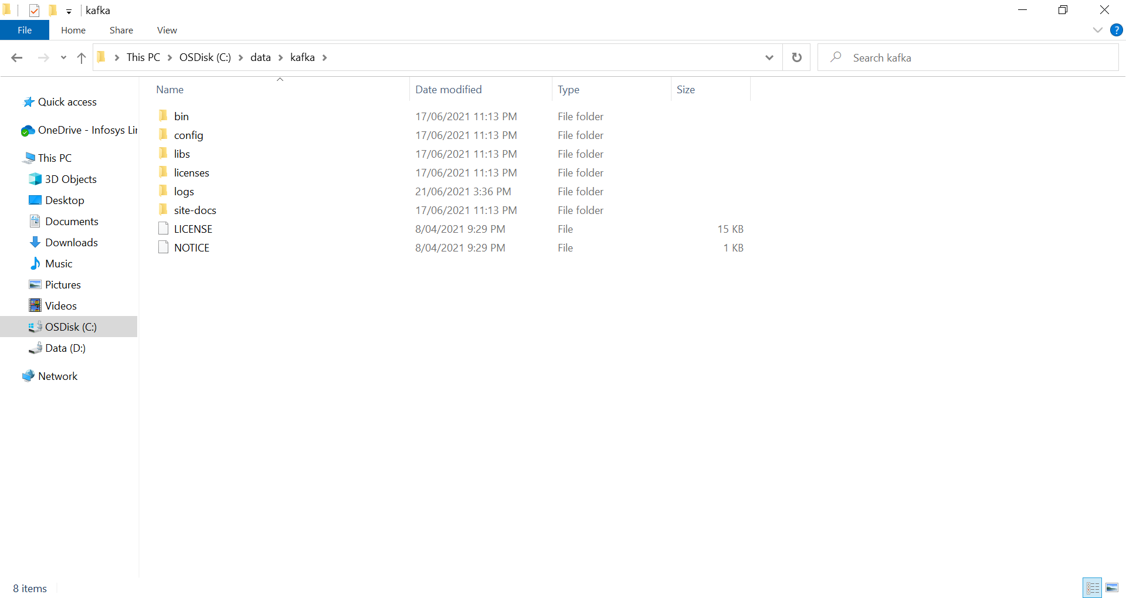

**Running zookeeper and Kafka:**

Use below command to run zookeeper

C:\data\kafka>.\bin\windows\zookeeper-server-start.bat .\config\zookeeper.properties

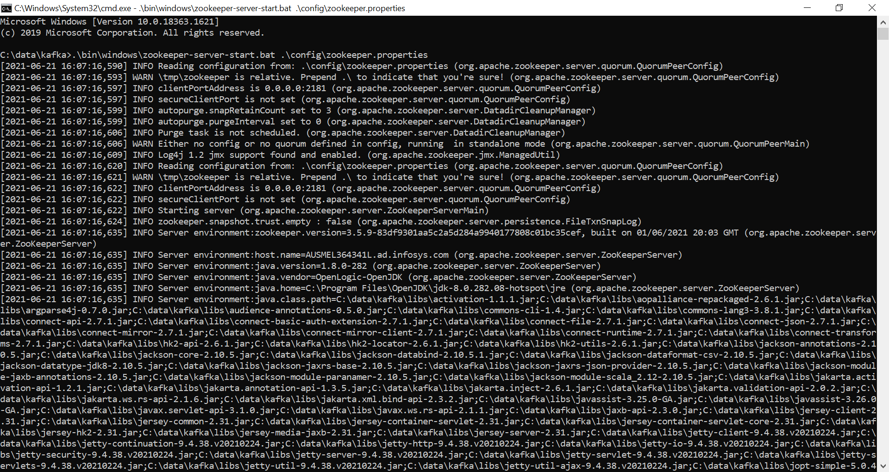

Use below command to run Kafka.

C:\data\kafka>.\bin\windows\kafka-server-start.bat .\config\server.properties

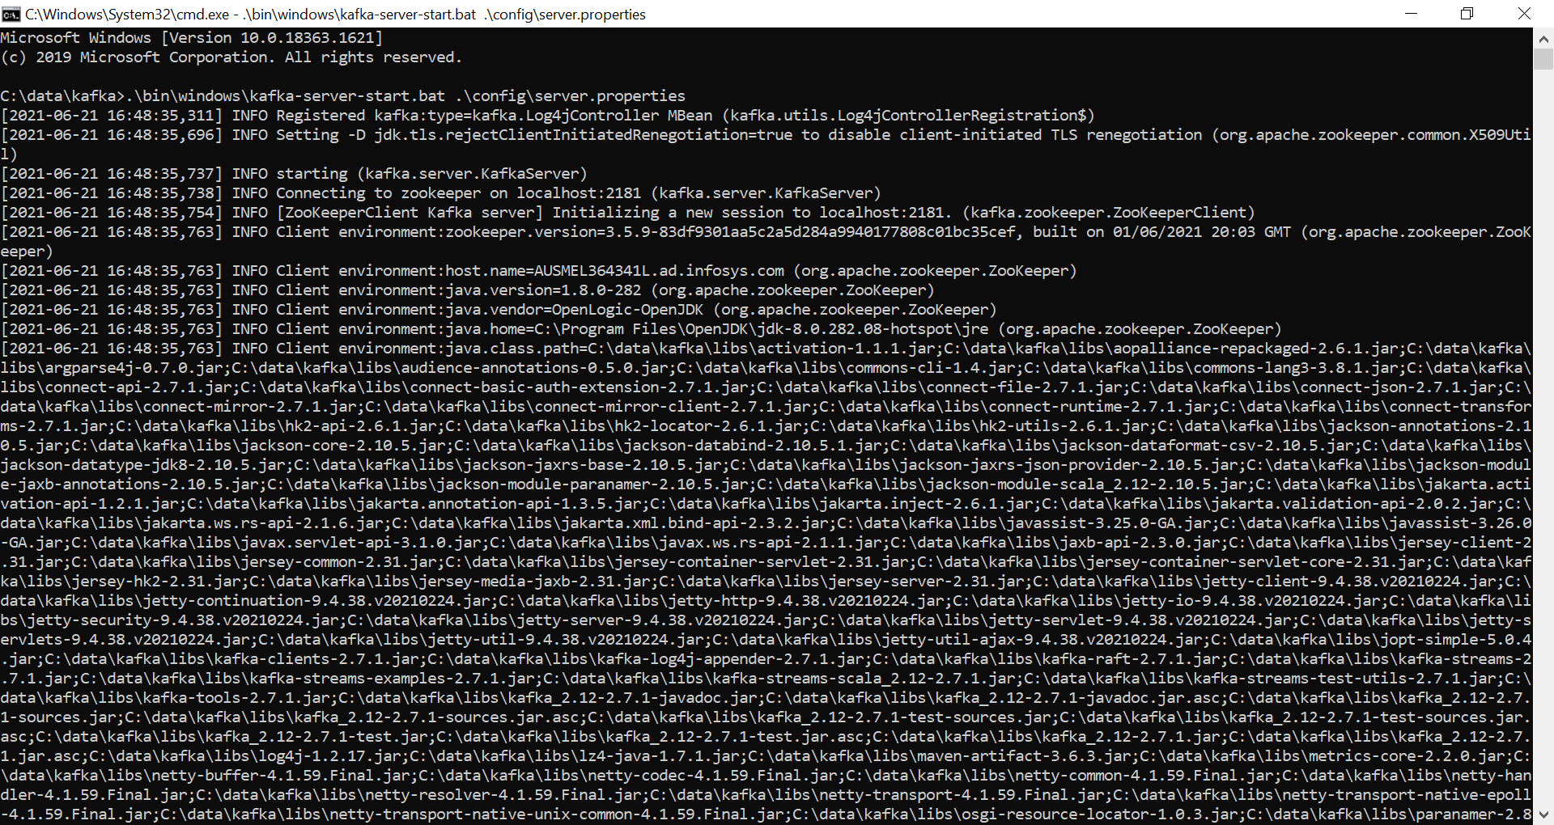

Creating topic :

C:\data\kafka> .\bin\windows\kafka-topics.bat –create –zookeeper localhost:2181 –replication-factor 1 –partitions 1 –topic product-transaction-topic

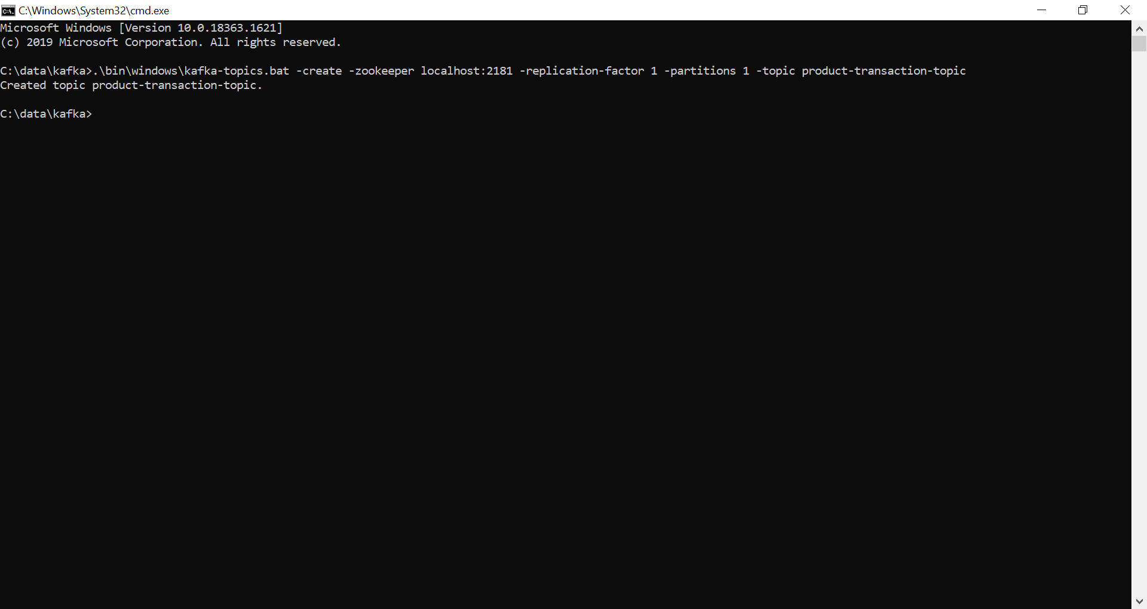

Run the following command to view the topic messages:

C:\data\kafka>.\bin\windows\kafka-console-consumer.bat –bootstrap-server localhost:9092 –topic product-transaction-topic

**Install PostgreSQL on Windows**:

There are three steps to complete the PostgreSQL installation:

1)Download PostgreSQL installer for Windows

2) Install PostgreSQL

3) Verify the installation

You can follow the following link and install the PostgresSQL

<https://www.postgresqltutorial.com/install-postgresql/>

**PTMS(Products-Transaction-Management-System) is maven project:**

Extract the Zip file into the home directory

The PTMS application can be run in the following ways:

1.Through eclipse

2.Through command line

**1.Through Eclipse:**

Step 1: Import project from eclipse

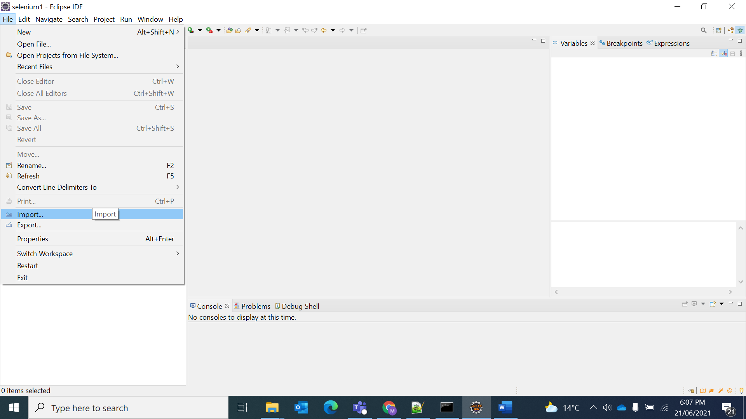

Step 2 : select Maven project and click the next button

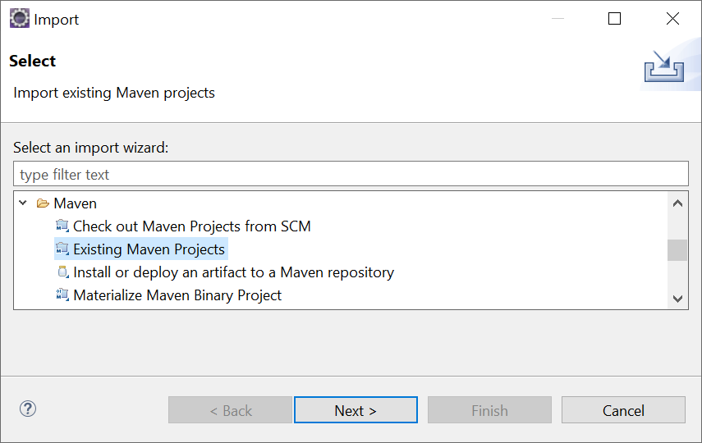

Step 3 : browse the project directory Click finish button

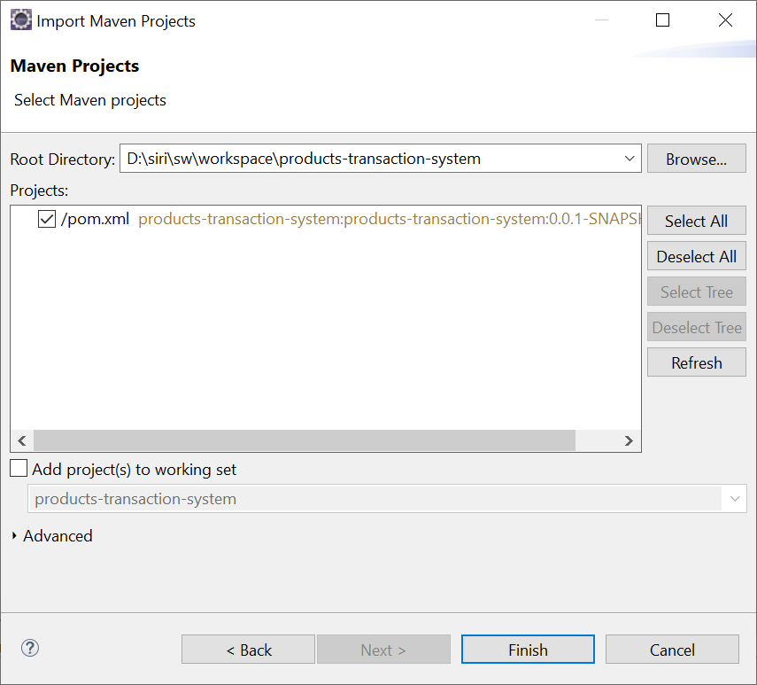

Step 4 : PTMS project will be loaded into eclipse 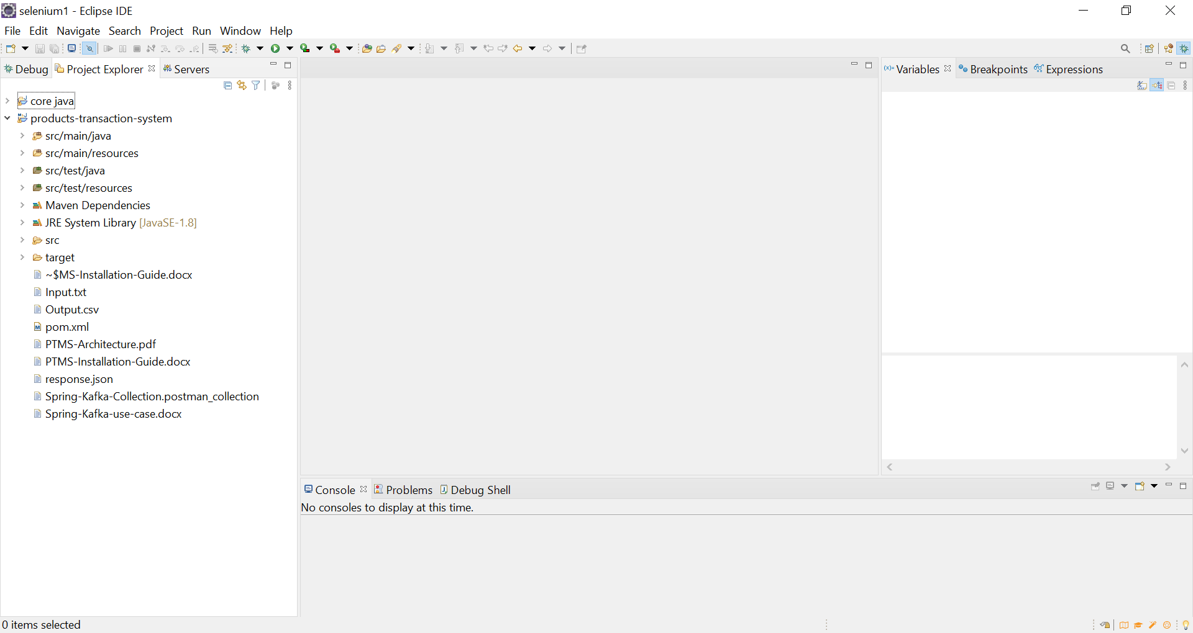

Step 5 : set the java build path 1.8 Apply and Close

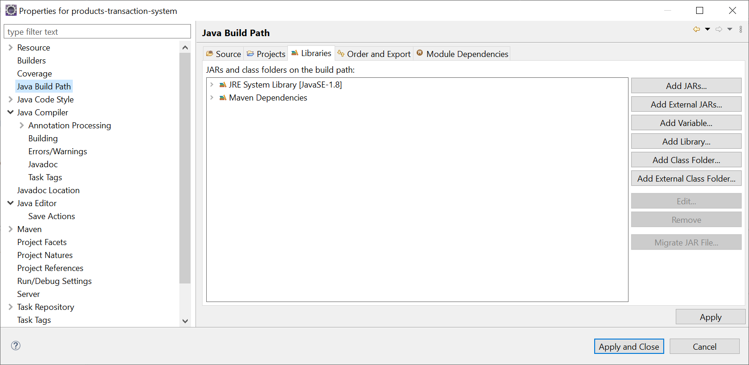

Step 6 : Right click on the PTMS project Select Run As and Maven build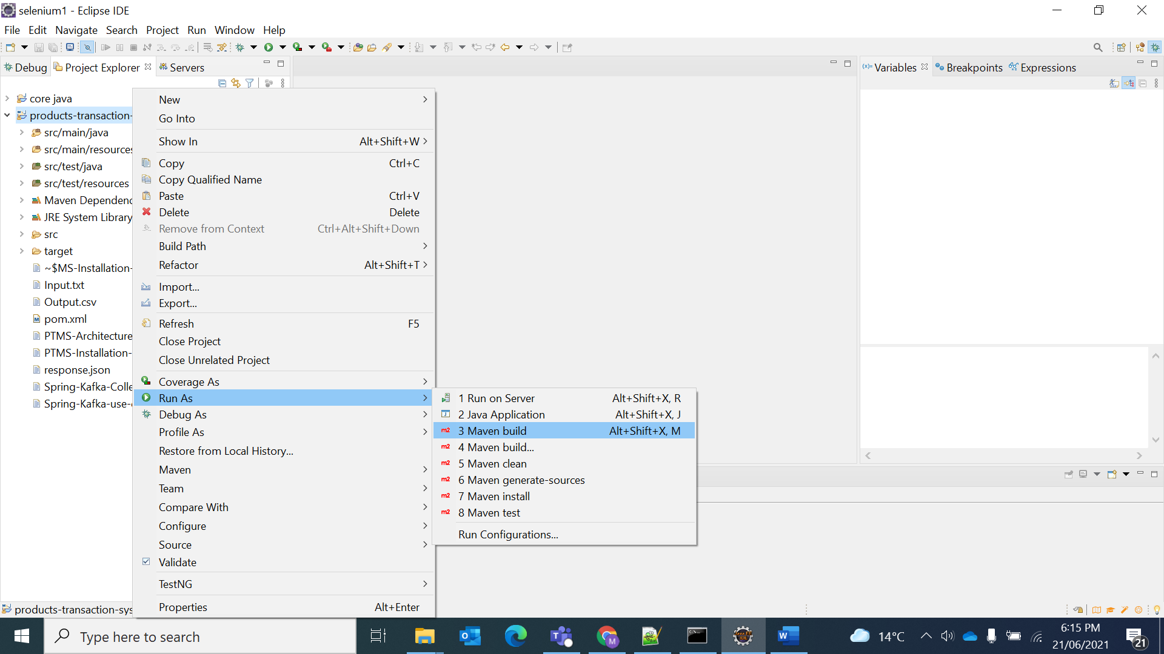

Step 7 : Enter the Goal text box as :spring-boot:run and click the run button

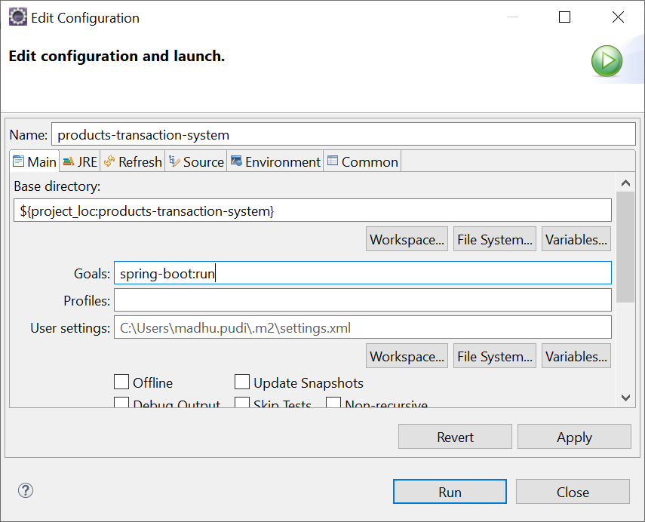

Step 8 : The PTMS module is up and running

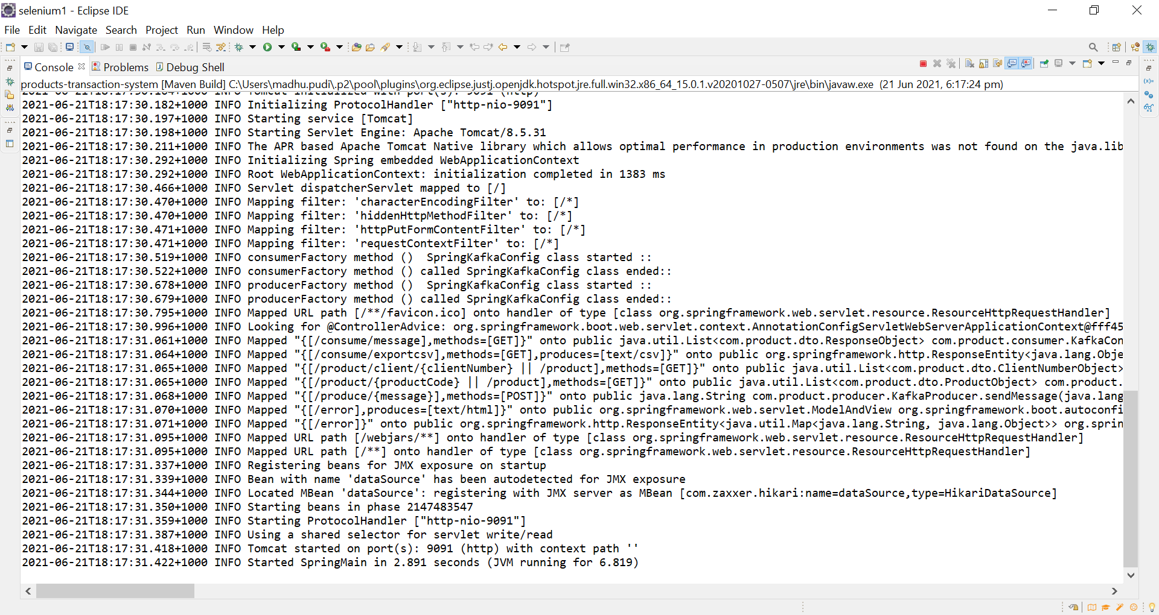

**2.PTMS running through command prompt:**

Step 1 : go to command prompt project home directory

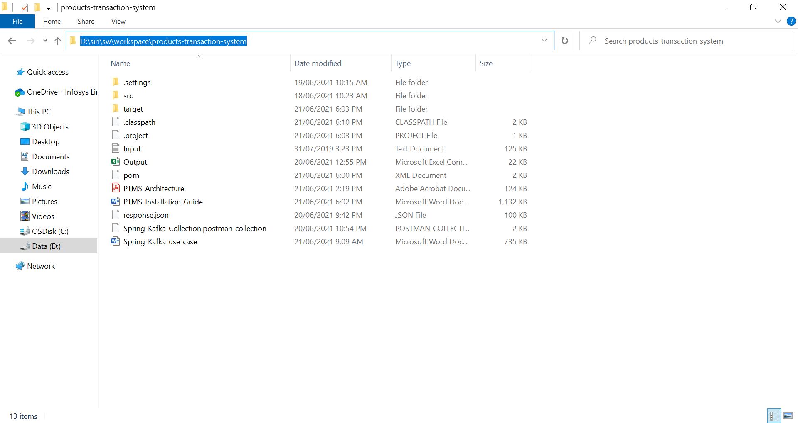

Step 2:Run the following command to create packages

D:\siri\sw\workspace\products-transaction-system>mnv clean install

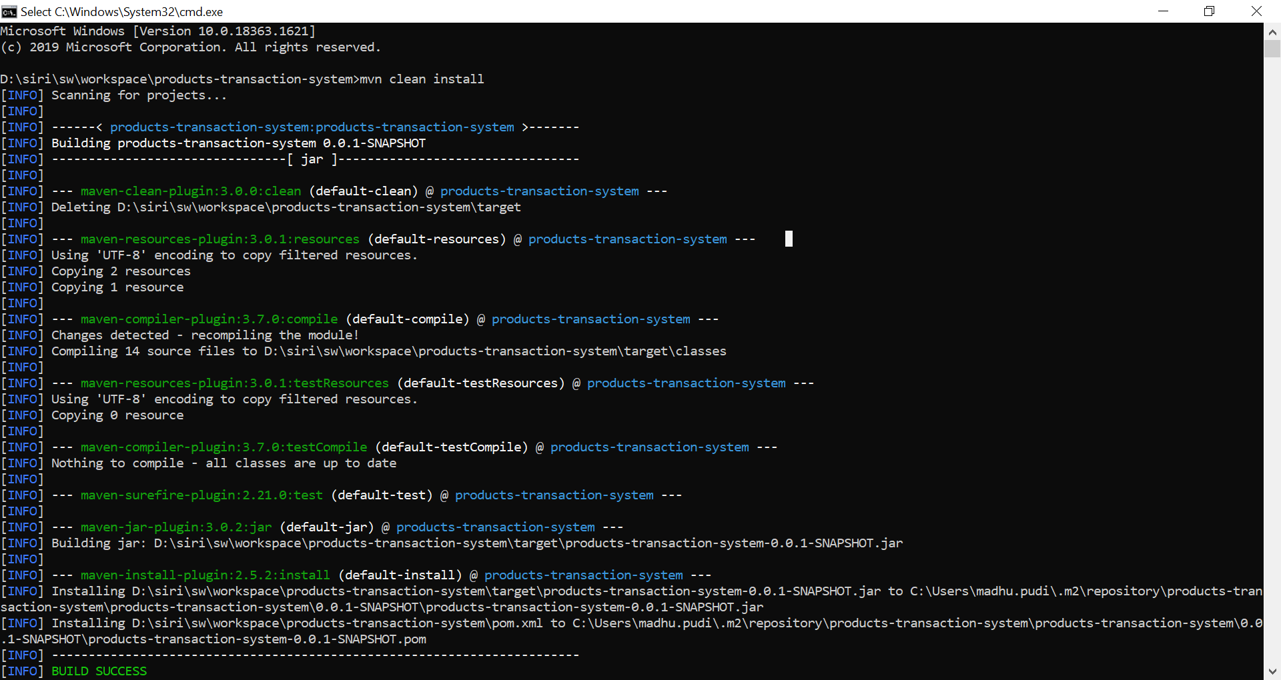

Step 3 : packages got created and execute following command to start the spring-boot application

D:\siri\sw\workspace\products-transaction-system>mvn spring-boot:run

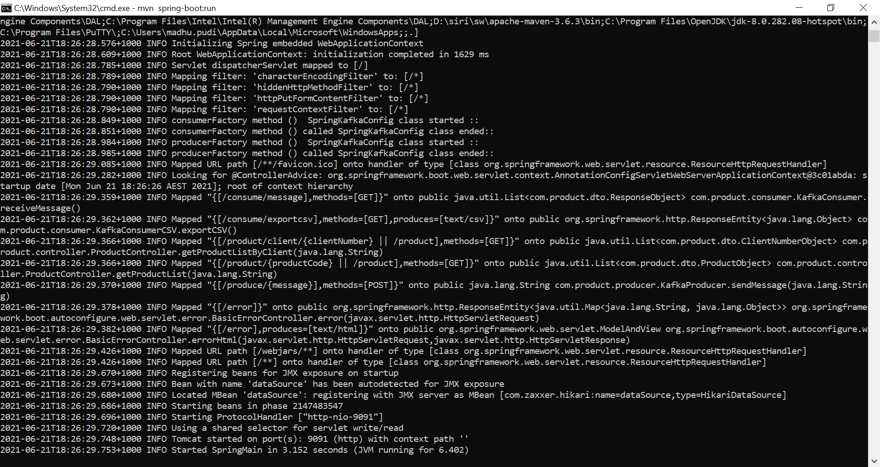

Now PTMS(**Products-Transaction-Management-System**) application is up and running.

Note : Before testing PTMS application, Create PRODUCTS table in PostgresSQL data base.

By using Use Case documents you can test PTMS application

Need to follow the Use case Sequence 1,2,3,4,5.