Use Case 1 : Parse the input text file send to the topic and inserting into the PRODUCTS table (PostgresSQL data base)

Post request : <http://localhost:9091/produce/hello>

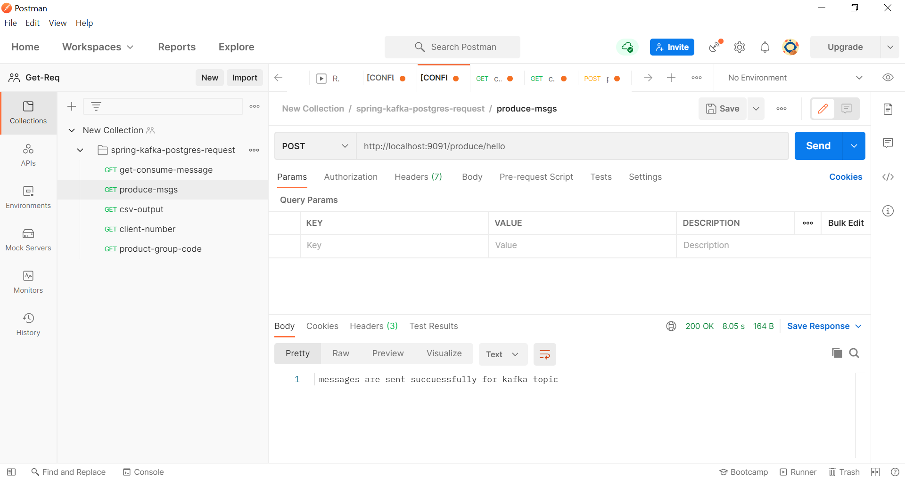

Use case 2: data is transforming from topic to consumer as csv file

get request: http://localhost:9091/consume/exportcsv

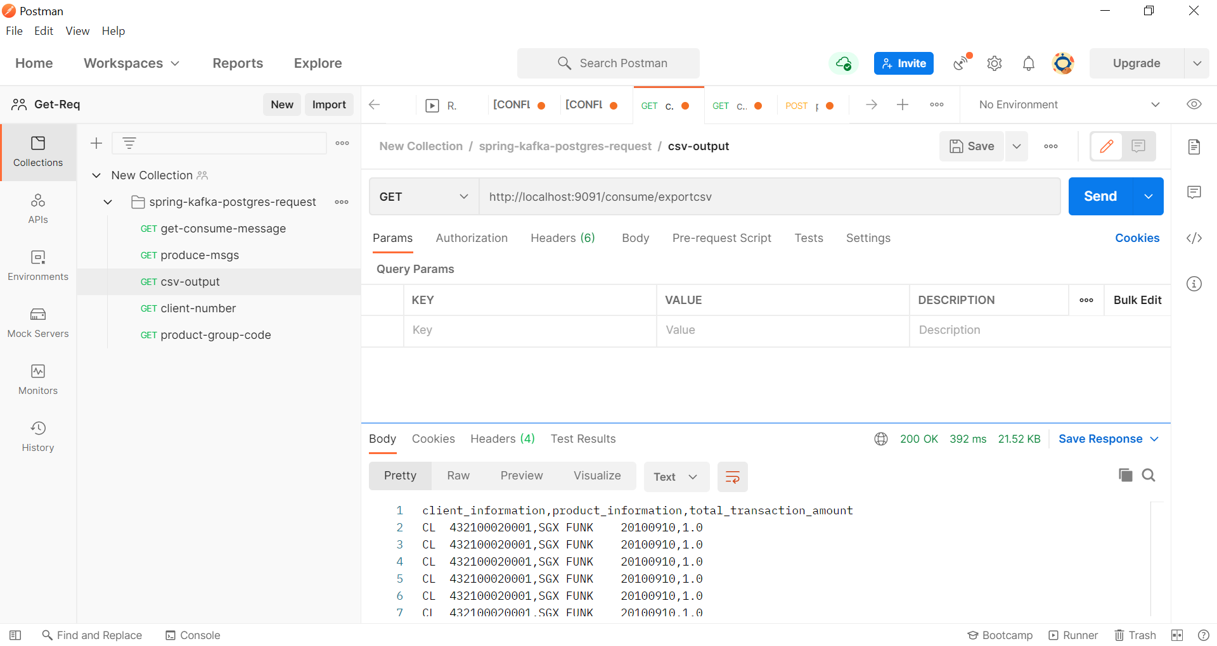

Use Case 4 : Total Transaction Amount by product is FU

Get request : <http://localhost:9091/product/FU>

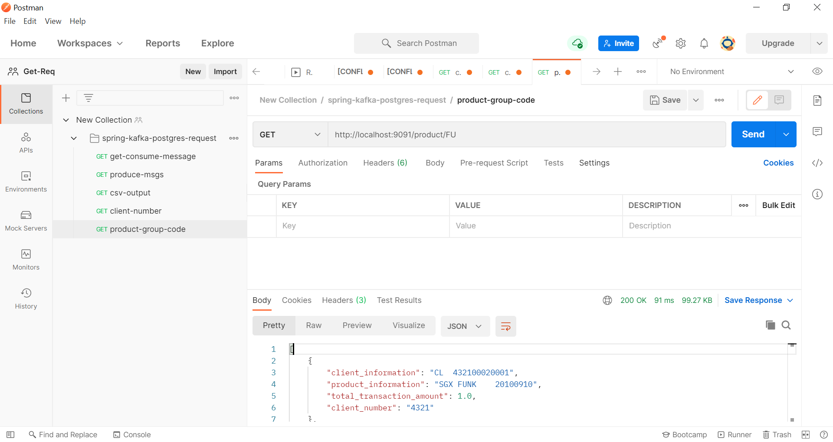

Use Case 5 : Total Transaction Amount by client number :

Get request :http://localhost:9091/product/client/4321

