AI Meeting Assistant: Technical Architecture Document
Inter IIT Bootcamp, Phase 2, ML Problem Statement
Implementation version: v3 (WhisperX for speech and speakers, Qwen2.5-72B-Instruct for both language-model roles)
Interface: Streamlit web app (app.py), run locally

1. What the system does
A user uploads an English meeting recording. In one run the system produces:
- a raw transcript (what the speech model heard),
- a refined transcript (domain terms and recognition slips corrected, meaning untouched),
- meeting minutes (summary, topics, organised sections),
- key decisions, each marked agreed or proposed,
- action items, with an owner or deadline only when the recording states one.
Every decision and action item carries the exact quote it came from, a timestamp that jumps the audio player to that moment, and a confidence tier with the reasons behind the score. The same record is available as Markdown and as JSON, generated from one object so the two cannot disagree.
Three rules shaped every module:
- The model proposes, deterministic code verifies. A 7B model is fast and cheap but occasionally invents or over-reads, so nothing it returns reaches the user without passing a check that does not use a language model.
- Every claim keeps a pointer back to the audio. A decision is stored with a verbatim quote, a timestamp and the clarity of that passage.
- Missing means “Unspecified”. Owners, deadlines and speaker names are reset to Unspecified whenever the transcript does not contain the evidence.

2. Models and their roles
Role | Model | Where it runs
Speech-to-text | WhisperX (faster-whisper engine) large-v3-turbo on COLAB T4 GPU. Voice activity detection by pyannote. | Colab GPU
Word alignment | wav2vec2 WAV2VEC2_ASR_BASE_960H | Colab GPU
Speaker labels | WhisperX diarization step, running pyannote speaker-diarization-community-1 | Colab GPU
Language model 1: transcript refinement | qwen/qwen-2.5-72b-instruct | OpenRouter API
Language model 2: minutes, decisions, tasks | qwen/qwen-2.5-72b-instruct, a separate call with its own prompt, output schema and validators | OpenRouter API
Domain retrieval | No model. Dictionaries, phonetic matching (Metaphone), fuzzy string similarity | Local machine
Evidence scoring | No model. Rule-based scorer | Local machine
The two language-model roles share one model id but are two distinct stages: different prompts, different inputs (raw paragraphs versus refined, speaker-labelled paragraphs), different output contracts and different safety checks.

3. Pipeline at a glance
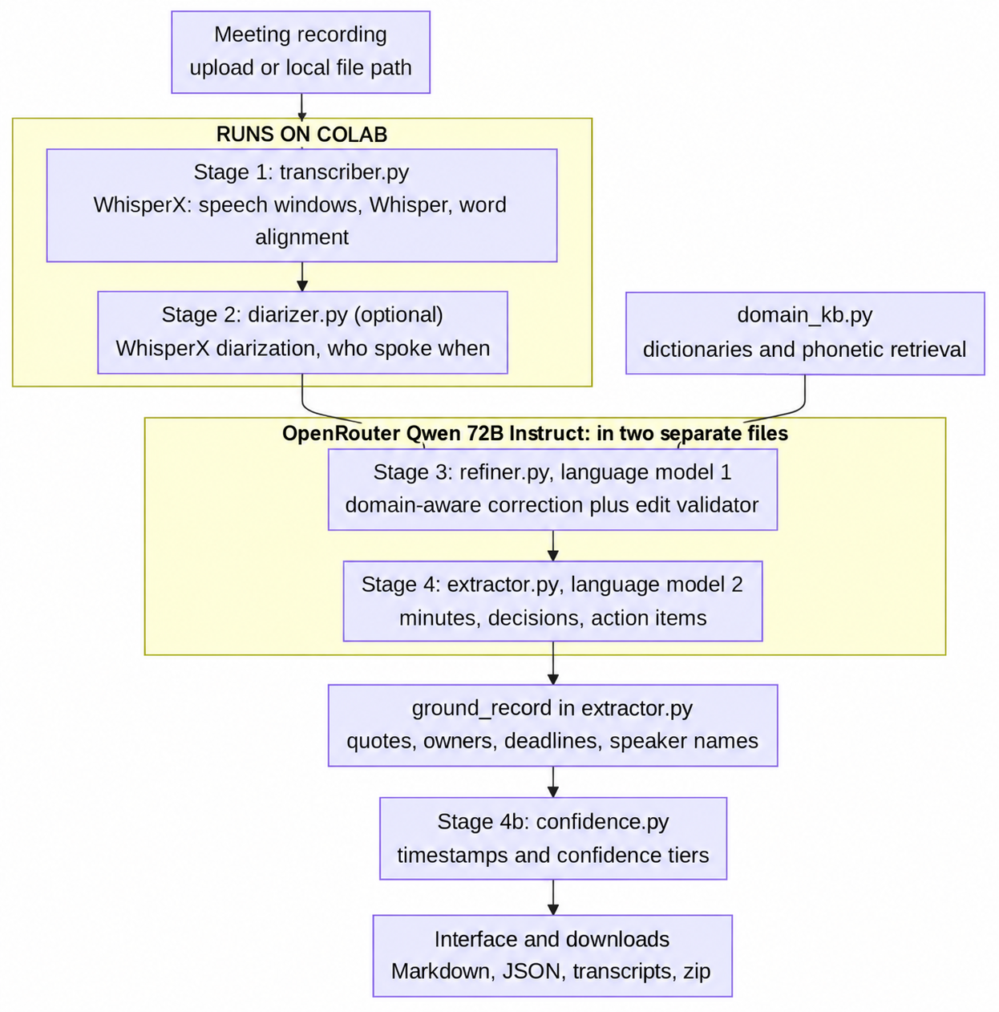

Figure 1. End-to-end pipeline
Step | File | Produces | Figures that matter
1 | transcriber.py | Segments with word times and a clarity value | 15 formats, 1 s to 2 h, English forced, speech windows up to 30 s
2 | diarizer.py | Same segments labelled Speaker 1, 2, ... | Optional, flicker smoothing under 0.9 s
3a | domain_kb.py | Glossary, suspect spans, spelling variants | 5 dictionaries, 185 terms, domain on at 3 cue hits
3b | refiner.py | Refined paragraphs and a full edit log | Batches of 10 paragraphs or 4200 characters, temperature 0.1
4 | extractor.py | Grounded MeetingRecord | One pass up to 30,000 characters, parts of 20,000 beyond that
4b | confidence.py | Timestamps, score 0 to 97, tier, reasons | Base 50, hard caps 30 / 55 / 59 / 79, ceiling 97

4. How data moves between the files
The files do not share state. Each stage receives a plain object and returns the next one, so any stage can be tested alone.
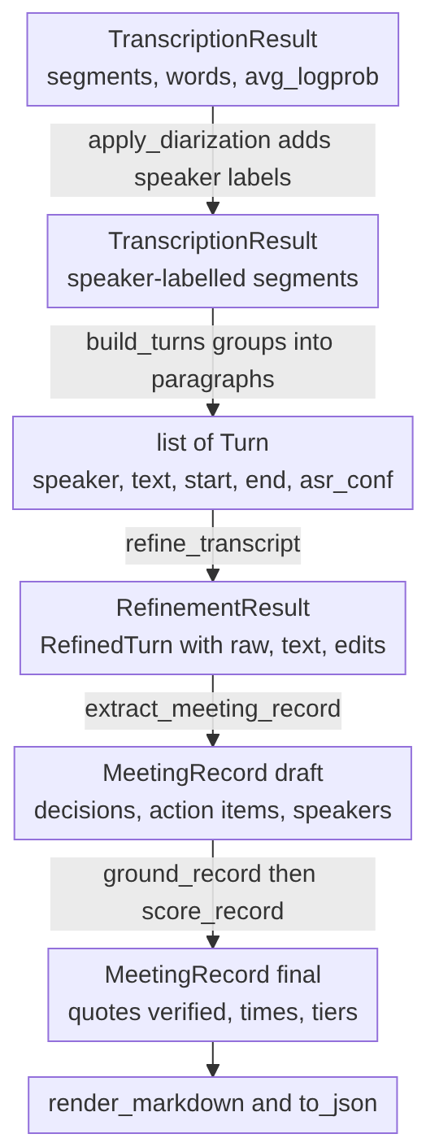
Figure 2. Data objects passed between files
Two details keep the chain honest. The raw text of every paragraph travels with the refined text, so both transcripts are always available. The audio timings and clarity of each paragraph travel all the way to confidence.py, which is how a decision made in the last stage can still point at second 482 of the recording.

5. Stage 1: transcription (transcriber.py)
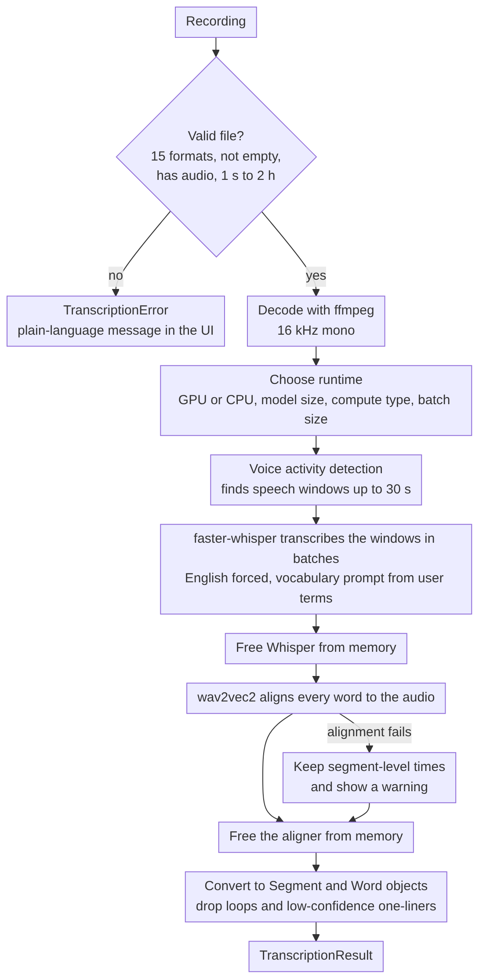
Figure 3. Stage 1, transcription flow
- Validation first. The file must have one of 15 supported extensions, be non-empty, be readable by ffprobe, contain an audio stream, and last between 1 second and 2 hours. Each failure gives a sentence written for the end user, for example “The file contains no audio track.”
- Decoding and runtime. ffmpeg converts any container to 16 kHz mono audio, so a video file works like a WAV. The runtime is chosen from the hardware: a GPU gets large-v3-turbo in float16 with a batch of 16, 8 or 4 depending on VRAM; a CPU gets small.en in int8 with a batch of 4.
- Transcription. Voice activity detection runs first so Whisper never sees silence. The speech windows (up to 30 s) are then transcribed in batches with beam size 5. Language is fixed to English, and terms typed into the “your own terms” box are passed to Whisper as a vocabulary prompt (capped at 800 characters), which nudges the spelling of names and jargon at the source.
- Word alignment. A wav2vec2 model assigns a start and end time to every word. These times make two later features possible: splitting a sentence where the speaker changes, and placing a timestamp inside a paragraph.
- One model at a time. Whisper is released from memory before the aligner loads, and the aligner before the diarizer. Peak memory is the largest single model, not the sum, which is the main protection for a modest laptop.
- Clean-up. The third repeat of an identical line in a row is dropped (a known Whisper loop), and so is any segment of three words or fewer whose average log-probability is below -1.5 (typical of a hallucinated “Thank you.” on noise).
The clarity value. Whisper reports avg_logprob for every segment. Each paragraph gets a clarity score between 0 and 1, defined as exp of the duration-weighted average of those values. confidence.py later lowers the score of any decision whose passage was poorly heard (clarity below 0.5 or 0.65).
From segments to paragraphs. build_turns() groups segments into the paragraphs every later stage works on. A new paragraph starts when the speaker changes, after a pause longer than 2.5 s, when adding text would pass 900 characters, or at a sentence end once the paragraph has passed 600 characters. Paragraph-sized units, rather than five-word fragments, give the refiner enough context to judge a correction.

6. Stage 2: speaker identification (diarizer.py)
Action items are usually spoken in the first person (“I’ll send the report by Friday”). Without knowing who said “I”, the only honest owner is Unspecified. This stage supplies the speaker.
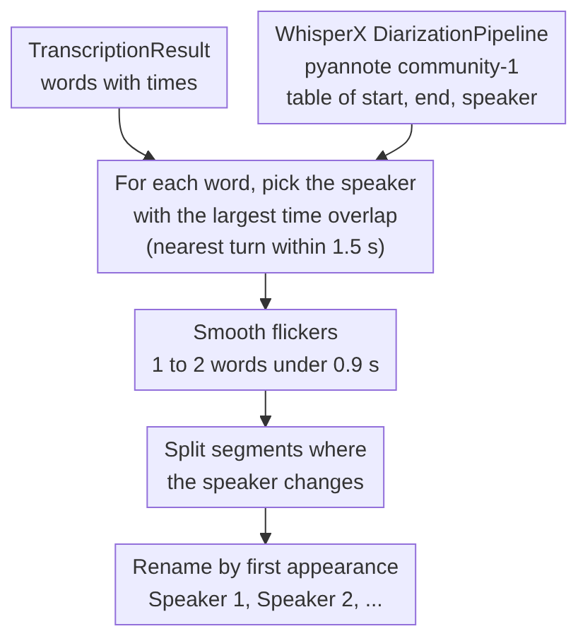
Figure 4. Stage 2, speaker identification flow
- Word-level assignment. Each word takes the speaker who talks most during that word, so a speaker change in the middle of a Whisper sentence splits the sentence instead of giving the whole thing to one person.
- Smoothing. A one or two word island of a different speaker, shorter than 0.9 s and sitting between two stretches of the same speaker, is treated as a labelling flicker and merged back.
- Naming. Raw labels are renamed Speaker 1, 2, ... in order of first appearance. Real names are never guessed here; the extractor attaches them later, and only with quoted evidence.
- Failure is not fatal. If the Hugging Face token is missing, access is denied or memory runs out, the run continues without speaker labels and the extractor switches to its no-speaker rules. This is the heaviest step on a CPU, so it is optional.

7. Stage 3: domain-aware refinement (domain_kb.py and refiner.py)
Whisper hears sounds, not vocabulary. “Cooper netties” for Kubernetes and “sequel database” for SQL database are errors of sound. A language model with no context may leave them or, worse, “fix” the wrong thing. The solution has three parts: retrieve relevant context without any model, give that context to the language model, then check every edit it proposes.

7.1 Retrieval without a vector database (domain_kb.py)
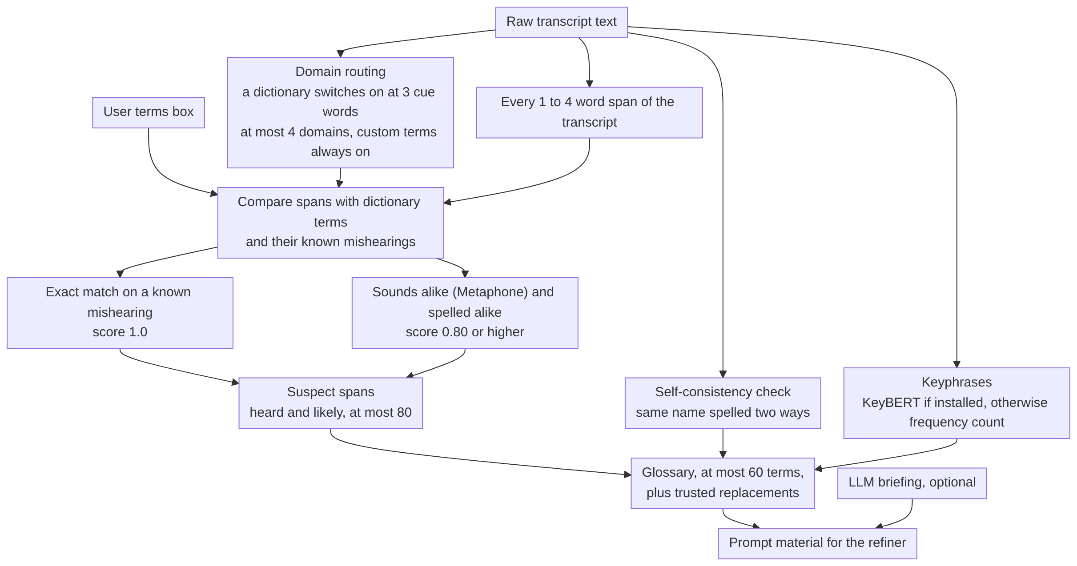
Figure 5. Stage 3, domain retrieval flow
Dictionaries. Five files hold 185 terms: software engineering and DevOps (68), data science and machine learning (41), business, finance and product management (36), municipal government (27) and formal meeting procedure (13). Each term lists its expansion and its aliases, the mishearings Whisper is known to produce. A dictionary switches on only when at least 3 of its cue words appear in the transcript, and at most 4 domains are active at once. Terms the user types in are always active.
Matching. Every span of 1 to 4 words is compared with every term and alias:
- An exact alias match on a known mishearing scores 1.0.
- A phonetic match reduces words to a Metaphone key, so “cooper netties” and “Kubernetes” land close together.
- A candidate is kept when it passes either the sound-and-spelling test (phonetic similarity at least 0.82, character similarity at least 0.60, same first sound) or a strict spelling test (character similarity at least 0.88, same first letter). The minimum final score is 0.80 for dictionary terms and 0.75 for user terms.
Two guards prevent false fixes: a span that merely starts like a real word is skipped (so Council is never “corrected” to Councillor), and spans containing digits or shorter than 4 letters are ignored.
Self-consistency. The same word spelled two ways inside one transcript (for example “Tarian” and “Terrian”) is clustered with occurrence counts. This catches names that no dictionary contains.
LLM briefing (optional). Before refinement the language model reads the meeting once (up to 28,000 characters, sampled from the start, middle and end beyond that) and returns the meeting type, names and a list of suspected mishearings. A suspected mishearing is accepted only if the “heard” words really occur in the transcript, at most 40 are kept, and each becomes a suspect span with score 0.9.

7.2 What the refiner sends to the model (refiner.py)
Paragraphs go to the model in batches of up to 10 paragraphs or 4200 characters at temperature 0.1. Each request carries the editor instructions, the glossary (capped at 3800 characters), the suspect spans that actually occur in the batch (at most 12) and a little preceding context. The instructions treat a suspect span as a hint, not an order, and forbid changes to numbers, dates, negations, modal verbs, who does what, and the status of a proposal. The reply is a JSON list of corrected passages. If a reply is cut off, the batch is retried one paragraph at a time, and a paragraph the model fails to return keeps its raw text.

7.3 The edit validator (validate_refinement)
A prompt is a request, not a guarantee. After the model answers, the proposed text is compared with the raw text word by word, and each individual change is accepted or rejected by code.

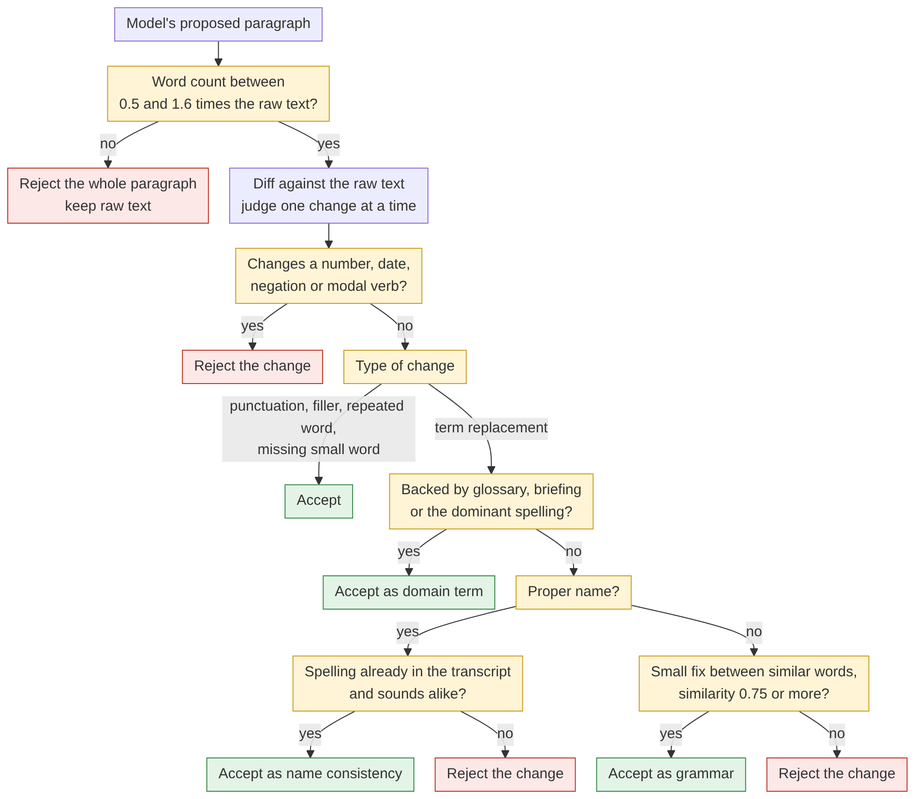
Figure 6. Stage 3, edit validator decision flow
Rule | Detail
Protected tokens | Numbers, dates, weekdays, months, negations and modal verbs must be identical before and after.
Name safety | A capitalised word is never lowercased, and a name may change only to a spelling that already occurs in the raw transcript and sounds alike.
Deletions and insertions | Only fillers, accidental repeats and a few function words may be removed. At most two grammar words, or a glossary-backed term, may be added.
Term replacements | Need evidence other than the model’s say-so: a trusted dictionary or briefing pair, glossary words that still sound like what was heard, or a spelling that dominates inside the same transcript.
Size limits | At most 6 words on each side of a term replacement. Rewrites above 8 words replaced or 10 words inserted are refused.
Every decision goes to an audit log with its kind (domain term, name consistency, grammar, capitalisation, punctuation, filler or rejected), the reason and a snippet of context. The interface shows accepted corrections, rejected corrections and a side-by-side diff, plus a list of suspected terms that were left unchanged.

8. Stage 4: minutes, decisions and tasks (extractor.py)
This is the second language-model role. It reads the refined paragraphs, labelled Speaker N: when diarization ran, and returns one structured record: a summary, key topics, sectioned minutes, decisions, action items and speaker names. The reply is validated against a pydantic model, and any unknown or malformed value is coerced to the conservative option (a decision becomes proposed, a task becomes unspecified).
The prompt encodes the problem statement’s two hard rules. A decision is agreed only when the group explicitly settles it (“we’ve decided”, “motion carried”, “no objections”), and anything merely suggested is proposed. An action item is assigned only when a named person, or the speaker themself in a first-person commitment, takes it, and a deadline is recorded only if a time limit is stated for that task, copied as spoken. Every decision and task must include a verbatim quote from the transcript.
Evidence features instead of self-reported confidence. The model is not asked how sure it is, because self-reported confidence is poorly calibrated. It reports facts it can read off the text: whether agreement was explicit, whether there was an objection, whether the wording was hedged, and whether the owner accepted. confidence.py turns those facts into a score.
Two speaker modes. With speaker labels, a first-person commitment can be attributed to the speaker. Without labels, “I’ll do it” cannot be attributed, so the owner stays Unspecified unless someone is named.
Long meetings and retries. A transcript up to 30,000 characters (about 7,500 tokens, a 25 to 30 minute meeting) goes in one call. Longer transcripts are split at paragraph boundaries into parts of about 20,000 characters, each extracted separately, and one small call merges the summary and topics while decisions and tasks are concatenated and de-duplicated. The limit is deliberately modest because a 7B model follows a long output contract best on moderate input. Invalid JSON is retried once with the validation error appended, a provider that rejects JSON mode is retried without it, and network or rate-limit errors get up to 4 attempts.

Grounding (ground_record)
After the model answers, deterministic checks verify what it claimed.
Check | Rule | Effect when it fails
Quote exists | At least 3 words, and at least 70 percent of its 4-word sequences occur in the transcript. | An agreed decision is downgraded to proposed. A task loses its owner and deadline.
Owner is a real name | The owner’s words occur in the transcript and are not a vague word (someone, team, everyone). | Owner becomes Unspecified.
Owner is a speaker | Speaker N is accepted only when the quote sits in that speaker’s own paragraph and contains first-person words. | Owner becomes Unspecified.
Deadline is spoken | Every non-filler word of the deadline occurs in the transcript. | Deadline becomes Unspecified.
Speaker names | The name must occur in the transcript, with a verbatim evidence quote located in that speaker’s paragraph or a neighbouring one. | Name stays Unspecified.
Every change made to a model answer is written to record.warnings and appears in the minutes under “Verification notes”.

9. Stage 4b: timestamps and confidence (confidence.py)
No language model is used here. The scorer answers two questions: where in the audio is this, and how strongly does the transcript support it?
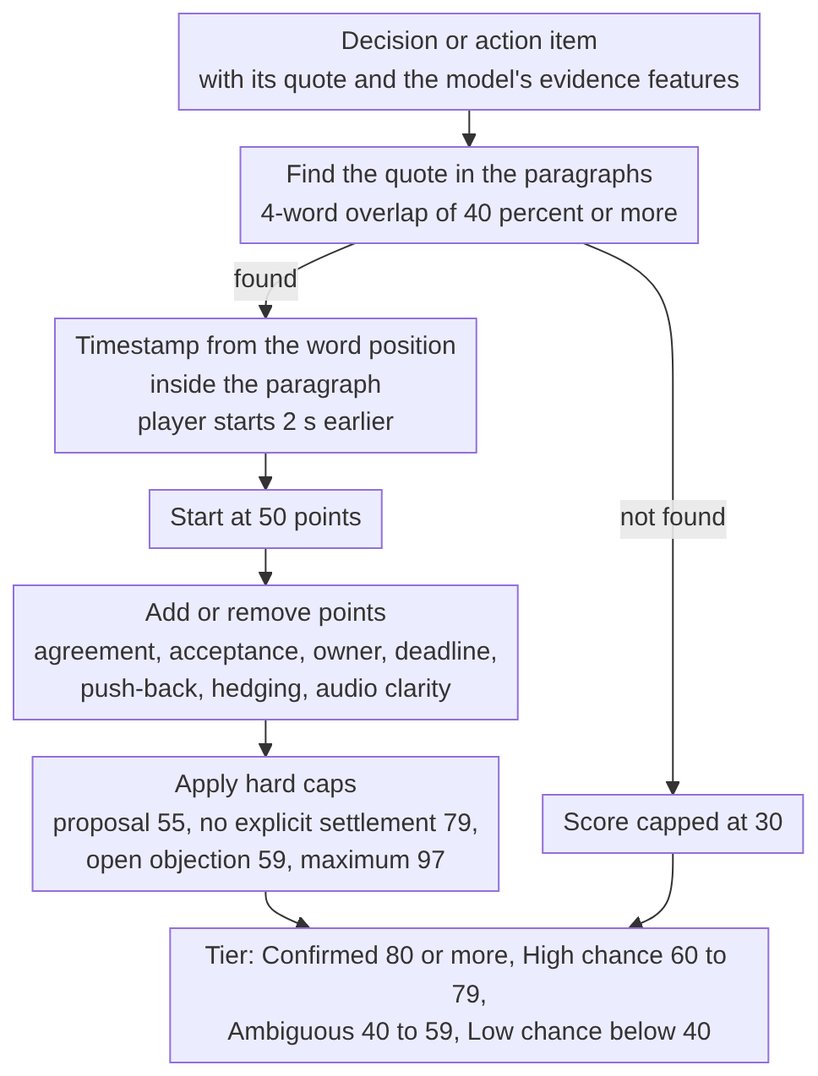
Figure 7. Stage 4b, confidence scoring flow
Cross-checking the model. The model’s evidence features are checked against wording found in the transcript, using phrase lists for formal settlement (“motion carried”), assent (“sounds good”), push-back (“I’m not convinced”), hedges (“maybe”) and commitments (“I’ll”). If the model claims explicit agreement but no agreement words appear in the quote or the next two paragraphs, the claim is downgraded to implicit. If no quote could be verified, the claim is dropped.

Scoring decisions (base 50)
Evidence | Points
Statement quote found verbatim / only the agreement quote found / no verifiable quote | +5 / -5 / -25
Explicit agreement / implicit agreement / none | +25 / +10 / -15
Settlement quote verified | +12
Formal settlement wording / strong assent / weak assent | +10 / +5 / +2
Acknowledged by a different speaker | +5
Objection unresolved / resolved / possible push-back in wording | -25 / -5 / -8
Hedged wording | -8 per hedge phrase, at most -20
Refiner changed words inside the quote | -3
Clarity below 0.5 / between 0.5 and 0.65 | -15 / -6

Scoring action items (base 50)
Evidence | Points
Quote found verbatim / not found | +5 / -25
Status assigned / proposed | +15 / -15
Owner accepted: explicit / implicit / nobody | +20 / +8 / -10
Commitment wording (“I’ll”) / acknowledged in the next reply | +5 / +3
Owner stated / deadline stated | +5 / +5
Hedged wording, push-back in the next reply, refiner edit in the quote | -8 per hedge (at most -20), -8, -3
Clarity below 0.5 / between 0.5 and 0.65 | -15 / -6

Hard rules applied last
Rule | Cap
Evidence could not be found in the recording | 30
A proposal (decision or task) | 55, never above Ambiguous
An agreed decision without explicit, quotable settlement | 79
An agreed decision with an open objection | 59
A task without a stated owner who explicitly accepted | 79
Unclear audio (clarity below 0.5) | 79
Everything | 97 maximum
An agreed decision with a verified quote never falls below 40, so it stays visible as Ambiguous instead of disappearing. The ceiling of 97 is intentional: the interface should never claim certainty, because the user can always press the timestamp and listen.

Worked example
From the integration test on a short scripted conversation: Speaker 2 asks for objections and Speaker 1 closes the point (“No objections, that is agreed.”) on the decision to move the release to the next sprint.
Evidence | Points
Base | 50
Statement quote found verbatim | +5
Explicit agreement stated | +25
Settlement quote verified | +12
Formal settlement wording (“that is agreed”) | +10
Acknowledged by a different speaker | +5
Raw total | 107
After the ceiling of 97 | 97, Confirmed
The action item in the same test (“I’ll update the runbook by Friday.”) also reached 97 for the same reason: verified quote, explicit assignment, explicit acceptance, first-person commitment, stated owner and stated deadline.
Timestamps. EvidenceLocator finds the paragraph that contains the quote and estimates its start from the word position inside the paragraph’s audio span. The estimate is accurate to the paragraph and approximate inside it, so the review player starts 2 seconds earlier and the listener hears the lead-in.

10. Orchestration and interface (app.py)
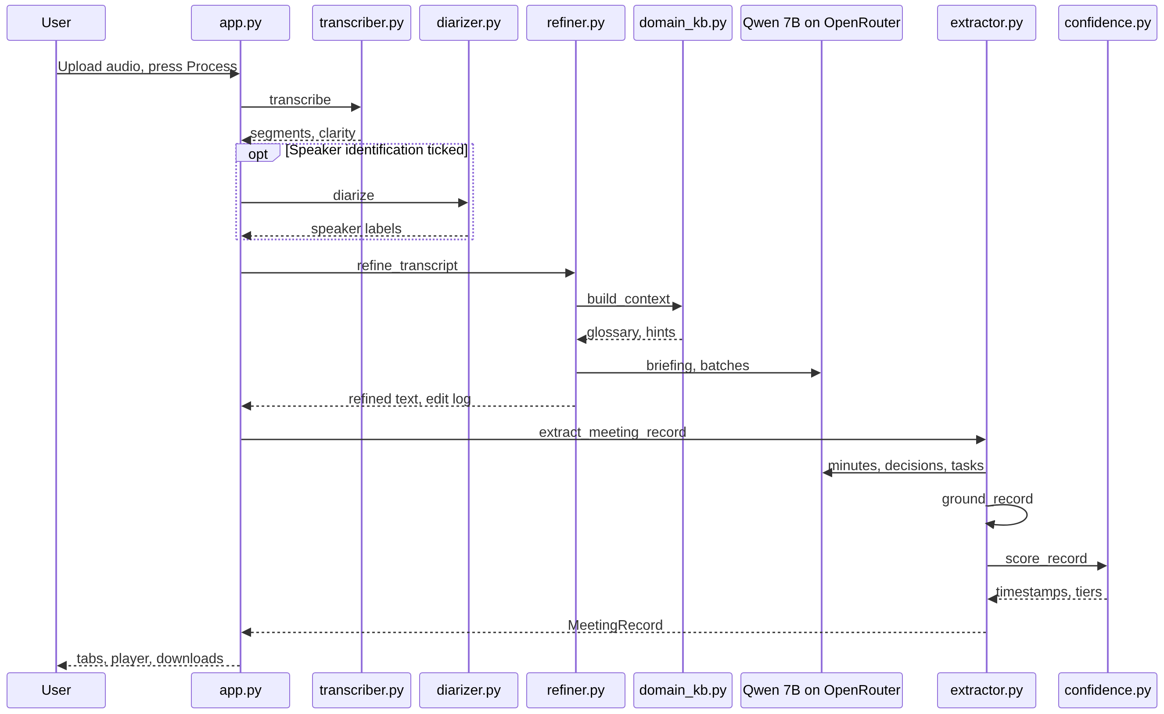
Figure 8. Orchestration sequence in app.py
The stages always run in the order transcription, speakers (optional), refinement, documentation. The progress bar weights them 35, 20, 25 and 20 percent, and a status panel prints one line per finished stage. The interface has seven tabs (raw transcript, refined transcript with diff and audit log, domain context, speakers, a decisions and tasks review with confidence bars and listen buttons, rendered minutes, and the JSON record) and downloads for the transcripts, the minutes, the record, the refinement report and a zip of everything. The Markdown minutes and the JSON are both rendered from the same MeetingRecord, so they always list identical decisions and tasks.

11. Failure handling
Situation | What happens
Unsupported, empty, corrupt or too short or long file, no audio track | Stage 1 stops with a specific sentence in the interface
Alignment model cannot load | Run continues with segment-level times and a warning
GPU or system memory exhausted | Message suggesting a smaller model or batch size
Hugging Face token missing or terms not accepted | Speaker labels skipped, warning shown, rest of the run unaffected
OpenRouter key wrong, model unavailable, credits exhausted | Specific message for each case
Model returns invalid JSON | Retry once with the error text, then fail with a clear message
Model proposes an unsafe edit | Rejected by the validator and logged
Model invents a quote, owner or deadline | Cleared by grounding and logged in warnings

12. Design trade-offs
- Local WhisperX instead of a hosted Whisper. Nothing is uploaded, there is no file-size limit, and word-level times come with the transcript. The cost is compute on the team machine, which is why the model size is configurable and why Whisper, the aligner and the diarizer never sit in memory together.
- A 72B model for both language roles. Cheap and quick, but weaker than a large model at long, strict JSON and at subtle agreement. The design compensates on the precision side, since quotes, owners and deadlines are verified by code and edits are validated one by one. It cannot create recall the model did not produce, so a decision the model fails to notice does not appear.
- A verification stage was tried and removed. An earlier iteration re-checked each claim with one extra model call per claim. With a 72B model and the deterministic checks already in place, the extra calls added latency and cost without a matching gain.
- Phrase lists are English only, which fits the problem statement’s English-language scope.
- Overlapping speech is weak. Whisper-based transcription and pyannote diarization both degrade when people talk over each other, and the clarity score is the signal that flags such passages.
- Speaker names exist only if the recording says them. A speaker the recording never names stays Speaker N.

13. Traceability to the problem statement
Requirement | Where it is met
Accept an English recording and run upload to output in one run | app.py runs stages 1 to 4b from one button
Speech-to-text produces a visible raw transcript | Stage 1, raw transcript tab and download
Language model corrects domain errors, preserving meaning, names, numbers, negation, commitments | Stage 3: domain retrieval, prompt rules, edit validator with protected tokens
Raw and refined transcripts kept and shown separately | Both stored on every paragraph, side-by-side diff tab
A separate language model stage produces minutes, decisions and tasks | Stage 4, own prompt, schema and validators
Never present a proposal as an agreed decision or an unstated assignment as confirmed | Status definitions, downgrade rules in grounding, proposal cap of 55
Owner or deadline only when the recording provides one | Default Unspecified, owner and deadline grounding rules
Clear errors for unsupported, empty or unreadable files | Stage 1 validation messages
Human-readable and machine-readable record with the same content | One MeetingRecord rendered to Markdown and JSON
Interactive interface with status, inspection and downloads | Streamlit app with status panel, 7 tabs, review player, downloads
Selected models and their roles identified | Section 2

