Frequency-selective

Wireless Channel

P/S

c1

q1

Precoding

x1

Add

CP

IFFT

S/P

S/P

S/P

Remove CP

FFT

Remove CP

FFT

P/S

Det

P/S

Det

S/P

IFFT

Add CP

P/S

x1

q2

c2

*K* users

*M* antenna

cM

xM

qN

S/P

IFFT

Add CP

P/S

Keterangan:

M = Jumlah antenna Tx

K = Jumlah user

N = Jumlah subcarrier

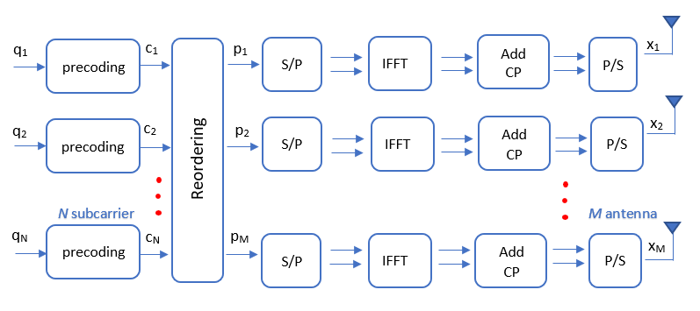

Frequency-selective

Wireless Channel

S/P

S/P

Remove CP

FFT

Remove CP

FFT

P/S

Det

P/S

Det

x1

p1

c1

q1

precoding

P/S

Reordering

Add

CP

IFFT

S/P

q2

S/P

IFFT

Add CP

P/S

x2

p2

c2

precoding

*N* subcarrier

*M* antenna

xM

pM

cN

qN

precoding

S/P

IFFT

Add CP

P/S

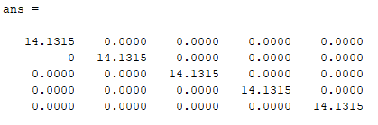

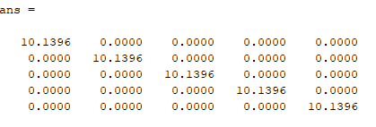

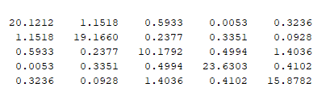

**BS Side**

x1

p1

c1

q1

precoding

P/S

Reordering

Add

CP

IFFT

S/P

q2

S/P

IFFT

Add CP

P/S

x2

p2

c2

precoding

*N* subcarriers

*M* antennas

xM

pM

cN

qN

precoding

S/P

IFFT

Add CP

P/S

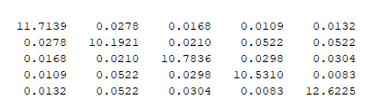

**User Side**

Frequency-selective

Wireless Channel

**User 1**

S/P

S/P

Remove CP

FFT

Remove CP

FFT

P/S

Det

P/S

Det

**User *K***

$$y_{K}$$

$$y_{1}$$