DAFTAR PUSTAKA

[1] Massive MIMO in 5G Network, 2018, Long Zao, Hui Zao, Springer SpringerBriefs in Electrical and Computer Engineering

[2] Antenna Selection in Massive MIMO Using Non-Central Principal Component Analysis, 2016   
M. T. A. Rana 26th International Telecommunication Networks and Applications Conference (ITNAC)

[3] Energy and Spectral Efficiency of Very Large Multiuser MIMO Systems, Hien Quoc Ngo, Thomas L. Marzetta, IEEE TRANSACTIONS ON COMMUNICATIONS, VOL. 61, NO. 4, APRIL 2013

[4] Fundamentals of massive MIMO

[5] M. Sadeghi, C. Yuen, and Y. H. Chew, “Sum rate maximization for uplink distributed massive MIMO

systems with limited backhaul capacity,” inProc. IEEE Global Telecommun. Conf. (GLOBECOM), Austin,

TX, Dec. 2014.

[6] E. Bj¨ ornson, J. Hoydis, M. Kountouris, and M. Debbah, “Hardware impairments in large-scale MISO systems: Energy efciency, estimation, and capacity limits, ” in Proc. Signal Processing and Optimization for Green Energy and Green Communications (DSP'13), Santorini, Greece, 201

[7] Performance of Conjugate and Zero-Forcing, Beamforming in Large-Scale Antenna Systems, Hong Yang, Thomas L. Marzetta

[8] Massive MU-MIMO Downlink TDD Systems with Linear Precoding and Downlink Pilots, Hien Quoc Ngo, Thomas L. Marzetta , 2013

[9] Stutzman W. L. dan Gary A. Thiele, Antenna Theory and Design, New York: John Wiley & Sons, 2013.

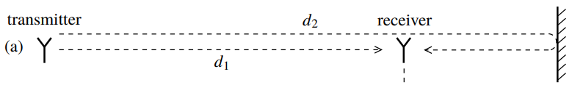

Membangun sistem

Analisa sistem Massive MIMO

Studi latar belakang

penelitian

Menentukan parameter sistem

Analisa pengaruh estimasi CSI terhadap kinerja sistem

Membangun sistem pemancar

Perkembangan Teknologi 5G

Analisa pengaruh pengaruh penambahan jumlah antena terhadap kinerja sistem

*Massive MIMO* dapat mendukung perkembangan 5G

Membangun sistem penerima

Analisa efisiensi spektrum pada sistem *Massive MIMO*

Penambahan jumlah elemen *array* dapat meningkatkan kapasitas

Membangun skema estimasi CSI

Analisa Efisiensi SpektrumSistem Multi User Massive MIMO Sel Tunggal Pada Kanal Rayleigh dan Random Line

of Sight

Simulasi pada kanal UR-LOS dengan kondisi imperfect CSI

Studi literatur estimasi CSI

Penulisan laporan

Studi literatur skema OFDM

Pembuatan *draft paper*

Simulasi pada kanal Rayleigh dengan kondisi imperfect CSI

Studi literatur teknik precoding

Mengumpulkan data hasil simulasi dan Analisa hasil simulasi

Simulasi estimasi CSI

Studi literatur tipe kanal

Proses publikasi

Simulasi pada kanal UR-LOS dengan kondisi perfect CSI

Studi literatur sistem kerja MU- *Massive MIMO*

Simulasi pada kanal Rayleigh dengan kondisi perfect CSI

Simulasi sistem Massive MIMO

Studi literatur

**Estimasi CSI**

**BTS**

**User**

**Transmisi**

Channel Estimation

Channel Estimation

Sinyal pilot diterima

Orthogonal pilot

**User**

**BTS**

**W**

**H**

**Kanal**

Data

stream

Decoding

Modulasi QAM

Decoding

OFDM

Precoding

|  |  |  |  |
| --- | --- | --- | --- |
| Uplink data | Uplink pilot | Downlink pilot | Downlink data |

1. Dengan downlink pilot

|  |  |  |
| --- | --- | --- |
| Uplink data | Uplink pilot | Downlink data |

1. Tanpa downlink pilot

asa

|  |  |  |  |  |
| --- | --- | --- | --- | --- |
| s1 | s2 | s3 | s4 | s5 |

|  |
| --- |
|  |
|  |
|  |

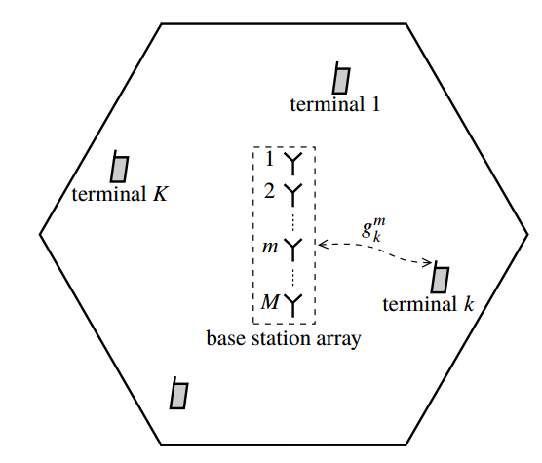

**User K**

**User 3**

**User 2**

**User 1**

**BTS**

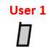

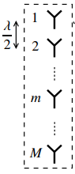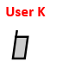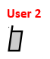









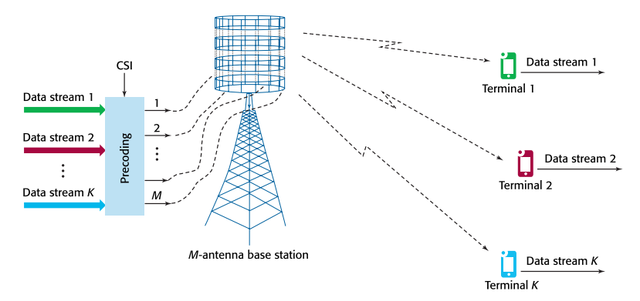

BTS dengan M-antena

User 3

User 2

User 1

User



Subcarrier

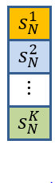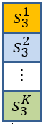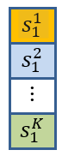





|  |
| --- |
|  |
|  |
|  |
|  |

|  |  |  |  |  |
| --- | --- | --- | --- | --- |
|  |  |  |  |  |

|  |  |  |  |  |
| --- | --- | --- | --- | --- |
|  |  |  |  |  |

|  |  |  |  |  |
| --- | --- | --- | --- | --- |
|  |  |  |  |  |

|  |  |  |  |  |  |  |  |  |  |  |  |  |  |
| --- | --- | --- | --- | --- | --- | --- | --- | --- | --- | --- | --- | --- | --- |
|  |  |  |  |  |  |  |  |  |  |  |  |  |  |

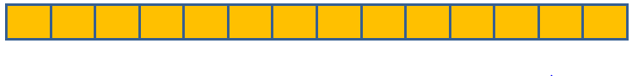

0

0

0

0

0

0

0

0

**Orthogonal** **pilot**

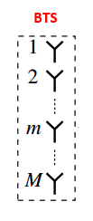

*Mean Square Error* (MSE)

Estimasi kanal

De-spreading pilot

Sinyal pilot diterima

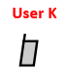

|  |  |
| --- | --- |
| Parameter | Urban |
| Frekuensi Carrier | 30GHz |
|  |  |
|  |  |
|  |  |
|  |  |
|  |  |





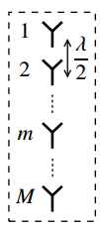

**BTS Arr**

User 1



User k





User K

|  |
| --- |
|  |
|  |
|  |



|  |
| --- |
|  |
|  |
|  |



|  |
| --- |
|  |
|  |
|  |

|  |
| --- |
|  |
|  |
|  |

|  |  |  |  |
| --- | --- | --- | --- |
|  |  |  |  |
|  |  |  |  |



**User 1**

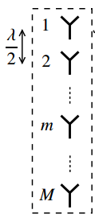

**BTS Array**

**User k**



**User K**

|  |  |
| --- | --- |
| Parameter | Suburban area |
| Frekuensi carrier | 30GHz |
| Spectral bandwidth | 20MHz |
| Jumlah Antena BTS | 100 antena |
| Jumlah user | 5 user |
| Gain antenna BTS | 0dBi |
| Gain antenna terminal | 0dBi |
| Noise figure BTS | 9dB |
| Noise figure perangkat user | 9dB |
| Temperatur perangkat user | 300K |
| Kecepatan mobitilas user | 284km/ha |
| Daya radias BTS | 1W |
| Daya radiasi perangkat user | 200Mw |

|  |  |
| --- | --- |
|  | **Subcarrier ke-N** |
|  | **……………** |
| **Cyclic prefix** |  |
|  |  |
|  |  |
|  |  |
|  | **……………** |
|  | **Subcarrier ke-2** |
|  | **Subcarrier ke-1** |

**Frekuensi**

**Bc = NBs**

**Nsubcarrier**

**Bs**

**Tcp**

**Ts**

**Tu**

**Waktu**

ada

**Ts**

|  |  |  |  |  |  |  |  |  |  |  |  |  |  |  |  |  |
| --- | --- | --- | --- | --- | --- | --- | --- | --- | --- | --- | --- | --- | --- | --- | --- | --- |
|  |  |  |  |  |  |  |  |  |  |  |  |  |  |  |  |  |

**Jumlah sampel data (Ns)**

**Cyclic**

**prefix**

**Tu**

**Tg**

**Time**

**Nslot simbol OFDM**

**Coherence interval**

**Frekuensi**

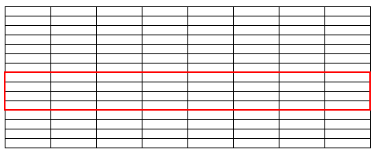

**Nsubcarriers**

**BC**

**Bs**

**Ts**

**Tslot**

**Waktu**

Studi literatur sistem komunikasi Massive MIMO

Membangun sistem Massive MIMO

Simulasi

Analisa

Publikasi dan laporan

Pembangkitan bit

Inisialisasi:

M, K ,N, L, nBit, SNR, frame, nPilot, nCP, modType, beta

Mulai

4-QAM

Pemetaan ke dalam subcarrier

User mengirim pilot

Perfect CSI ?

BTS menerima sinyal pilot

Pembentukan matriks precoding

BTS mengestimasi kanal

IFFT

IFFT+CP

Rayleigh/

UR- LOS

Menentukan sudut user

Membentuk matriks kanal Rayleigh

Membentuk matriks kanal UR-LOS

Perkalian sinyal dengan kanal UR-LOS + AWGN

Perkalian sinyal dengan kanal Rayleigh + AWGN

Membuang CP

FFT

Selesai

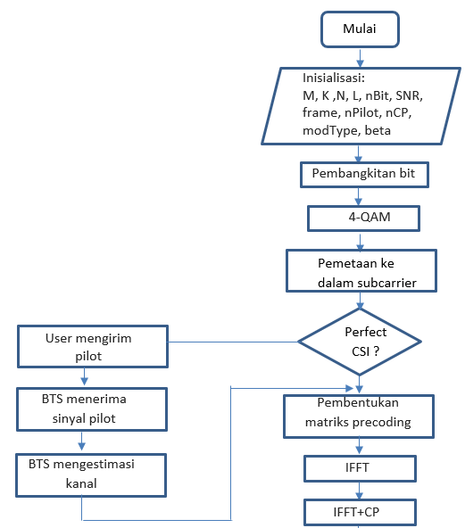

Ya

Tidak

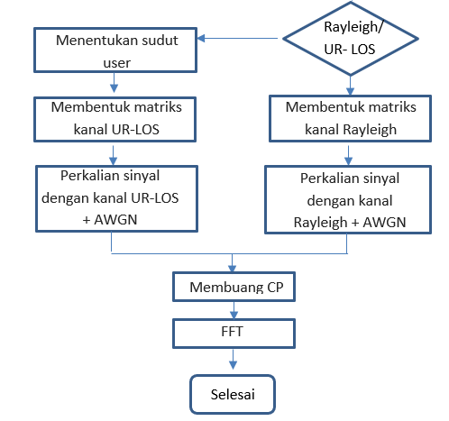

Rayleigh

UR- LOS

**Kanal**

**Transmitter**

Data

stream

Modulasi QAM

Precoding

OFDM

(IFFT)

**Receiver**

Zero Forcing Detector

QAM

Demod

OFDM

(FFT)

Modulasi QAM

Add CP

Invers

FFT

Precoding

Remove CP

FFT

Detector

Demodulasi QAM

|  |  |  |  |  |  |  |  |  |  |  |  |  |  |  |  |  |  |  |  |  |  |  |  |
| --- | --- | --- | --- | --- | --- | --- | --- | --- | --- | --- | --- | --- | --- | --- | --- | --- | --- | --- | --- | --- | --- | --- | --- |
| **No** | **Kegiatan** | **Semester 1** | | | | | | | | | **Semester 2** | | | | | | **Semester 3** | | | | | | |
| **1** | **2** | | **3** | **4** | **5** | **6** | | **1** | | **2** | **3** | **4** | **5** | **6** | | **1** | **2** | **3** | **4** | **5** | **6** |
| 1 | Studi Literatur |  |  | |  |  |  |  | |  | |  |  |  |  |  | |  |  |  |  |  |  |
| 2 | Membangun sistem pemancar |  |  | |  |  |  |  | |  | |  |  |  |  |  | |  |  |  |  |  |  |
| 3 | Membangun scenario model kanal |  |  | |  |  |  |  | |  | |  |  |  |  |  | |  |  |  |  |  |  |
| 4 | Membangun sistem penerima |  |  | |  |  |  |  | |  | |  |  |  |  |  | |  |  |  |  |  |  |
| 5 | Simulasi pembangkitan kanal |  |  | |  |  |  |  | |  | |  |  |  |  |  | |  |  |  |  |  |  |
| 6 | Simulasi estimasi CSI dengan jumlah user skala kecil |  |  | |  |  |  |  | |  | |  |  |  |  |  | |  |  |  |  |  |  |
| 7 | Simulasi transmisi dengan elemen array skala kecil |  |  | |  |  |  |  | |  | |  |  |  |  |  | |  |  |  |  |  |  |
| **U J I A N P R O P O S A L** | | | | | | | | | | | | | | | | | | | | | | | |
| 6 | Simulasi estimasi CSI dengan jumlah elemen array massive |  | |  |  |  |  |  |  | | |  |  |  |  |  | |  |  |  |  |  |  |
| 7 | Simulasi pembangkitan data dan multiplexing OFDM |  | |  |  |  |  |  |  | | |  |  |  |  |  | |  |  |  |  |  |  |
| 8 | Simulasi transmisi dengan kanal Rayleigh |  | |  |  |  |  |  |  | | |  |  |  |  |  | |  |  |  |  |  |  |
| 9 | Simulasi transmisi dengan kanal random LOS |  | |  |  |  |  |  |  | | |  |  |  |  |  | |  |  |  |  |  |  |
| 10 | Simulasi proses decoding di receiver |  | |  |  |  |  |  |  | | |  |  |  |  |  | |  |  |  |  |  |  |
| 11 | Analisa |  | |  |  |  |  |  |  | | |  |  |  |  |  | |  |  |  |  |  |  |
| 12 | Penulisan paper |  | |  |  |  |  |  |  | | |  |  |  |  |  | |  |  |  |  |  |  |
| 13 | Penulisan thesis |  | |  |  |  |  |  |  | | |  |  |  |  |  | |  |  |  |  |  |  |
| **U J I A N T E S I S** | | | | | | | | | | | | | | | | | | | | | | | |

BTS membentuk precoding matrix

BTS membangkitkan data untuk masing-masing user

OFDM

User mentransmisikan pilot ke BTS

BTS mengestimasi CSI melalui sinyal pilot yang diterima

BTS mentransmisikan sinyal ke user

Menghitung BER dan efisiensi spektrum

Simulasi Pada Kondisi Imperfect CSI

BTS membentuk precoding matrix

BTS membangkitkan data untuk masing-masing user

OFDM

BTS diasumsikan telah mengetahui CSI

BTS mentransmisikan sinyal ke user

Menghitung BER dan efisiensi spektrum

Simulasi Pada Kondisi Perfect CSI