Student ID | Student Name | Contribution %
p2510877 | Kendrick Slamat | 25
p2510819 | Ang Wei Chong | 25
p2510864 | Chin Guan Chung (Leader) | 25
P2518507 | Hannah How | 25
SCHOOL OF COMPUTING (SOC)

This is the submission template for CA2 task a) to d) by group. Fill group members’ name and student ID below, and your answers to respective tasks in subsequent pages. Put group leader in the first row and only leader makes the submission on Brightspace.

Class: DAAA/FT/2B/21
Group Number: Group 4

CA2 Group Template
Diploma in Applied AI & Analytics
ST1501
Data Engineering

2026/2027 Semester 1

- Fill below tables for data quality issues found and how it is fixed (the changes made instead of tools/procedures). Extend the table if necessary. One sample error with description is shown here and you should delete it from your answers. Reminder that you can assume no timetable clash in the appointments and hence do not need to check it. Focus on issues described in topic E including inconsistencies, invalid values, etc.
File | Row | What’s the problem? | How do you fix it?
data.xlsx / Members | M0197 | Invalid TierID 'T00001' (extra zero; no such tier exists) | Corrected to 'T0001'
data.xlsx / Members | All 301 rows | Gender stored as 'Male'/'Female' but schema requires CHAR(1) | Mapped to 'M'/'F'
data.xlsx / Members | M0301 | DateOfBirth stored as datetime '1990-05-08 00:00:00' instead of a date | Truncated to '1990-05-08'
data.xlsx / Members | All rows | Two contact fields (ContactNo, Email) but Member table has a single Contact column | Used Email as Contact, consistent with how staff contacts are stored
data.xlsx / Members | 43 rows | Missing Occupation | Kept as NULL (column is nullable; value genuinely unknown)
staff.csv | All 51 rows | Gender stored as 'Male'/'Female' but schema requires CHAR(1) | Mapped to 'M'/'F'
staff.csv | 1 row | StartDatetime in inconsistent format '2/18/2011 13:55' (rest are ISO); schema needs DATE | Parsed both formats and truncated to date
staff.csv | S0003 | 'Julia Mahmud' has Gender = Male, which cannot be verified against any source | Left unchanged; flagged for tutor
data.xlsx / BookCopies | 4 rows | Status misspelled as 'Availble' | Corrected to 'Available'
data.xlsx / BookCopies | B00489 copy 2 | Status 'Available' although the copy has an open (unreturned) loan | Status set to 'On Loan', per circulation rules in the case description
data.xlsx / Loans | M0107/B00153 | Row references StaffID 'S0101' (staff run S0001-S0051) and CopySeqNo 8 (book has 3 copies); DueDate 2023-04-02 precedes LoanDatetime 2024-07-04 | Row removed: it violates two foreign keys and cannot be repaired without fabricating data. To confirm with tutor.
data.xlsx / Loans | 7 rows | Missing LoanStatus (6 returned, 1 outstanding) | No correction needed for insertion: LoanStatus is not a column in the Loan table; status is derivable from ReturnDatetime

Submit your SQL INSERT statements for data insertion to the OLTP tables in OLTP_insert.sql. If you apply bulk loading, submit each of the cleaned data files used during insertion as well.

Paste your database diagram of your OLTP tables with the use of “database/reverse engineer” function in MySQL workbench.
<< PASTE MySQL Workbench reverse-engineered diagram of CA22B2105 here >>

- Design your DW using star or snowflake schema. Paste your ERD that illustrates your design in the box below, with a short explanation of key design focus and considerations.

Briefly explain your design, such as choice of dimensions/measurements, assumptions and considerations, etc.
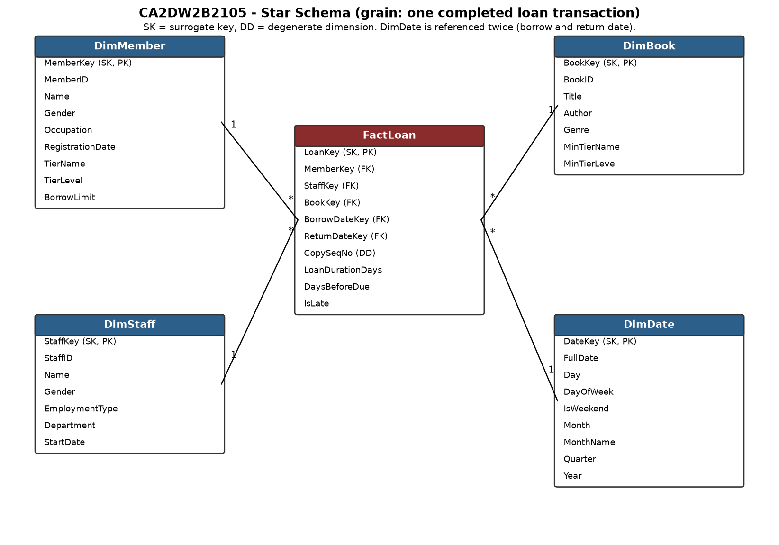
Design explanation: We adopted a STAR SCHEMA with one fact table, FactLoan, whose grain is one completed loan transaction (a book borrowed and returned), matching the brief's primary analytical focus on loan duration and borrowing activity. Four dimensions surround it: DimMember, DimStaff, DimBook and DimDate. Every table, including the fact and time dimension, uses an AUTO_INCREMENT surrogate key. Membership-tier attributes (TierName, TierLevel, BorrowLimit) are denormalised into DimMember, and the minimum-tier requirement into DimBook, so no snowflaked outrigger tables are needed - this keeps queries to single joins and suits the read-oriented workload. DimDate is kept at DAY granularity as instructed (date, day of week, weekend flag, month, quarter, year) and is role-played twice by the fact table, as borrow date and return date. CopySeqNo is carried as a degenerate dimension for traceability to the physical copy. Pre-computed measures: LoanDurationDays (return - borrow), DaysBeforeDue (due - return; negative means late) and an IsLate flag, so common analyses need no date arithmetic at query time. Assumptions: only completed loans are loaded (the single open loan is excluded from the fact table); slowly changing dimensions are out of scope per the brief - if tier changes had to be tracked, DimMember could be extended to SCD Type 2 with effective-date columns.

- Submit your CREATE table statements for DW table creations in DW_create.sql. Use appropriate SQL statements to extract and load data from OLTP tables to the DW and submit all your queries in DW_insert.sql.

Paste your database diagram for your DW in the box below. Explain with data to show how you verify that your insertion is successful.
<< PASTE MySQL Workbench reverse-engineered diagram of CA2DW2B2105 here >>
ETL verification: (1) Row-count reconciliation - completed loans in OLTP (SELECT COUNT(*) FROM Loan WHERE ReturnDatetime IS NOT NULL) = 12,343 and FactLoan = 12,343; DimMember = Member = 301; DimBook = Book = 500; DimStaff = Staff = 51. (2) Measure reconciliation - SUM(DATEDIFF(ReturnDatetime, StartDatetime)) computed directly on the OLTP Loan table = 108,801 days, identical to SUM(LoanDurationDays) in FactLoan, proving the duration measure was derived correctly for every row. (3) Referential integrity - a LEFT JOIN from FactLoan to each dimension returns 0 orphan rows, and all foreign keys are enforced by constraints so no fact row can reference a missing dimension member. The verification queries are included at the bottom of DW_insert.sql.

- Describe and discuss your analysis done using the DW. Briefly explain clearly your objective, results and insights for each analysis. Your group should produce 6 different analyses if group size is 3, or 8 different analyses if group size is 4. Separately submit all your queries in DW_query.sql. (So do not include your statements in this template, only results and discussion)
1.
Objective: identify long-term and seasonal trends in loan volume by month and year (time dimension). Results: monthly completed loans grew from ~35/month in 2020 to 2,838 in December 2025, with a clear year-end surge every year (Dec 2022: 90 vs Nov 57; Dec 2024: 235 vs Nov 177; Dec 2025: 2,838 vs Nov 1,188). Average loan duration stays stable at 8-9.5 days throughout. Insight: borrowing activity is growing rapidly (roughly doubling year on year since 2023) and peaks sharply in November-December. Staffing and stock planning should anticipate the December peak; the stable duration shows the 14-day policy comfortably covers actual reading time.

2.
Objective: find the borrowing pattern across days of the week to support staffing decisions (time dimension). Results: Sunday (35.9%) and Saturday (33.9%) together account for 69.8% of all loans; each weekday contributes only 5-7% (Friday lowest at 5.3%). Insight: demand is overwhelmingly a weekend phenomenon. Counter staffing and shelving operations should be concentrated on weekends, while system maintenance and stock-taking are best scheduled on Fridays.

3.
Objective: compare genre popularity in absolute loans and loans per title, plus reading pace (book dimension). Results: Research Journal has the most total loans (2,093) but only 21.8 loans per title, while Young Adult has the highest intensity (31.2 loans per title from just 39 titles); Children is high on both (1,873 loans, 28.0 per title). Average duration is similar across genres (8.4-9.3 days). Insight: Research Journal's volume comes from its large catalogue (96 titles), whereas Young Adult and Children titles are individually in much higher demand - these genres are the best candidates for additional copies.

4.
Objective: detect outstanding members with significantly higher/lower activity (member dimension; loan count and total duration measures). Results: the top borrower, Evan Seah (Premium), completed 454 loans; Isaac Wilson (Premium) holds books longest in aggregate (5,726 days over 409 loans). Two of the top five are only Basic tier (Jasper Johnson 331, Theodore Campbell 324 loans). The least active members completed only 9-11 loans. Insight: activity varies by a factor of ~50 between the most and least active members. The heavy Basic-tier borrowers are prime candidates for tier upgrades, and the low-activity group could be targeted with re-engagement campaigns.

5.
Objective: examine whether membership tier relates to return discipline (member dimension x lateness measures). Results: late-return rate falls as tier rises - Basic 8.94%, Advanced 8.12%, Premium 7.94% - while average loan duration rises with tier (8.54 to 9.39 days). Insight: higher-tier members keep books slightly longer but return them more punctually, so the higher borrow limits given to upper tiers are not causing overdue problems. Late-return interventions (reminders, penalties) would be most effective aimed at Basic members.

6.
Objective: multi-dimensional analysis (genre x month) - do Children and Young Adult loans spike in school-holiday months? Results: Children loans climb from 65 in January to 486 in December (7.5x), with secondary highs in June-July (126/131); Young Adult mirrors this (51 in January to 301 in December). Insight: youth borrowing is strongly seasonal and concentrated in the November-December school holidays, compounding the overall year-end surge from Analysis 1. The library should time children's programmes, new acquisitions and extra copies of popular youth titles for Q4.

