Student ID | Student Name | Contribution %
p2510877 | Kendrick Slamat | 25
p2510819 | Ang Wei Chong | 25
p2510864 | Chin Guan Chung (Leader) | 25
P2518507 | Hannah How | 25
SCHOOL OF COMPUTING (SOC)

This is the submission template for CA2 task a) to d) by group. Fill group members’ name and student ID below, and your answers to respective tasks in subsequent pages. Put group leader in the first row and only leader makes the submission on Brightspace.

Class: DAAA/FT/2B/21
Group Number: Group 4

CA2 Group Template
Diploma in Applied AI & Analytics
ST1501
Data Engineering

2026/2027 Semester 1

- Fill below tables for data quality issues found and how it is fixed (the changes made instead of tools/procedures). Extend the table if necessary. One sample error with description is shown here and you should delete it from your answers. Reminder that you can assume no timetable clash in the appointments and hence do not need to check it. Focus on issues described in topic E including inconsistencies, invalid values, etc.
File | Row | What’s the problem? | How do you fix it?
data.xlsx / Members | M0197 | Invalid TierID 'T00001' (extra zero; no such tier exists) | Corrected to 'T0001'
data.xlsx / Members | All 301 rows | Gender stored as 'Male'/'Female' but schema requires CHAR(1) | Mapped to 'M'/'F'
data.xlsx / Members | M0301 | DateOfBirth stored as datetime '1990-05-08 00:00:00' instead of a date | Truncated to '1990-05-08'
data.xlsx / Members | All rows | Two contact fields (ContactNo, Email) but Member table has a single Contact column | Used Email as Contact, consistent with how staff contacts are stored
data.xlsx / Members | 43 rows | Missing Occupation | Kept as NULL (column is nullable; true value is unknown)
staff.csv | All 51 rows | Gender stored as 'Male'/'Female' but schema requires CHAR(1) | Mapped to 'M'/'F'
staff.csv | S0028 | StartDatetime in inconsistent format '2/18/2011 13:55' (rest are ISO); schema needs DATE | Parsed both formats and truncated to date
data.xlsx / BookCopies | 4 rows | Status misspelled as 'Availble' | Corrected to 'Available'
data.xlsx / BookCopies | B00489 copy 2 | Status 'Available' although the copy has an open (unreturned) loan | Status set to 'On Loan', per circulation rules in the case description
data.xlsx / Loans | M0107/B00153 | Row references StaffID 'S0101' (staff run S0001-S0051) and CopySeqNo 8 (book has 3 copies); DueDate 2023-04-02 precedes LoanDatetime 2024-07-04 | Row removed: it violates two foreign keys and cannot be repaired without fabricating data. To confirm with tutor.

Submit your SQL INSERT statements for data insertion to the OLTP tables in OLTP_insert.sql. If you apply bulk loading, submit each of the cleaned data files used during insertion as well.

Paste your database diagram of your OLTP tables with the use of “database/reverse engineer” function in MySQL workbench.
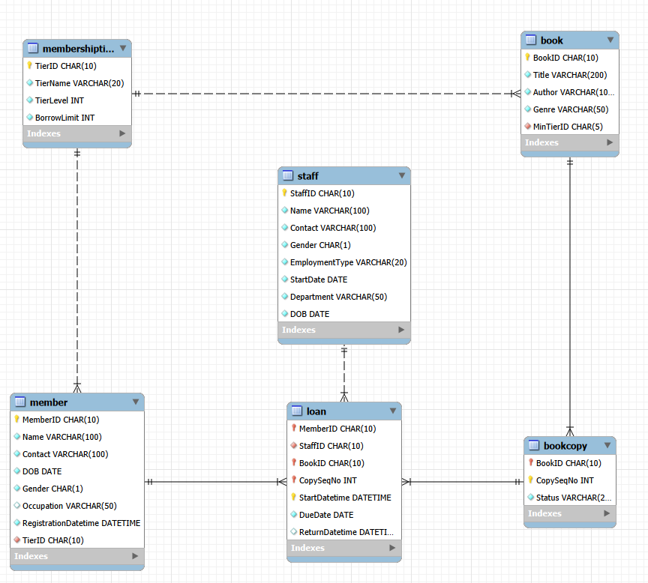

- Design your DW using star or snowflake schema. Paste your ERD that illustrates your design in the box below, with a short explanation of key design focus and considerations.

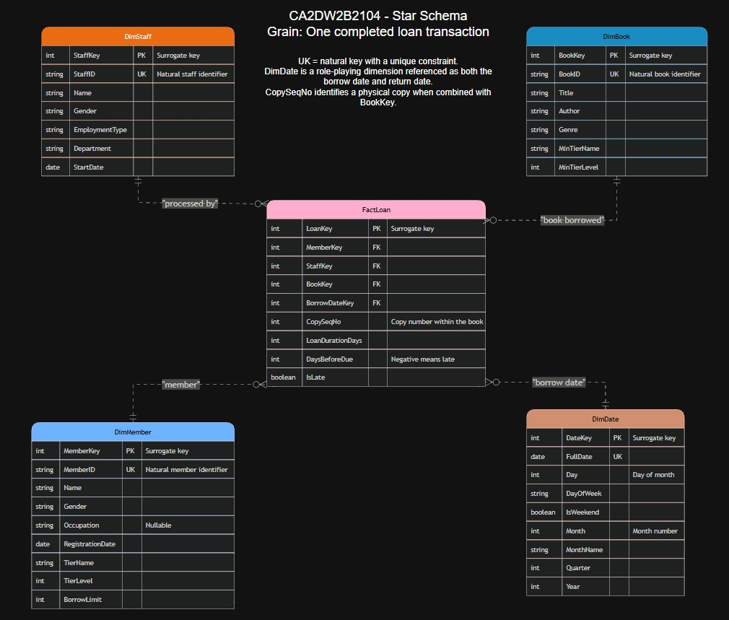

Briefly explain your design, such as choice of dimensions/measurements, assumptions and considerations, etc.

Overview
The warehouse uses a star schema: one central fact table holding the numbers we analyse, surrounded by a single layer of dimension tables holding the descriptive context. There is one fact table, FactLoan, and four dimensions: DimMember, DimStaff, DimBook and DimDate.
We considered a snowflake schema, which is the same idea, but it splits dimensions further into sub-tables to remove repeated values. The only table worth splitting here is MembershipTier, which supplies tier attributes to both DimMember and DimBook. Keeping it separate would add a second join to every tier-based question and save three rows, so we denormalised its attributes into both dimensions instead, meaning we copied them in and accepted the duplication. With 301 members, 500 books and 51 staff, dimension size is not so much of a storage concern.

Grain
The grain of FactLoan, meaning the exact real-world event that one fact row represents, is one completed loan transaction: one physical copy of one book, borrowed by one member, issued by one staff member, and returned. Every measure in the table is true at that level, and each fact row holds one foreign key, a column pointing at another table’s primary key, per dimension.
FactLoan is a transaction fact table, so each row records one business event and is never updated afterwards. That suits the job here, because the analysis we need is about loans that have run their full course, from borrowing through to return.

What the design has to support
The warehouse has to answer questions about loan duration and borrowing activity, and on top of that transaction volume, book popularity and seasonal trends. These are used in our analysis. Each of those lands on a specific part of the design:

What analysis requires | Where it is stored | Where we use it
Loan duration | LoanDurationDays | Q1 average duration by month; Q8 duration by lateness band
Borrowing activity (completed loans) | Grain of FactLoan, with DimMember | Q5 most and least active members; Q6 loans per member by tier
Transaction volume | Row count of FactLoan, sliced by any dimension | Q2 by staff department; Q3 by weekday
Book popularity | DimBook (Genre, Title, Author) | Q7 loans per title by genre
Seasonal trends | DimDate (Month, Quarter, DayOfWeek, IsWeekend) | Q1 monthly trend; Q4 youth genres by month
Return discipline | DaysBeforeDue, IsLate | Q2 and Q6 late-return rate; Q8 severity bands

Every analysis reads FactLoan and at most two dimensions, with no chained dimension joins (joining a dimension to a sub-dimension) which would be required in a snowflake schema.

Naming conventions
Pattern | Meaning | Examples
Dim / Fact prefix | The table’s role in the schema | DimMember, FactLoan
Key suffix | Surrogate key, generated inside the warehouse | MemberKey, BorrowDateKey
ID suffix | Natural key carried over from the OLTP system | MemberID, BookID
Days suffix | A measure counted in whole days | LoanDurationDays, DaysBeforeDue
Is prefix | A boolean flag where 1 means true | IsLate, IsWeekend
Min prefix | A minimum or threshold value | MinTierName, MinTierLevel
Full words, no abbreviations | Readable without a data dictionary | EmploymentType, RegistrationDate

Dimensions
All five tables, including DimDate and FactLoan, use an AUTO_INCREMENT surrogate key as the primary key. A surrogate key is a system-generated identifier with no business meaning, used only inside the warehouse. Each dimension also keeps its natural key from the OLTP system (MemberID, StaffID, BookID) under a unique constraint, so any warehouse row can be traced back to its source record.
DimMember carries the member’s tier attributes (TierName, TierLevel, BorrowLimit) and DimBook carries the minimum tier needed to borrow the title (MinTierName, MinTierLevel). Both come from MembershipTier, denormalised as described above.
DimDate is day-level and holds FullDate, Day, DayOfWeek, IsWeekend, Month, MonthName, Quarter and Year. Because these are stored as columns, our queries group on them directly and never apply date functions to fact rows.
CopySeqNo stays in FactLoan as a degenerate dimension, which is an identifier taken from the source system that has no descriptive attributes of its own to justify a dimension table. Combined with BookKey it identifies the physical copy, so any fact row can be traced back to its OLTP Loan record. We keep it for traceability rather than analysis; none of our analyses group by it.

Measures
FactLoan stores three measures, meaning numeric values meant to be aggregated. All three are computed once during the ETL load (Extract from OLTP, Transform, Load into the warehouse) rather than recalculated in every query.

Measure | Definition | Aggregation
LoanDurationDays | Return date minus borrow date | Fully additive; can be summed across any dimension
DaysBeforeDue | Due date minus return date; a negative value means the book came back late | Additive, but averaged rather than summed in practice
IsLate | BOOLEAN, stored by MySQL as TINYINT(1): 1 = late, 0 = on time. Set where the return date is after the due date | Not additive as a flag; AVG(IsLate) gives the late-return rate

IsLate duplicates the sign of DaysBeforeDue. We store it anyway so that a late-return rate is one AVG() instead of a CASE expression repeated in every query, which is how the staff and membership-tier analyses use it. Together with BorrowDateKey, these measures carry all three dates of a loan: borrow, return and due. That is why we did not need a second foreign key to DimDate, and we come back to that in the assumptions below.

Assumptions and considerations

1. Using only completed loans.
The brief asks us to focus on loan duration and borrowing activity for books that have been borrowed and returned, so FactLoan holds 12,343 of the 12,344 OLTP loan records. The one outstanding loan has no return date, which leaves all three measures undefined, so it cannot sit at this grain. Reporting on loans still out is therefore out of scope. The structure for that would be an accumulating snapshot fact table, whose rows are updated as an event progresses, and we were not asked for it.

2. No slowly changing dimensions.
DimMember and DimBook hold current values only. This is a SCD Type 1, where an update overwrites the old value and no history is kept. The consequence is that a member’s 2020 loans are counted against the tier they hold today, which is worth bearing in mind when reading Analysis 6, since it groups by current TierName rather than the tier held at the time of each loan. Tracking that history would need SCD Type 2, where each change adds a new dimension row with validity dates.

3. Having a singular data role
FactLoan carries one foreign key to DimDate, on the borrow date. We considered a second key for the return date but rejected it as it was redundant: LoanDurationDays is the difference between the borrow and return dates, so the return date is recoverable as borrow date + LoanDurationDays, and the due date as borrow date + LoanDurationDays + DaysBeforeDue. One date key and two measures therefore carry all three dates without a second relationship. Every analysis we run is anchored to when a loan started, so the borrow date is the role that earns a foreign key. The trade-off we accept is that grouping returns by calendar attributes such as month or quarter would mean deriving the return date first and re-joining to DimDate, rather than joining on a stored key.

4. Date coverage.
DimDate is pre-populated every day from 2020-01-01 to 2026-12-31, which is 2,557 rows and covers all borrow and return dates with room to spare. We generated every day rather than only the dates that appear in loans so that a day with no activity still exists in the dimension; a time series then shows a genuine zero instead of skipping the day.

Glossary of all the terms we’ll use in this document
Term | Meaning
OLTP | Online Transaction Processing, the day-to-day operational database that records live transactions
Data warehouse (DW) | A separate database structured for analysis and reporting over historical data
Star schema | One fact table joined directly to a single layer of dimension tables
Snowflake schema | A star whose dimensions are split further into sub-tables to remove repeated values
Fact table | The central table, holding the numeric measures and the foreign keys to the dimensions
Dimension table | Holds the descriptive attributes used to filter and group the facts
Grain | The precise real-world event that one fact table row represents
Measure | A numeric column in the fact table meant to be aggregated
Additive | A measure that can validly be summed across every dimension
Surrogate key | A system-generated key with no business meaning (AUTO_INCREMENT), used as the primary key inside the DW
Natural key | The identifier inherited from the source system, such as MemberID
Primary key | The column that uniquely identifies each row of a table
Foreign key | A column referencing another table’s primary key, which keeps the links valid
Denormalisation | Deliberately copying attributes into a table to avoid a join, accepting the duplication
Degenerate dimension | A source-system identifier kept in the fact table because it has no attributes of its own
SCD Type 1 / Type 2 | Slowly Changing Dimension. Type 1 overwrites and keeps no history; Type 2 adds a new row per change
Transaction fact table | One row per business event, written once and not updated
Accumulating snapshot | A fact table whose rows are updated as a multi-step process progresses
ETL | Extract, Transform, Load, the process that moves data from OLTP into the warehouse
TINYINT(1) | How MySQL physically stores a BOOLEAN: 1 is true, 0 is false

- Submit your CREATE table statements for DW table creations in DW_create.sql. Use appropriate SQL statements to extract and load data from OLTP tables to the DW and submit all your queries in DW_insert.sql.

Paste your database diagram for your DW in the box below. Explain with data to show how you verify that your insertion is successful.

Reverse Engineered diagram:
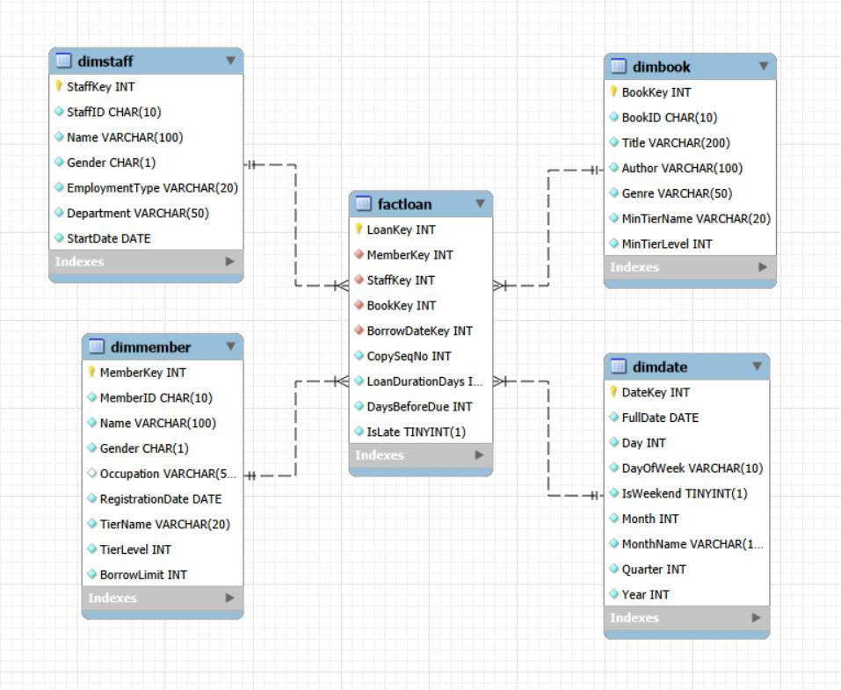

How we checked the load was successful:
We ran four checks, all of them in DW_verify.sql, labelled C1 to C4 in that file. Each one compares something in the warehouse against the OLTP database it was loaded from, so anything that went wrong during the load would show up as a pair of numbers that fail to agree.

Row counts (C1). FactLoan contains 12,343 rows, which is exactly the number of Loan records in the OLTP database that have a return date. The dimensions match their source tables too: DimMember 301 against Member 301, DimBook 500 against Book 500, and DimStaff 51 against Staff 51. DimDate holds 2,557 rows, one per day. Counting both sides and getting the same answer tells us that nothing was dropped on the way in and nothing was written twice.

Loan duration (C2). LoanDurationDays is not copied from the OLTP database; it is worked out during the load as the return date minus the borrow date. To check that this calculation ran correctly on every row instead of just most of them, we added up the durations straight from the OLTP loans, then separately added up the LoanDurationDays column in FactLoan. Both totals come to 108,801 days. Since the two agree exactly, the same calculation was applied to every fact row.

Orphan keys (C3). Every row in FactLoan points at a member, a staff member, a book and a borrow date. A fact row that points at something which does not actually exist is called an orphan, and it normally means a key failed to match while the data was being loaded. To look for any, we joined FactLoan to each of the four dimensions using a LEFT JOIN, which keeps every fact row in the result even when the dimension has nothing matching it, and leaves the dimension columns empty wherever the match failed. Counting the rows with an empty dimension key returns 0, so every fact row is linked to a real dimension row.

Date coverage (C4). DimDate runs from 2020-01-01 to 2026-12-31, which is 2,557 days. That covers every borrow date in the data along with the later dates needed for due dates and returns, so no loan was left out because its date fell outside the calendar.

Between them the four checks cover the three things that can realistically go wrong in a load: records going missing or being duplicated, a calculated measure coming out wrong, and a key that fails to resolve.

- Describe and discuss your analysis done using the DW. Briefly explain clearly your objective, results and insights for each analysis. Your group should produce 6 different analyses if group size is 3, or 8 different analyses if group size is 4. Separately submit all your queries in DW_query.sql. (So do not include your statements in this template, only results and discussion)

- Analysis 1: Long-term and seasonal loan trends (Kendrick)
Objective: Analyse completed-loan volume by month and year and assess whether loan duration changes over time.
Results: Completed-loan volume grew from 27-49 loans per month in 2020 to 2,838 in December 2025. End-of-year peaks recur: December 2022 recorded 90 loans versus 57 in November, December 2024 recorded 235 versus 177, and December 2025 recorded 2,838 versus 1,188. Monthly average duration was generally 8-9.5 days.
Insight: Demand is growing quickly and is heavily concentrated near the end of the year. Staffing, shelving and stock planning should increase for November and December. Because loan duration did not rise with volume, the immediate capacity issue is transaction volume rather than longer borrowing periods.

- Analysis 2: Staff workload by department and employment type (Kendrick)
Objective: Compare completed-loan workload across staff departments and employment types, together with average loan duration and late-return rate.
Results: Circulation part-time staff processed the most completed loans at 2,243, followed by Circulation full-time staff at 1,981. Digital Services full-time staff processed the fewest at 470. Average duration across the groups ranged from 8.57 to 9.18 days, while late-return rates ranged from 7.50% for Membership full-time to 8.94% for Reference part-time staff.
Insight: Circulation is the main staffing priority, especially for part-time coverage. Late-return rates remain broadly similar across groups, so higher workload is not accompanied by a clearly worse return outcome. The result supports staff deployment, training and workload balancing.

- Analysis 3: Borrowing pattern by day of week (Hannah)
Objective: Identify the days with the highest completed-loan activity so daily operations can be scheduled more effectively.
Results: Sunday accounts for 4,425 completed loans (35.85%) and Saturday for 4,189 (33.94%). Together, weekends contribute 8,614 loans, or 69.79% of all completed loans. Weekdays each contribute 5.31%-6.65%, with Friday lowest at 655 loans (5.31%).
Insight: Counter staffing and shelving should be concentrated on weekends. Lower-demand Fridays are more suitable for system maintenance, stock-taking and other work that may temporarily reduce service capacity.

- Analysis 4: Youth-genre demand across the year (Hannah)
Objective: Determine whether Children and Young Adult borrowing rises during school-holiday periods.
Results: Children loans rise from 65 in January to 486 in December, a 7.5-fold increase, with secondary peaks of 126 and 131 in June and July. Young Adult follows the same pattern, rising from 51 loans in January to 301 in December.
Insight: Youth borrowing is strongly seasonal and is concentrated in the November-December school-holiday period. The library should schedule programmes, acquisitions and extra copies of popular youth titles before the fourth quarter.

- Analysis 5: Members with unusually high or low activity (Guan Chung)
Objective: Identify members whose number of completed loans or total borrowing duration differs substantially from the rest.
Results: Evan Seah, a Premium member, completed the most loans at 454. Isaac Wilson, also Premium, recorded the greatest total borrowing duration at 5,726 days across 409 loans. Jasper Johnson and Theodore Campbell are Basic members but still completed 331 and 324 loans respectively. The least active members completed only 9-11 loans.
Insight: Member activity varies by roughly a factor of 50. Highly active Basic members should be reviewed for tier-upgrade eligibility against the full policy criteria, rather than upgraded automatically. The least active group could be targeted through recommendations, reminders or re-engagement campaigns.

- Analysis 6: Membership tier and return discipline (Guan Chung)
Objective: Examine how average completed loans per active member, late-return rate and average loan duration differ by membership tier.
Results: Average completed loans per active member rises with tier: Basic members average 34.03 completed loans across 172 active members, Advanced members average 42.84 across 88, and Premium members average 68.00 across 40. The late-return rate decreases from 8.94% for Basic to 8.12% for Advanced and 7.94% for Premium, while average duration increases from 8.54 to 9.39 days.
Insight: Higher-tier active members complete more loans on average while also recording lower late-return rates, although this association does not prove that tier causes the behaviour. Premium engagement appears strongest, while reminders and late-return interventions would have the greatest effect when directed at Basic members.

- Analysis 7: Genre popularity and demand per title (Wei Chong)
Objective: Compare total loans, loans per title and average reading duration across book genres.
Results: Research Journal has the highest total volume at 2,093 loans across 96 titles, or 21.8 loans per title. Young Adult has the highest demand per title at 31.2 loans across 39 titles. Children is also strong, with 1,873 loans and 28.0 loans per title. Average duration is similar across the reported genres, at 8.35-9.25 days.
Insight: Research Journal leads mainly because its catalogue is large, while Young Adult and Children titles are borrowed more intensively. Additional copies would therefore be most useful in the Young Adult and Children categories.

- Analysis 8: Severity of late returns (Wei Chong)
Objective: Separate loans returned on time or early from loans that were 1-3 days, 4-7 days or at least 8 days late.
Results: Of 12,343 completed loans, 11,298 (91.53%) were returned on time or earlier. Late loans were split into 189 returned 1-3 days late (1.53%), 205 returned 4-7 days late (1.66%), and 651 returned 8 or more days late (5.27%). The average loan duration rises from 7.37 days for on-time or early loans to 28.50 days for loans returned 8 or more days late.
Insight: Most loans are returned on time, but the 8-or-more-days-late band is the largest late-return category. This group should be the priority for targeted reminders and follow-up, while shorter delays may be handled with lighter touch interventions.

