Student ID | Student Name | Contribution %
p2510877 | Kendrick Slamat | 25
p2510819 | Ang Wei Chong | 25
p2510864 | Chin Guan Chung (Leader) | 25
P2518507 | Hannah How | 25
SCHOOL OF COMPUTING (SOC)

This is the submission template for CA2 task a) to d) by group. Fill group members’ name and student ID below, and your answers to respective tasks in subsequent pages. Put group leader in the first row and only leader makes the submission on Brightspace.

Class: DAAA/FT/2B/21
Group Number: Group 4

CA2 Group Template
Diploma in Applied AI & Analytics
ST1501
Data Engineering

2026/2027 Semester 1

- Fill below tables for data quality issues found and how it is fixed (the changes made instead of tools/procedures). Extend the table if necessary. One sample error with description is shown here and you should delete it from your answers. Reminder that you can assume no timetable clash in the appointments and hence do not need to check it. Focus on issues described in topic E including inconsistencies, invalid values, etc.
File | Row | What’s the problem? | How do you fix it?
data.xlsx / Members | M0197 | Invalid TierID 'T00001' (extra zero; no such tier exists) | Corrected to 'T0001'
data.xlsx / Members | All 301 rows | Gender stored as 'Male'/'Female' but schema requires CHAR(1) | Mapped to 'M'/'F'
data.xlsx / Members | M0301 | DateOfBirth stored as datetime '1990-05-08 00:00:00' instead of a date | Truncated to '1990-05-08'
data.xlsx / Members | All rows | Two contact fields (ContactNo, Email) but Member table has a single Contact column | Used Email as Contact, consistent with how staff contacts are stored
data.xlsx / Members | 43 rows | Missing Occupation | Kept as NULL (column is nullable; true value is unknown)
staff.csv | All 51 rows | Gender stored as 'Male'/'Female' but schema requires CHAR(1) | Mapped to 'M'/'F'
staff.csv | 1 row | StartDatetime in inconsistent format '2/18/2011 13:55' (rest are ISO); schema needs DATE | Parsed both formats and truncated to date
staff.csv | S0003 | 'Julia Mahmud' has Gender = Male, which cannot be verified against any source | Left unchanged; flagged for tutor
data.xlsx / BookCopies | 4 rows | Status misspelled as 'Availble' | Corrected to 'Available'
data.xlsx / BookCopies | B00489 copy 2 | Status 'Available' although the copy has an open (unreturned) loan | Status set to 'On Loan', per circulation rules in the case description
data.xlsx / Loans | M0107/B00153 | Row references StaffID 'S0101' (staff run S0001-S0051) and CopySeqNo 8 (book has 3 copies); DueDate 2023-04-02 precedes LoanDatetime 2024-07-04 | Row removed: it violates two foreign keys and cannot be repaired without fabricating data. To confirm with tutor.
data.xlsx / Loans | 7 rows | Missing LoanStatus (6 returned, 1 outstanding) | No correction needed for insertion: LoanStatus is not a column in the Loan table; status is derivable from ReturnDatetime

Submit your SQL INSERT statements for data insertion to the OLTP tables in OLTP_insert.sql. If you apply bulk loading, submit each of the cleaned data files used during insertion as well.

Paste your database diagram of your OLTP tables with the use of “database/reverse engineer” function in MySQL workbench.
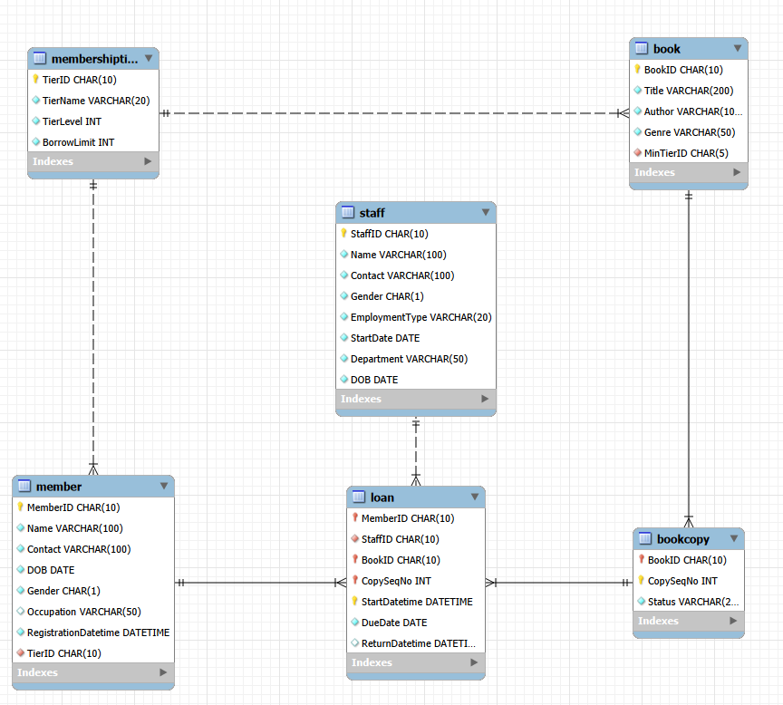

- Design your DW using star or snowflake schema. Paste your ERD that illustrates your design in the box below, with a short explanation of key design focus and considerations.

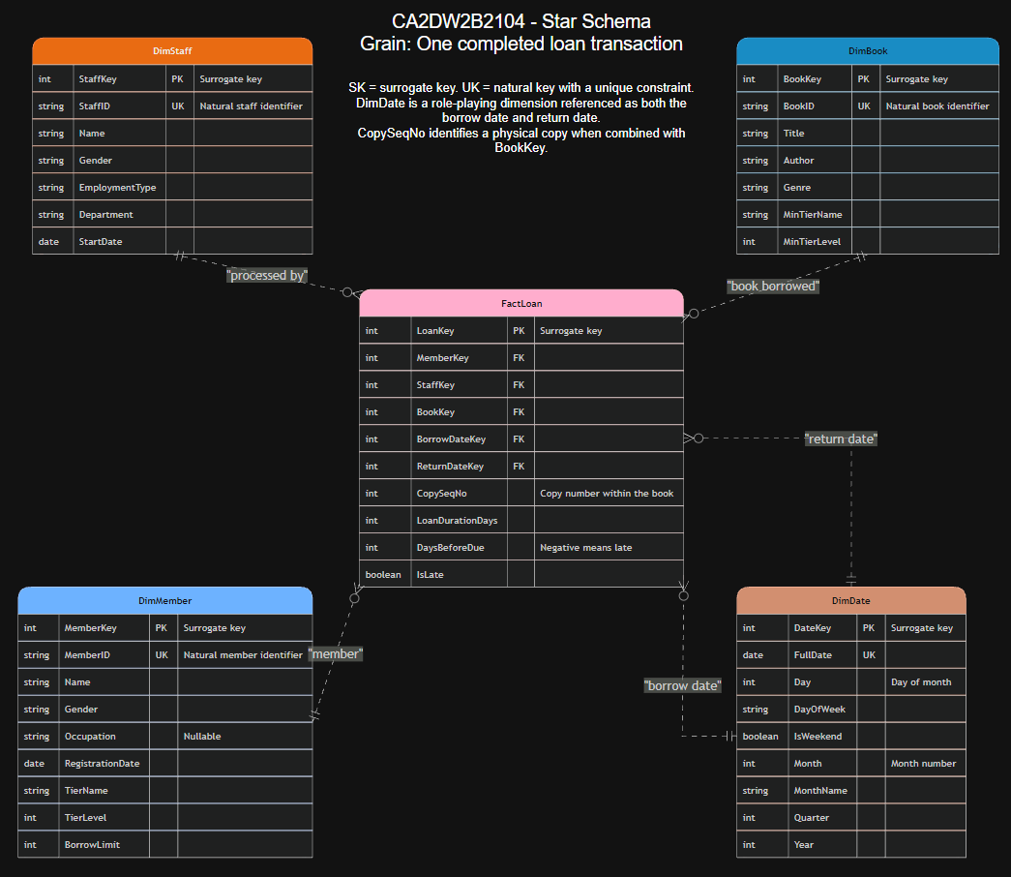

Briefly explain your design, such as choice of dimensions/measurements, assumptions and considerations, etc.

We used a Star Schema with one fact table, called FactLoan. The grain of this table is one completed loan transaction, meaning one book that has been borrowed and returned. FactLoan is connected to four-dimension tables: DimMember, DimStaff, DimBook and DimDate.

All tables use an AUTO_INCREMENT surrogate key, including the fact table and date dimension. The membership tier details, such as TierName, TierLevel and BorrowLimit, are included directly in DimMember. The minimum membership tier required to borrow a book is also included in DimBook. This avoids the need for a snowflake schema and keeps the database structure simpler by reducing the number of joins needed.

DimDate is stored at day-level granularity, as required in the assignment. It contains attributes such as the full date, day of the week, weekend indicator, month, quarter and year. FactLoan uses DimDate twice: once for the borrow date and once for the return date.
CopySeqNo is stored in the fact table as a degenerate dimension. This allows each loan transaction to be traced back to the specific physical copy of the book without creating another dimension table.

Several values are calculated before being loaded into the fact table. LoanDurationDays shows the number of days between the borrow and return dates. DaysBeforeDue is calculated by subtracting the return date from the due date, where a negative value means that the book was returned late. An IsLate flag is also included to clearly show whether a loan was overdue. These pre-calculated values make common analysis easier because date calculations do not need to be repeated in every query.
We assumed that only completed loans would be loaded into FactLoan. Therefore, the single loan that is still open is excluded. Slowly changing dimensions are also outside the scope of this assignment. However, if changes to a member’s membership tier needed to be tracked in the future, DimMember could be changed into a Slowly Changing Dimension Type 2 by adding effective-date and expiry-date columns.

- Submit your CREATE table statements for DW table creations in DW_create.sql. Use appropriate SQL statements to extract and load data from OLTP tables to the DW and submit all your queries in DW_insert.sql.

Paste your database diagram for your DW in the box below. Explain with data to show how you verify that your insertion is successful.

Creation of table statements:
-- Date dimension, day-level granularity
CREATE TABLE DimDate (
DateKey INT AUTO_INCREMENT PRIMARY KEY, -- surrogate key
FullDate DATE NOT NULL UNIQUE,
Day INT NOT NULL,
DayOfWeek VARCHAR(10) NOT NULL,
IsWeekend BOOLEAN NOT NULL,
Month INT NOT NULL,
MonthName VARCHAR(10) NOT NULL,
Quarter INT NOT NULL,
Year INT NOT NULL
);

CREATE TABLE DimMember (
MemberKey INT AUTO_INCREMENT PRIMARY KEY, -- surrogate key
MemberID CHAR(10) NOT NULL, -- natural key
Name VARCHAR(100) NOT NULL,
Gender CHAR(1) NOT NULL,
Occupation VARCHAR(50) NULL,
RegistrationDate DATE NOT NULL,
TierName VARCHAR(20) NOT NULL, -- denormalised tier attributes (star schema)
TierLevel INT NOT NULL,
BorrowLimit INT NOT NULL
);

CREATE TABLE DimStaff (
StaffKey INT AUTO_INCREMENT PRIMARY KEY, -- surrogate key
StaffID CHAR(10) NOT NULL, -- natural key
Name VARCHAR(100) NOT NULL,
Gender CHAR(1) NOT NULL,
EmploymentType VARCHAR(20) NOT NULL,
Department VARCHAR(50) NOT NULL,
StartDate DATE NOT NULL
);

CREATE TABLE DimBook (
BookKey INT AUTO_INCREMENT PRIMARY KEY, -- surrogate key
BookID CHAR(10) NOT NULL, -- natural key
Title VARCHAR(200) NOT NULL,
Author VARCHAR(100) NOT NULL,
Genre VARCHAR(50) NOT NULL,
MinTierName VARCHAR(20) NOT NULL,
MinTierLevel INT NOT NULL
);

-- Fact table: one row per completed loan transaction (borrowed and returned)
CREATE TABLE FactLoan (
LoanKey INT AUTO_INCREMENT PRIMARY KEY, -- surrogate key
MemberKey INT NOT NULL,
StaffKey INT NOT NULL,
BookKey INT NOT NULL,
BorrowDateKey INT NOT NULL,
ReturnDateKey INT NOT NULL,
CopySeqNo INT NOT NULL, -- degenerate dimension
LoanDurationDays INT NOT NULL, -- return date - borrow date
DaysBeforeDue INT NOT NULL, -- due date - return date (negative = late)
IsLate BOOLEAN NOT NULL,
FOREIGN KEY (MemberKey) REFERENCES DimMember(MemberKey),
FOREIGN KEY (StaffKey) REFERENCES DimStaff(StaffKey),
FOREIGN KEY (BookKey) REFERENCES DimBook(BookKey),
FOREIGN KEY (BorrowDateKey) REFERENCES DimDate(DateKey),
FOREIGN KEY (ReturnDateKey) REFERENCES DimDate(DateKey)
);

Reverse Engineered diagram:
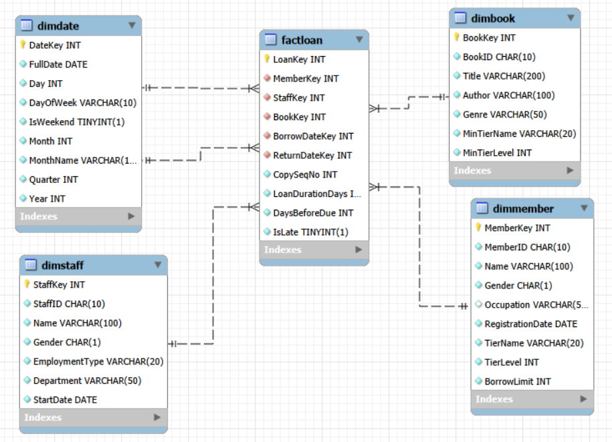

How to verify successful insertion: (Change ts up)

ETL verification: (1) Row-count reconciliation - completed loans in OLTP (SELECT COUNT(*) FROM Loan WHERE ReturnDatetime IS NOT NULL) = 12,343 and FactLoan = 12,343; DimMember = Member = 301; DimBook = Book = 500; DimStaff = Staff = 51. (2) Measure reconciliation - SUM(DATEDIFF(ReturnDatetime, StartDatetime)) computed directly on the OLTP Loan table = 108,801 days, identical to SUM(LoanDurationDays) in FactLoan, proving the duration measure was derived correctly for every row. (3) Referential integrity - a LEFT JOIN from FactLoan to each dimension returns 0 orphan rows, and all foreign keys are enforced by constraints so no fact row can reference a missing dimension member. The verification queries are included at the bottom of DW_insert.sql.

- Describe and discuss your analysis done using the DW. Briefly explain clearly your objective, results and insights for each analysis. Your group should produce 6 different analyses if group size is 3, or 8 different analyses if group size is 4. Separately submit all your queries in DW_query.sql. (So do not include your statements in this template, only results and discussion)

- Long-term and seasonal loan trends
Objective: Identify changes in completed-loan volume by month and year and determine whether loan duration changes over time.
Results: Monthly completed loans rose from about 35 per month in 2020 to 2,838 in December 2025. A year-end surge appears repeatedly: December 2022 recorded 90 loans compared with 57 in November; December 2024 recorded 235 compared with 177; and December 2025 recorded 2,838 compared with 1,188. Average loan duration remained broadly stable at about 8 to 9.5 days.
Insight: Demand is growing quickly and is heavily concentrated near the end of the year. Staffing, shelving and stock planning should be increased for November and December. The stable duration also suggests that the 14-day loan period is generally sufficient.

- Borrowing pattern by day of week
Objective: Determine which days generate the highest borrowing activity so that daily operations can be scheduled more effectively.
Results: Sunday accounts for 35.9% of completed loans and Saturday for 33.9%. Together, weekends contribute 69.8% of all loans. Each weekday contributes only about 5% to 7%, with Friday the lowest at 5.3%.
Insight: Counter staffing and shelving should be concentrated on weekends. Lower-demand Fridays are more suitable for system maintenance, stock-taking and other work that may temporarily reduce service capacity.

- Genre popularity and demand per title
Objective: Compare total loans, loans per title and average reading duration across book genres.
Results: Research Journal has the highest total volume at 2,093 loans, but this equals only 21.8 loans per title across 96 titles. Young Adult has the highest demand per title at 31.2 loans across 39 titles. Children is also strong, with 1,873 loans and 28.0 loans per title. Average duration is similar across genres at about 8.4 to 9.3 days.
Insight: Research Journal leads mainly because its catalogue is large, while Young Adult and Children titles are borrowed more intensively. Additional copies would therefore be most useful in the Young Adult and Children categories.

- Members with unusually high or low activity
Objective: Identify members whose number of completed loans or total borrowing duration differs substantially from the rest.
Results: Evan Seah, a Premium member, completed the most loans at 454. Isaac Wilson, also Premium, recorded the greatest total borrowing duration at 5,726 days across 409 loans. Jasper Johnson and Theodore Campbell are Basic members but still completed 331 and 324 loans respectively. The least active members completed only 9 to 11 loans.
Insight: Member activity varies by roughly a factor of 50. Highly active Basic members may be suitable candidates for tier upgrades, while the least active group could be targeted through recommendations, reminders or re-engagement campaigns.

- Membership tier and return discipline
Objective: Examine whether membership tier is associated with late-return rate and average loan duration.
Results: The late-return rate decreases as tier rises: Basic 8.94%, Advanced 8.12% and Premium 7.94%. At the same time, average loan duration increases from 8.54 days for Basic members to 9.39 days for Premium members.
Insight: Higher-tier members keep books slightly longer but return them more punctually. Their higher borrowing limits do not appear to create a larger overdue problem. Reminders and late-return interventions would have the greatest effect when directed at Basic members.

- Youth-genre demand across the year
Objective: Determine whether Children and Young Adult borrowing rises during school-holiday periods.
Results: Children loans rise from 65 in January to 486 in December, a 7.5-fold increase, with secondary peaks of 126 and 131 in June and July. Young Adult follows the same pattern, rising from 51 loans in January to 301 in December.
Insight: Youth borrowing is strongly seasonal and is concentrated in the November-December school-holiday period. The library should schedule programmes, acquisitions and extra copies of popular youth titles before the fourth quarter.

- Staff workload by department and employment type
Objective: Compare completed-loan workload across staff departments and employment types, together with average loan duration and late-return rate.
Results: [Paste the actual Analysis 7 output here after running the added SQL query. State which department/employment-type group processed the most completed loans and compare its late-return rate with the other groups.]
Insight: This analysis shows where circulation work is concentrated and whether full-time and part-time staff handle different transaction volumes. The result can support staff deployment, training and workload balancing.

- Severity of late returns
Objective: Separate loans returned on time or early from loans that were 1-3 days, 4-7 days or at least 8 days late.
Results: [Paste the actual Analysis 8 output here after running the added SQL query. Report the count and percentage in each return-timing band.]
Insight: A severity breakdown distinguishes occasional minor delays from serious overdue behaviour. Mild cases may only need reminders, while repeated or long delays may justify stronger follow-up or penalties.

