Student ID | Student Name | Contribution %
p2510877 | Kendrick Slamat | 25
p2510819 | Ang Wei Chong | 25
p2510864 | Chin Guan Chung (Leader) | 25
P2518507 | Hannah How | 25
SCHOOL OF COMPUTING (SOC)

This is the submission template for CA2 task a) to d) by group. Fill group members’ name and student ID below, and your answers to respective tasks in subsequent pages. Put group leader in the first row and only leader makes the submission on Brightspace.

Class: DAAA/FT/2B/21
Group Number: Group 4

CA2 Group Template
Diploma in Applied AI & Analytics
ST1501
Data Engineering

2026/2027 Semester 1

- Fill below tables for data quality issues found and how it is fixed (the changes made instead of tools/procedures). Extend the table if necessary. One sample error with description is shown here and you should delete it from your answers. Reminder that you can assume no timetable clash in the appointments and hence do not need to check it. Focus on issues described in topic E including inconsistencies, invalid values, etc.
File | Row | What’s the problem? | How do you fix it?
data.xlsx / Members | M0197 | Invalid TierID 'T00001' (extra zero; no such tier exists) | Corrected to 'T0001'
data.xlsx / Members | All 301 rows | Gender stored as 'Male'/'Female' but schema requires CHAR(1) | Mapped to 'M'/'F'
data.xlsx / Members | M0301 | DateOfBirth stored as datetime '1990-05-08 00:00:00' instead of a date | Truncated to '1990-05-08'
data.xlsx / Members | All rows | Two contact fields (ContactNo, Email) but Member table has a single Contact column | Used Email as Contact, consistent with how staff contacts are stored
data.xlsx / Members | 43 rows | Missing Occupation | Kept as NULL (column is nullable; true value is unknown)
staff.csv | All 51 rows | Gender stored as 'Male'/'Female' but schema requires CHAR(1) | Mapped to 'M'/'F'
staff.csv | S0028 | StartDatetime in inconsistent format '2/18/2011 13:55' (rest are ISO); schema needs DATE | Parsed both formats and truncated to date
data.xlsx / BookCopies | 4 rows | Status misspelled as 'Availble' | Corrected to 'Available'
data.xlsx / BookCopies | B00489 copy 2 | Status 'Available' although the copy has an open (unreturned) loan | Status set to 'On Loan', per circulation rules in the case description
data.xlsx / Loans | M0107/B00153 | Row references StaffID 'S0101' (staff run S0001-S0051) and CopySeqNo 8 (book has 3 copies); DueDate 2023-04-02 precedes LoanDatetime 2024-07-04 | Row removed: it violates two foreign keys and cannot be repaired without fabricating data. To confirm with tutor.

Submit your SQL INSERT statements for data insertion to the OLTP tables in OLTP_insert.sql. If you apply bulk loading, submit each of the cleaned data files used during insertion as well.

Paste your database diagram of your OLTP tables with the use of “database/reverse engineer” function in MySQL workbench.
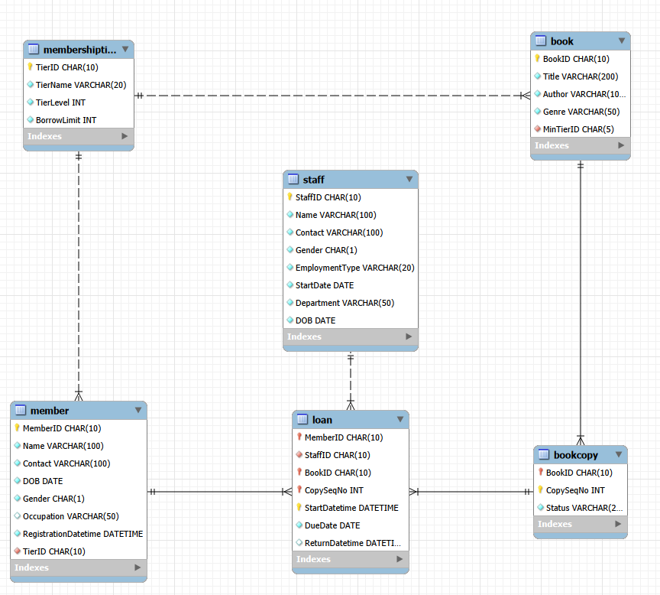

- Design your DW using star or snowflake schema. Paste your ERD that illustrates your design in the box below, with a short explanation of key design focus and considerations.

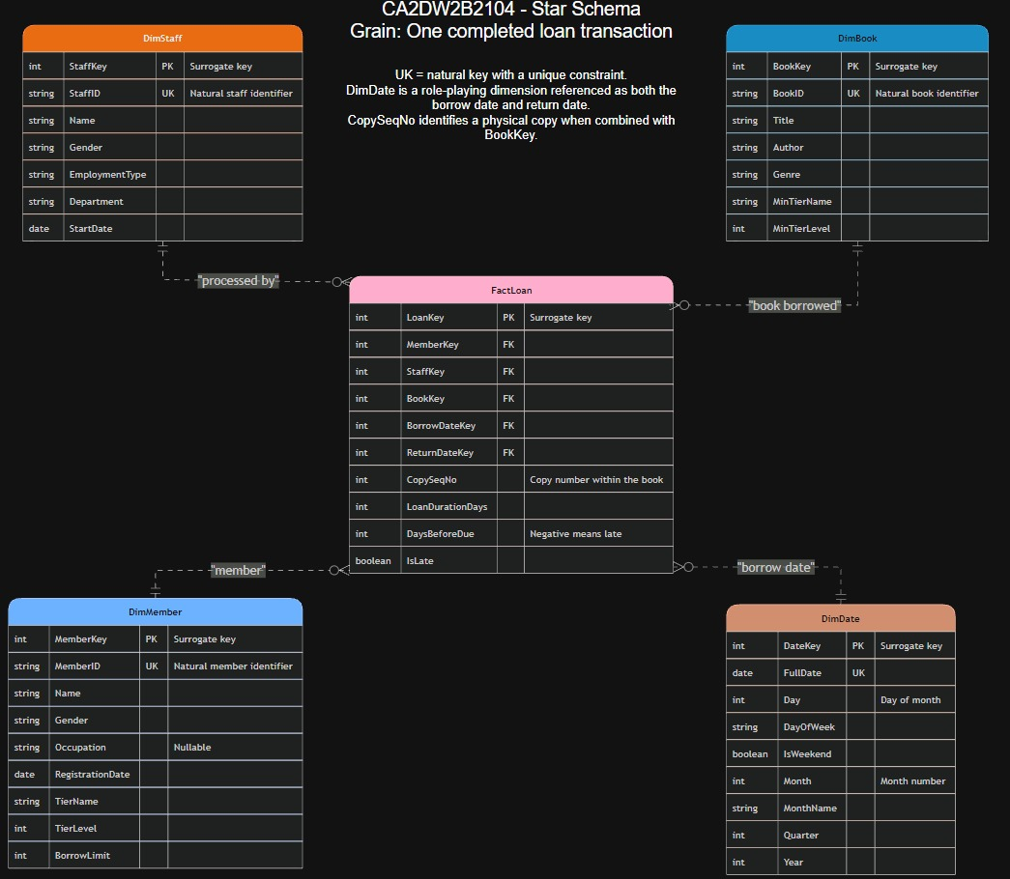

Briefly explain your design, such as choice of dimensions/measurements, assumptions and considerations, etc.

To support the required analysis, we used a star schema centred on FactLoan. Its grain is one completed loan: one physical book copy borrowed by one member and returned. FactLoan links once to each of four dimensions: DimMember, DimStaff, DimBook and DimDate.

Every table, including FactLoan and DimDate, uses an AUTO_INCREMENT surrogate key. DimMember stores the member's current TierName, TierLevel and BorrowLimit, while DimBook stores the minimum tier needed to borrow each book. These denormalised attributes keep the model in star form and reduce joins in analytical queries.

DimDate has day-level granularity and includes FullDate, day of week, weekend indicator, month, quarter and year. FactLoan references DimDate once through BorrowDateKey, which records when the loan began. Return-related analysis is supported by LoanDurationDays, DaysBeforeDue and IsLate instead of a second date-dimension relationship, so the model matches the ERD and remains easy to interpret.
CopySeqNo is kept in FactLoan as a degenerate dimension. It identifies the physical copy involved in each loan and preserves traceability to the operational system without adding a separate, low-value dimension table.

During the load, LoanDurationDays is calculated as the difference between the borrow and return dates. DaysBeforeDue is due date minus return date, so a negative result indicates a late return. IsLate is stored as a clear Boolean flag. Persisting these measures keeps later analyses consistent and avoids repeating calculations in every query.
FactLoan contains only completed loans because the project's analytical focus is borrowing activity and duration for books that have been returned; the single open loan is excluded. Slowly changing dimensions are outside scope. If membership-tier history is required later, DimMember can be extended to a Type 2 slowly changing dimension with effective-date, expiry-date and current-row attributes.

- Submit your CREATE table statements for DW table creations in DW_create.sql. Use appropriate SQL statements to extract and load data from OLTP tables to the DW and submit all your queries in DW_insert.sql.

Paste your database diagram for your DW in the box below. Explain with data to show how you verify that your insertion is successful.

Reverse Engineered diagram:
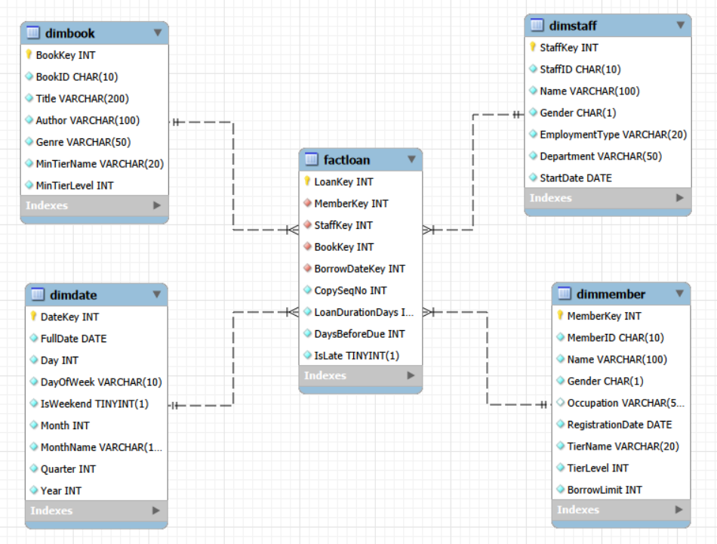

How successful insertion was verified

Row-count reconciliation. FactLoan contains 12,343 rows, exactly matching the number of completed Loan records in the OLTP database. The dimension counts also reconcile to their source entities: DimMember 301/Member 301, DimBook 500/Book 500 and DimStaff 51/Staff 51. DimDate contains 2,557 day-level rows. Matching counts confirm that the intended records were loaded without omission or duplication.
Measure reconciliation. The total loan duration calculated directly from completed OLTP loans is 108,801 days, exactly the same as the total LoanDurationDays stored in FactLoan. This confirms that the duration transformation was applied consistently to every loaded fact.
Referential-integrity and date-range checks. A left-join validation across FactLoan and all four dimensions returns 0 orphan rows, confirming every fact points to a valid member, staff member, book and borrow date. DimDate runs from 2020-01-01 to 2026-12-31, covering the dates required by the load. Together, these checks validate record completeness, transformed measures and dimension-key integrity. The verification SQL is included in the submitted DW scripts.

- Describe and discuss your analysis done using the DW. Briefly explain clearly your objective, results and insights for each analysis. Your group should produce 6 different analyses if group size is 3, or 8 different analyses if group size is 4. Separately submit all your queries in DW_query.sql. (So do not include your statements in this template, only results and discussion)

- Analysis 1: Long-term and seasonal loan trends
Objective: Analyse completed-loan volume by month and year and assess whether loan duration changes over time.
Results: Completed-loan volume grew from 27-49 loans per month in 2020 to 2,838 in December 2025. End-of-year peaks recur: December 2022 recorded 90 loans versus 57 in November, December 2024 recorded 235 versus 177, and December 2025 recorded 2,838 versus 1,188. Monthly average duration was generally 8-9.5 days.
Insight: Demand is growing quickly and is heavily concentrated near the end of the year. Staffing, shelving and stock planning should increase for November and December. Because loan duration did not rise with volume, the immediate capacity issue is transaction volume rather than longer borrowing periods.

- Analysis 2: Borrowing pattern by day of week
Objective: Identify the days with the highest completed-loan activity so daily operations can be scheduled more effectively.
Results: Sunday accounts for 4,425 completed loans (35.85%) and Saturday for 4,189 (33.94%). Together, weekends contribute 8,614 loans, or 69.79% of all completed loans. Weekdays each contribute 5.31%-6.65%, with Friday lowest at 655 loans (5.31%).
Insight: Counter staffing and shelving should be concentrated on weekends. Lower-demand Fridays are more suitable for system maintenance, stock-taking and other work that may temporarily reduce service capacity.

- Analysis 3: Genre popularity and demand per title
Objective: Compare total loans, loans per title and average reading duration across book genres.
Results: Research Journal has the highest total volume at 2,093 loans across 96 titles, or 21.8 loans per title. Young Adult has the highest demand per title at 31.2 loans across 39 titles. Children is also strong, with 1,873 loans and 28.0 loans per title. Average duration is similar across the reported genres, at 8.35-9.25 days.
Insight: Research Journal leads mainly because its catalogue is large, while Young Adult and Children titles are borrowed more intensively. Additional copies would therefore be most useful in the Young Adult and Children categories.

- Analysis 4: Members with unusually high or low activity
Objective: Identify members whose number of completed loans or total borrowing duration differs substantially from the rest.
Results: Evan Seah, a Premium member, completed the most loans at 454. Isaac Wilson, also Premium, recorded the greatest total borrowing duration at 5,726 days across 409 loans. Jasper Johnson and Theodore Campbell are Basic members but still completed 331 and 324 loans respectively. The least active members completed only 9-11 loans.
Insight: Member activity varies by roughly a factor of 50. Highly active Basic members should be reviewed for tier-upgrade eligibility against the full policy criteria, rather than upgraded automatically. The least active group could be targeted through recommendations, reminders or re-engagement campaigns.

- Analysis 5: Membership tier and return discipline
Objective: Examine whether membership tier is associated with late-return rate and average loan duration.
Results: The late-return rate decreases as tier rises: Basic 8.94% (523 late returns from 5,853 loans), Advanced 8.12% (306 from 3,770) and Premium 7.94% (216 from 2,720). Average loan duration increases from 8.54 days for Basic members to 9.39 days for Premium members.
Insight: In this dataset, higher-tier members keep books slightly longer but have lower late-return rates. This is an association, not proof that tier causes return behaviour. Reminders and late-return interventions would have the greatest effect when directed at Basic members.

- Analysis 6: Youth-genre demand across the year
Objective: Determine whether Children and Young Adult borrowing rises during school-holiday periods.
Results: Children loans rise from 65 in January to 486 in December, a 7.5-fold increase, with secondary peaks of 126 and 131 in June and July. Young Adult follows the same pattern, rising from 51 loans in January to 301 in December.
Insight: Youth borrowing is strongly seasonal and is concentrated in the November-December school-holiday period. The library should schedule programmes, acquisitions and extra copies of popular youth titles before the fourth quarter.

- Analysis 7: Staff workload by department and employment type
Objective: Compare completed-loan workload across staff departments and employment types, together with average loan duration and late-return rate.
Results: Circulation part-time staff processed the most completed loans at 2,243, followed by Circulation full-time staff at 1,981. Digital Services full-time staff processed the fewest at 470. Average duration across the groups ranged from 8.57 to 9.18 days, while late-return rates ranged from 7.50% for Membership full-time to 8.94% for Reference part-time staff.
Insight: Circulation is the main staffing priority, especially for part-time coverage. Late-return rates remain broadly similar across groups, so higher workload is not accompanied by a clearly worse return outcome. The result supports staff deployment, training and workload balancing.

- Analysis 8: Severity of late returns
Objective: Separate loans returned on time or early from loans that were 1-3 days, 4-7 days or at least 8 days late.
Results: Of 12,343 completed loans, 11,298 (91.53%) were returned on time or early. Late loans were split into 189 returned 1-3 days late (1.53%), 205 returned 4-7 days late (1.66%), and 651 returned 8 or more days late (5.27%). The average loan duration rises from 7.37 days for on-time or early loans to 28.50 days for loans returned 8 or more days late.
Insight: Most loans are returned on time, but the 8-or-more-days-late band is the largest late-return category. This group should be the priority for targeted reminders and follow-up, while shorter delays may be handled with lighter-touch interventions.

