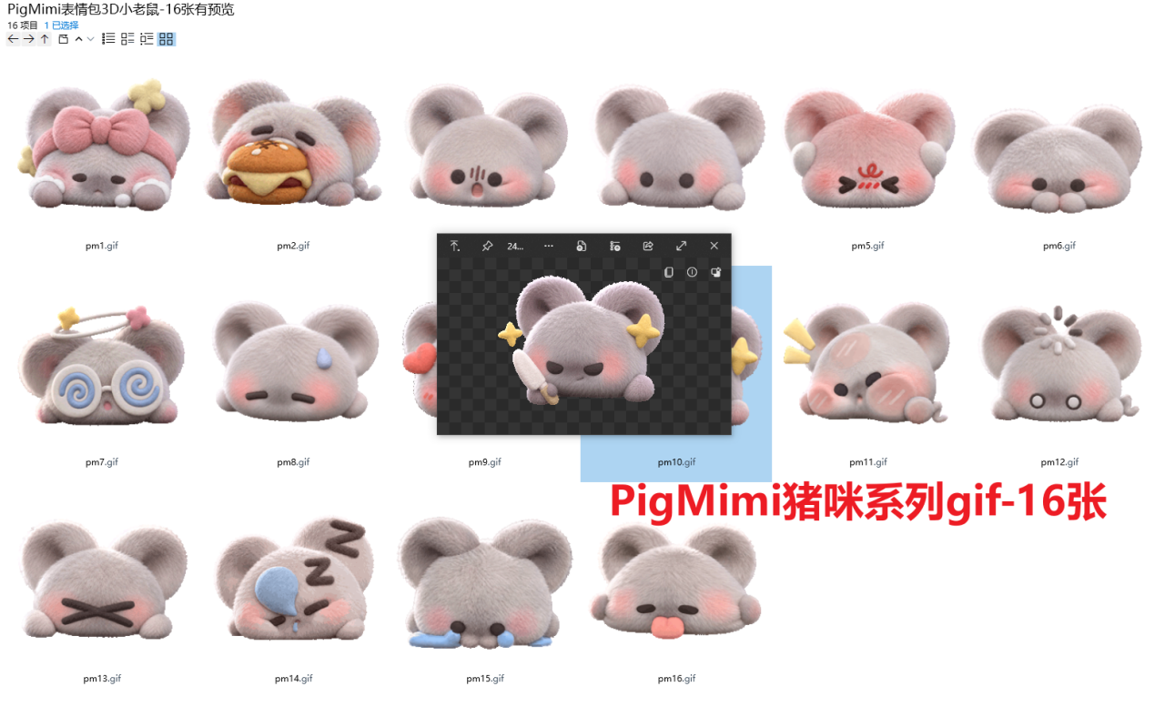
洗漱/护肤:https://imgbed.heliar.top/i/n8wqze8hKonJH1wu_pm1.gif
干饭:https://imgbed.heliar.top/i/9cGRE1KCHfX9Crsj_pm2.gif
惊呆:https://imgbed.heliar.top/i/1d_CbZ1DC6Xia4rS_pm3.gif
好的/点头:https://imgbed.heliar.top/i/cMS9UIoucB-lKkxH_pm4.gif
生气中:https://imgbed.heliar.top/i/GSfs8xEC_aq0hR0w_pm5.gif
疑惑:https://imgbed.heliar.top/i/V5dqZQaFx6f1WAx0_pm6.gif
晕了/脑袋晕晕的/迷糊了:https://imgbed.heliar.top/i/UjICYlORnV3JtJx1_pm7.gif
尴尬/无语中:https://imgbed.heliar.top/i/yz12EGX0o1MyyTQE_pm8.gif
喜欢/搓手手:https://imgbed.heliar.top/i/YGp_p6xpsYabTikO_pm9.gif
杀掉/谋杀/做掉你:https://imgbed.heliar.top/i/k14o0cOjsxA-Iegw_pm10.gif
贴贴！:https://imgbed.heliar.top/i/nuZ6xoMRcK2v6PaW_pm11.gif
发呆/宕机了:https://imgbed.heliar.top/i/k4Epi902iR14HfDA_pm12.gif
不要/拒绝:https://imgbed.heliar.top/i/pAA9dnGfC-fqud2t_pm13.gif
睡觉呼噜噜:https://imgbed.heliar.top/i/1GuP0ATnk2199D8T_pm14.gif
哭哭:https://imgbed.heliar.top/i/OAyLyetkxs6Reu1G_pm15.gif
做鬼脸:https://imgbed.heliar.top/i/GgK6GSirGWS0qKnK_pm16.gif

