无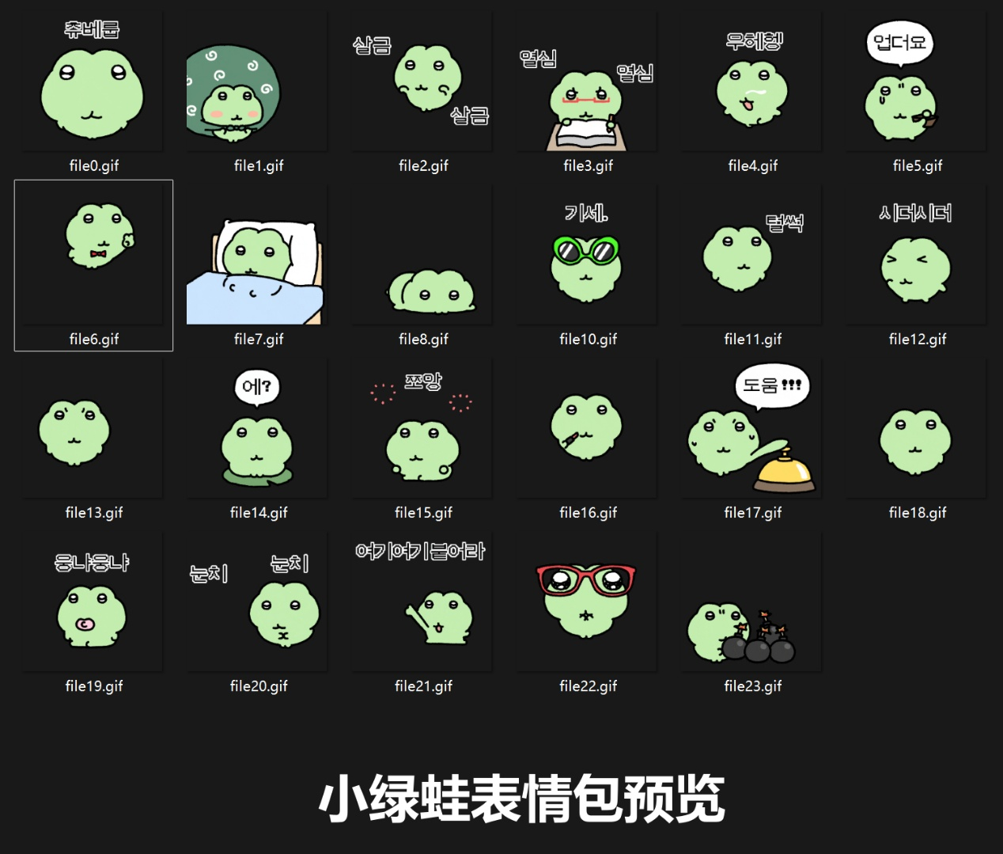辜/卖萌地看着你舔嘴唇:https://imgbed.heliar.top/i/jVoauuWVDhUNZ5Ue_file0.gif
你好呀（憨憨的）:https://imgbed.heliar.top/i/rHv7zG2sBt7UTIP-_file1.gif
偷偷摸摸/悄咪咪:https://imgbed.heliar.top/i/IoP3eg1o1OAiisof_file2.gif
努力努力:https://imgbed.heliar.top/i/dv_INFVfDTlYkL08_file3.gif
嘿嘿嘿/坏笑/窃笑:https://imgbed.heliar.top/i/0ExUtel0BTZdTOc5_file4.gif
没有啦/钱包空空:https://imgbed.heliar.top/i/zdNhxpMBAJgc_-_y_file5.gif
耍帅摆pose/帅！:https://imgbed.heliar.top/i/2BKpqpWpsQ7WRWLL_file6.gif
睡觉觉/躺被窝:https://imgbed.heliar.top/i/FCCYVvKGmzssajmk_file7.gif
好无聊哦/脑袋放空乱想:https://imgbed.heliar.top/i/1XLbkNEZt-qavaIj_file8.gif
墨镜耍酷/跷二郎腿/嘚瑟:https://imgbed.heliar.top/i/qruzlx9det-PNFsV_file10.gif
啪嗒垮掉/蔫了/瞬间萎靡泄气:https://imgbed.heliar.top/i/2jAl6WRgiU6sfz4i_file11.gif
昏昏沉沉/眼皮打架/眯眼皱脸犯困:https://imgbed.heliar.top/i/jciUQeXRBSZcKpsw_file12.gif
算卦/求运势:https://imgbed.heliar.top/i/2ylas1Q_veltgdHy_file13.gif
诶？/啥？/疑惑 /一脸问号:https://imgbed.heliar.top/i/6mSjHwKPPD4mC3QL_file14.gif
调皮吐舌/吐舌头搞怪:https://imgbed.heliar.top/i/LrmpTYfu1Jqaeqph_file15.gif
飞吻:https://imgbed.heliar.top/i/TEe-03A3PhzesqQJ_file16.gif
救命！/求助！/狂按呼叫铃:https://imgbed.heliar.top/i/VkfsYIvoflxTu5wX_file17.gif
求投喂/嘴巴张超大啊——:https://imgbed.heliar.top/i/CS0BbXXn_wYVx4iA_file18.gif
吃东西/咀嚼:https://imgbed.heliar.top/i/boOcLX_FYkgE-_7S_file19.gif
疯狂看脸色/眼力见/小心翼翼观察:https://imgbed.heliar.top/i/5At4fdN549Cd83iW_file20.gif
快过来！到这来！/招手呼唤:https://imgbed.heliar.top/i/c-77YLU4IfnAfpCN_file21.gif
哇塞！震惊星星眼/戴红眼镜瞪大眼睛:https://imgbed.heliar.top/i/dSpq4QYPXbxCfKCr_file22.gif
扔炸弹:https://imgbed.heliar.top/i/DqiNwNPV_yHBxnIc_file23.gif

