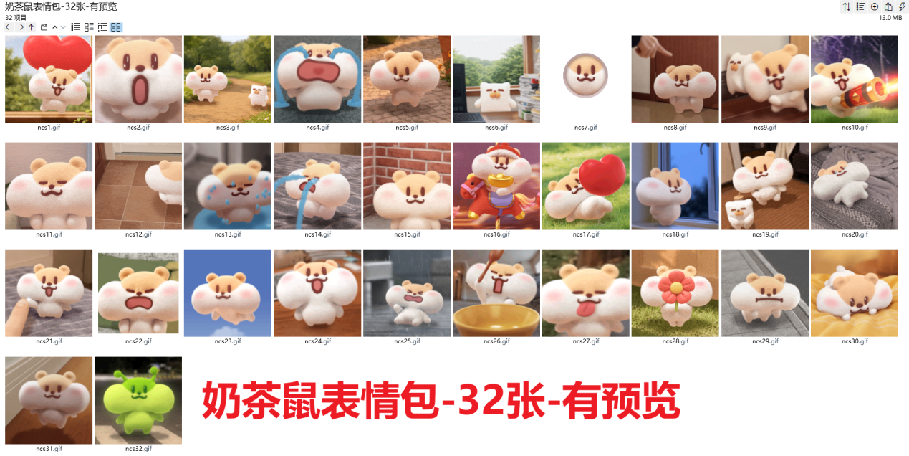
爱心:https://imgbed.heliar.top/i/Xg0TBpDGjgXa6HnP_ncs1.gif
哇哦:https://imgbed.heliar.top/i/JcX3kvfqyNcf415G_ncs2.gif
好朋友:https://imgbed.heliar.top/i/WZemqyRvk1NyFwIX_ncs3.gif
一直在哭:https://imgbed.heliar.top/i/M-CVuCPa5JQakU8A_ncs4.gif
小心思:https://imgbed.heliar.top/i/ppdk07NfcCtf2SbV_ncs5.gif
飞走:https://imgbed.heliar.top/i/z-gVlcwPe4yO_BhW_ncs6.gif
冒头:https://imgbed.heliar.top/i/k4zzhdIhdxbVhg4__ncs7.gif
骂:https://imgbed.heliar.top/i/g8uY03_OzF_3ErZs_ncs8.gif
自动钻头:https://imgbed.heliar.top/i/JwoomhFiBPVQwtQG_ncs9.gif
放烟花啦:https://imgbed.heliar.top/i/C8arW-wvNbAyKUE4_ncs10.gif
哈欠:https://imgbed.heliar.top/i/kgQCaNvBOLVxEtVq_ncs11.gif
踱步:https://imgbed.heliar.top/i/CYO_L9ql-jMt9Yyp_ncs12.gif
紧张:https://imgbed.heliar.top/i/cm884xzn6lCIphcJ_ncs13.gif
呜呜:https://imgbed.heliar.top/i/tP5_HZCtm-Xtr1NB_ncs14.gif
害怕:https://imgbed.heliar.top/i/S4hVeL9tHU5pPahK_ncs15.gif
喜欢:https://imgbed.heliar.top/i/rQZuShaD4WA6fl16_ncs17.gif
吹风:https://imgbed.heliar.top/i/1hRGW_DDjfjAeQqe_ncs18.gif
跳舞:https://imgbed.heliar.top/i/9HMXnaH6mgAZP0rw_ncs19.gif
哭麻了:https://imgbed.heliar.top/i/DCW6bw7NBGsqLq0i_ncs20.gif
好耶:https://imgbed.heliar.top/i/EcEGzkBL6q9DU_Li_ncs21.gif
发癫:https://imgbed.heliar.top/i/Mm-o6aGyDLGUPsEE_ncs22.gif
飞呀飞:https://imgbed.heliar.top/i/vCcXIIbOWGLbXOLd_ncs23.gif
好的:https://imgbed.heliar.top/i/TMCRKfToojMCnFUX_ncs24.gif
痛心:https://imgbed.heliar.top/i/Z2aqv-VQRdJce9Pd_ncs25.gif
饭啊:https://imgbed.heliar.top/i/0xGaL-KwCoMOuIYP_ncs26.gif
吐舌头:https://imgbed.heliar.top/i/Rw5exu5rkaSYhICO_ncs27.gif
嘿:https://imgbed.heliar.top/i/bHgY3cKz_dpAtUbn_ncs28.gif
丧:https://imgbed.heliar.top/i/0ioq3eYp-2HP7CRu_ncs29.gif
摇尾巴:https://imgbed.heliar.top/i/Jtx5OfpWuCiOeb-X_ncs30.gif
偷偷:https://imgbed.heliar.top/i/2A782nyj7cxzPri-_ncs31.gif
未知生物:https://imgbed.heliar.top/i/0q6A5KwwNhxUUdkU_ncs32.gif

