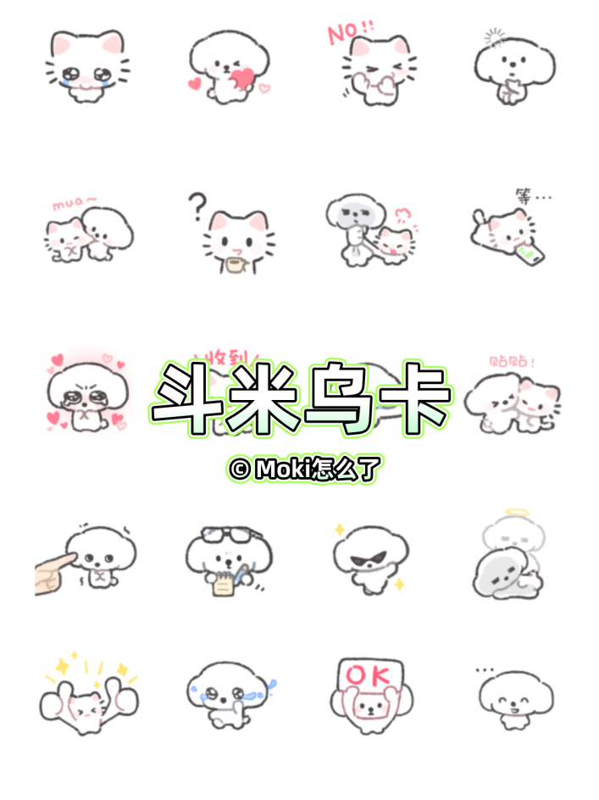
小狗好累:https://i.postimg.cc/6QNS89Mr/dmwk1.png
小狗思考:https://i.postimg.cc/43TMYJWV/dmwk2.png
小狗收到:https://i.postimg.cc/VNcTJYKD/dmwk3.png
紧张:https://i.postimg.cc/zf1MyJxp/dmwk4.png
赞:https://i.postimg.cc/CKVtRFc7/dmwk5.png
对手指:https://i.postimg.cc/mrGqPbdx/dmwk6.png
OK:https://i.postimg.cc/hGbYxHYZ/dmwk7.png
爱你:https://i.postimg.cc/VNBhM3hV/dmwk8.png
哭:https://i.postimg.cc/1zcd6LdT/dmwk9.png
委屈:https://i.postimg.cc/KYrWLdVX/dmwk10.png
贴贴:https://i.postimg.cc/0Nd4mL3x/dmwk11.png
威胁:https://i.postimg.cc/W46yrQK3/dmwk12.png
爱你:https://i.postimg.cc/VNBhM3Td/dmwk13.png
哭:https://i.postimg.cc/jjQ1NG9w/dmwk14.png
我真棒:https://i.postimg.cc/ZRbMLwtb/dmwk15.png
红温:https://i.postimg.cc/cHxbcFy4/dmwk16.png
打脑袋:https://i.postimg.cc/9MmnBL5D/dmwk17.png
晚安:https://i.postimg.cc/26kKx0RL/dmwk18.png
早:https://i.postimg.cc/PxXRMSsD/dmwk19.png
摸头:https://i.postimg.cc/Jnr2QpVb/dmwk20.png
疑惑:https://i.postimg.cc/Qt8yqfGk/dmwk21.png
再见:https://i.postimg.cc/mDL5Smfy/dmwk22.png
生气:https://i.postimg.cc/Twd4ctMc/dmwk23.png
赞:https://i.postimg.cc/j5xFhM0v/dmwk24.png
哭:https://i.postimg.cc/FRrBxT5D/dmwk25.png
OK:https://i.postimg.cc/RFgbpw4c/dmwk26.png
无语:https://i.postimg.cc/k4ThYWqW/dmwk27.png
好:https://i.postimg.cc/Ssgt1ck7/dmwk28.png
哇:https://i.postimg.cc/fL8gqYDf/dmwk29.png
生气:https://i.postimg.cc/TwtHNnft/dmwk30.png
爱你:https://i.postimg.cc/gJgBt3mM/dmwk31.png
送花:https://i.postimg.cc/PxSFV1TV/dmwk32.png
抱:https://i.postimg.cc/50skK8bR/dmwk33.png
抓狂:https://i.postimg.cc/W35fY0Tx/dmwk34.png
哭:https://i.postimg.cc/G2XSgvb0/dmwk35.png
爱你:https://i.postimg.cc/3Rtbf23T/dmwk36.png
不:https://i.postimg.cc/G2XSgvbR/dmwk37.png
思考:https://i.postimg.cc/nrMSyMhg/dmwk38.png
亲:https://i.postimg.cc/NFLC3L0f/dmwk39.png
疑问:https://i.postimg.cc/2y39s35S/dmwk40.png
掐你:https://i.postimg.cc/XqX1RXv5/dmwk41.png
等待信息:https://i.postimg.cc/3NWfsWwm/dmwk42.png
喜欢你:https://i.postimg.cc/D0DpnFW1/dmwk43.png
小猫收到:https://i.postimg.cc/J0gYMmyX/dmwk44.png
世界再见:https://i.postimg.cc/vTj2bM1f/dmwk45.png
贴贴:https://i.postimg.cc/pr7cRx9B/dmwk46.png
指:https://i.postimg.cc/gj5tmdws/dmwk47.png
记下:https://i.postimg.cc/5yGKb1Hs/dmwk48.png
闪亮:https://i.postimg.cc/T1SNfGy7/dmwk49.png
倒下:https://i.postimg.cc/mkqpBRc6/dmwk50.png
小狗点赞:https://i.postimg.cc/hvwZcgJY/dmwk51.png
小猫哭哭:https://i.postimg.cc/ryYPSGhq/dmwk52.png
小狗说好:https://i.postimg.cc/XNDzwK2V/dmwk53.png
小狗心动:https://i.postimg.cc/PfFRmb6x/dmwk54.png
小猫爱你:https://i.postimg.cc/v8SNW7P1/dmwk55.png
小狗敬礼:https://i.postimg.cc/gcBTvyMj/dmwk56.png
小猫求你:https://i.postimg.cc/L40bzkyJ/dmwk57.png
炫耀/嘚瑟:https://i.postimg.cc/gcBTvyM6/dmwk58.png
小猫对手指|那个|扭捏:https://i.postimg.cc/MZrFy0sQ/dmwk59.png
小狗紧张:https://i.postimg.cc/PfFRmb6Y/dmwk60.png
小猫生气:https://i.postimg.cc/xjF4KGsG/dmwk61.png
小猫晚安:https://i.postimg.cc/v8SNW7Pz/dmwk62.png

