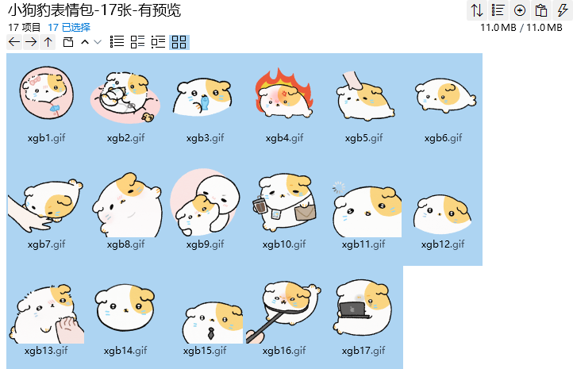
打哈欠:https://imgbed.heliar.top/i/Opt1lDFRCxRvcTb9_xgb1.gif
进食中:https://imgbed.heliar.top/i/103v86oX-g2j0pPr_xgb2.gif
震惊:https://imgbed.heliar.top/i/aFlRUorkOMpeyLrR_xgb3.gif
生气:https://imgbed.heliar.top/i/BH2TSSNIQELrUvYQ_xgb4.gif
摸摸头/被摸头/想被摸头:https://imgbed.heliar.top/i/b2S6OGdjScmDe6ng_xgb5.gif
啊达起身:https://imgbed.heliar.top/i/bF65Y2PQpHjTHGOl_xgb6.gif
咬你一口:https://imgbed.heliar.top/i/VUGaEXk_AUaXWIY7_xgb7.gif
你好呀:https://imgbed.heliar.top/i/J2M1192zRJX0l9zv_xgb8.gif
太可爱了要你脸颊:https://imgbed.heliar.top/i/ug1sCO1bQ_Xw4WJr_xgb9.gif
来口咖啡续命:https://imgbed.heliar.top/i/5vsz1YTe3D1YIpvw_xgb10.gif
宕机:https://imgbed.heliar.top/i/HiTV0JHjTsMB27xE_xgb11.gif
期待/心动:https://imgbed.heliar.top/i/aM0fcpEbkUu4P8o3_xgb12.gif
挠挠下巴:https://imgbed.heliar.top/i/GRNTl5d4EQeMZ0yn_xgb13.gif
哭:https://imgbed.heliar.top/i/Gi4QAUHZuUInhc_9_xgb14.gif
收到:https://imgbed.heliar.top/i/vX11-AB-29a5TfeH_xgb15.gif
生气了:https://imgbed.heliar.top/i/7Mwc3tqAF4KsxNIf_xgb16.gif
工作中/进入工作状态:https://imgbed.heliar.top/i/kXS24wKu4EPywKnR_xgb17.gif

