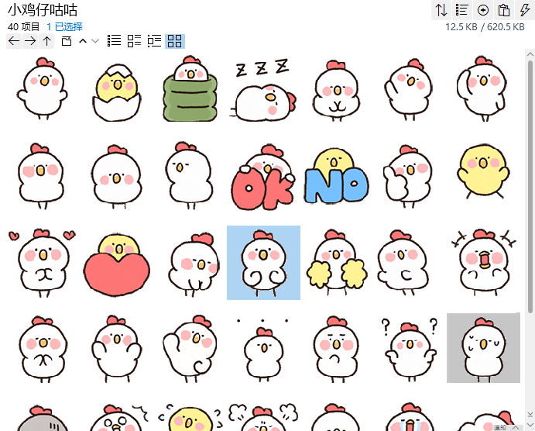
深呼吸:https://i.postimg.cc/rmbVyt8M/jzgg1.gif
我来了/出生了:https://i.postimg.cc/j59xqJsR/jzgg2.gif
探头:https://i.postimg.cc/26JkjBzf/jzgg3.gif
呼呼大睡:https://i.postimg.cc/wvPqxs6p/jzgg4.gif
鞠躬/礼貌:https://i.postimg.cc/ZRgbYyTb/jzgg5.gif
挥手:https://i.postimg.cc/B6ySZ1qn/jzgg6.gif
敬礼:https://i.postimg.cc/FRqrFJ99/jzgg7.gif
转一圈:https://i.postimg.cc/63SW6G95/jzgg8.gif
点头:https://i.postimg.cc/B6ySZ1qX/jzgg9.gif
摇头:https://i.postimg.cc/TwSd2WRh/jzgg10.gif
OK:https://i.postimg.cc/d1XsQTq3/jzgg11.gif
No:https://i.postimg.cc/Y9Vr2mpv/jzgg12.gif
点赞:https://i.postimg.cc/hvdSXPjS/jzgg13.gif
蹦跳:https://i.postimg.cc/RhHMWVFv/jzgg14.gif
搓手/喜爱:https://i.postimg.cc/brtzZNJy/jzgg15.gif
喜欢/爱你:https://i.postimg.cc/0jw8z2Q5/jzgg16.gif
垂头丧气:https://i.postimg.cc/Hnyprsxr/jzgg17.gif
摩拳擦掌/准备好了:https://i.postimg.cc/j27sDd5L/jzgg18.gif
加油/应援:https://i.postimg.cc/tJxXsCT1/jzgg19.gif
左右摇晃:https://i.postimg.cc/VvCYJL6r/jzgg20.gif
大叫:https://i.postimg.cc/brtzZNJt/jzgg21.gif
鼓掌:https://i.postimg.cc/C5qFRL1n/jzgg22.gif
鼓舞/一鼓作气/抬手:https://i.postimg.cc/fy9wVTL0/jzgg23.gif
伸懒腰:https://i.postimg.cc/7h2x5Y67/jzgg24.gif
无语叽:https://i.postimg.cc/brtzZNJR/jzgg25.gif
歪头:https://i.postimg.cc/sxhVMDX4/jzgg26.gif
疑惑/不知道:https://i.postimg.cc/PJwtCrxz/jzgg27.gif
冒汗/心虚:https://i.postimg.cc/SRMynNsd/jzgg28.gif
惆怅/沮丧:https://i.postimg.cc/Dm37LkJ1/jzgg29.gif
震惊:https://i.postimg.cc/Hj1TXDcQ/jzgg30.gif
着急跺脚:https://i.postimg.cc/s1C37dQY/jzgg31.gif
气鼓鼓:https://i.postimg.cc/SjbmCF2f/jzgg32.gif
啜泣:https://i.postimg.cc/K4hmBSkQ/jzgg33.gif
大哭:https://i.postimg.cc/dDcJrPk5/jzgg34.gif
瘫坐在地/摆烂:https://i.postimg.cc/c6GdwygD/jzgg35.gif
乖巧/谦虚:https://i.postimg.cc/ThvTgMLC/jzgg36.gif
小白鸡招手/再见:https://i.postimg.cc/G9nbGwTr/jzgg37.gif
小黄鸡挥手:https://i.postimg.cc/3WQ3m54z/jzgg38.gif
跳舞/律动:https://i.postimg.cc/WtcsgLqP/jzgg39.gif
偷偷探身/偷听:https://i.postimg.cc/QVZj1G92/jzgg40.gif

