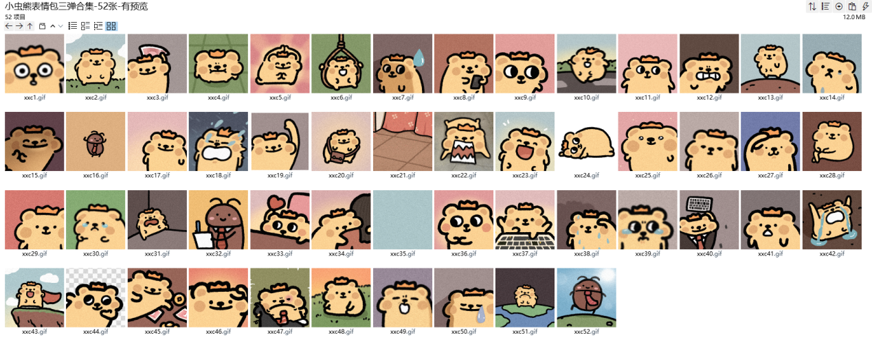
爱心:https://imgbed.heliar.top/i/69EkV8Uf0Gc5AYtO_xxc1.gif
打钱:https://imgbed.heliar.top/i/OvGHXRSVbPq4QAqN_xxc2.gif
呜哇:https://imgbed.heliar.top/i/noFZuxST9r5qwlke_xxc3.gif
求求:https://imgbed.heliar.top/i/38frglG_NJU9NrX9_xxc4.gif
荡秋千:https://imgbed.heliar.top/i/iqS-IX2l1z2Vyr1c_xxc5.gif
汗:https://imgbed.heliar.top/i/naeS1ZCnxTXuq_4e_xxc6.gif
瞎了:https://imgbed.heliar.top/i/Ar4C_cs_xNuTgwD0_xxc7.gif
什么:https://imgbed.heliar.top/i/yAln_PMOD8XzhUgl_xxc8.gif
点头:https://imgbed.heliar.top/i/VjT3itr2_M6a2Mvh_xxc9.gif
乐:https://imgbed.heliar.top/i/cu96WmSG9LnhZy0q_xxc10.gif
嘚瑟:https://imgbed.heliar.top/i/zJPXtCxKiKa9O3pf_xxc11.gif
咬牙切齿:https://imgbed.heliar.top/i/8vX8Q0KLahROXXBw_xxc12.gif
小获全胜:https://imgbed.heliar.top/i/01UHsT_D4UtoGhSl_xxc13.gif
sad:https://imgbed.heliar.top/i/zjyH8TTxygg2rG-g_xxc14.gif
嘿嘿嘿嘿:https://imgbed.heliar.top/i/LJPB20wEaDzMjRp0_xxc15.gif
嗨起来:https://imgbed.heliar.top/i/K1JEFylmBDBaEm24_xxc16.gif
给你:https://imgbed.heliar.top/i/qn-etkv5w9fDI8K8_xxc17.gif
爆哭:https://imgbed.heliar.top/i/eXl6nXt0nJnd8xEJ_xxc18.gif
扇耳光:https://imgbed.heliar.top/i/5XwiBxa8Y9JvEuw7_xxc19.gif
甩:https://imgbed.heliar.top/i/X1PC1yFWe2gpTdEC_xxc20.gif
开心:https://imgbed.heliar.top/i/MrSSswjpjOV5T7zT_xxc21.gif
疯狗:https://imgbed.heliar.top/i/cI-_E0el1ZVvqf7B_xxc22.gif
哈哈哈:https://imgbed.heliar.top/i/Z-DQB_XYNAMXcvMY_xxc23.gif
那个:https://imgbed.heliar.top/i/6LJsQCv3wZumFXSU_xxc24.gif
哇:https://imgbed.heliar.top/i/ofkInt53qS2vps8R_xxc25.gif
冷漠:https://imgbed.heliar.top/i/m20wkdGWppdIuX7p_xxc26.gif
挠头:https://imgbed.heliar.top/i/7i3Humb3cz5-JcbD_xxc27.gif
翘二郎腿:https://imgbed.heliar.top/i/BaQ5fFXqeawZnYV-_xxc28.gif
嘘:https://imgbed.heliar.top/i/X8YqS-o9IIlhbh_K_xxc29.gif
惨惨:https://imgbed.heliar.top/i/L7TTPJCjNYOZJ-Rt_xxc30.gif
别过来:https://imgbed.heliar.top/i/9hk2YFwdeUG4gVPd_xxc31.gif
记下:https://imgbed.heliar.top/i/aemTYE9aOiPUBIcy_xxc32.gif
爱了:https://imgbed.heliar.top/i/sDHTI3NcZm-lvao3_xxc33.gif
抱抱:https://imgbed.heliar.top/i/t_FbpzoXPFHL1bOS_xxc34.gif
好:https://imgbed.heliar.top/i/rNzZeSycJ8VrgSIZ_xxc35.gif
哎呀:https://imgbed.heliar.top/i/L_xgs_GB8TaxSAjs_xxc36.gif
上班:https://imgbed.heliar.top/i/RKDgGEV3-l54o-1f_xxc37.gif
流汗:https://imgbed.heliar.top/i/5RDzlZXtox2sL2Bx_xxc38.gif
瞪:https://imgbed.heliar.top/i/yTUz3lm8MWVhrmOt_xxc39.gif
键盘攻击:https://imgbed.heliar.top/i/NnSzebewXsI9qsuE_xxc40.gif
麻了:https://imgbed.heliar.top/i/sRYqIkQ_PBb7vd9I_xxc41.gif
天啊:https://imgbed.heliar.top/i/YtyLs56Dn_xYiqnE_xxc42.gif
元气满满:https://imgbed.heliar.top/i/VouL14lWSSE8H2R4_xxc43.gif
思考:https://imgbed.heliar.top/i/qs3qEJy4d-vGmdSq_xxc44.gif
钱来:https://imgbed.heliar.top/i/NFRcPj0RNOsIZ0r7_xxc45.gif
淘气:https://imgbed.heliar.top/i/4TD6IhmbLRZMuN8D_xxc46.gif
烦:https://imgbed.heliar.top/i/pfqGO4NpQBmXuvYw_xxc47.gif
嗯:https://imgbed.heliar.top/i/Qtrb3lJh7Tnuovj4_xxc48.gif
什么东西:https://imgbed.heliar.top/i/oHjx4dQ4vOeKcd8S_xxc49.gif
眼泪:https://imgbed.heliar.top/i/p-OWmHPGK6sYpvAq_xxc50.gif
踩:https://imgbed.heliar.top/i/fizsXL4ZwU7830oZ_xxc51.gif
螂来:https://imgbed.heliar.top/i/hKyJKGVGErWZJzun_xxc52.gif

