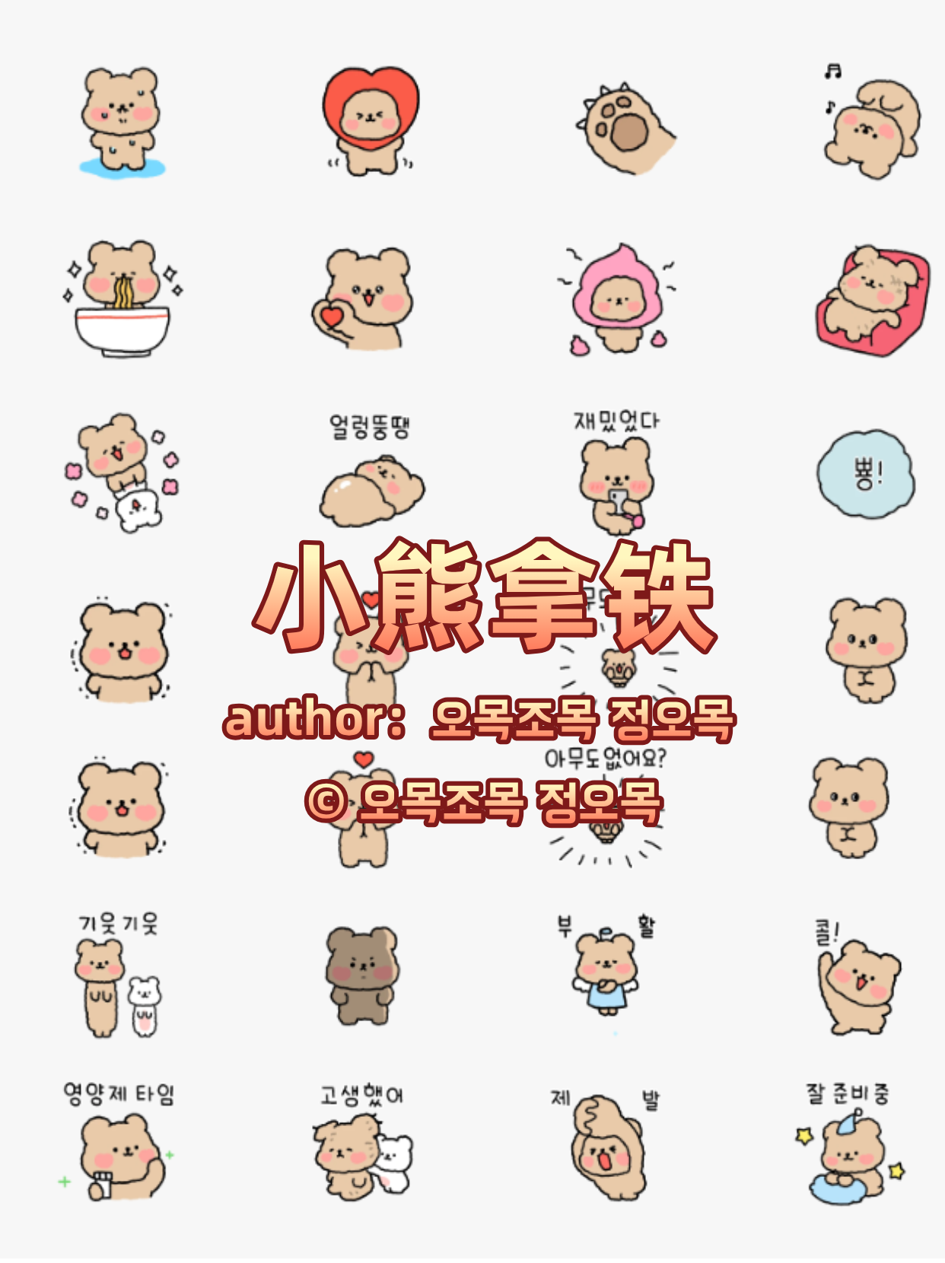
流汗|紧张|心虚:https://i.postimg.cc/T24nfsQB/Bear1.gif
爱心套头扭屁屁:https://i.postimg.cc/T24nfsQz/Bear2.gif
阴暗地露爪子:https://i.postimg.cc/bYB1p5LW/Bear3.gif
开心蹬腿:https://i.postimg.cc/44Sps0wM/Bear4.gif
嗦面:https://i.postimg.cc/8k0LNYtD/Bear5.gif
比心:https://i.postimg.cc/CMQbS2mg/Bear6.gif
懵…:https://i.postimg.cc/Y2sQMPb7/Bear7.gif
瘫在沙发:https://i.postimg.cc/ZYM64QV4/Bear8.gif
和小兔贴贴转圈:https://i.postimg.cc/15VwtKYL/Bear9.gif
晕乎乎:https://i.postimg.cc/Kv3Bz5s6/Bear10.gif
等消息|好好玩:https://i.postimg.cc/hPQTj05R/Bear11.gif
嘭！消失|出现！:https://i.postimg.cc/L6gLXVbM/Bear12.gif
哇|颤抖:https://i.postimg.cc/m21CDS5T/Bear13.gif
双手合十比心:https://i.postimg.cc/wTRLvkG6/Bear14.gif
大叫有人吗？:https://i.postimg.cc/zXHKBkcD/Bear15.gif
乖巧|扭捏|扣手:https://i.postimg.cc/Kv3Bz5HG/Bear16.gif
探头探脑:https://i.postimg.cc/4NHVd1Sn/Bear17.gif
黑脸小熊|叉腰:https://i.postimg.cc/28Lh6xKV/Bear18.gif
复活嘞|天使转圈圈:https://i.postimg.cc/PrvYxMRL/Bear19.gif
好嘞！:https://i.postimg.cc/Dy4LZcMS/Bear20.gif
回复HP值:https://i.postimg.cc/g29R66CX/Bear21.gif
辛苦啦:https://i.postimg.cc/RZrfnnkN/Bear22.gif
拜托:https://i.postimg.cc/T38mWWz5/Bear23.gif
准备就寝中|拍拍枕头:https://i.postimg.cc/0ygmJJTJ/Bear24.gif

