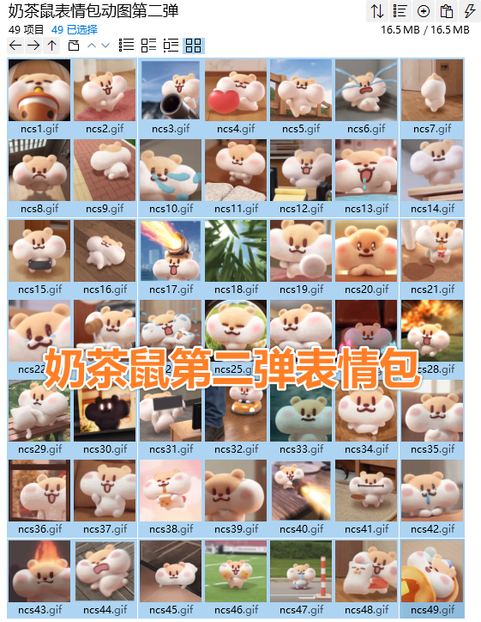
喝奶茶:https://i.postimg.cc/d0DTjSbG/ncs1.gif
开心扭来扭去:https://i.postimg.cc/0NrJ0HTD/ncs2.gif
开大炮打你:https://i.postimg.cc/253B7XsZ/ncs3.gif
抱抱爱心:https://i.postimg.cc/MGXjmrCD/ncs4.gif
雄赳赳气昂昂地大步走:https://i.postimg.cc/CKdfs637/ncs5.gif
呜哇眼泪四溅:https://i.postimg.cc/hGh713k0/ncs6.gif
在呢:https://i.postimg.cc/253B7Xs0/ncs7.gif
生气捏拳颤抖:https://i.postimg.cc/TPhWJHzN/ncs8.gif
逃:https://i.postimg.cc/SKjzftB5/ncs9.gif
泪，如泉涌:https://i.postimg.cc/LshZ30c0/ncs10.gif
困鼠:https://i.postimg.cc/rpztNYBv/ncs11.gif
恼火:https://i.postimg.cc/nLMQGP88/ncs12.gif
流口水:https://i.postimg.cc/DzD4jPhj/ncs13.gif
看着我:https://i.postimg.cc/cJjt9BWk/ncs14.gif
抖脸:https://i.postimg.cc/VNT0GWwh/ncs15.gif
锤扁/被反复捶打:https://i.postimg.cc/HLK8Z9mR/ncs16.gif
扛着大炮轰炸:https://i.postimg.cc/XvhBHkWT/ncs17.gif
我在摸摸头:https://i.postimg.cc/Ls7gC3RK/ncs18.gif
重拳出击:https://i.postimg.cc/jj9ng4KV/ncs19.gif
认真:https://i.postimg.cc/XvhBHk33/ncs20.gif
爱了爱了:https://i.postimg.cc/pd75GJxP/ncs21.gif
可怜:https://i.postimg.cc/Pqcv3Qht/ncs22.gif
敲打:https://i.postimg.cc/k5ZR1v9q/ncs23.gif
抱头痛哭:https://i.postimg.cc/nL59RGZz/ncs24.gif
快乐:https://i.postimg.cc/g0r6HBCh/ncs25.gif
来:https://i.postimg.cc/fbFS2fZk/ncs26.gif
打call:https://i.postimg.cc/3w60SF7N/ncs27.gif
跑啊:https://i.postimg.cc/CKtnPsYR/ncs28.gif
没事的:https://i.postimg.cc/hjdzHQPG/ncs29.gif
两眼发光:https://i.postimg.cc/3Rv4P0Jr/ncs30.gif
砸电脑:https://i.postimg.cc/KzMkd3vG/ncs31.gif
创你:https://i.postimg.cc/63v2D458/ncs32.gif
再见:https://i.postimg.cc/4d97rHNc/ncs33.gif
来了:https://i.postimg.cc/gJZXfLkL/ncs34.gif
没问题:https://i.postimg.cc/KzMkd3vL/ncs35.gif
心:https://i.postimg.cc/xCzJWNTM/ncs36.gif
好耶:https://i.postimg.cc/26ZbPL8Q/ncs37.gif
开心:https://i.postimg.cc/ZRdB1vKL/ncs38.gif
嘿嘿:https://i.postimg.cc/gJZXfLkD/ncs39.gif
拿机关枪扫:https://i.postimg.cc/KzMkd3vf/ncs40.gif
沉默:https://i.postimg.cc/j57wGndM/ncs41.gif
可怜兮兮地挂着鼻涕:https://i.postimg.cc/KjhkFcRP/ncs42.gif
发火:https://i.postimg.cc/WzcFjphg/ncs43.gif
躺在地上来回翻滚/闹:https://i.postimg.cc/x8VJYjcK/ncs44.gif
就这样吧/放弃挣扎:https://i.postimg.cc/3NQ47rdj/ncs45.gif
啦啦队:https://i.postimg.cc/d3ckvQL4/ncs46.gif
呆/无助/老婆你在哪:https://i.postimg.cc/2yNbmjV0/ncs47.gif
醒醒:https://i.postimg.cc/0j1Mx5bt/ncs48.gif
睡觉:https://i.postimg.cc/0j1Mx5bW/ncs49.gif

