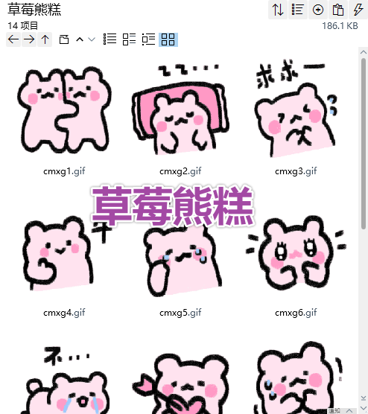
抱抱:https://imgbed.heliar.top/i/0JFkI9A6cTznRaUS_cmxg1.gif
睡了/就寝:https://imgbed.heliar.top/i/Zq8J6uXw7OFKrBSj_cmxg2.gif
求求/拜托拜托:https://imgbed.heliar.top/i/3FR9yWej95LsVyjZ_cmxg3.gif
牛/厉害:https://imgbed.heliar.top/i/WQnV45-FzXRSGlxx_cmxg4.gif
呜呜/擦眼泪:https://imgbed.heliar.top/i/TpYuRHbQ-APLBrd4_cmxg5.gif
期待:https://imgbed.heliar.top/i/IpN9K-IknJqmv5Fc_cmxg6.gif
不！！:https://imgbed.heliar.top/i/eyl9WUdHHtoPbeHF_cmxg7.gif
爱了:https://imgbed.heliar.top/i/ZzyDQQaAb9N2ZXAD_cmxg8.gif
害怕:https://imgbed.heliar.top/i/tg0QG7jAQBPs3v9z_cmxg9.gif
哭:https://imgbed.heliar.top/i/yeMGaCUPWBRlKa3f_cmxg10.gif
穷/我好穷啊:https://imgbed.heliar.top/i/9-u6uEoBrn3VqU_R_cmxg11.gif
ok:https://imgbed.heliar.top/i/pUhUoiGhhbuqMEpY_cmxg12.gif
怒:https://imgbed.heliar.top/i/dnJUkoai3pGYKHaj_cmxg13.gif
呼/松口气:https://imgbed.heliar.top/i/TDOUw5MELpZW5_4x_cmxg14.gif

