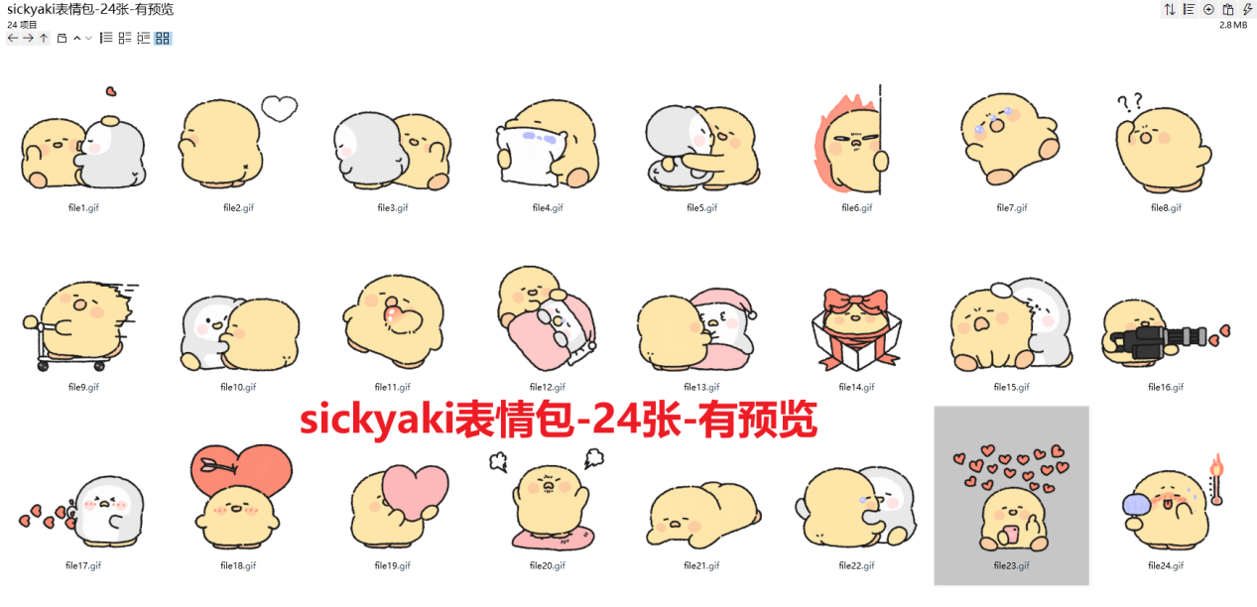
疯狂亲亲/亲亲狂魔:https://imgbed.heliar.top/i/0nhUDnx-AtXsblp9_file1.gif
放屁:https://imgbed.heliar.top/i/N4eAMxp0XtDxJR___file2.gif
打你屁股:https://imgbed.heliar.top/i/XZKFJHRlskLcySND_file3.gif
哭湿枕头:https://imgbed.heliar.top/i/W6TRtOQzbJVpnJQh_file4.gif
用力抱你/紧紧抱你:https://imgbed.heliar.top/i/JbUvFYMtwCvhyzNP_file5.gif
生气:https://imgbed.heliar.top/i/lhAD-D2b4VAPGccG_file6.gif
躺地上大哭大闹:https://imgbed.heliar.top/i/7FA7JjCnBHTU9-Y6_file7.gif
在哪在哪/疑惑:https://imgbed.heliar.top/i/Sa-fvzevR5yLTGjF_file8.gif
骑着滑板车滑走/过来/我来了:https://imgbed.heliar.top/i/FQ7x_h45wa4gZDpH_file9.gif
超级吸附贴贴:https://imgbed.heliar.top/i/AppWAvlaCp0oRF0M_file10.gif
心跳加速:https://imgbed.heliar.top/i/8jqIbGpcMW031DtX_file11.gif
摸摸头/晚安:https://imgbed.heliar.top/i/tvIbrPpzujHsDFPB_file12.gif
醒醒:https://imgbed.heliar.top/i/AXKWG56-i2WGX30J_file13.gif
礼物来了:https://imgbed.heliar.top/i/900lrDo815K8BL5H_file14.gif
咬你脸蛋:https://imgbed.heliar.top/i/S4iZ7fq4rcuDe55B_file15.gif
爱心机关枪:https://imgbed.heliar.top/i/C9lz94MTWpkYJFvE_file16.gif
被爱心击中:https://imgbed.heliar.top/i/s7vBiIx9MVFetPtF_file17.gif
一见倾心:https://imgbed.heliar.top/i/3lDy7hcFy6Rc9RKz_file18.gif
让我掏个爱心给你:https://imgbed.heliar.top/i/hLdhmbqfPPFEUx2h_file19.gif
在爱心上踩！/没爱了/踩你:https://imgbed.heliar.top/i/QTJEqJG08McMX2vV_file20.gif
膜拜中:https://imgbed.heliar.top/i/pLpPcx0p23hFkllv_file21.gif
安慰中/不哭不哭:https://imgbed.heliar.top/i/MKLRcMEW_Xzi7eJo_file22.gif
发消息:https://imgbed.heliar.top/i/mAS7MLBPpuJUKp_9_file23.gif
好热啊/发烧了:https://imgbed.heliar.top/i/O_7IzoBgBfIJqEce_file24.gif

