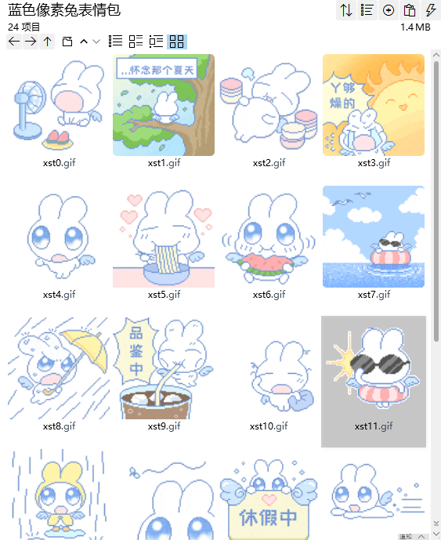
张嘴对着风扇吹，啊——:https://imgbed.heliar.top/i/sNNXotH0eWYvhyRg_xst0.gif
怀念那个夏天:https://imgbed.heliar.top/i/-6qchvdyhWqTIvr0_xst1.gif
好饱好饱:https://imgbed.heliar.top/i/7zqAkTjCmYRfmzwM_xst2.gif
丫够燥的（热死了）:https://imgbed.heliar.top/i/3zXfWoN2rRDbR5za_xst3.gif
比耶/萌萌的:https://imgbed.heliar.top/i/2pjwPGr8Xhji0COV_xst4.gif
幸福:https://imgbed.heliar.top/i/FvMKDEg_ENdvOxah_xst5.gif
吃瓜:https://imgbed.heliar.top/i/gqM4Vw-Eg4yEWrB9_xst6.gif
游泳:https://imgbed.heliar.top/i/5MgEDB1j9qQGF9g7_xst7.gif
淋雨前进:https://imgbed.heliar.top/i/wFBg-8LLvxTeJQeI_xst8.gif
品鉴中:https://imgbed.heliar.top/i/FKxFS9TJ2zAbdcEK_xst9.gif
揉揉眼睛:https://imgbed.heliar.top/i/tfsl-_7lVZ2mrxeJ_xst10.gif
戴墨镜/酷:https://imgbed.heliar.top/i/Ik-ld8yYMD7VLQp8_xst11.gif
捂住:https://imgbed.heliar.top/i/XD9h2cAWVAVkqlKf_xst12.gif
打蚊子:https://imgbed.heliar.top/i/23LszLYbI49is8ZA_xst13.gif
休假中:https://imgbed.heliar.top/i/q6WERRmvjwEkU8mf_xst14.gif
我来了:https://imgbed.heliar.top/i/eRy2wE1L-UQhRLkC_xst15.gif
好热哦:https://imgbed.heliar.top/i/vluCgcyo8Gqfk4KR_xst16.gif
呜呜呜:https://imgbed.heliar.top/i/GY425xFKmB7y5K47_xst17.gif
哈哈哈哈:https://imgbed.heliar.top/i/qyHZ0tAFdwIbY5jH_xst18.gif
上号！！！:https://imgbed.heliar.top/i/5OFZFF4AZgS05euO_xst19.gif
谢谢你:https://imgbed.heliar.top/i/pIQ2ATxepKpwNgmj_xst20.gif
嗯？？？？:https://imgbed.heliar.top/i/IKo_T6-DJPMeDgxN_xst21.gif
好耶:https://imgbed.heliar.top/i/L3Lm8KfoNXcXVV6T_xst22.gif
洗澡:https://imgbed.heliar.top/i/-EuAgNlvckIx9_rS_xst23.gif

