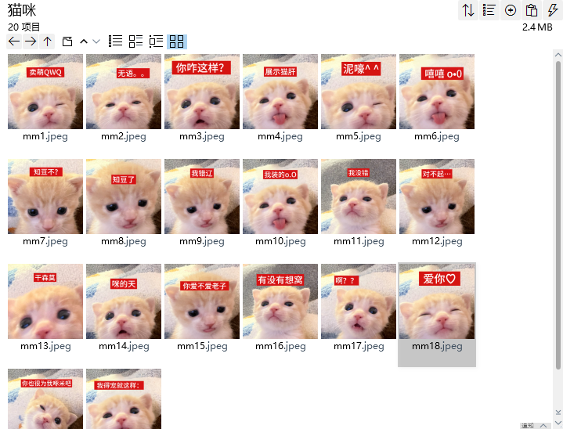
卖萌QWQ:https://imgbed.heliar.top/i/Bru7cHmJqa0FSz-z_mm1.webp
无语:https://imgbed.heliar.top/i/I6O5NjI5eAydh-iW_mm2.webp
你咋这样:https://imgbed.heliar.top/i/kZ_f1TC5sifkUcD7_mm3.webp
展示猪肝（舌头）:https://imgbed.heliar.top/i/rkc6mm2Q6lKo95tM_mm4.webp
泥嚎^^:https://imgbed.heliar.top/i/LHKFEGyRo7UHZTtV_mm5.webp
嘻嘻:https://imgbed.heliar.top/i/Pq2oMQG1k-Kg8itC_mm6.webp
知道不！:https://imgbed.heliar.top/i/3gQdtP0DXMfbrXLH_mm7.webp
知道了:https://imgbed.heliar.top/i/20p-1rBy2BuV2WeJ_mm8.webp
我错了:https://imgbed.heliar.top/i/F_6haEp-s8kvobFi_mm9.webp
我装的:https://imgbed.heliar.top/i/oh_W0qVjRL78hRHP_mm10.webp
我没错:https://imgbed.heliar.top/i/uUtxzCBoLg3t2E1q_mm11.webp
对不起:https://imgbed.heliar.top/i/6vKW7QZ2lRV_ugGo_mm12.webp
干森么:https://imgbed.heliar.top/i/SO3Vq4YgZrBY2F41_mm13.webp
咪的天:https://imgbed.heliar.top/i/9P-mGBwdA2V-3uH4_mm14.webp
你爱不爱老子:https://imgbed.heliar.top/i/jmVUT00ppEleAH3Z_mm15.webp
有没有想窝:https://imgbed.heliar.top/i/p-UqRQL6zZrruwG__mm16.webp
啊？？:https://imgbed.heliar.top/i/JT-kP78YT7s3Dkwk_mm17.webp
爱你:https://imgbed.heliar.top/i/CukKdxAb2SuprmgS_mm18.webp
你也为我啄米（着迷）吧:https://imgbed.heliar.top/i/xCGdDoGjhRN5GPZw_mm19.webp
我得宠了就这样嘚瑟/卖萌:https://imgbed.heliar.top/i/78KJRE5eB_jXlQ94_mm20.webp

