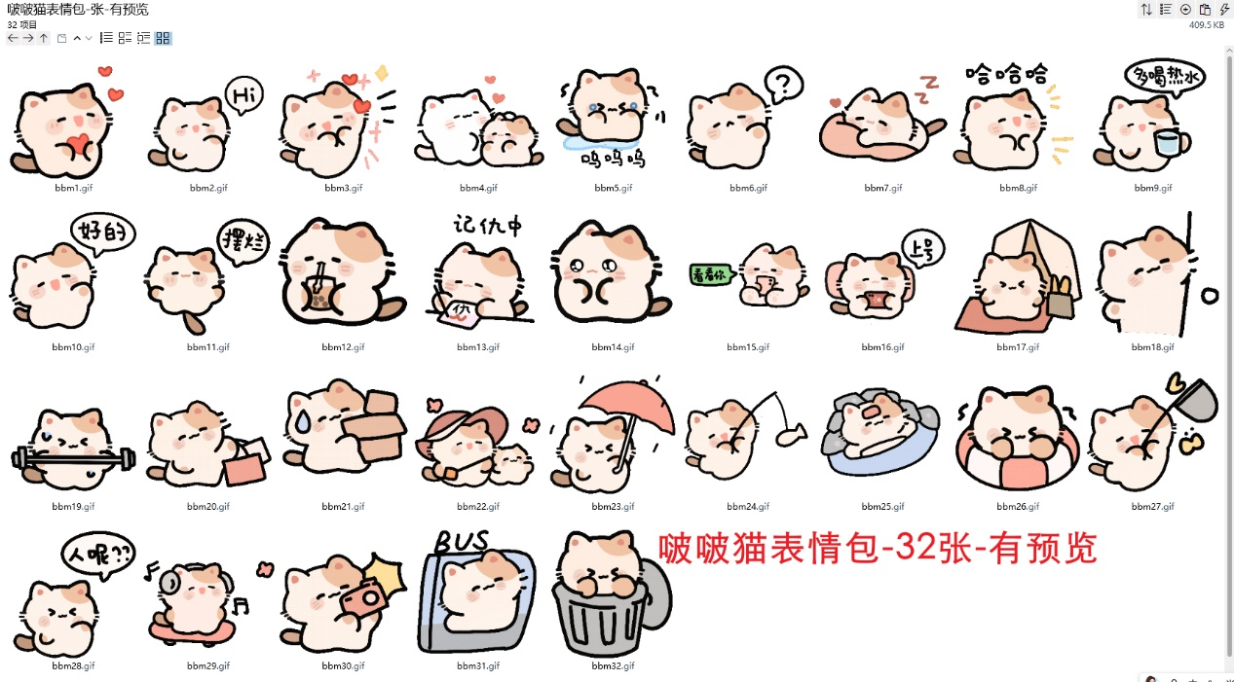
爱你:https://imgbed.heliar.top/i/y1b4BLKpWFARq_Hr_bbm1.gif
你好:https://imgbed.heliar.top/i/v0tWHDsD6o0y3wL0_bbm2.gif
爱了:https://imgbed.heliar.top/i/S5ul_uBMgG46CEfz_bbm3.gif
摸摸:https://imgbed.heliar.top/i/1Jrn0x6fx9KKj99I_bbm4.gif
呜呜呜:https://imgbed.heliar.top/i/gO1ojtxsrT2sWz85_bbm5.gif
问号:https://imgbed.heliar.top/i/fKUGUWvT48fIeS7l_bbm6.gif
睡觉:https://imgbed.heliar.top/i/x-B68e5T_EFsvxeb_bbm7.gif
哈哈哈:https://imgbed.heliar.top/i/lcPsB9Mlag3B32aH_bbm8.gif
多喝热水:https://imgbed.heliar.top/i/zJiHX2Agd2b9UQT3_bbm9.gif
好的:https://imgbed.heliar.top/i/lWEqabN4-643tBta_bbm10.gif
摆烂:https://imgbed.heliar.top/i/2ccHpa-2AO6vgQYq_bbm11.gif
喝奶茶:https://imgbed.heliar.top/i/kwDfavD2ZtY9fsbR_bbm12.gif
记仇:https://imgbed.heliar.top/i/Q6Koo9QjHMMBIxjO_bbm13.gif
无辜:https://imgbed.heliar.top/i/9X2J1pULRjagadXL_bbm14.gif
看看你:https://imgbed.heliar.top/i/GgBSDKKs9LNVhfCw_bbm15.gif
上号！:https://imgbed.heliar.top/i/5_fZNia922WB2slk_bbm16.gif
在家等你呀:https://imgbed.heliar.top/i/aefUNsNVqRecEuWa_bbm17.gif
偷看:https://imgbed.heliar.top/i/ZWDQP_kQgg3O7-Jq_bbm18.gif
健身:https://imgbed.heliar.top/i/7xCXZNUST9rYKBRt_bbm19.gif
购物:https://imgbed.heliar.top/i/AJwg0nxHa4KUOhC-_bbm20.gif
拿快递:https://imgbed.heliar.top/i/AVkmypAPcgtkuQxQ_bbm21.gif
牵手~:https://imgbed.heliar.top/i/DaFIvIyveunThxdH_bbm22.gif
下雨了:https://imgbed.heliar.top/i/rNZUEwLtvvYpNp9S_bbm23.gif
钓鱼:https://imgbed.heliar.top/i/shrXZcaZsuVn8ZfG_bbm24.gif
温泉/泡澡/洗澡:https://imgbed.heliar.top/i/dB1SEOE84xlVbOj9_bbm25.gif
游泳:https://imgbed.heliar.top/i/SazYnPmoIr_TunI6_bbm26.gif
抓蝴蝶:https://imgbed.heliar.top/i/5SNvtwSLZhTDpffB_bbm27.gif
人呢:https://imgbed.heliar.top/i/8DtKfK19KSMkhl-8_bbm28.gif
滑板:https://imgbed.heliar.top/i/cU2DWnv89id1E_sC_bbm29.gif
拍照:https://imgbed.heliar.top/i/7dI5rx1DkJ3LfXOD_bbm30.gif
公交:https://imgbed.heliar.top/i/WIqkkl8OTRspE0t9_bbm31.gif
呆在垃圾桶里:https://imgbed.heliar.top/i/mH1LJhqG7zM424kr_bbm32.gif

