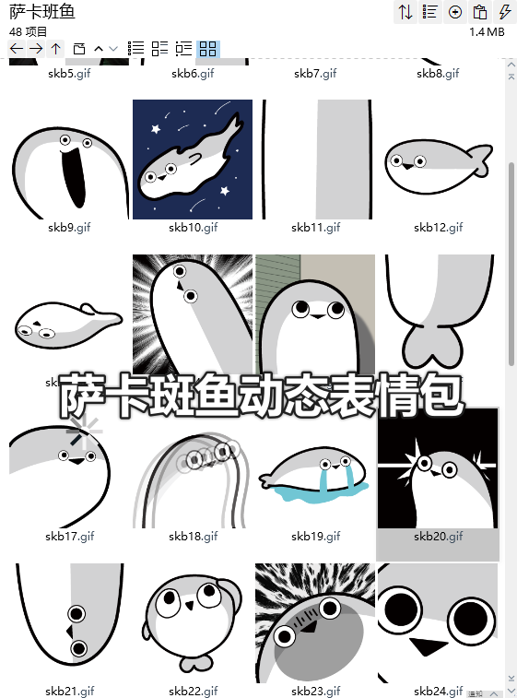
思索:https://imgbed.heliar.top/i/ekWhy7mFi91bqgpT_skb25.gif
哭:https://imgbed.heliar.top/i/5Y6HgfnTGWjH8jY0_skb26.gif
摇摆:https://imgbed.heliar.top/i/_Ibzre_4O4IHNt4b_skb27.gif
流汗/心虚:https://imgbed.heliar.top/i/vY4BbaBoJfQi0Ik1_skb28.gif
过载/宕机:https://imgbed.heliar.top/i/fBnuX6YMC4l88p3Q_skb29.gif
鱼头:https://imgbed.heliar.top/i/u39Y8oasb1HbGn9E_skb30.gif
加一:https://imgbed.heliar.top/i/UjAz9cdn-wemAvzu_skb31.gif
被戳:https://imgbed.heliar.top/i/1JbjgU-oEESx1Gsl_skb32.gif
跳:https://imgbed.heliar.top/i/CRgNscBQ5niyxxJU_skb33.gif
创你:https://imgbed.heliar.top/i/gkJaW7Uz7LuhLo-D_skb34.gif
鱼身:https://imgbed.heliar.top/i/fW3FUDARpURHOE4e_skb35.gif
嗨嗨嗨/hello:https://imgbed.heliar.top/i/QEfv2voVyPuEosvR_skb36.gif
进化了/我变聪明了:https://imgbed.heliar.top/i/4BvabS1Mi6yCp8UY_skb37.gif
强:https://imgbed.heliar.top/i/0Qpxar8h4atFaeFq_skb38.gif
疑问:https://imgbed.heliar.top/i/0s_wW38CR8CaOJgT_skb39.gif
鱼尾:https://imgbed.heliar.top/i/DXqJ2p6rPr-wA-eo_skb40.gif
上厕所/玩手机:https://imgbed.heliar.top/i/luiOfDQOksEv89CQ_skb41.gif
生气/红温:https://imgbed.heliar.top/i/fwjLF4Ilk_twoG3w_skb42.gif
降落:https://imgbed.heliar.top/i/e8ATCr7Zwx4OCC_Z_skb43.gif
挣扎:https://imgbed.heliar.top/i/NveRaqTdw31hBSV9_skb44.gif
鱼往下游:https://imgbed.heliar.top/i/P-cwyaNR-uIJHIdQ_skb45.gif
脸红/害羞:https://imgbed.heliar.top/i/anmATvFYvi4hT9Vu_skb46.gif
冲冲冲:https://imgbed.heliar.top/i/OCQgCMt__JxZClUn_skb47.gif
撒娇/扭扭:https://imgbed.heliar.top/i/aNabg0UJxXq8CbJf_skb48.gif

