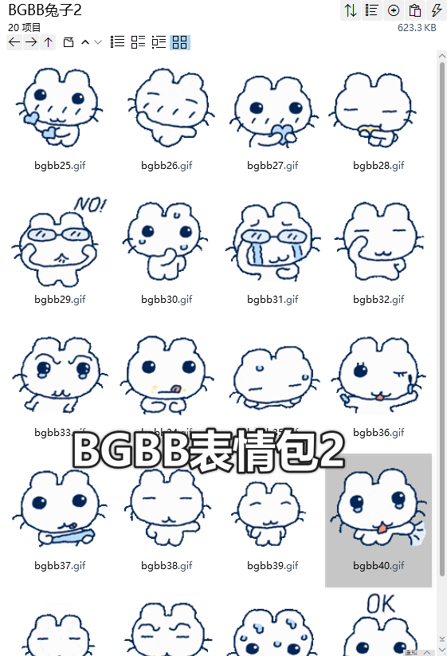
理理我/爱心:https://i.postimg.cc/HnHcbCR9/bgbb25.gif
开心/同手同脚:https://i.postimg.cc/T1GLnXFV/bgbb26.gif
小心翼翼:https://i.postimg.cc/D0FJ1KHQ/bgbb27.gif
偷吃:https://i.postimg.cc/x8YJLShR/bgbb28.gif
NO:https://i.postimg.cc/wMHyDdZ0/bgbb29.gif
紧张/冒汗:https://i.postimg.cc/nrZjqtg3/bgbb30.gif
擦眼泪/欣慰擦泪:https://i.postimg.cc/x8YJLShg/bgbb31.gif
做鬼脸:https://i.postimg.cc/HnHcbCRS/bgbb32.gif
眨眼睛/委屈:https://i.postimg.cc/1XPnDZ2C/bgbb33.gif
舔嘴巴:https://i.postimg.cc/d3vkGKpN/bgbb34.gif
啊！什么？/惊讶:https://i.postimg.cc/prxhKt41/bgbb35.gif
魅力四射/涂睫毛膏:https://i.postimg.cc/HnHcbCRh/bgbb36.gif
准备揍你/严刑逼供:https://i.postimg.cc/5y1Y8MTG/bgbb37.gif
心塞:https://i.postimg.cc/gjdX3PQf/bgbb38.gif
翘脚:https://i.postimg.cc/NFY9RwS3/bgbb39.gif
可怜/理理我嘛:https://i.postimg.cc/sxyQ5RbF/bgbb40.gif
奸诈/狡诈/邪恶:https://i.postimg.cc/MHxM18g2/bgbb41.gif
让我想想/思考:https://i.postimg.cc/8cDJLVxV/bgbb42.gif
狼狈:https://i.postimg.cc/90VRyjsh/file43.gif
OK:https://i.postimg.cc/hvgzVqNS/file44.gif

