GPT生图词
image-2或者image-2.5应该都行，不保证效果

效果预览，可能会不太稳定

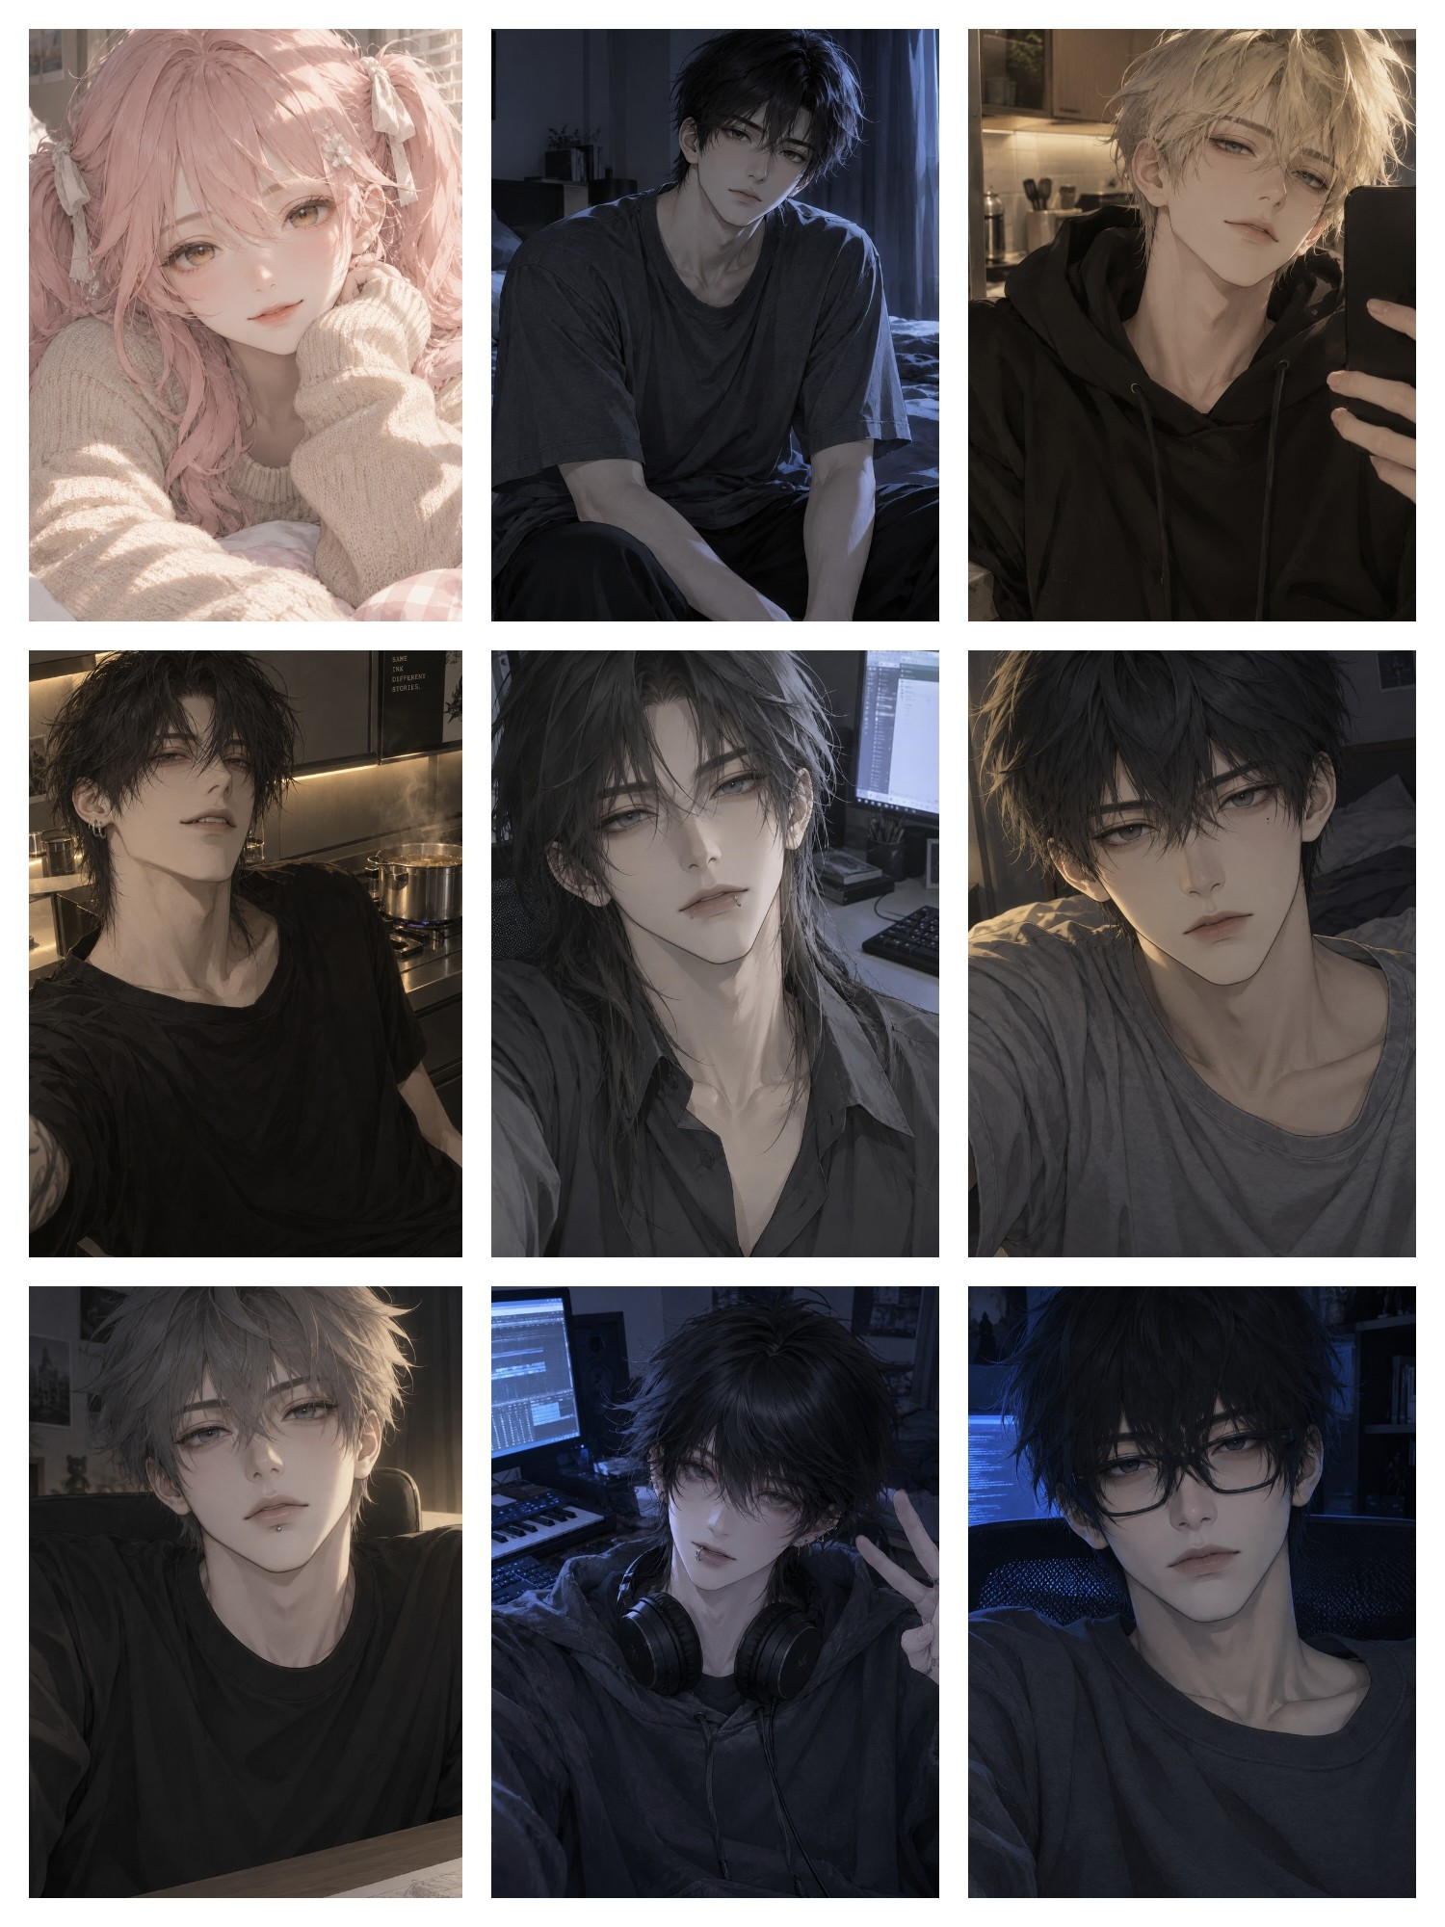

正面high-end Japanese anime character illustration, refined 2.5D anime aesthetic, elegant and natural anime facial structure, delicate yet clearly illustrated features, sophisticated male character design, naturally varied facial proportions, subtle facial asymmetry, harmonious eye spacing, naturally shaped jawline, softly defined cheekbones, smooth but believable transition from forehead to nose bridge, delicate nose with subtle shading, naturally shaped lips with soft tonal variation, expressive half-lidded eyes, intricate iris details with restrained highlights, layered dark eyelashes, soft and nuanced eye reflections, relaxed and slightly tousled hair, distinct hair clumps with fine individual strands, loose flyaway hairs, beautifully controlled linework, soft painterly rendering, clean anime contours blended with delicate tonal shading, dimensional face without photorealistic anatomy, natural skin gradients, subtle warm undertones, gentle shadows around the eyes and nose, understated highlights, soft directional lighting, restrained ambient occlusion, balanced contrast, muted sophisticated color palette, atmospheric depth, intimate candid portrait, effortless elegance, mature yet youthful charm, visually distinctive character identity, organic artistic variation, polished Japanese light novel character art, exquisite facial rendering, understated beauty, natural and emotionally expressive appearance

负面generic AI male face, repetitive face template, identical facial proportions, overly narrow elongated face, excessively sharp V-shaped chin, exaggerated pointed jaw, unnaturally symmetrical face, oversized eyes, glass marble eyes, excessively glossy irises, multiple artificial catchlights, doll-like face, plastic skin, waxy skin, excessive skin smoothing, airbrushed face, over-sharpened facial details, overly sculpted cheekbones, harsh nose contour, exaggerated nose bridge, stiff lips, artificial lip gloss, hyperrealistic skin texture, photorealism, 3D CGI, game character render, AI short drama poster aesthetic, overprocessed beauty filter, excessive bloom, excessive rim lighting, harsh HDR, overexposed skin, muddy facial shadows, oversaturated colors, overly crisp hair strands, hair made of countless uniform thin lines, excessive micro-detail, artificial perfection, lifeless expression, rigid facial structure, low-quality facial anatomy, uncanny appearance

