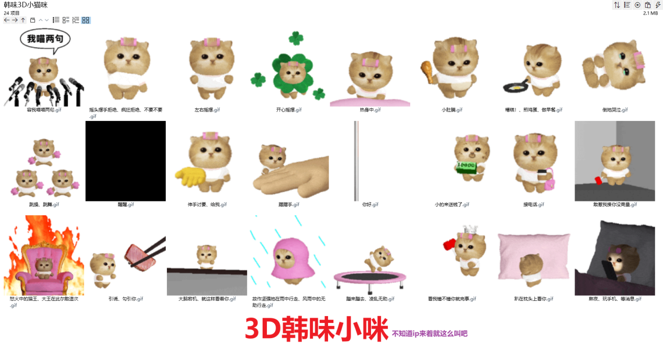
熬夜/玩手机/等消息:https://imgbed.heliar.top/i/QqLBY-bK6eJmBgQ5_mm1.gif
热身中:https://imgbed.heliar.top/i/MQYIGbpsFTXn-xJN_mm2.gif
醒醒:https://imgbed.heliar.top/i/Z_phtOispg47ejh2_mm3.gif
倒地哭泣:https://imgbed.heliar.top/i/rWc49dhhbCYfOhOy_mm4.gif
趴在枕头上看你:https://imgbed.heliar.top/i/hq7fml-m9e-GN8ml_mm5.gif
接电话:https://imgbed.heliar.top/i/VFStW_dwPGFToFJv_mm6.gif
故作坚强地在雨中行走/风雨中的无助行走:https://imgbed.heliar.top/i/n3bOw8Re6TFDmqwT_mm7.gif
看我锤不锤你就完事:https://imgbed.heliar.top/i/O67nqZF2KKB7W80g_mm8.gif
跳操/跳舞:https://imgbed.heliar.top/i/AE9s0vzUy9D4m6rE_mm9.gif
你好:https://imgbed.heliar.top/i/lXGYNTBlFD8t-D1d_mm10.gif
敢惹我揍你没商量:https://imgbed.heliar.top/i/J4FMPzl9TQR5qMP0_mm11.gif
小的来送钱了:https://imgbed.heliar.top/i/TsgjgB58Kez-n1it_mm12.gif
蹦来蹦去/凌乱无助:https://imgbed.heliar.top/i/PiWFTIBXtJhVkWSf_mm13.gif
小肚腩:https://imgbed.heliar.top/i/M9CZVWgrhI6B2PKG_mm14.gif
伸手讨要/给我:https://imgbed.heliar.top/i/7gyeSccPGjMutnGQ_mm15.gif
左右摇摆:https://imgbed.heliar.top/i/9xon-4c5PGT3lC6x_mm16.gif
开心摇摆:https://imgbed.heliar.top/i/NF5F0ZHQdcI54lwQ_mm17.gif
蹭蹭手:https://imgbed.heliar.top/i/zjfa-En1QSf1il_U_mm18.gif
怒火中的猫王/大王在此尔等造次:https://imgbed.heliar.top/i/iah3yFdBmQBjpVVr_mm19.gif
糟糕！/煎鸡蛋/做早餐:https://imgbed.heliar.top/i/3w_JRD5g2JoVGotU_mm20.gif
容我喵喵两句:https://imgbed.heliar.top/i/t2d53cAb1OXMwePT_mm21.gif
摇头摆手拒绝/疯狂拒绝/不要不要:https://imgbed.heliar.top/i/UV7FRUqi-fs2KWHl_mm22.gif
引诱/勾引你:https://imgbed.heliar.top/i/BBV4ic5vYqqCfxER_mm23.gif
大脑宕机/就这样看着你:https://imgbed.heliar.top/i/nOwRgNNspS4WQKU8_mm24.gif

