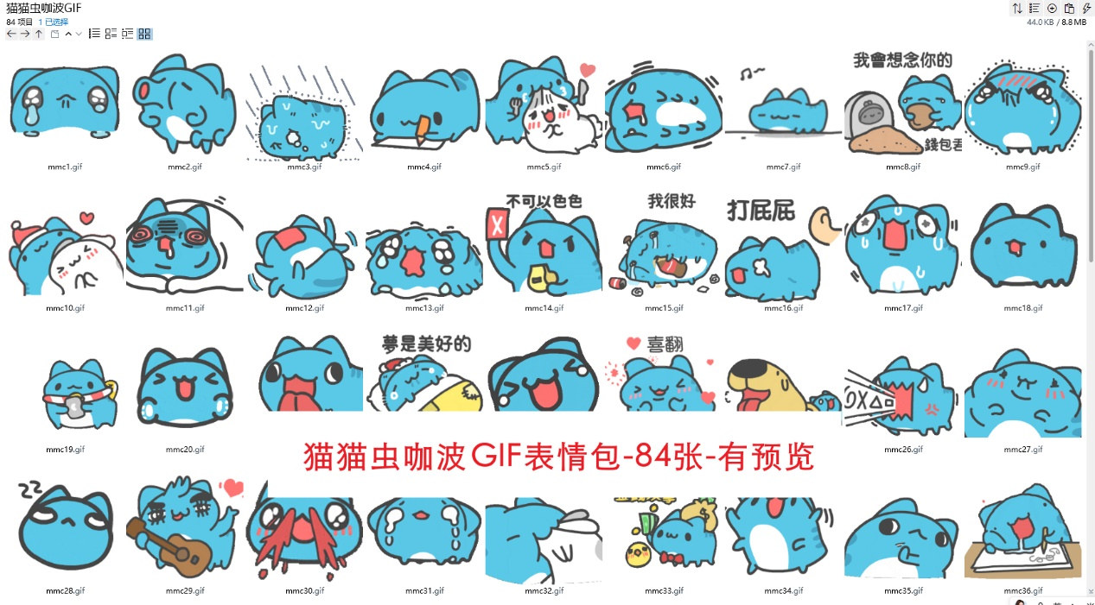

眼睛充满高光地掉眼泪/琼瑶式落泪:https://imgbed.heliar.top/i/Lbd13nN9cjg-bYR4_mmc1.gif
跳大神:https://imgbed.heliar.top/i/WzpI4D72CPohp--t_mmc2.gif
淋雨中:https://imgbed.heliar.top/i/NWdq-mru7Pk0sQsV_mmc3.gif
画爱心:https://imgbed.heliar.top/i/rEQ9Jj8F4JtxPcR2_mmc4.gif
我要吃你/把你吃掉❤️:https://imgbed.heliar.top/i/jmEfoqtXXQ82VxAb_mmc5.gif
倒地上抽搐:https://imgbed.heliar.top/i/WXPB4cQvLLVMphwz_mmc6.gif
蹦蹦跳跳赶路:https://imgbed.heliar.top/i/ggI8nepZ46ZYs5Zh_mmc7.gif
我会想念你的:https://imgbed.heliar.top/i/-lqyMiiRLcaciaa3_mmc8.gif
憋住:https://imgbed.heliar.top/i/L5ApW4o3bXXgWVql_mmc9.gif
疯狂蹭蹭:https://imgbed.heliar.top/i/WKPTVTOhfb2s9LSz_mmc10.gif
没睡醒:https://imgbed.heliar.top/i/4fC_RiuIk-B0s5Ie_mmc11.gif
躺地上闹:https://imgbed.heliar.top/i/BViSaTjWAbVlMrPR_mmc12.gif
泪眼朦胧:https://imgbed.heliar.top/i/mDywAq8LdtyFVJ7C_mmc13.gif
不可以色色:https://imgbed.heliar.top/i/r6VG6AERWimzCKXG_mmc14.gif
我很好（假的）:https://imgbed.heliar.top/i/eFeYwcbKpyTy94Bs_mmc15.gif
打屁屁:https://imgbed.heliar.top/i/upEDvFN2ozbGW3BA_mmc16.gif
冒虚汗:https://imgbed.heliar.top/i/6DRXIv1EDtQ6_tk8_mmc17.gif
流口水:https://imgbed.heliar.top/i/enhE8afDruZrmH5a_mmc18.gif
被围观:https://imgbed.heliar.top/i/CgJdLC-_mcSu15vv_mmc19.gif
疯狂鼓掌:https://imgbed.heliar.top/i/U6KDAfevfFhhYR2p_mmc20.gif
甩舌头:https://imgbed.heliar.top/i/2e4E5JyCLzHmqh_A_mmc21.gif
做梦:https://imgbed.heliar.top/i/ea1LQy6sKlTVUMGd_mmc22.gif
笑出眼泪:https://imgbed.heliar.top/i/WRQ74PjX8kjbZZdl_mmc23.gif
喜欢！/喜翻:https://imgbed.heliar.top/i/7v8zOM9swG2ejPi9_mmc24.gif
被打脸:https://imgbed.heliar.top/i/Rq8mvApHAnL1b8bk_mmc25.gif
怒吼输出:https://imgbed.heliar.top/i/xaUtFlMojrgpQqaI_mmc26.gif
融化:https://imgbed.heliar.top/i/JBEN3RrMp-bodgaU_mmc27.gif
翻白眼:https://imgbed.heliar.top/i/-7S3Oqzr78lvCszq_mmc28.gif
弹唱顺便比心:https://imgbed.heliar.top/i/DrSsjcEaQkBfXwqK_mmc29.gif
喷大鼻血/太刺激了:https://imgbed.heliar.top/i/ppSUtvuu9m1KSyBQ_mmc30.gif
委屈流眼泪:https://imgbed.heliar.top/i/O5aF1nzJBXSxx9RB_mmc31.gif
把你吞吃入腹:https://imgbed.heliar.top/i/i-DQ-beD9JcWFJ83_mmc32.gif
发起老钱攻击:https://imgbed.heliar.top/i/iTzZcv_MjLs35nRE_mmc33.gif
左右摇摆:https://imgbed.heliar.top/i/x4q-d6Velogxqd5G_mmc34.gif
疯狂拒绝:https://imgbed.heliar.top/i/3ib2_5ip4vWlK2sP_mmc35.gif
边睡边做笔记/鬼画符:https://imgbed.heliar.top/i/EGS0YtwWUOTczEmR_mmc36.gif
疯狂抽你脸/抽你！:https://imgbed.heliar.top/i/SFRAQV1Fmvnw1XLO_mmc37.gif
左右摇摆用耳朵扇出一堆爱心:https://imgbed.heliar.top/i/ie-1pdUyBHEDfg-8_mmc38.gif
进攻:https://imgbed.heliar.top/i/Bpp7Ns6tRdZOXF6k_mmc39.gif
没问题！:https://imgbed.heliar.top/i/BeevDFmRNhNN-btK_mmc40.gif
起床:https://imgbed.heliar.top/i/yo9EyJaF6VB8ArDw_mmc41.gif
来回翻滚闹/我要闹了/不要嘛不要吗:https://imgbed.heliar.top/i/kDTGLYvYQCJSq8HG_mmc42.gif
被闹钟鞭打/不想起床:https://imgbed.heliar.top/i/OZQpCdlwjcKfl1sP_mmc43.gif
疑惑地跑过来舔了你一顿吐舌头跑开了:https://imgbed.heliar.top/i/qyj4B4u-8dSAEUa8_mmc44.gif
睡觉中:https://imgbed.heliar.top/i/ZToacJNcChnKFtVG_mmc45.gif
疯狂摇尾巴中:https://imgbed.heliar.top/i/Tf-mLaQhRaQ8sQjU_mmc46.gif
朝着左右超级鞠躬/崇拜:https://imgbed.heliar.top/i/bnD8CZRwpukiCRDN_mmc47.gif
你好wink:https://imgbed.heliar.top/i/4ufJF8t_CJfEL8Hf_mmc48.gif
不要啊不要啊/卖萌式的可怜表情:https://imgbed.heliar.top/i/CYCgCAHWKsdsvejJ_mmc49.gif
来亲亲~:https://imgbed.heliar.top/i/JZ6CViko9e2UnCvc_mmc50.gif
来着爱心的猫火车嘟嘟嘟:https://imgbed.heliar.top/i/sGS5YWXwVmThnVaH_mmc51.gif
点头yes:https://imgbed.heliar.top/i/WzWhVBHYlqoTJUUg_mmc52.gif
倒头就睡:https://imgbed.heliar.top/i/BtU8xaHd9F0Ewfky_mmc53.gif
躲过爱心攻击:https://imgbed.heliar.top/i/Nv1_ypyBLvQfw8r1_mmc54.gif
喵了一个喵字的气泡:https://imgbed.heliar.top/i/jGQVGqgootz7a6ox_mmc55.gif
疯狂摇摆吐舌头舔你:https://imgbed.heliar.top/i/6X3o4OcnMduee-m5_mmc56.gif
超级强壮地点赞:https://imgbed.heliar.top/i/S4jVMPo4omarxSDI_mmc57.gif
来回不倒翁式摇摆:https://imgbed.heliar.top/i/TTQsWM3d3pZPUF6-_mmc58.gif
被可爱晕倒/被可爱击晕:https://imgbed.heliar.top/i/wL_eNsaW6lAsYRdy_mmc59.gif
来回摇晃醒醒啊/给我清醒一点啊:https://imgbed.heliar.top/i/Z8hrWfk9FiUXibX1_mmc60.gif
让我舔舔呗/舔你~/骚扰你:https://imgbed.heliar.top/i/IUHgUE0PYCs5eOcf_mmc61.gif
淡定——/禅定:https://imgbed.heliar.top/i/1ws9xKYChY0cf59N_mmc62.gif
流口水左右晃脑:https://imgbed.heliar.top/i/1WF_dKaaKQ7I8Elf_mmc63.gif
一阵骂人的输出:https://imgbed.heliar.top/i/YUpO1eC03HuJa3e5_mmc64.gif
气鼓鼓地背对你:https://imgbed.heliar.top/i/_IVSA7Nkh7oZtlBD_mmc65.gif
大脑被奇怪的知识涌入了？？:https://imgbed.heliar.top/i/ILoNVTSDNnH6hfK1_mmc66.gif
疯狂进食:https://imgbed.heliar.top/i/c_otdx-pWS6UtVq3_mmc67.gif
发射爱心光波:https://imgbed.heliar.top/i/ldEV8AkpZc2r0nJR_mmc68.gif
殴打（敲打）键盘:https://imgbed.heliar.top/i/ewcnrp01dDqPMqwe_mmc69.gif
摇头no:https://imgbed.heliar.top/i/RLuJKO8c363s9dJc_mmc70.gif
噢噢噢噢噢:https://imgbed.heliar.top/i/MI1xUAwE5luxaxD7_mmc71.gif
笑到颤抖:https://imgbed.heliar.top/i/RwQPzX0MaK0xLqBB_mmc72.gif
扭来扭去:https://imgbed.heliar.top/i/_i6wQA0jS9X9jrDZ_mmc73.gif
来回摇摆:https://imgbed.heliar.top/i/HaO01Qcn5tFnuPyY_mmc74.gif
扎穿本子:https://imgbed.heliar.top/i/tTnuTrG5b8hllj6-_mmc75.gif
流小鼻血:https://imgbed.heliar.top/i/XSVjMLldfJ2Jl_Wu_mmc76.gif
害羞到蹭枕头:https://imgbed.heliar.top/i/eyHgbzEuVKWw3IgI_mmc77.gif
心碎哭哭:https://imgbed.heliar.top/i/whFnWKE8c__2s7U4_mmc78.gif
360°舔你甩舌头:https://imgbed.heliar.top/i/-GItcMUCmRoysBwi_mmc79.gif
猫猫祟祟（鬼鬼祟祟）地出现:https://imgbed.heliar.top/i/GM6pnVRdrQ3WkDWC_mmc80.gif
委屈地憋住眼泪玩手指:https://imgbed.heliar.top/i/rKKtxGGV6Me0O8lp_mmc81.gif
侧面wink/你好:https://imgbed.heliar.top/i/CjY9ssIlOeSZYmjx_mmc82.gif
攻击笔记本电脑/working:https://imgbed.heliar.top/i/LTtvbm4Oj02atq8i_mmc83.gif
抓狂进攻:https://imgbed.heliar.top/i/KABR1EvtJT9EEKL7_mmc84.gif

