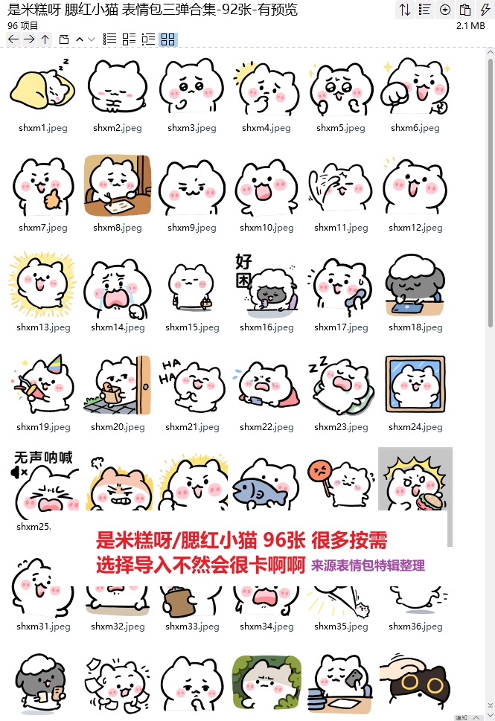
静:https://imgbed.heliar.top/i/Bh0UuVJzHYHyRAOC_shxm1.webp
晚安:https://imgbed.heliar.top/i/hbkT-5e5AaNaLR_z_shxm2.webp
犹豫:https://imgbed.heliar.top/i/N6mbmkruQlvVsq4s_shxm3.webp
思考:https://imgbed.heliar.top/i/WGLjeuL660PWXGyj_shxm4.webp
激动:https://imgbed.heliar.top/i/_sJu-U4LBcKTYLm0_shxm5.webp
赞:https://imgbed.heliar.top/i/4oeNKqfbpRHHw95c_shxm6.webp
加油:https://imgbed.heliar.top/i/xbCwR5pcov-KnkCc_shxm7.webp
困:https://imgbed.heliar.top/i/bxImnrFB3Wf9Medh_shxm8.webp
哼:https://imgbed.heliar.top/i/YXf1JbvrxowMyrsR_shxm9.webp
哇哦:https://imgbed.heliar.top/i/_sSq8ihaVQYyRd9J_shxm10.webp
扶额:https://imgbed.heliar.top/i/3lfueOEo0Go7shzy_shxm11.webp
哦:https://imgbed.heliar.top/i/Et9VsSbkaKWwzuL6_shxm12.webp
登场:https://imgbed.heliar.top/i/lrSdJ0grubJi69Ln_shxm13.webp
哇:https://imgbed.heliar.top/i/orgOdiMKIdCmCn0U_shxm14.webp
回家:https://imgbed.heliar.top/i/hYR6muCa7XP9x-IK_shxm15.webp
好困:https://imgbed.heliar.top/i/Qj5G_WOpbjuA8ypa_shxm16.webp
呃:https://imgbed.heliar.top/i/qjiN6kzd23fCYcqK_shxm17.webp
关电脑:https://imgbed.heliar.top/i/Q3f3cZzOb-6wPS6a_shxm18.webp
庆祝:https://imgbed.heliar.top/i/oX8cmm68Hkql266R_shxm19.webp
看:https://imgbed.heliar.top/i/xXKtIIZc8YYGeDwa_shxm20.webp
哈哈:https://imgbed.heliar.top/i/6IrJlvA4qnMAbn8d_shxm21.webp
哭:https://imgbed.heliar.top/i/sJtTBv7qDlyWqhb8_shxm22.webp
睡觉:https://imgbed.heliar.top/i/gV_FUNzCtWp8-SpI_shxm23.webp
凝视:https://imgbed.heliar.top/i/Q43YEmW1D2LlLRPO_shxm24.webp
呐喊:https://imgbed.heliar.top/i/kUkjiif-SJVU1Y0P_shxm25.webp
生气:https://imgbed.heliar.top/i/ZJirHddDCbEieQcZ_shxm26.webp
棒:https://imgbed.heliar.top/i/l0naMEybiG6Du6Nb_shxm27.webp
鱼:https://imgbed.heliar.top/i/rgCB_tJ-1FSgNlgI_shxm28.webp
难过:https://imgbed.heliar.top/i/24OElbh0X2KGZibt_shxm29.webp
惊呆:https://imgbed.heliar.top/i/k2wfAk7Zc6GVT6fp_shxm30.webp
解释:https://imgbed.heliar.top/i/tVJNaYVngfTK2JCB_shxm31.webp
黑脸:https://imgbed.heliar.top/i/03xMQI5eQmUH2V4e_shxm32.webp
皱眉:https://imgbed.heliar.top/i/k8ws7N-eNu0UvFDz_shxm33.webp
大喊:https://imgbed.heliar.top/i/zeiWCESMVMeDegfT_shxm34.webp
冲啊:https://imgbed.heliar.top/i/m6dKEDvLMjd1JjJ__shxm35.webp
跑:https://imgbed.heliar.top/i/ROCcrYi4QpndR5Ef_shxm36.webp
跑来:https://imgbed.heliar.top/i/2IlpLa8MX_JnrE1t_shxm37.webp
慌乱:https://imgbed.heliar.top/i/cxLcl8Vg9ABqyvFo_shxm38.webp
思考:https://imgbed.heliar.top/i/p6x4GUhZlFEIKMhK_shxm39.webp
观察:https://imgbed.heliar.top/i/w6SrSM-j7YurwCct_shxm40.webp
愁:https://imgbed.heliar.top/i/9el9yUHVItDW53qB_shxm41.webp
摸:https://imgbed.heliar.top/i/oDGZofIO2OxtRlPt_shxm42.webp
裹紧:https://imgbed.heliar.top/i/Azzu-rj2_dhhPcFL_shxm43.webp
笑:https://imgbed.heliar.top/i/LR3Ca37giOyWF9JH_shxm44.webp
泣:https://imgbed.heliar.top/i/Uej7ReL16Edngz7T_shxm45.webp
好困:https://imgbed.heliar.top/i/Ng7mYzRCk2o9-u8j_shxm46.webp
哈哈:https://imgbed.heliar.top/i/2JKfCPexufu4gmHL_shxm47.webp
注意:https://imgbed.heliar.top/i/N-nTtzBYAJx07MgR_shxm48.webp
失眠:https://imgbed.heliar.top/i/Px3Mb3Umwe9pi_dc_shxm49.webp
热:https://imgbed.heliar.top/i/uuvoOOZyFzmDDXCb_shxm50.webp
思考:https://imgbed.heliar.top/i/ZzVshImki1BlkBgl_shxm51.webp
急切:https://imgbed.heliar.top/i/T_9JusIXVuS6KU79_shxm52.webp
震惊:https://imgbed.heliar.top/i/yZ2NvUNWHFTezSo2_shxm53.webp
吃饭:https://imgbed.heliar.top/i/Vn3a9f0JQjoFtMFc_shxm54.webp
卖乖:https://imgbed.heliar.top/i/5_G7Xz-lEbOj0DZA_shxm55.webp
担心:https://imgbed.heliar.top/i/D-uJIMBrBNhVtFPK_shxm56.webp
啊:https://imgbed.heliar.top/i/BM2bWC1GdWHGCZpK_shxm57.webp
等:https://imgbed.heliar.top/i/tHvI5pYlkUfHfFnc_shxm58.webp
哈气:https://imgbed.heliar.top/i/LCs-EtFHJwGqgwjR_shxm59.webp
嚼:https://imgbed.heliar.top/i/n0l_McyKQdazTuVW_shxm60.webp
太好了:https://imgbed.heliar.top/i/LOdMSTzYk120wWTb_shxm61.webp
紧张:https://imgbed.heliar.top/i/_srjqI1DjR9OHDNT_shxm62.webp
笑出泪:https://imgbed.heliar.top/i/zpCQ_6RbI5IY05xK_shxm63.webp
诶:https://imgbed.heliar.top/i/aCJjpX3j72efbjxo_shxm64.webp
啧:https://imgbed.heliar.top/i/hYcCaI_aYskB1dxq_shxm65.webp
哇:https://imgbed.heliar.top/i/lSkeT1vQrMBAIPu1_shxm66.webp
舒适:https://imgbed.heliar.top/i/-EUOJr3IAgqEtUZX_shxm67.webp
担忧:https://imgbed.heliar.top/i/0ZL3USAhBX00G4Dh_shxm68.webp
打招呼:https://imgbed.heliar.top/i/4nP9Op2kgCUwOgZN_shxm69.webp
清醒:https://imgbed.heliar.top/i/huAMAuqqqJk8ps_k_shxm70.webp
嗯:https://imgbed.heliar.top/i/ptuf2AmBgduGbH9n_shxm71.webp
等下:https://imgbed.heliar.top/i/Ajw7naZr2YoD5-OV_shxm72.webp
零食:https://imgbed.heliar.top/i/5DNnQmYJzHbjpuwc_shxm73.webp
无语:https://imgbed.heliar.top/i/7AtJvg3ZntvVOncs_shxm74.webp
高兴:https://imgbed.heliar.top/i/mfyh1KPDfVogL6_k_shxm75.webp
嘿嘿:https://imgbed.heliar.top/i/YzaBwQTOizz-VyDM_shxm76.webp
指责:https://imgbed.heliar.top/i/Hd6pABq_zPfvIwxu_shxm77.webp
不看:https://imgbed.heliar.top/i/pfLQwEL3VvN_JAtL_shxm78.webp
惊呆:https://imgbed.heliar.top/i/7VclDhqFs7OuhheX_shxm79.webp
疑问:https://imgbed.heliar.top/i/sSBRiiOrZgzpZkRj_shxm80.webp
难受:https://imgbed.heliar.top/i/WU4mvg72z8SV0rLD_shxm81.webp
欲言又止:https://imgbed.heliar.top/i/clwezb5bm3hS9yVY_shxm82.webp
喜欢:https://imgbed.heliar.top/i/ZOXc7iR2EZlOrn3o_shxm83.webp
震惊:https://imgbed.heliar.top/i/4_-FmDlOlCoiOwwh_shxm84.webp
我:https://imgbed.heliar.top/i/Hc5yf1yEsopGyYEL_shxm85.webp
看手机:https://imgbed.heliar.top/i/h1gpgTMbY69llN3V_shxm86.webp
累:https://imgbed.heliar.top/i/K_EWqn-fcOC_BGbq_shxm87.webp
赶:https://imgbed.heliar.top/i/QTVFmgT2chqpebCq_shxm88.webp
呃:https://imgbed.heliar.top/i/xp77w0moJ7wW_dQ0_shxm89.webp
忧愁:https://imgbed.heliar.top/i/Dfnt5hrWzT9E119C_shxm90.webp
生气:https://imgbed.heliar.top/i/XOqDz_Z53PQ8I7dA_shxm91.webp
吃面:https://imgbed.heliar.top/i/b5KpIOi8kv5lNWq-_shxm92.webp
吃瓜:https://imgbed.heliar.top/i/qV0rC0ucthN4DXeK_shxm93.webp
飞奔:https://imgbed.heliar.top/i/JJyTPbx5OUp7mF5u_shxm94.webp
求助:https://imgbed.heliar.top/i/flqXxHhz-T62wAji_shxm95.webp
等我:https://imgbed.heliar.top/i/pAX32WqnunSTZw2k_shxm96.webp

